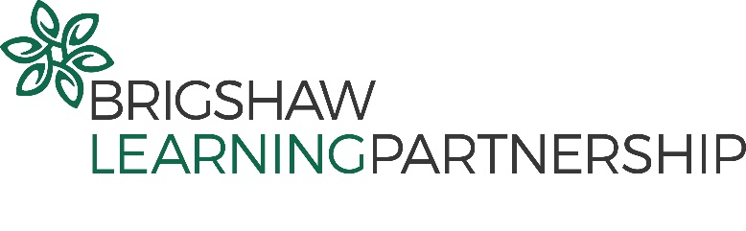

Local Governing Body
Meeting schedule and attendance 2021-22

Governor | 5.10.21 | 2.12.21 | 8.3.22 | 28.6.22 | Challenge Day: 7.2.22 | Challenge Day: 28.6.22
Lucy Marshall (Chair) |  | N
Cllr James Lewis |  |  | N | N | N | N
Chris Clarke
Chris Reid |  |  | N |  | N | N
Melinda Hiller |  |  |  | N
Sarah Tustin-Smith
Beverly Doubtfire |  |  |  |  | N/A | N/A
Richard Howitt |  |  |  |  | N/A | N/A
Janet Montgomerie
Stuart Owen |  | N | R | R | R | R
Barbara Husband |  |  | R | R | R | R
Susan Green |  |  | R | R | R | R

- Attended
N Absent
R Resigned

