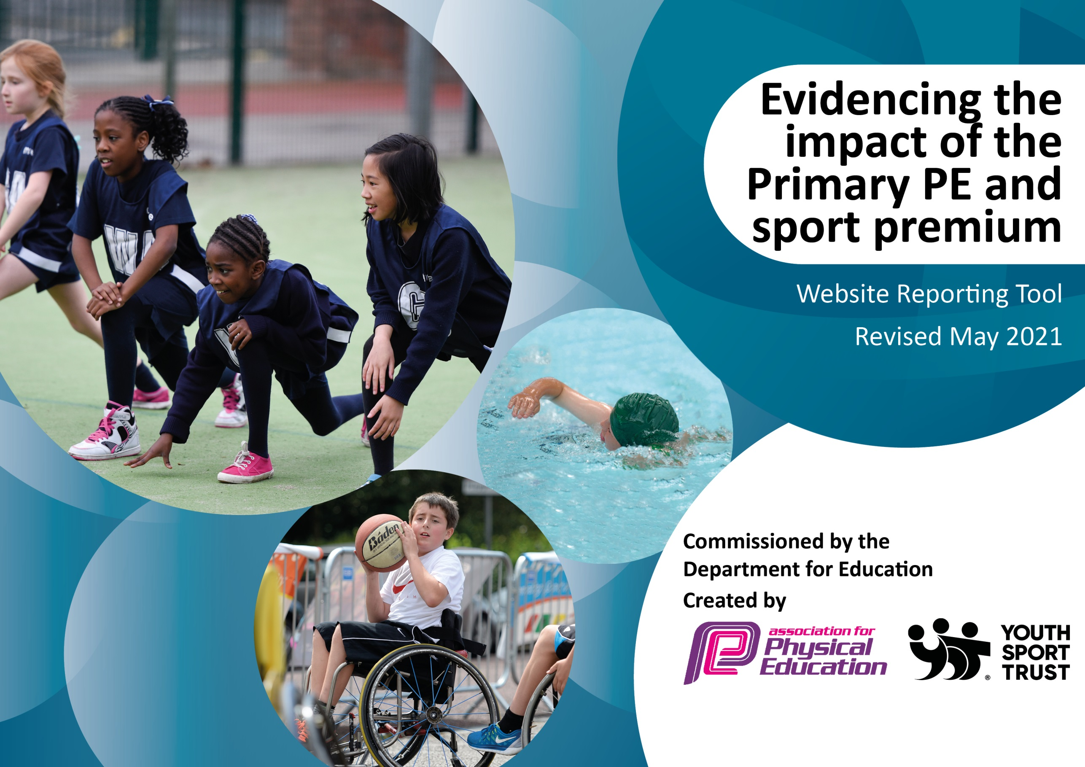

It is important that your grant is used effectively and based on school need. The Education Inspection Framework (Ofsted 2019 p64) makes clear there will be a focus on ‘whether leaders and those responsible for governors all understand their respective roles and perform these in a way that enhances the effectiveness of the school’.

Under the Quality of Education criteria (p41) inspectors consider the extent to which schools can articulate their curriculum (INTENT), construct their curriculum (IMPLEMENTATION) and demonstrate the outcomes which result (IMPACT).

To assist schools with common transferable language this template has been developed to utilise the same three headings which should make your plans easily transferable between working documents.

Schools must use the funding to make additional and sustainable improvements to the quality of Physical Education, School Sport and Physical Activity (PESSPA) they offer. This means that you should use the Primary PE and sport premium to:

- Develop or add to the PESSPA activities that your school already offer
- Build capacity and capability within the school to ensure that improvements made now will benefit pupils joining the school in future years
- The Primary PE and sport premium should not be used to fund capital spend projects; the school’s budget should fund these.
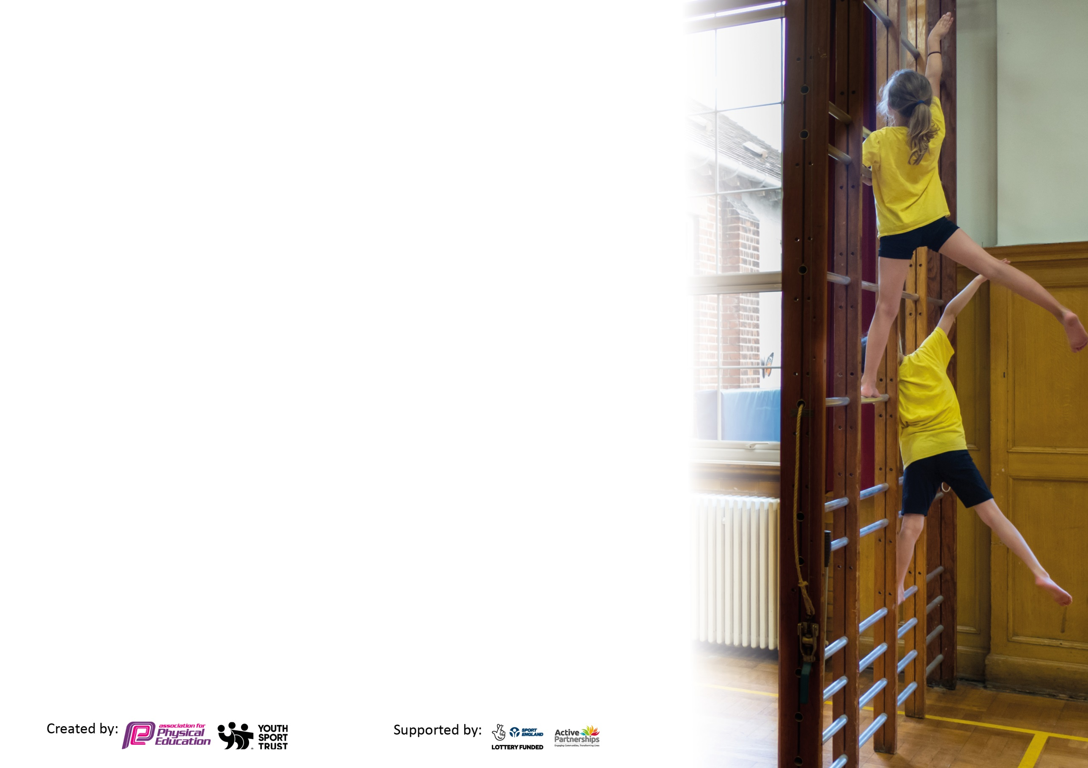
Please visit gov.uk for the revised DfE guidance including the 5 key indicators across which schools should demonstrate an improvement. This document will help you to review your provision and to report your spend. DfE encourages schools to use this template as an effective way of meeting the reporting requirements of the Primary PE and sport premium.

We recommend you start by reflecting on the impact of current provision and reviewing the previous spend.

Schools are required to publish details of how they spend this funding, including any under-spend from 2019/2020, as well as on the impact it has on pupils’ PE and sport participation and attainment by the end of the summer term or by 31st July 2021 at the latest.

We recommend regularly updating the table and publishing it on your website throughout the year. This evidences your ongoing self-evaluation of how you are using the funding to secure maximum, sustainable impact. Final copy must be posted on your website by the end of the academic year and no later than the 31st July 2021. To see an example of how to complete the table please click HERE.

Please note: Although there has been considerable disruption in 2020 it is important that you publish details on your website of how you spend the funding - this is a legal requirement.
Support for review and reflection - considering the 5 key indicators from DfE, what development needs are a priority for your setting and your pupils now and why? Use the space below to reflect on previous spend and key achievements and areas for development.

N.B. In this section you should refer to any adjustments you might have made due to Covid-19 and how these will influence further improvement.
Key achievements to date until July 2021: | Areas for further improvement and baseline evidence of need:
Increased pupil participation in a range of extra-curricular sports clubs.  An increased wide range of sports opportunities / competitions  Focus on development of Girls participation in school sport  An increase in the number of pupils taking part in intra school competitions  An increase in the number of pupils taking part in inter school competitions  Playleader trained pupils and playleader programmes in place  Children confident in self & peer assessment in PE  Provision for More able pupils  Practical Staff CPD for PE subject leaders  *All pupils in year 2,4,5,6 accessed inter school competitions (2019) restrictions in 2020/21 due to Covid 19 prevented full access)  Achievement of Sainsbury’s School Games Mark award in 2018-19 | 30 minutes a day physical activity (development of health and activity)  Consistent use of Personal challenge across the whole school  Increased engagement of girls and disadvantaged /hard to reach pupils.  Further develop the sports organizing crew  Develop more links with community  *Maintain high-level involvement in inter school competitions and extend intra school competitions (need to adapt for Covid 19)  *Staff CPD continuous need to update / keep informed / how to adapt  Return to school (post school closure) focus:  *Use PE to build stamina, strength and flexibility  *Improve basic movements, agility, balance, coordination, object control  *Support with developing positive mental health, deal with anxiety  *Develop confidence to try new things  *Develop social interaction, collaboration and teamwork

Meeting national curriculum requirements for swimming and water safety.

N.B Complete this section to your best ability. For example you might have practised safe self-rescue techniques on dry land which you can transfer to the pool when school swimming restarts.
Due to exceptional circumstances priority should be given to ensuring that pupils can perform safe self rescue even
if they do not fully meet the first two requirements of the NC programme of study.
What percentage of your current Year 6 cohort swim competently, confidently and proficiently over a distance of at least 25 metres?  N.B. Even though your pupils may swim in another year please report on their attainment on leaving primary school at the end of the summer term 2021.  Please see note above. | 60%
What percentage of your current Year 6 cohort use a range of strokes effectively [for example, front crawl, backstroke and breaststroke]?  Please see note above. | 60%
What percentage of your current Year 6 cohort perform safe self-rescue in different water-based situations? | 100%
Schools can choose to use the Primary PE and sport premium to provide additional provision for swimming but this must be for activity over and above the national curriculum requirements. Have you used it in this way? | Yes/No

Text in green is provision through the Brigshaw Learning Partnership PE and Sport offer.
This is 25% of our PE and Sport premium spend.
Text in blue is specific to Kippax North
*Covid 19 guidance dependent
Action Plan and Budget Tracking
Capture your intended annual spend against the 5 key indicators. Clarify the success criteria and evidence of impact that you intend to measure to evaluate for pupils today and for the future.

Academic Year: 2021/22 | Total fund allocated: £ | Date Updated:
Key indicator 1: The engagement of all pupils in regular physical activity – Chief Medical Officers guidelines recommend that primary school pupils undertake at least 30 minutes of physical activity a day in school |  |  |  | Percentage of total allocation:
 |  |  |  | 25%
Intent | Implementation |  | Impact
Your school focus should be clear what you want the pupils to know and be able to do and about  what they need to learn and to  consolidate through practice: | Make sure your actions to achieve are linked to your intentions: | Funding allocated: | Evidence of impact: what do pupils now know and what can they now do? What has changed?: | Sustainability and suggested next steps:
Increase pupil activity time through the school day from pre-school to after school club to move towards 30minutes activity per day. | Promote/use of range of activity initiatives  5 quick activity wins /Disney 10 min shake up / ‘go noodle’ activity  ‘Body coach’ for schools videos  Development of quick wins for physical activity in the school day  Purchase and use of Walk to school week resources for all classes 2021  Provision of targeted after school sports clubs to engage hard to reach/inactive pupils  Playleader training for pupils to run activity during break times.  Provision of cycling taster day and cycling competition day  Skipping school to deliver skipping workshops to year four and year two in preparation for festivals, but also using this as a springboard for skipping at break and lunches using ropes from last year’s programme. | Part of the £4000 invested in the Brigshaw Learning Partnership PE & Trust offer. | Majority of pupils are more active during the school day.
 | Playleaders  Pupils to apply to be Playleaders  Playleader training from Gavin Parkinson  Arrange playleader rota  Mr Westerman to assist sport during dinner times for KS2 – sports games on playground and accessibility to cycle track for fitness.  Enrichment clubs  Arrange after school enrichment club programme for the year with a range of different sports  Pupil survey to find out what extra clubs the pupils would like  Identify pupils who aren’t engaging in after school sports and activity and invite directly to before and after school clubs and engage with parents.  In school  Bikeability training Level 3 Y6  Bikeability training Level 2 Y5  Provision of balanceability training Y2  Extra cycling sessions through British Cycling - three-tiered approach: Year 5/6 training session, Y5/6 intra-school competition, Y5/6 inter-school competition  Cycle track maintenance  Trim trail | £3420  £1200  TBC | Group of Year 5/6 children trained to lead playground games for KS1/KS2 children.  Timetable set up to allow for daily playleader games.  Active playtimes – less active children offered use of cycle track for exercise.  Evidence in the form of Sports club Attendance registers.  Personal invites targeted children who have not accessed after school clubs / school day health and fitness offers such as golden mile and playleaders.  High percentage of Y2 children can ride a bike.  Children in FS and KS1 to access trim trail on a dinner time to develop fitness and motor skills
Key indicator 2: The profile of PESSPA being raised across the school as a tool for whole school improvement |  |  |  | Percentage of total allocation:
 |  |  |  | 25%
Intent | Implementation |  | Impact
Your school focus should be clear what you want the pupils to know and be able to do and about  what they need to learn and to  consolidate through practice: | Make sure your actions to achieve are linked to your intentions: | Funding allocated: | Evidence of impact: what do pupils now know and what can they now do? What has changed? | Sustainability and suggested next steps:
Increased focus on health and activity to increase alertness of pupils during the school day.  Development of cross curricular skills through PE – including areas such as leadership, resilience, determination team work and oracy.  Use of PE and Sport to develop pupil confidence, enjoyment and pride in school achievements. | ‘PE and Sport Offer booklet’ that details the intent and implementation of PE & Sport across the BLP.  Provision of quick wins for High quality PE to create creative and reflective learners as well as leaders.  Provision of intra school competition and inter school online virtual competition. Accessible by all pupils, rebuilding their confidence and engagement levels.  The use of trophies, certificates and awards  for the inter school competitions to celebrate success  Provision of activities in Key indicator 1 to improve health of pupils leading to more focused minds at key points in the school day.  Playleader training for pupils to run activity during break times.  Sports awards evening for all BPP/Trust schools  Provision of activities in Key indicator 5 to allow pupils to re-engage with school sport and the wider community.  Access to my personal best resource pack as part of YST membership.  Access to Sport Education style videos for staff to help o develop Sport Education style PE lesson pupils to develop leadership, teamwork and confidence  Purchase of walk to school week resources for all classes in key stage one and key stage two | Part of the £4000 invested in the Brigshaw Learning Partnership PE & Trust offer. | Improved oracy and use of key terminology and increased vocabulary within PE lessons.  Pupils able to explain where they need to improve and what they need to do in order to improve.  Pupils develop leadership skills and teamwork skills.  Confident pupils who take pride in their achievement and pride in their school’s achievements.  A culture where success of all students is celebrated through the use of trophies and medals of wining classes and pupils, as well as pupils working on their ‘personal best’ challenges. | These strategies can be used by all staff and encouraged by the PE lead.  Sustainable.  To keep it sustainable a refocus on the strategies will be needed
 | Provision of all above activities in Key Indicator One.  Self-assessment and peer assessment with PE lessons including continued development of key words and correct terms within PE when self and peer assessment takes place.  Use of social media (twitter) and school blog to celebrate pupils’ achievements within PE. |  | 100% of KS2 children can self-evaluate (explain what they are good at, where they need to improve and what they need to do in order to improve) after PE lessons using the Bronze, Silver and Gold being a PE learner posters displayed in the hall.  Pupils take part in whole school celebrations, reviewing their involvement in PE, Sport and Health activities within school and across the Trust to raise profile of PE and competitions within school. 12 children selected for further inter-school celebration at Brigshaw Trust Sports Awards.  Profile of PE sports events raised within the parent community.

Key indicator 3: Increased confidence, knowledge and skills of all staff in teaching PE and sport |  |  |  | Percentage of total allocation:
 |  |  |  | 25%
Intent | Implementation |  | Impact
Your school focus should be clear | Make sure your actions to | Funding | Evidence of impact: what do | Sustainability and suggested
what you want the pupils to know | achieve are linked to your | allocated: | pupils now know and what | next steps:
and be able to do and about | intentions: |  | can they now do? What has
what they need to learn and to |  |  | changed?:
consolidate through practice:
Provide high quality PE lessons that are ‘Covid Safe’  Improved quality of PE within school to develop competence and confidence of pupils.  To develop pupils’ basic movement literacy  To provide challenge to more able students | Access to a shared online resource of lesson exemplars. Including the use of Sport Education’ in lessons  Half termly PE leader meetings to provide support and guidance for PE leaders to discuss / share / support good practice.  Quick wins for high quality PE document used as a guide for staff to ensure high quality PE  Joint observations, team teaching, joint planning offer available.  Membership of Youth Sports Trust  Membership of AfPE  Access to YST and AfPE online CPD including amongst others live webinars on high quality PE and Health and safety within PE  Planning and support meetings available for PE leaders to help with the development of PE and Sport  Use of our own BLP PE Essentials poster as a tool create ambition for pupil attainment / assessment within PE. | Part of the £4000 invested in the Brigshaw Learning Partnership PE & Trust offer. | Improved staff confidence in delivering PE and ability to challenge more able and support developing students.  School develops and are aware of their intent, implementation and impact of their PE curriculum  PE leaders up to date with latest guidance and initiatives through membership of professional bodies  Staff are aware of how certain activities progress over the key stages and have a variety of activities they can use to challenge students at different levels & ages.  Staff are aware of and know the importance of delivering fundamental movement skills at an early age.  Evidence:  Assessment records of staff show pupil progress.  PE leader observations show development of lessons  Joint ‘drop ins’ with PE leader and Learning Partnership PE Coordinator validate improving session judgements.  Drop in feedback sheets give feedback to act upon that improve outcomes.
 | Use of specialist staff delivering PE lessons, and staff observing to develop their knowledge.  Attended PE leader meetings.  Planned intent, implementation  Lesson observations by Adam Palmer - feedback to AW  Termly meetings with Adam Palmer to discuss/monitor PE provision.  Use BLP google drive  Use of quick wins to encourage staff to show high quality ‘basics’ in PE. Based on 2012 Ofsted report.  PE leader will have half termly meetings with staff delivering PE to discuss provisions  Ensure Premier Sport PE portal is accessed by all teachers and ensure they can use it confidently to inform their DofL judgements. |  | Improved staff confidence in delivering PE and ability to challenge more able and support developing students.  School developed and are aware of their intent, implementation and impact of their PE curriculum  Staff are aware of how certain activities progress over the key stages and have a variety of activities they can use to challenge students at different levels & ages.  Pupil progress is good within lessons and across the key stages.
Key indicator 4: Broader experience of a range of sports and activities offered to all pupils |  |  |  | Percentage of total allocation:
 |  |  |  | 25%
Intent | Implementation |  | Impact
Your school focus should be clear | Make sure your actions to | Funding | Evidence of impact: what do | Sustainability and suggested
what you want the pupils to know | achieve are linked to your | allocated: | pupils now know and what | next steps:
and be able to do and about | intentions: |  | can they now do? What has
what they need to learn and to |  |  | changed?:
consolidate through practice:
Provide a broad range of sports and activities to engage all pupils within school making sure we are addressing disadvantaged, girls & inactive pupils. | Use of personal challenge to allow all pupils access to some level of competition if they are unable to engage with after school provision  Provision of Cycling taster sessions and cycling competitions with pro ride during school day for a full year group.  Provision of skipping workshops for year two and year four and access to BLP skipping festival  Year 3,4,5,6 have two opportunities to access an inter school cross country competition.  Access to Leeds and West Yorkshire school games cross country competition.  Provision of dance in a day project.  Provision of sports competitions in netball, football, tag rugby, athletics, paralympics, multi skills, badminton, sportshall athletics, handball, dodgeball, rounders  The BLP offer covers all year groups from year 1 to year 6 in a wide range of sports.  Provision of an Olympic week of sport with an external coaching agency for each year group in each school, with a focus on alternative sports for each year group  Or 6 weeks of after school clubs | Part of the £4000 invested in the Brigshaw Learning Partnership PE & Trust offer.  25% | Children still access a range of sports even with restrictions that were in place.  Development of cultural capital.  Pupils enjoy PE and Sport and have experience of a range of activities.
 | Identify hard to reach pupils and invite to after different sports clubs / activities / events to engage all pupils.  PE leader to review current sports provided and identify any gaps in provision.  PE leader to use student voice to identify sports and activity preferences of pupils.  Provision of after year long after school enrichment clubs through Premier Sport to widen the range of activities e.g fencing, archery, tchoukball including an increased provision for KS1 (all year)  Class rota set up to allow 100% of KS2 the opportunity to access the table tennis tables at least one play time a week.  A broad range of activities taught within the PE curriculum.  Skipping competition for Y4 and Y2  Inter-school competitions for football  Olympic themed week. All children F2-Y6 to take part in a range of activities: archery, ultimate frisbee, dodgeball, tchoukball, handball and athletics.  Cycle track maintenance  PE servicing costs  PE resource order  Leeds schools’ sports association affiliation | £400  £120 | All pupils in KS1 and KS2 given access to new sports activity beyond normal lessons – inactive children targeted and personal invites given.  Pupils enthused by sport and given the chance to find a sport and activity that they enjoy.  Participation in Leeds schools’ events such as cross country with a pathway to county and national finals

Key indicator 5: Increased participation in competitive sport |  |  |  | Percentage of total allocation:
 |  |  |  | 25%
Intent | Implementation |  | Impact
Your school focus should be clear | Make sure your actions to | Funding | Evidence of impact: what do | Sustainability and suggested
what you want the pupils to know | achieve are linked to your | allocated: | pupils now know and what | next steps:
and be able to do and about | intentions: |  | can they now do? What has
what they need to learn and to |  |  | changed?:
consolidate through practice:
To allow all pupils opportunity to represent the school in inter school competitive sport from year 1 to year 6.  To develop further opportunities through intra school sport | Provision of inter school competitions and festivals in  Netball X 4  Football X 2  Tag Rugby  Skipping  Cross Country X 2  Sportshall athletics X 2  Rounders  Multi Skills X 2  Badminton X 2  Dance X 1  Big Sports day for all year 4,5,6 pupils covering handball, tag rugby, dodgeball, athletics, relay races.  Girls only sports mornings engage girls in sports competition. | Part of the £4000 invested in the Brigshaw Learning Partnership PE & Trust offer.  25% | All pupils from year 1 to year 6 were able to access the competitions as they are being run as intra school.  Increased engagement from previous years.  Comparison of scores as a virtual competition across the cluster of schools allows pupils to celebrate of success  Increased confidence in pupil’s own ability to take part in a competition
To allow all pupils opportunity to represent the school in inter school competitive sport from year 1 to year 6.  To develop further opportunities through intra school sport | To promote intra school and personal best challenges and competitions with all classes  To engage pupils in inter school sports competition.  To plan intra school competition in conjunction with Premier Sport to link to the PE topic for each half-term as a finale to each PE topic.  Full day Sports Day involving a range of different competitive sports – athletics, handball and archery |  | High percentage of children from Y1-6 took part in intra/inter school competitions  Most children from F2-Y6 took part in at least 4 competitive sporting events such as athletics, handball and archery.  Increase pride of children in taking part in inter school competitions.

