Lion TCR clinched the "Most Innovative Enterprise of the Year" Award at the 2023 Cell and Gene Therapy Asia Industry Star Awards.

On April 3, 2023, the results of the Cell and Gene Therapy Asia Industry Star Awards in the Asia-Pacific region were officially announced. Lion TCR, a biotechnology company, was awarded the "Most Innovative Enterprise of the Year" award for 2023.
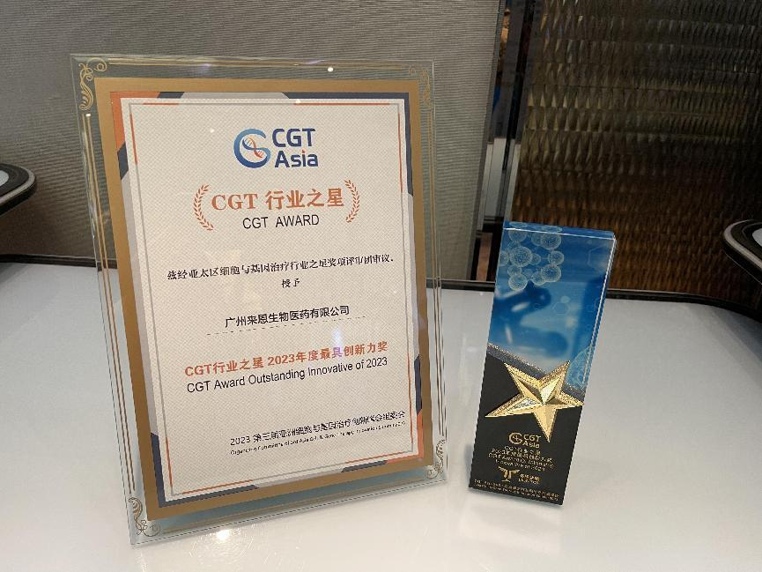

The third annual CGT Asia 2023 Innovation Summit, organized by Taas Labs, was held in Shanghai on April 3-4, 2023. More than 200 global cell and gene therapy companies, alongside 1,500 attendees from China and abroad, participated to discuss industry prospects and collaboration opportunities. The conference focused on core topics such as the commercialization of cell therapy products, progress in the development of stem cell therapy drugs, smart technology support for commercialization pathways, medical insurance programs enabling listings of cell therapies, the latest hot topics and innovative research in gene therapy, drug development optimization and delivery technology, strengthening R&D transformation from the laboratory to the clinic, and the development of rare disease gene therapy drugs. The conference aimed to promote technological innovation and integration development of cell gene therapy research and industry and strived to provide a fruitful networking platform for its participants.

Dr. Tina Wang, Chief Medical Officer and Chief Operating Officer of Lion TCR, was also invited to give a keynote speech. She introduced Lion TCR's TCR T cell therapy targeting hepatitis B virus antigens, using mRNA encoding technology and the companies’ clinical experiences with immunotherapy. Dr Tina also stressed Lion TCR’s commitment to continued innovation to benefit patients.
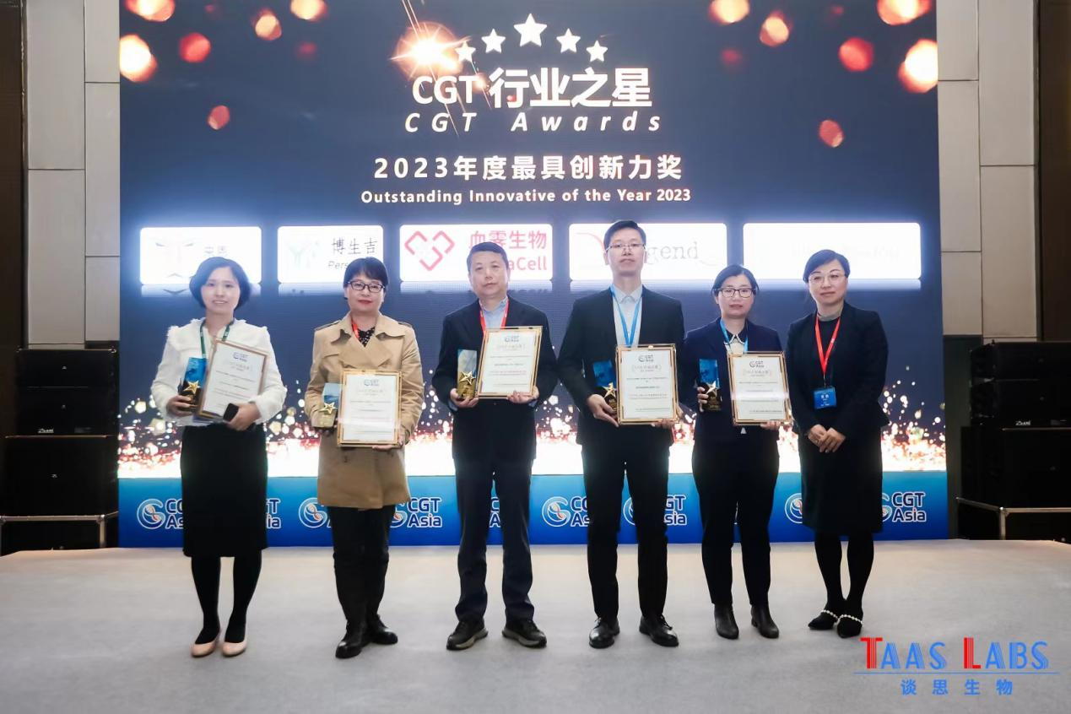
Dr. Tina Wang (second from left), Chief Medical Officer and Chief Operating Officer of Lion TCR, represented the company to receive the award.

As a biotechnology company focusing on cell therapy, Lion TCR is committed to pushing the frontiers of novel yet effective and safe immunotherapies. To this end, its use of mRNA encoding TCR in clinical trials for liver cancer treatment has shown good safety and significant efficacy. Through its TCR discovery platform, Lion TCR has discovered several novel targets suitable for different indications, which would be critical towards answering currently unmet clinical needs. The company relentlessly innovates in order to provide patients with more personalized, effective, and safe treatment options, in the process continuously pushing the boundaries of the immunotherapy industry's development.
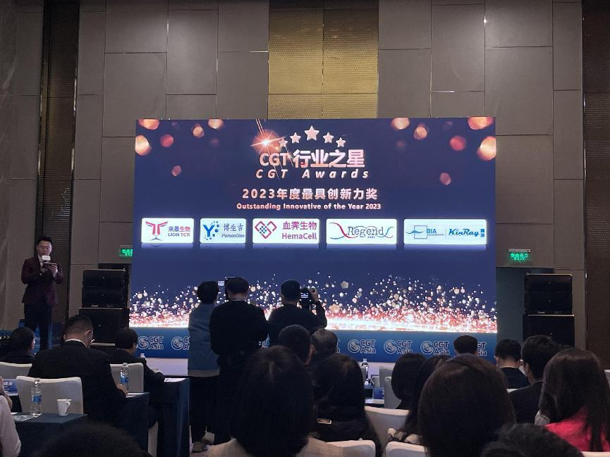
In this nomination for the Cell and Gene Therapy Asia Industry Star Awards in the Asia-Pacific region, Lion TCR stood out and won the "Most Innovative Enterprise of the Year” award" for the year 2023, which is testament to its excellence in technological innovation, cutting edge research and development capabilities, and sound clinical strategy being recognised by the industry.

Moving forwards, Lion TCR shall continue to tirelessly innovate and strengthen its technological capabilities in order to accelerate the development of new immunotherapies and answer to the many currently unmet clinical needs. Lion TCR will do its utmost to contribute to the healthy development of the industry.

About Lion TCR:
Lion TCR is a clinical-stage biotechnology company focused on TCR-based cell therapy. It is a pioneer in the direct use of mRNA to encode TCRs in immune cells, and has shown good safety and significant efficacy in clinical trials for the treatment of liver cancer. Through its TCR discovery platform, the company is discovering novel targets and developing innovative therapies for unmet clinical needs. Recognising the need to address accessibility and scalability of immunotherapy, the company has also established a platform for autologous cell therapy and off-the-shelf therapy products.

About the CGT Awards:
The "CGT Cell and Gene Therapy Asia Industry Star Award" is a global award aimed at providing strong support for the direction of cell and gene therapy research and transformation, promoting industry research and development capabilities, and enhancing brand influence. The nominees are evaluated by professionals based on technical practicality and innovation, market performance (market share, benchmark products/companies), customer evaluation (quality assurance, service process clarity), growth potential, and intellectual property. The organizer, Taas Labs, focuses on the latest developments in the Chinese and global biopharmaceutical industry, providing a platform for online and offline communication and information for different fields such as cell therapy, gene therapy, DNA/RNA therapy, and vaccines, accelerating the development of the Chinese biopharmaceutical industry and helping to create a global biopharmaceutical industry center.

