Document Title: SciAps TranslationTable_Z-901 Lithium Specifications
Rev Date: 1221
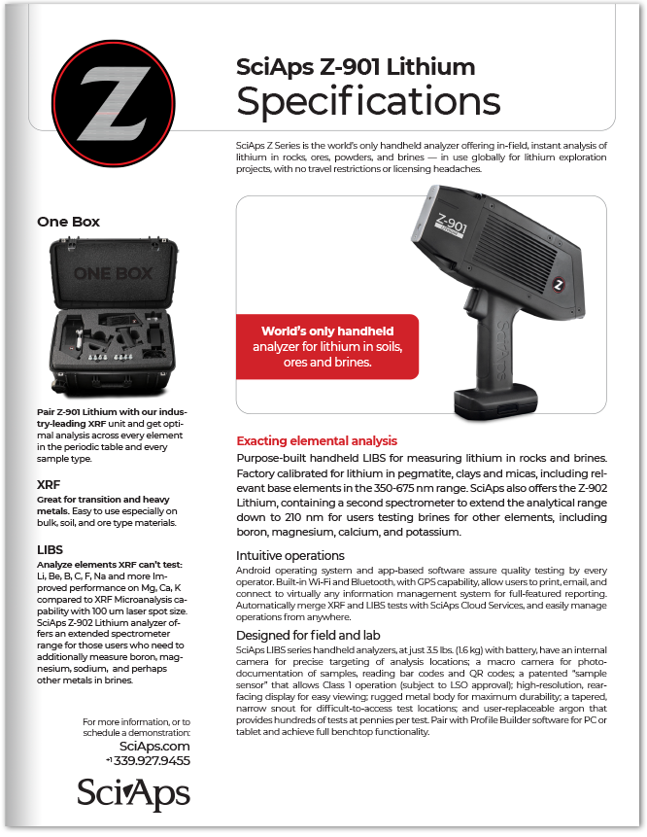
Layout Preview | English Text | Translated Text
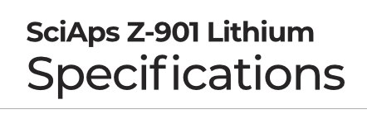 | SciAps Z-901 Lithium
 | Specifications
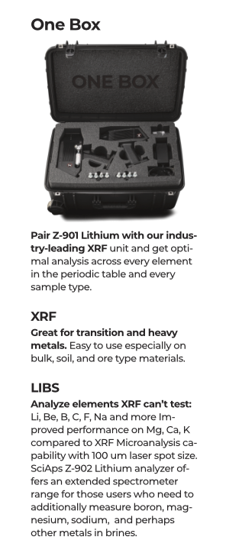 | One Box
 | Pair Z-901 Lithium with our industry-leading XRF
 | unit and get optimal analysis across every element in the periodic table and every sample type.
 | XRF
 | Great for transition and heavy metals.
 | Easy to use especially on bulk, soil, and ore type materials.
 | LIBS
 | Analyze elements XRF can’t test:
 | Li, Be, B, C, F, Na and more Improved performance on Mg, Ca, K compared to XRF Microanalysis capability with 100 um laser spot size. SciAps Z-902 Lithium analyzer offers an extended spectrometer range for those users who need to additionally measure boron, magnesium, sodium, and perhaps other metals in brines.
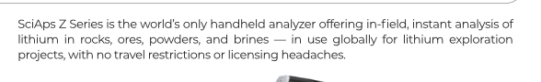 | SciAps Z Series is the world’s only handheld analyzer offering in-field, instant analysis of lithium in rocks, ores, powders, and brines — in use globally for lithium exploration projects, with no travel restrictions or licensing headaches.
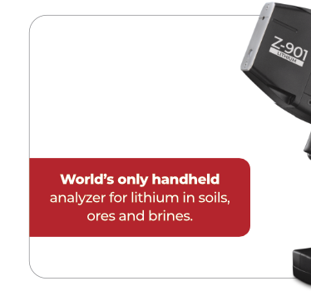 | World’s only handheld
 | analyzer for lithium in soils, ores and brines.
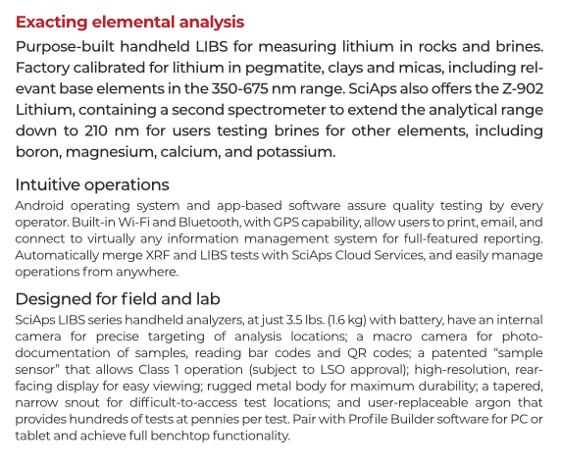 | Exacting elemental analysis
 | Purpose-built handheld LIBS for measuring lithium in rocks and brines. Factory calibrated for lithium in pegmatite, clays and micas, including relevant base elements in the 350-675 nm range. SciAps also offers the Z-902 Lithium, containing a second spectrometer to extend the analytical range down to 210 nm for users testing brines for other elements, including boron, magnesium, calcium, and potassium.
 | Intuitive operations
 | Android operating system and app-based software assure quality testing by every operator. Built-in Wi-Fi and Bluetooth, with GPS capability, allow users to print, email, and connect to virtually any information management system for full-featured reporting. Automatically merge XRF and LIBS tests with SciAps Cloud Services, and easily manage operations from anywhere.
 | Designed for field and lab
 | SciAps LIBS series handheld analyzers, at just 3.5 lbs. (1.6 kg) with battery, have an internal camera for precise targeting of analysis locations; a macro camera for photo-documentation of samples, reading bar codes and QR codes; a patented “sample sensor” that allows Class 1 operation (subject to LSO approval); high-resolution, rear-facing display for easy viewing; rugged metal body for maximum durability; a tapered, narrow snout for difficult-to-access test locations; and user-replaceable argon that provides hundreds of tests at pennies per test. Pair with Profile Builder software for PC or tablet and achieve full benchtop functionality.
 | For more information, or to schedule a demonstration:
SciAps.com
Local Phone Number
(BACK)
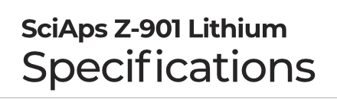 | SciAps Z-901 Lithium
 | Specifications
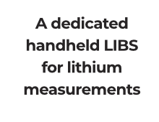 | A dedicated handheld LIBS for lithium measurements
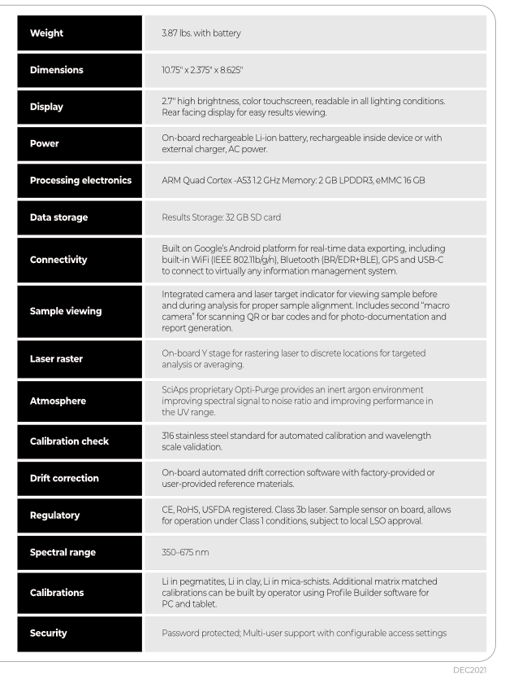 | Weight
 | 3.87 lbs. with battery
 | Dimensions
 | 10.75" x 2.375" x 8.625"
 | Display
 | 2.7″ high brightness, color touchscreen, readable in all lighting conditions. Rear facing display for easy results viewing.
 | Power
 | On-board rechargeable Li-ion battery, rechargeable inside device or with external charger, AC power.
 | Processing electronics
 | ARM Quad Cortex -A53 1.2 GHz Memory: 2 GB LPDDR3, eMMC 16 GB
 | Data storage
 | Results Storage: 32 GB SD card
 | Connectivity
 | Built on Google’s Android platform for real-time data exporting, including built-in WiFi (IEEE 802.11b/g/n), Bluetooth (BR/EDR+BLE), GPS and USB-C to connect to virtually any information management system.
 | Sample viewing
 | Integrated camera and laser target indicator for viewing sample before and during analysis for proper sample alignment. Includes second “macro camera” for scanning QR or bar codes and for photo-documentation and report generation.
 | Laser raster
 | On-board Y stage for rastering laser to discrete locations for targeted analysis or averaging.
 | Atmosphere
 | SciAps proprietary Opti-Purge provides an inert argon environment improving spectral signal to noise ratio and improving performance in the UV range.
 | Calibration check
 | 316 stainless steel standard for automated calibration and wavelength scale validation.
 | Drift correction
 | On-board automated drift correction software with factory-provided or user-provided reference materials.
 | Regulatory
 | CE, RoHS, USFDA registered. Class 3b laser. Sample sensor on board, allows for operation under Class 1 conditions, subject to local LSO approval.
 | Spectral range
 | 350–675 nm
 | Calibrations
 | Li in pegmatites, Li in clay, Li in mica-schists. Additional matrix matched calibrations can be built by operator using Profile Builder software for PC and tablet.
 | Security
 | Password protected; Multi-user support with configurable access settings
 | YouTube.com/SciAps
If applicable, please add:
LOCAL COMPANY NAME
LOCAL WEBSITE
LOCAL PHONE

