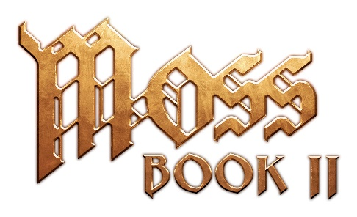

MOSS: BOOK II LAUNCHES JULY 21 ON META QUEST 2

Moss: Book II Set to Debut as One of the Most Stunning Games on Meta Quest 2

Distinguished Composer Jason Graves to Delight Fans with the Moss: Book II Official Soundtrack

SEATTLE – June 9, 2022 – The wait is almost over for millions of Meta Quest 2 owners eager to explore the magical world within Moss: Book II, the award-winning sequel to the fan favorite VR game Moss. Announced during today’s UploadVR Summer Showcase, Moss: Book II will launch on Quest 2 on Thursday, July 21, 2022. Greeted by critical acclaim when released on PlayStation VR earlier this year, Moss: Book II is being hailed as an essential and must-play VR title. Players can now add Moss: Book II to their Quest Store wishlist. And for those wanting to jump in and play Moss before Moss: Book II’s release, Moss is now 25% off for a limited time.

"For this release, we didn't just want to get Book II running on Quest 2 and call it a day, so we took our time diligently balancing all aspects of the game, across graphics and gameplay, with the end goal being a truly memorable experience,” said Tyler Walters, technical artist, Polyarc. “Throughout this process, we were regularly excited by the level of fidelity we were able to achieve on Quest 2, often finding ways to make the game look and play better than ever."

In addition to the vibrant look and feel of Moss: Book II, players will find a deep sense of immersion and physical connection to the world when leveraging the two-controller setup of the Quest 2. Playing with both hands provides a natural feeling, allowing players to express themselves more freely in the world when reaching in to manipulate the environment, interact with the beloved hero Quill, or engage the weapon inventory system during battle.

Along with today’s Quest 2 announcement, Polyarc opened pre-order for the Moss: Book II Official Soundtrack (OST) composed by two-time BAFTA award-winning composer Jason Graves. Graves returns to score Quill’s new adventure and elevates the player experience with his elegant, heartfelt, and thematic score. The soundtrack features Graves on solo piano, acoustic guitars, and Celtic harp, with additional instrumental performances from Kristin Naigus (Irish whistles, flute, oboe, English horn), Reinoud Ford (cello), and Tom Strahl (bouzouki, oud).

“The original Moss holds a very special place in my heart and Moss: Book II is an extremely personal score,” said Graves. “Adding new instruments to the ensemble, I put together a small ‘pub band’ of soloists to underscore Quill's heroism and heartbreak, and even acquired a beautiful baby grand piano that acts as the heart and soul of the score, performing most cues live on the piano, then adding other instruments to flesh out the themes. I hope this soundtrack takes players back to the magical world of Moss with every listening.”

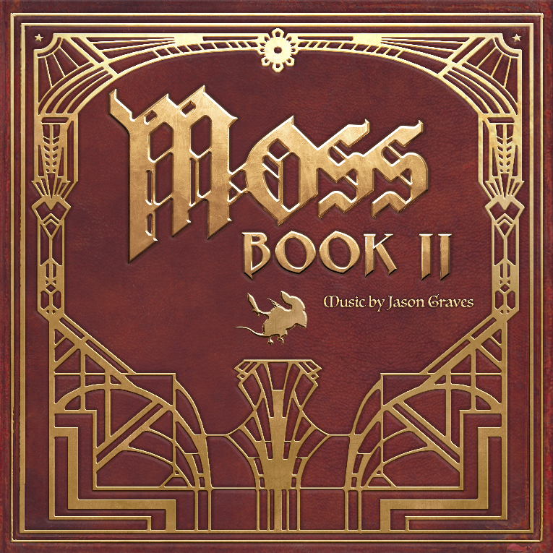

The soundtrack consists of 17 in-game tracks for more than 140 minutes of music. The first three tracks — “When One Door Shuts,” “The Starthing’s Way,” and “The Winter Glass” — can be sampled on Bandcamp now. For soundtrack collectors and fans of physical versions, pre-order is now available for a limited run of premium CD and vinyl albums at Materia Collective and Bandcamp.

To stay up to date on all the latest about Moss: Book II, players can follow Polyarc on Twitter, Facebook, YouTube, and Instagram. Visit https://www.polyarcgames.com/ for more information.

© 2022 Polyarc, Inc. All rights reserved. Moss and Moss: Book II are trademarks of Polyarc, Inc.

About Polyarc
Polyarc, located in Seattle, was founded in 2015 to explore the energizing and momentous creative possibilities of virtual and augmented reality, and to champion a culture where deep collaboration, creative expression, and high player value are at the forefront of every innovation. Polyarc self-published Moss in 2018 which ranks as one of the top-rated VR games of all time and has received more than 80 global industry awards and nominations. Polyarc’s team is made up of talented developers with deep experience working on well-known, AAA franchises such as Destiny, Halo, Red Dead Redemption, and Guild Wars. https://www.polyarcgames.com/

Polyarc is hiring. Check out the open positions: https://www.polyarcgames.com/work

About Moss: Book II
Moss: Book II picks up right where the story in Moss left off. Having rescued her uncle Argus, Quill’s adventure continues with the revelation that a winged tyrant is hunting her within the castle where her uncle was held captive. But Quill has a plan of her own, one that could finally end the merciless rule of the Arcane and save the world from a great unmaking. The journey will be trying—filled with triumph and heartbreak alike—but new allies, old friends, and the very nature of the castle itself can offer help along the way. Yet in the end, it is you alone who can lift Quill up to save this world, and together, rise to legend.
https://www.polyarcgames.com/bookii
# # #

