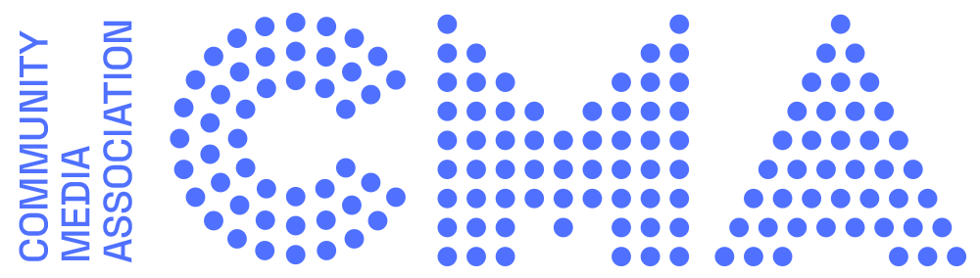

NEWS RELEASE
FOR IMMEDIATE PUBLICATION

The 40th anniversary of the Community Media Association is being celebrated in 2023 with a refreshing new brand, a Community Media Festival and a modern and up to date website at communitymedia.uk

The CMA launched in 1983 as the Community Radio Association, changing its name in the late 1990’s to reflect new circumstances while staying true to the central mission of supporting and growing community based, grassroots, and non-profit media in the UK.

Chair, Dom Chambers said “The CMA is a forward-looking organisation focused on the direction of progress. We have been working hard behind the scenes to explore what we need to be to offer dynamic leadership. We fundamentally believe creativity in the arts can be an agent for social change. This is made more potent and powerful when driven by business models that exist for community benefit. We felt a new look to the CMA was needed to best represent a reinvigorated approach. Our council is delighted to present our new logo and website. Bold, visionary and dynamic; we are all set for the New Year and all the challenges and opportunities it will bring.”

Designer Alan Watt who created the new logo said "I wanted to capture the idea of community at the heart of the CMA. It’s the people that make the CMA so each dot of the logo is representative of an individual and it's only when they come together that they make a whole. As a modern and dynamic organisation the CMA needed a strong, contemporary identity to engage with their audience through multiple channels; a logo that can work equally well at small scale on an iPhone as it will on a billboard”

In a fast shifting media landscape the CMA offers all-encompassing and inclusive leadership to the burgeoning contribution non-profit sectors are making to the audio and radio industry in the UK as well as society in general.

The annual CMA event the Community Media Festival bringing together local broadcasters from around the country will hold prominence this year as we reflect on the 40 year history of the organisation and the future of local, community broadcasting in the UK. More details on the anniversary festival will be announced soon.

The team at the Community Media Association are very much looking forward to highlighting the work of non-profit broadcasters across the country in 2023 on the new website, on its social media channels and in the monthly newsletter. You can reach the communications team on email office@communitymedia.uk and on Twitter and Instagram @community_media

ENDS

