2023 Best in Class Marketing Awards
Application Form

- This nomination form may be downloaded here: https://bmma.org/best-in-class-awards/

- Submission deadline: January 13, 2023

- Forward applications to: lauren@researchfirst.com. We will acknowledge receipt of your application within 48 hours. If you do not receive a confirmation, please follow up with Lauren Roux (228-234-4373) to assure we have received it.

- Please complete one application for each award nomination submission. If you wish to submit more than one nomination, please do so on separate forms to avoid any confusion. This year we will take submissions for two awards recognizing excellence or innovation:
  - Marketing
  - Marketing Partnership

- What value do the BIC awards bring to our members?
  - Peer recognition (within the BMMA and one’s own organization)
  - Ability to claim your product/service “Award Winning” in the public domain
  - Provide the opportunity to other members to learn more about industry best practices (award winners may present their programs at the Annual Meeting)
  - Award plaque

- Overview
The BMMA will recognize teams / companies that have demonstrated broadband services marketing innovation or excellence. The Board of Directors will review the applications and select the winners

The awards, which signify superior marketing programs related to broadband services, will be presented at the BMMA 2023 Annual Meeting. Award recipients will be invited to present their programs at the BMMA 2023 Annual Meeting. They will also receive recognition in a general press release and on the BMMA web site. Award “finalists” may be invited to present as a Hot Topic on a monthly call. We encourage ALL vendor and service provider members to submit entries!

BMMA Best-in-Class awards:

- Are open to all active members of the BMMA.
- May include activities that can be classified as either “marketplace” oriented or “product” oriented.
- Will be based on activities during the calendar year from January until December 2021.

- Table of contents

Part 1 – Award descriptions ……………………………………………………………………………. page 2
Part 2 – Applicant and nominee contact details …………………………………………… page 3
Part 3 – Award nomination forms
- Marketing ……………………………………………………………………………………………….... page 4
- Marketing Partnership……………………………………………………………………………….. page 5

Part 1 – Award descriptions
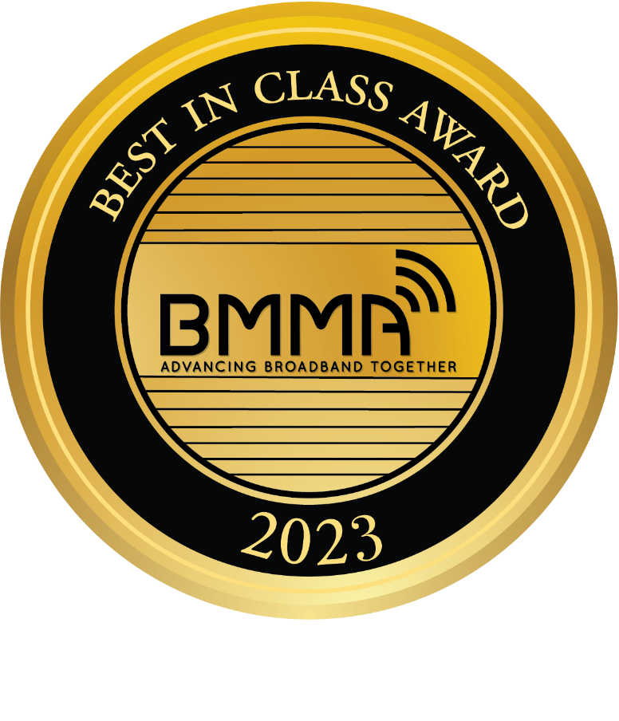

The BMMA will recognize teams / companies that have demonstrated innovation or excellence in marketing broadband services.

Below is a brief description of each award.

  - Marketing Awards (2)
Awarded to one service provider and to one vendor that best display marketing innovation or excellence. All areas of marketing are eligible for this award (i.e. product, promotions, advertising, channel, packaging, etc.).
  - Marketing Partnership Award
Awarded to a partnership of two or more members that best displays teamwork on a marketing initiative. All areas of marketing are eligible for this award (i.e. product, promotions, advertising, channel, packaging, etc.). Up to one Marketing Partnership award will be granted each year (each “partner” will receive an award.)

Part 2 – Applicant and nominee contact details

Please complete all details below to the best of your ability.

A. Person submitting this nomination

Name:

Company:

Email:

Telephone:

B. Nominee – team/company responsible for this product, service or program

Indicate the award for which you are nominating this team/company.
(Select one – see descriptions on next page.):

_____ Marketing Award

_____ Marketing Partnership Award

Company/Team:

Primary Contact name:

Email:

Telephone:

Product/Service or Program Name:
Part 3 – Award nomination forms

Please complete one application for each award nomination submission. If you wish to submit more than one nomination, please do so on separate forms to avoid any confusion.
To complete your nomination for one of the Marketing Awards, complete section A.
To complete your nomination for the Marketing Partnership Award, complete section B.
- Marketing Awards
Awarded to one service provider and to one vendor that best display marketing innovation or excellence. All areas of marketing are eligible for this award (i.e. product, promotions, advertising, channel, packaging, etc.).

Please answer all of the questions below to the best of your ability. Thank you!

1. (5 points) Provide a name for the submission. Describe the product/service or program. When was this product/service or program officially announced/launched? During what period did the product/service or program campaign run?

2. (20 points) What is the target market for this product/service or program and how well does it meet the needs of this market, capture their attention, fill an obvious market void, etc.? Please describe and be specific about examples that support your conclusion.

3. (35 points) Please explain why this product/service or program demonstrates marketing excellence or innovation. How was this demonstrated in promotions, pricing, product, and/or channel selection?

4. (15 points) Please describe how the nominee overcame any barriers such as resource availability, funding, communications challenges, resistance to change, etc.

5. (25 points) Describe the achievement of the product/service or program's objectives (ex. sales objectives, retention objectives, financial)?

6. (BONUS 10 points) Please provide any other relevant information or material to support this nomination.
- Marketing Partnership Award
Awarded to a partnership of two or more members that best displays teamwork on a marketing initiative. All areas of marketing are eligible for this award (i.e. product, promotions, advertising, channel, packaging, etc.). One Marketing Partnership award will be granted each year (each “partner” will receive an award.)

Please answer all of the questions below to the best of your ability. Thank you!

1. (5 points) Provide a name for the submission. Describe the partnership initiative. During what timeframe did the partnership take place? When did the product/service or program launch?

2. (20 points) What is the target market for this product/service or program and how well were the needs of the market identified? How well did the product/services or program meet the identified needs? How well did the product/service or program’s execution help capture the market’s attention? Please describe and be specific about examples that support your conclusion.

3. (35 points) Please explain why this product/service or program demonstrates superior teamwork. How did each party contribute to the end result? How were the strengths of each member drawn upon to bring the product/service or program to market? How did the good teamwork benefit both members? Why do the nominees deserve to be recognized for outstanding partnership in the field of marketing?

4. (15 points) Please describe how the nominee overcame any barriers such as resource availability, integration of processes/systems, funding, communications challenges, resistance to change, two separate companies with differing goals, etc.

5. (25 points) Describe the achievement of the product/service or program's objectives (ex. sales objectives, retention objectives, financial, ROI / ROE, etc.). How did the marketing partnership impact these results?

6. (BONUS 10 points) Please provide any other relevant information or material to support this nomination.

