2023 Scholarship Application Checklist

Application and required documents must be submitted as one package. (Failure to comply with any of the requirements will result in an automatic disqualification.)

- Create a profile at the 2023 Scholarship Application
- The 2023 CTSF Scholarship application must be completed entirely, and you must submit all required documentation.
- GPA Information - Minimum GPA is 2.5 unweighted
  - High school students must submit the following documents when completing the application.
    - Last high school transcripts (official or unofficial)
    - Acceptance letter from an accredited institution of higher education or vocational institution. If a letter of acceptance has yet to be received, you must show proof of enrollment for the fall semester.
  - College/Undergraduate/Graduated - must submit the following documents when completing the application.
    - Most recent college transcripts (official or unofficial)
    - Proof of enrollment for the fall semester

- Essay - Must include the following:
  - Ensure to answer the requested questions located on the application.
  - Double-spaced.
  - Times New Roman, 12 font, one-inch margin.
  - Add your name and email address on the top right side of each page.
Example:
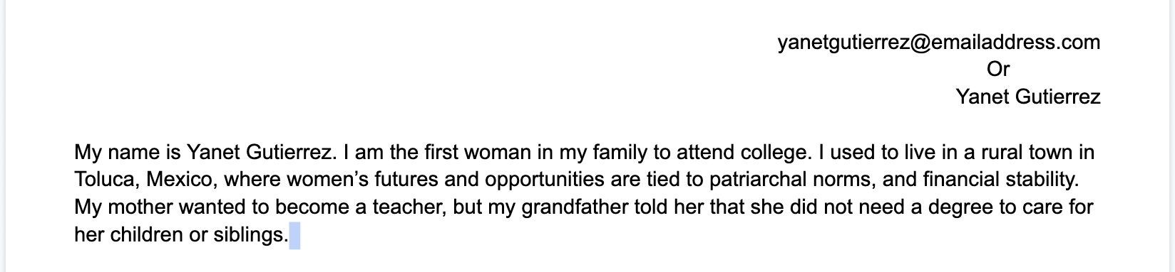
  - Check spelling and grammar
  - 500-word limit

- School, Community, and Civic Engagement
  - School, Community, and Civic Engagement Involvement - Due to the current Covid-19 restrictions, we have modified the Volunteer Hours for School, Community, and Civic Engagement. We will continue to ask applicants to submit hours completed as volunteers. For the 2023 application, we will accept applications that still need 50 hours. To satisfy this requirement, we will ask each applicant to submit a brief paragraph (250 words) describing how they have supported their communities, family members, and/or overall personal/professional growth.

- Financial Information: All applicants must submit proof of income by submitting the following information:
  - Filing as a dependent - Family income tax forms, including all dependents living at home.
    - Tax return filing must be filed in 2022.
    - Provide the most recent W2 forms from all income sources in your household.
  - Filing as an independent -
    - Tax return filing must be filed in 2022.
    - Provide the most recent W2 forms of all income earners in your household.

- 2 Letters of Recommendation

  - Each applicant must provide two (2) letters of recommendation from a mentor, counselor, teacher/professor, non-profit staff, or employer.
    - It could be on a letterhead sheet, but it must have the following information: the recommender's name and email address.
    - Each recommendation letter should mention the applicant's contribution to their community, school, and/or work. Most importantly, it highlights the applicant’s determination to achieve educational goals.
How to request a letter of recommendation:
- Give an advanced notice.
- Ask in person first, briefly explaining the opportunity and the importance of submitting the letter of recommendation on time. Send a follow-up via email after the meeting.
- Use the following example as a way to request your letter of recommendation.
Dear Professor X.,
I hope you are well. I am applying to The Catalino Tapia Scholarship and would like to know if you feel comfortable writing a strong letter of recommendation on my behalf.
I thoroughly enjoyed my time as [add details about the relationship with the recommender]. As my [teacher/counselor/manager], you can honestly and effectively vouch for the [list of skills or qualifications] I have demonstrated during my time as your student.
I appreciate you considering my request. The deadline for submitting the letter is [date]. I’ve attached an updated version of my [resume/add details about how you excel during his/her class] and the [job posting/admission requirements]. You will receive an email from The Catalino Tapia Scholarship Foundation requesting the submission of a letter of recommendation on my behalf.[this will be submitted through the application portal]. If you need any additional information, don’t hesitate to contact me.
Thank you for your time and support.

Your Name
Phone number
Email address

