Flex Strip 1200-80 Double Mono

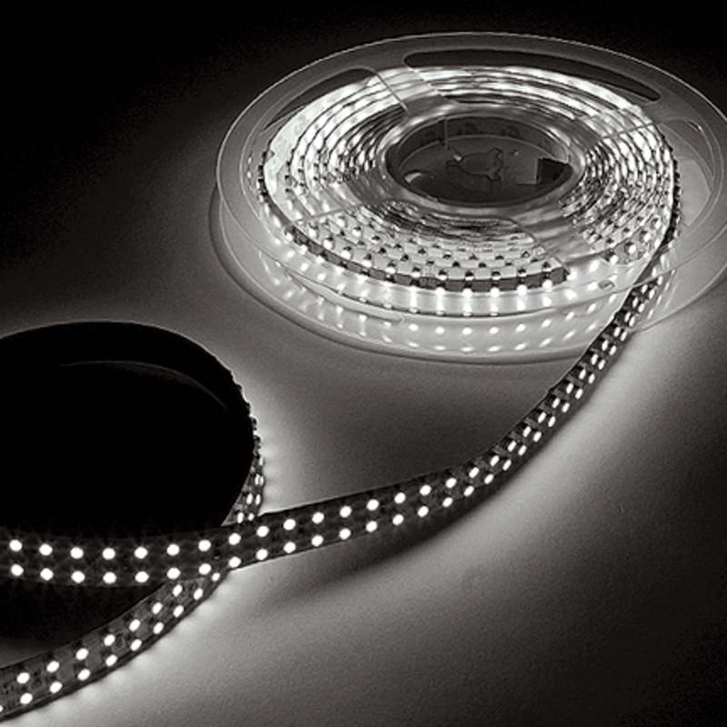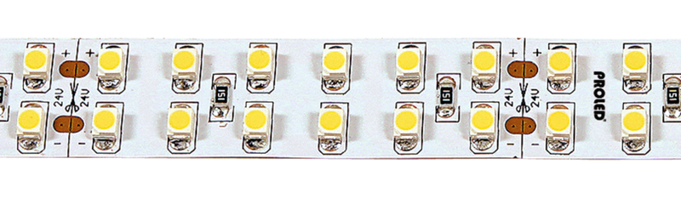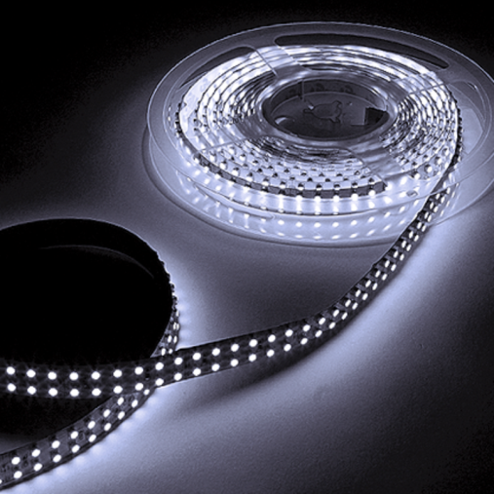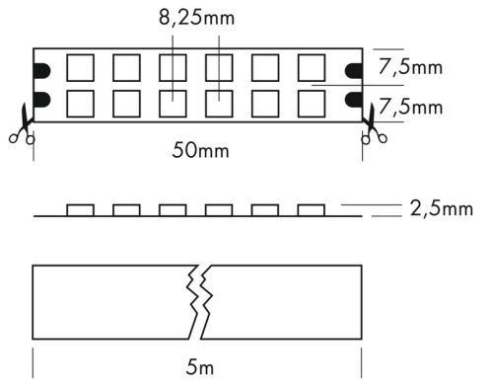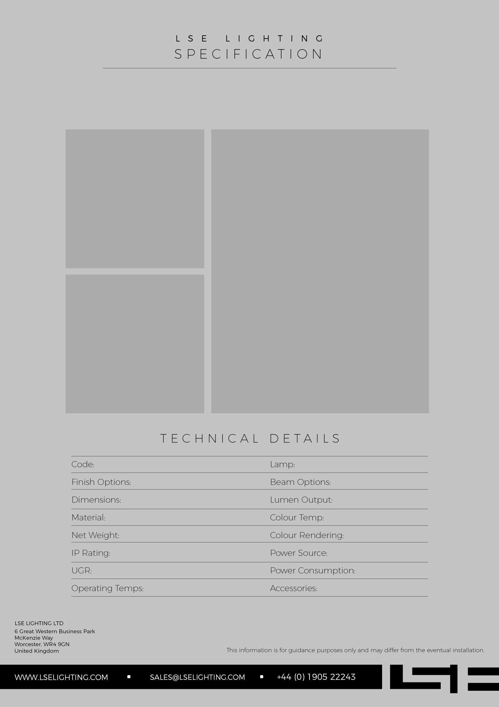

SMD CHIP

2100-5700k

**Match**

|  |
| --- |
| K. CRI >80. 199 lm. 95 lm/W. |

**Match**

-

-

80

-10° C till +45° C

-

-

20

Shown Above

Aluminium

24 VDC

0.15kg

320-1760lm/m (depends on colour temp

120°

Flex Strip 1200-80 Double Mono