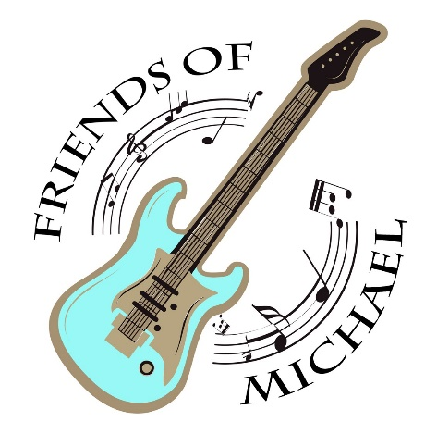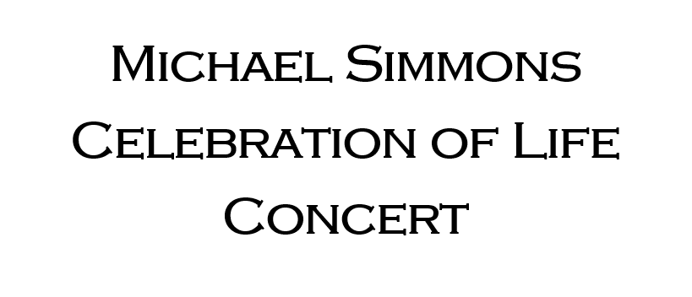

Sponsorship Registration
Name: ________________________________________________________________________________________________
Organization Name: _________________________________________________________________________________
Address: ____________________________________________________________________________________________
Email Address: ______________________________________________________________________________________
Phone: _______________________________________________________________________________________________
Ticket Recipient Name(s): ____________________________________________________________________________

Sponsorship Levels

_____ $25,000 “Jerry Garcia” _____ $3,000 “Lynyrd Skynyrd”
Includes 10 Tickets Includes 3 Tickets

_____ $15,000 “John Mayer” _____ $1,500 “Derek Trucks”
Includes 8 Tickets Includes 2 Tickets

_____ $10,000 “Eric Clapton” _____ $1,000 “Joe Bonamassa”
Includes 6 Tickets Includes 1 Ticket

_____ $5,000 “Tom Petty”
Includes 5 Tickets
Event Details:
Friday, September 23rd , 6:00 pm
188 Hill St, Suffield CT
Send inquiries to Info@friendsofmichael.com

Please mail completed form and make checks payable to
the Burton & Phyllis Hoffman Foundation
c/o Friends Of Michael
750 Connecticut Blvd, East Hartford CT 06108

