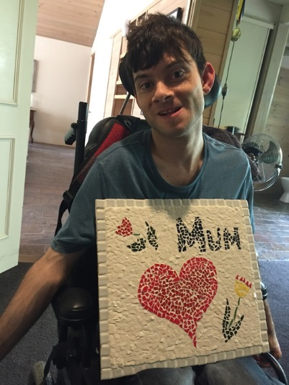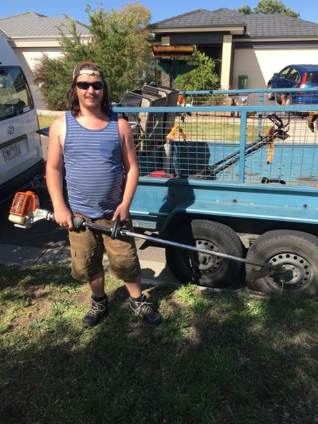
My NDIS Planning Workbook

What is NDIS?
The National Disability Insurance Scheme (NDIS) gives people with a permanent and significant disability the financial support to ensure that all participants have the right support available to them and have the choice and control over their life and the supports that they receive.

What is NDIA?
The National Disability Insurance Agency (NDIA) is an independent statutory agency. Their role is to carry out the National Disability Insurance Scheme ensuring that all participants with a permanent and significant disability have the right supports in place to live a fulfilled life and that their families and carers are also supported.

Am I Eligible?
To be eligible for the NDIS you must have a permanent or significant disability that:
- Reduces your ability to participate effectively in activities, or perform tasks or actions, unless you have support, and
- Effects your capacity for social and economic participation, and
- Means that you are likely to require support under the NDIS for your lifetime.
You must also be:
- An Australian Citizen or,
- The holder of a permanent Visa or,
- Hold a protected special category visa or
- Be aged under 65

What if I am over 65?

If you are over 65 and currently receive Disability support you will not be disadvantaged. You will have access to the “Commonwealth Continuity Support Program”.
This program will support you if you are:
- 65 years and over or 50 years and over if you are an Aboriginal or Torres Strait Islander, at the time the NDIS starts in your area.
- Assessed as being not eligible for the NDIS at the time it starts in your area.
- Are an existing client of state-administered specialist disability services at the time this programme starts in your area?
There is further information available to you about the Commonwealth Continuity of Support Programme on the Department of Health website.
If by any chance you are not eligible for the Commonwealth Continuity of Support Programme it is suggested that you contact MY AGED CARE on 1800-200-422 (free call). There will be staff there that you can talk to that will help you understand the steps required to see care and support.

When do I start planning?
Now is the time to start preparing for your NDIS plan. By starting to think about your needs and goals now, will help you get ready to transition into the scheme when it becomes available to you.
For all people that live in Victoria and are eligible for NDIS the scheme will be available and rolled out by the 30th June 2019.

Who will do my plan for me?
There will be someone from the NDIS that will be allocated to do your plan with you. This might be a planner, a plan Support Coordinator or a Local Area Coordinator (LAC).
This person will initially make contact with you over the phone. They will start to gather information about you. This is the start of the planning process. If at any time you feel uncomfortable with this or you feel you are not able to tell the planner exactly what you want then you have every right to ask the planner for a face to face meeting. This may take a little longer to organise however this may be better for you in the long run.
Remember this is your plan and you need to feel comfortable during this process.

What is an NDIS plan?
Your NDIS plan will be all the things that you discussed at your meeting. Your plan will focus on the supports you need to help you achieve your goals.
The NDIS have developed an Outcomes Framework that will help you think about goals in the different areas of your life and help the planner explore if these areas already exist and if not are further supports required.
The Outcomes Frameworks looks at:
- Daily Living 5. Work
- Home 6. Social and Community Participation
- Health and Well-being 7. Relationships
- Lifelong Learning 8. Choice and Control

NDIS Planning Process
This workbook has been created to support you through this process and get you ready for your phone call and/or meeting with your planner. It will take you through all of your current activities and supports and will help you identify what is working and what you would like to achieve or change in your life. It is best to involve all of your family, friends and carers who support you now. They can help you look at your life, what your aspirations and goals are, and what supports you may require not only now but into the future.

The plan will be developed based on what is reasonable and necessary.

There are five steps in developing your plan under the NDIS.
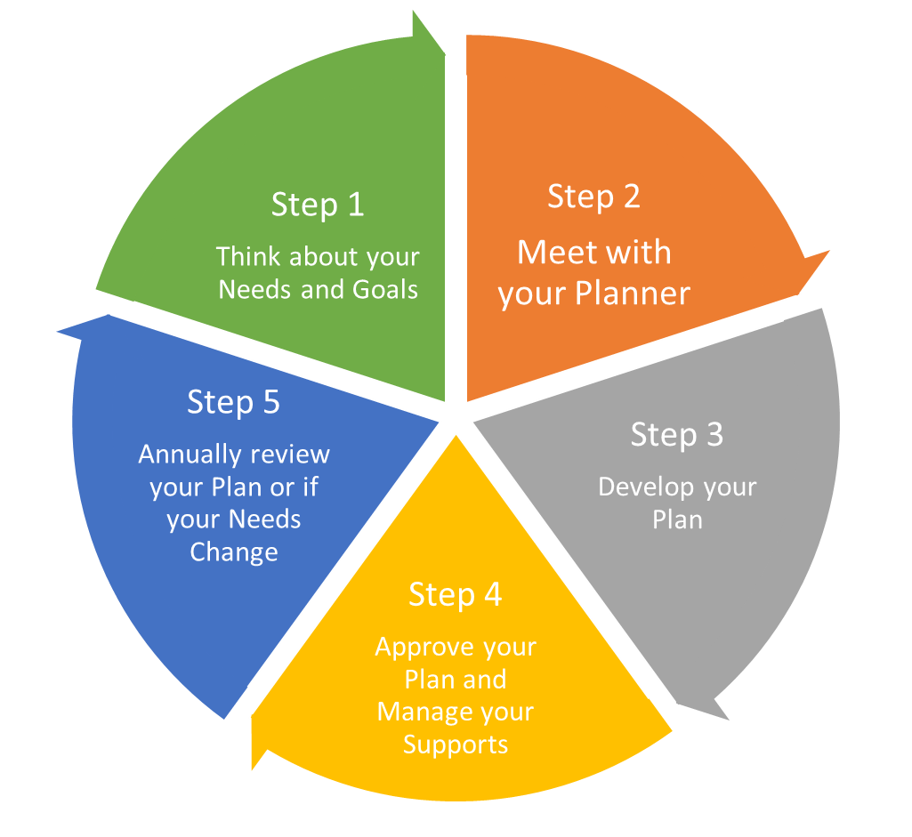

Step 1
Think about your needs and goals and all the things you access now.
- What supports do you get now?
- What services do you use?
- Where do you do these activities?
- What supports do you need to help you get ready in the morning?
- What supports do you need when you come home from your day?
- Who supports you to do them? You need to include your formal and informal supports.
Formal Supports: These are people that help you that get paid to support you.
Informal Supports: These are people that help you that do not get paid such as mum, dad, other family members, aunties, uncles, friends, neighbours etc.
Other areas of supports you need to think about are:
- How do you get to these activities? Does someone drive you to and from venues, do you catch public transport or is there a bus that comes and picks you up at your house or another meeting point somewhere in the community.
- When you are at these activities do you need support for the whole day or part of the day?
- Do you need support for specific tasks such as personal care or meal assistance?

Think about what other areas of your life that you currently access for support such as:
- Behaviour support
- Therapies
- Aids and Equipment
- Specialised clothing or orthotics
- A modified home environment.

Now let’s look at the funding that you currently receive. Do you get funding for:
- Futures for Young Adults (FFYA)
- An Individualised Support Package (ISP)
- Flexible Respite Package
- Respite for Older Carers package (ROC)
- Mobility Allowance
- Continence Aids Payment Scheme (CAPS)
- State- Wide Equipment Program (SWEP)
- Nutritional Supplements (Home Enteral Nutrition HEN)

Currently all of the above funding sources are funded separately however under the NDIS all of these services will be funded within your NDIS plan.
We know there is a lot to think about but you need to consider all of your funding sources, write them down in this booklet, so when you talk or meet with your planner you can ensure they will be included in your NDIS plan.
Once you have filled in all the things that you do on a daily basis we will then look at what you would like to improve in your supports, what you do not receive but would like to and what you might need in the future.
This is really important information to capture. For example if you only have funding or three respite stays every year and feel that you need more write it down. You need to let your planner know that only three stays per year is not enough for you and your family.
Let’s fill in the pages below. Write down absolutely everything you can think of. All the activities you do on a daily basis, everything you do after you have left Blairlogie, the things you do on your weekend. Your therapies, how you get to different activities. Take your time as you need to capture all of this information. This will ensure that your plan really does meet your support needs and requirements for now and into the future.

Fill in all everything you do now and the supports that you currently have to achieve this?
Monday
Time of the Day | What I do now and wish to continue? | What I do not have, what I would like to have and what Supports I need?
Morning

Lunch

Afternoon

Dinner

Bedtime

Fill in all everything you do now and the supports that you currently have to achieve this?
Tuesday
Time of the Day | What I do now and wish to continue? | What I do not have, what I would like to have and what Supports I need?
Morning

Lunch

Afternoon

Dinner

Bedtime

Fill in all everything you do now and the supports that you currently have to achieve this?
Wednesday
Time of the Day | What I do now and wish to continue? | What I do not have, what I would like to have and what Supports I need?
Morning

Lunch

Afternoon

Dinner

Bedtime

Fill in all everything you do now and the supports that you currently have to achieve this?
Thursday
Time of the Day | What I do now and wish to continue? | What I do not have, what I would like to have and what Supports I need?
Morning

Lunch

Afternoon

Dinner

Bedtime

Fill in all everything you do now and the supports that you currently have to achieve this?
Friday
Time of the Day | What I do now and wish to continue? | What I do not have, what I would like to have and what Supports I need?
Morning

Lunch

Afternoon

Dinner

Bedtime

Fill in all everything you do now and the supports that you currently have to achieve this?
Saturday
Time of the Day | What I do now and wish to continue? | What I do not have, what I would like to have and what Supports I need?
Morning

Lunch

Afternoon

Dinner

Bedtime

Fill in all everything you do now and the supports that you currently have to achieve this?
Sunday
Time of the Day | What I do now and wish to continue? | What I do not have, what I would like to have and what Supports I need?
Morning

Lunch

Afternoon

Dinner

Bedtime

Occasional Activities include monthly groups you may join, respite you may access or any other activity that you do not do each week.
Occasional Activities
Month | What I do now and would like to continue to do? | What I do not do, would like to do and how often? | What supports I need?
January
February
March
April
May
June
July
August
September
October
November
December
Write in the therapies that you currently receive and that you would like to continue to receive. If you do not receive any therapies and would like to for a particular reason then write it down so that your planner can assess whether or not that these therapies are reasonable and necessary for your health and well-being.

Therapies
Therapies | What I have now? | What I would like to continue? | What I would like but do not have? | What supports do I need?
Occupational Therapy
Physio Therapy
Speech Therapy
Behaviour Support
Other

If you are using therapist they will be expected to provide progress reports to you, your family and NDIS at agreed times.

You need to know that not all therapies will be covered in your NDIS plan. Therapies such as massage is considered to be more appropriately provided by the health care system and is not viewed as reasonable and necessary under the NDIS guidelines.

Look at the transport that you currently use. Does mum, dad or a family member drive you to your daily placement or recreational activities or do you catch a bus that is provided by the service that you use? Is this something that you would like to continue with or are there changes to be made that better suit your and your family’s requirements.

Transport
Transport | What I have now? | What I would like to continue? | What I would like in the future?

Aids and Equipment is another area in your life that you need to look at. What services or equipment do you currently use or access on a daily basis? What don’t you use and is it important to be able to use some of these services now and into your future.

Aids & Equipment
Aids and Equipment | What I have now? | What I would like to continue? | What I would like but do not have? | What supports do I need?
Wheelchair

Walkers

AFO’s

Communication Devices
Specialised Clothing

Orthotics

Home Modifications
Transport Modifications
PEG Feed Equipment
Catheter Equipment
Colostomy Bags etc.
Continence Aids
Other

You have now documented as much information as you can about the supports that you currently have, what you would like to maintain and what supports you do not have that you would like to have which will ensure that you are able to live the life that you want.

Now let’s have a look at your goals and aspirations now and into the future. Use the boxes below to write your goals in the different areas of your life.

Education
Would you like to attend a course either at a Community House, TAFE or University?

Employment
Would you like to volunteer or get a job in the future?

Health & Wellbeing
Would you like to be more active?

Independence
Would you like to get around your home or local community with less support or assistance from others?

Living Arrangements
Would you like to modify your home or live with a friend or independently?

Social Participation
Would you like to have more access to see your friends, make new friends, join clubs and attend different events of your choice?

Step 2
You have gone through Step 1 and are now clear on what services you are getting and the things that are working well for you. You have also documented what you would like to improve in your supports, what you do not receive but would like to and what you might need in the future.
Now it is time to look at developing your plan. The plan will be developed by looking at what supports are classed as reasonable and necessary for you to live the life that you want. This is where you will have contact with your planner. This may be over the phone or if you do not feel comfortable with this it is your right to request a face to face meeting.
You can have a support person there with you when you meet and talk with your planner. You should start to think about who that person might be. You may decide to choose one person or you may want several people with you. It is up to you who and what you choose to do.
When you are talking to your planner the planner will work with you to develop a plan that will support you to live the life you want and you choose. This booklet has been developed to assist you to tell your planner all the supports you currently have and all the supports you would like to ensure you have now and into the future.
You will be given funding under the NDIS that aligns with your plan. Your funding will be broken into three Support Purpose Categories. They are:

- CORE
Core supports include assistance with daily living, except where there is a budget allocated for Supported Independent Living (SIL) which is always agency managed; Transport, Consumables and assistance with Social and Community participation. You can choose how to spend your core support funding however you cannot reallocate this money to other support purposes.

- CAPITAL
This is generally one off funding that can include items such as assistive technologies or equipment, home or vehicle modifications, or for Specialist Disability Accommodation. Your budget under this item will be restricted to specific items only which will be identified in your plan.
The funding for these supports if required will include assessment, delivery, set-up, and adjustment and maintenance costs. Most of these items require quotes which means prices can be negotiated with you and your family in accordance with the specifications which are developed by an assessing therapist.

- CAPACITY BUILDING
This funding category is there to support you to build on your independence and skills. If you have funding in your plan under capacity building it must be used to achieve the goals which will be set out in your NDIS plan. These supports can include: Support Coordination, Improved Living Arrangements, Increased Social and Community Participation, Finding and Keeping a Job, Improved Relationships, Improved Health and Wellbeing, Improved Learning, Improved Life Choices and Improved Daily Living Skills.

Remember this is your plan. You have the right to feel comfortable with your planner, have the support you need to plan and invite who you would like during the development of your plan. If you are unsure of anything ASK questions. If you do not understand anything ASK to have the information proved in a format that you understand.
You want your plan to be right from the beginning. If you feel that something has been missed or you are unhappy with your plan then you are entitled to appeal this decision. Information for this process is found on the NDIS website at www.ndis.gov.au

Step 3
With all the information that you have gathered in the previous pages you are now ready to develop your plan with your planner and your selected support people, such as your mum, dad or family members.
You might be asked to get an assessment to ensure that you receive the right supports to meet your needs. Some of these assessments may be medical, psychological or other examinations which will all be completed by the right qualified specialist. If this is something that you need to get done the planner will discuss with you and your family members why you need this assessment, how it will be done and what information that the planner will receive.

Step 4
Once your plan has been developed and finalised you will be contacted by an NDIS representative to discuss how to put your plan into action. When you have these conversations and you receive your plan, with the support from your family should thoroughly read through your plan and make sure that you and your family understand what your plan states.
You also need to decide about how you with your family are going to manage your NDIS Plan. You can choose between “Plan/ Agency Managed” and “Self-Managed”.
- Plan Managed means: You can have funding for a Planned Management Service Provider included in your plan. If this occurs the NDIS will pay your plan manager who will directly pay for all supports that they have been asked to manage.

- Agency Managed means: The NDIS manages your plan and they will directly pay your support providers. You have to choose registered service providers if your plan is managed this way.

- Self-Managed means: You can manage part or all of your NDIS plan. The NDIS will pay you directly for the supports you claim under your plans budget. By self-managing it enables you to have choice and control over the people that you pay to support you.

You are also responsible for requesting and paying the invoices related to the supports you have received through your NDIS plan.

Self-managing also provides you with the opportunity to purchase your supports from people and organisations that have not registered with the NDIA. These supports must be incorporated in your NDIS Plan.

Remember it does not matter how you and your family choose to manage your NDIS plan as no matter which option you choose you can still remain in control of the services and supports you choose to engage.

Step 5

Your NDIS plan will be reviewed every 12 months or if your needs and supports change. A NDIS representative will contact you to see how your goals are going and ensure that you are getting the supports you need.
If for whatever reason your circumstances change you are able to request a plan review at any time you need to contact the NDIS and complete a change of circumstances form.
If you are not happy with a decision about our NDIS plan and the support budget that you have been allocated you are able to request a review of the plan decision. There will be further information on the website www.ndis.gov.au or contact them on 1800 800 110

