- Pre-Execution
  - Verify all equipment and tags needed to complete all tests:
    - Air Sampler(s), eSprayer(s), Wireless Modules, Air Pressurizer, Cords, Laser Distance Measurer, Power Supplies
    - Tags
    - Labels: Origin Points, Sample Points and Samples

  - Walk the facility map accuracy for:
    - Test Locations, access, and names or descriptions

  - Make real-time changes if test location(s), Origin Point(s) and/or Sample Point(s) have changed on:
    - Project Configuration
    - Facility Maps

  - Find an area away from test locations to set-up and prepare for execution
    - Hall, conference room, office, etc.

  - Verify the area and ceiling height of each test location
    - Area (sqft), Ceiling Height (ft), Volume (ft³)
    - Basic Formula for Area = Length x Width
    - Basic Formula for Area of a Triangle: A = (h_{b}b)/2
    - Basic Formula for Area of a Circle: A = πr² (Pi = 3.14)
    - Basic Formula for Area of a Trapezoid: A = [(a + b)/2]h
    - Addition of Areas: Area A + Area B = Total Area

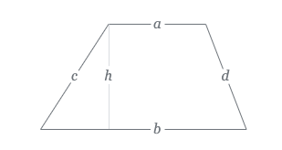
A

B

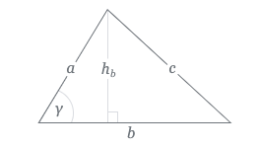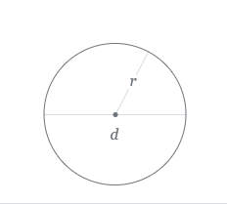

  - Verify the equipment that is needed for each test after you verify the total area
Total Area sqft | Air Samplers | eSprayers | Modules
<2000 | 1 | 1 | 0
2001-4000 | 1 | 2 | 2
4001-6000 | 2 | 3 | 3
6001-8000 | 2 | 4 | 4

- Set-Up
  - See UL Quick Set-Up Guide
  - See UL Quick Start Guide

- Mock Test
  - Before execution run a mock test (no nozzle or tag is attached to the eSprayer) to verify proper set-up.
  - When using wireless modules: PRESS THE START BUTTON ON THE MODULE NOT THE AIR SAMPLER

- Origin and Sample Point Positioning Variations

2-OP and 1-SP

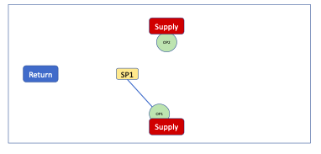

3-OP and 2-SP

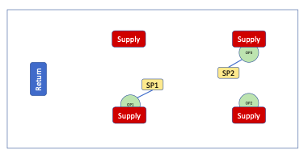

3-OP and 2-SP

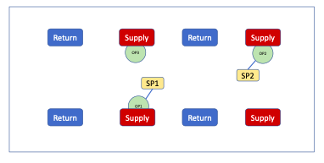

4-OP and 2-SP

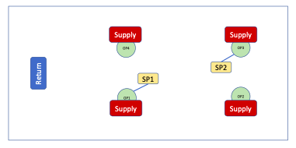

4-OP and 2-SP

