veriDART®: Guidance and Terminology Guide

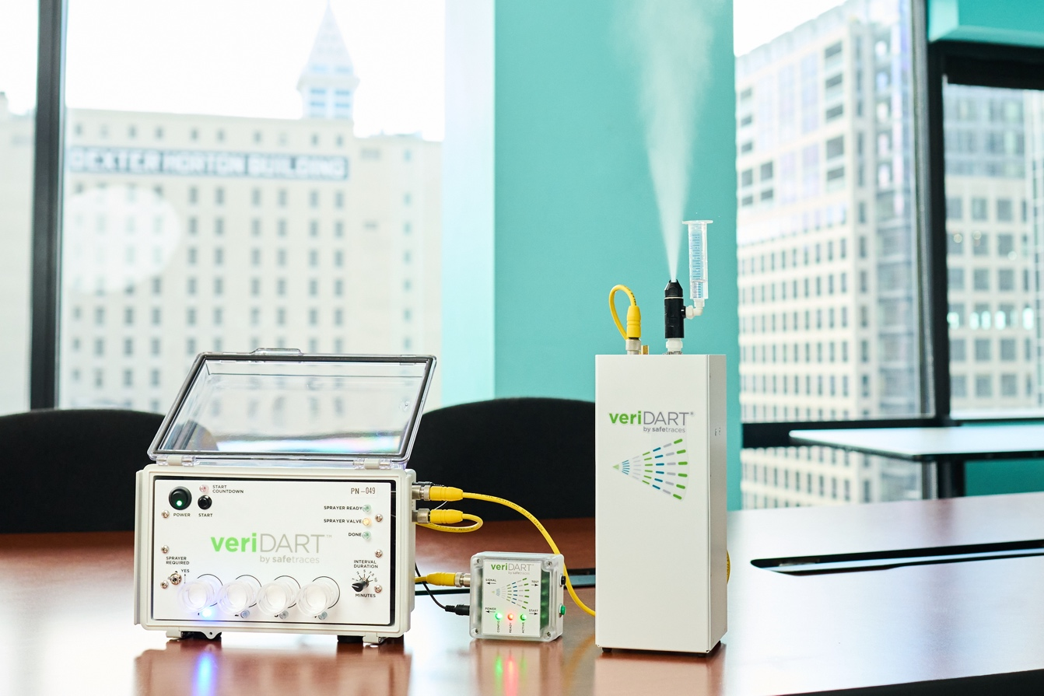

October 2022

- Statement of Work (SOW)
  - Contains all the information that is needed to start a plan and prepare for a project. Including Test Type(s), Sample Type(s) and Scope.

- Test Types and Test Descriptions
  - Survey Test
    - What: Used to verify aerosol migration patterns within a building or areas with a building
    - Why: This test can be conducted under varying scenarios as well as gain baseline data about the HVAC condition of the test environment. This test provides useful information about HVAC system balance.
    - How: Aerosols are released and sampled in several defined locations to determine airflows which are displayed on floorplan heatmaps.
    - Where: Typically, the Survey Test is conducted over a large area and may include offices, restrooms, open areas, break rooms, conference rooms, trafficking areas, etc.

  - UL Verification Test
    - What: Used to verify aerosol reduction rates in occupied spaces.
    - Why: To ensure adequate ventilation/filtration/dilution in areas where occupants gather or are in close proximity to each other.
    - How: This test consists of Desktop Review (Ventilation and filtration performance evaluated based on a building’s design, HVAC system specifications and other key building data), Field Evaluation (Ventilation and filtration performance evaluated in high-density areas) and Verification Mark (Building owner and operator is issued a UL Marketing Claim Verification Mark if a building achieves 99% aerosol removal within 1 hr. in all test locations and passes the Desktop Review).
    - Where: Ventilation and filtration performance evaluated in high-density areas.

  - Dilution Test
    - What: This test is functionally the same as the UL Verification test without the Desktop Review and Verification Mark. No UL verification is granted.‍
    - Why: This test evaluates aerosol removal rates, often used for scenario testing of various HVAC settings or other mitigation strategies like in-room HEPA filtration.‍
    - Where: Typically, the Dilution test is conducted in enclosed areas but also useful in large open areas such as cubicle areas.

  - Mini-Survey Test:
    - What: Used to verify localized aerosol migration patterns.
    - Why: This test is a more focused Survey Test to measure isolation of an enclosed areas vs surrounding areas or to identify localized aerosol migration patterns. This test may also be combined with the Dilution Test to offer further diagnostic capabilities in occupied spaces. It is also useful as a follow-up test when localized problems are detected with a General Survey and/or Dilution test.
    - Where: A single emission point and four samplers are deployed typically in and around enclosed areas or open areas where localized aerosol migration patterns need to be evaluated.

  - Recirculation Test
    - What: Used to verify aerosol dilution/filtration through the HVAC Duct system (return and supply).‍
    - Why: This test is typically used to monitor the aerosol flow from the occupied space through the HVAC system to verify high dilution/filtration of the supply air.‍
    - Where: Release points are selected in the occupied area, which is served by the RTU, or AHU being tested while the samples are collected both upstream (return air) and downstream (supply air) of the filters and outside air damper or Air Handling System(s).

- Sample Types
  - Air
    - Used in all Test Types.

  - Swab
    - Used for fomite sampling during Survey Tests.

- Test Matrix (Scope)
  - Sample Size
    - Survey: 8 OP x 12 SP, 16 OP x 24 SP
    - UL Verification: 1-4 OP x 1-4 SP
    - Dilution: 1 OP x 4 SP
    - Mini Survey: 1 OP x 4 SP
    - Recirculation: #OP x #SP

- Facility Map
  - Use to identify the area that will be tested as well as the location of the Origin and Sample Points(s).

- Origin Point (OP)
  - The location where a single tag solution will be released.
  - Typically, noted as OP-.
  - Typically, Origin Points are used in multiples of eight.
  - All Origin Points will be pinpointed on the facility map(s).

- Sample Point (SP)
  - The location where a single air sample pump and/or weigh boat collects the released tags from the Origin Point.
  - Typically, noted as SP-00_
  - Typically, Sample Points are used in multiples of 12.
  - All Sample Points will be pinpointed on the facility map(s).

- Origin and Sample Point Selections
  - Consider
    - Facility Type
      - Work Office, Production, Hospital, Nursing Home, ect.

    - Facility Size
      - Small and Medium (up to 100,000 sq. ft)
      - Large (100,000 sq. ft or more)

    - Workforce Population
      - Small Population (1 to 100)
      - Medium Population (101 to 999)
      - Large Population (>1000)

    - Facility Layout
      - Work/Production Areas
      - Closed/Open Areas.
      - Meeting and Gathering Areas.
      - Welfare Areas such as Restrooms, Breakrooms and Lunchrooms.
      - Greeting Areas such as Reception and Waiting Areas.
      - Trafficking Routes.

    - HVAC Systems
      - Number and Location of Air-handlers.
      - Make-up air percentage.
      - Number of Air-Changes.

    - Controlled or Non-Controlled Airflow Patterns
      - Directional (Positive/Negative)
      - Nondirectional (Open)

    - Standalone Devices
      - HEPA
      - Air Cleaner
      - Fans
      - Exhaust

    - Natural Ventilation
      - Windows
      - Doors
      - Facility Structure (Cracks/Holes)

Origin/Sample Point Locations | Examples
High Traffic Areas | Hallways, Common Areas, Kitchen, Lunch Areas, Reception
High Touch Points (Fomites) | Kitchen, Break Areas, Labs, Reception, Restrooms
High Density Area | Open Office, Cubicles, Corridors, Break Areas
Team in Close Proximity for  Extended Periods of Time | Conference Rooms, Call Center, Restroom
Contact with the Public | Reception, Shipping and Receiving,  Retail Area, Contractor Access Areas
Closed Room Area | Office, Conference Room, Restroom
Open Room Area | Open Workstations, Cubicles,  Conference Room with Door Open
Negative Pressure Area | Restroom, Electrical Room, Lab, Kitchens, Areas with Significant Exhaust
Positive Pressure Area | Any Area with Intentional Positive Pressure Relative to Surrounding Areas
Low Airflow Area | Restroom, Areas with known limited air circulation
Area with Non-Typical  Temp/RH settings | Area set either lower or higher temp/RH  than usual, Walk in Refrigerator, Food Handling Area
Area with no HVAC  Thermostat Control | General understanding of the ambient surrounding
Survey typical area performance | General understanding of the surrounding area
Communication of Zones  (HVAC at typical setting) | Selected to identify mixing of air between  zones with HVAC operating normally
Communication of Zones  (HVAC non-typical setting) | Selected to identify mixing of air between zones  with HVAC operating in a non-standard configuration
HVAC Setting Survey | HVAC set to mimic seasonal  or other typical operational mode
Test Filter Performance | Typically, near a main air return duct at the air handler

- Facility Map
  - Use to identify the area that will be tested as well as the location of the Origin and Sample Points(s).

- Origin Point (OP)
  - The location where a single tag solution will be released.
  - Typically, noted as OP-.
  - Typically, Origin Points are used in multiples of eight.
  - All Origin Points will be pinpointed on the facility map(s).

- Sample Point (SP)
  - The location where a single air sample pump and/or weigh boat collects the released tags from the Origin Point.
  - Typically, noted as SP-00_
  - Typically, Sample Points are used in multiples of 12.
  - All Sample Points will be pinpointed on the facility map(s).

- Scenario
  - The conditions that you are testing under.
    - Baseline (Typical environment conditions)
    - HVAC On/Off.
    - HEPA Filter On/Off.
    - MERV 8/13.
    - Doors Open/Close.
    - Windows Open/Close.
    - Exhaust On/Off.
    - etc.

- Interval
  - Interval Count
    - The number of samples taken at a single Sample Point. A Sample Point may have more than one Interval depending on the type of test being completed.

  - Interval Duration
    - The total sampling time in minutes.

- Tag System
  - Tag
    - Unique DNA sequences. One unique tag is released at a single Origin Point.

Examples: A1, A2, A3, A4, A5, A6, A7, A8.
B1, B2, B3, B4, B5, B6, B7, B8.
C1, C2, C3, C4, C5, C6, C7, C8

  - Panel
    - Contains the subsets of each tag.
      - Typically, noted as Panel A and Panel B and are used to execute Survey Project Plans.
      - Panel C is typically used in Dilution Project, Mini-Survey Project and Recirculation Plans.

Examples: Panel A contains tags: A1, A2, A3, A4, A5, A6, A7, A8.
Panel B contains tags: B1, B2, B3, B4, B5, B6, B7, B8.
Panel C contains tags: C1, C2, C3, C4, C5, C6, C7, C8

- Date Coding
  - Expiration Date
    - The tag solution must be used by this date. This information is found on the spray bucko.

Example: TAG- B02: Expiration: Feb 2, 2021

  - Lot Number
    - The date which the tag solution was poured into the bucko. This number is extremely important and is linked to the number that is used to determine to DNA log reduction for the final report visualizations. This information is found on the spray bucko.

Example: TAG- B02: Lot #: 20201211

- Numbering
  - Scenario Number
    - Unique identifiers that outline the conditions within each test(s).

  - Origin Point Count
    - The total number of Origin Points in each Test Scenario.

  - Sample Point Count
    - The total number of Sample Points in each Test Scenario.

  - Sample Number
    - The unique number given to each sample. This number is not the same as the Sample Point Number. A Sample Point may have more than one Sample Number.

  - Sample Count
    - The total number of samples taken in each Test Scenario. This number is affected by the number of intervals at each Sample Point.

- Project Plan Overview
  - A charted summary which contains all the details of the project.

- Facility Maps
  - Generic Floor Plan
    - Clean floor plan that will be used to mark-up as needed before, during or after the test project. A generic floor plan will be needed to visualize (converted to heat maps) the results once sample analysis is completed.

  - Annotated Floor Plan
    - Contains all Origin and Sample Points.

- Examples: Project Plan Overview

Project Plan Example: Chart 1 (One Survey “Air” Test)

Test Name | Test Number | Scenarios | OP Count
Survey | 1 | 1 | 8
SP Count | Interval Count | Interval Duration | Sample Total
12 | 1 | 30 | 12
Sample Numbers | SN-001 to SN-012 | Tags | A1-A8

