veriDART®: Project Planning Training Document

**October 2022**

# **Objective and Goals**

* **Objective:** Train Field Technicians to create project plans based upon the agreed and approved Statement of Work.
* **Goal:** Gain baseline knowledge of the different test types.
* **Goal:** Gain baseline knowledge of “Project and Test Planning”.
* **Goal:** Use veriDART Portal to create project plans by:
  + Accessing and navigating the portal to create project plans, which include:
    - Upload floor plans.
    - Create tests.
    - Download order form to order equipment and materials from the designated supplier.
    - Download labels and project configuration plan.
    - Update project plan when changes occur.
* **Goal:** Gain baseline knowledge of the equipment and set-up for executing project plans.
* **Goal:** Gain baseline knowledge of project execution and documentation.

# **Test Types**

1. **UL Verification Test:** Assess aerosol rate of reduction in occupied spaces.
   1. **What:** Used to verify aerosol reduction over time.
   2. **Why:** This test consists of **Desktop Review** (Ventilation and filtration performance evaluated based on a building’s design, HVAC system specifications and other key building data), **Field Evaluation** (Ventilation and filtration performance evaluated in high-density areas) and **Verification Mark** (Building owner and operator is issued a UL Marketing Claim Verification Mark if a building achieves 99% aerosol removal within 1 hr. in all test locations and passes the Desktop Review).
   3. **Where:** Ventilation and filtration performance evaluated in high-density areas.
2. **Customized Tests**
   1. **Survey Test:** Assess aerosol migration patterns from a release point to surrounding occupied spaces.
      1. **What:** Used to verify aerosol migration over distance.
      2. **Why:** This test can be conducted under varying scenarios as well as gain baseline data about the HVAC condition of the test environment. This test provides useful information about HVAC system balance.
      3. **Where:** Typically, the Survey Test is conducted over a large area and may include offices, restrooms, open areas, break rooms, conference rooms, trafficking areas, etc.
   2. **Dilution Test:**
      1. **What:** This test is the same as the UL Verification. However, for passed tests no UL certification is granted.
      2. **Why:** To evaluate aerosol removal rates, often used for scenario testing of various HVAC settings or other mitigation strategies like in-room HEPA filtration.
      3. **Where**: Typically, in enclosed area but also useful in large open areas such as cubicle areas
   3. **Mini-Survey Test:** Verify local isolation of an enclosed area verses the surrounding or to identify localized aerosol migration patterns. This test may also be combined with the Dilution Test to offer further diagnostic capabilities in occupied spaces.
      1. **What:** Used to verify isolation of an enclosed area such as a patient room or conf room from surrounding areas or aerosol migration over a small distance or area.
      2. **Why:** This test is a more focalized Survey Test.
      3. **Where:** The test is conducted in smaller areas than the primary Survey Test and is often used as a follow-up test for areas that may have unexpected results in either the Survey and/or Dilution Tests.
   4. **Recirculation Test:** Verify the dilution of the air at the Return and Supply at the Air Handler Unit Level.
      1. **What:** Used to verify aerosol dilution through the HVAC Duct system.
      2. **Why:** This test is typically used to monitor the aerosol flow from the occupied space through the HVAC Filtering system to verify high dilution/filtration of the supply air.
      3. **Where:** Release points are selected in the occupied area, which is served by the RTU, or AHU being tested while the samples are collected both upstream (return air) and downstream (supply air) of the filters and outside air damper or Air Handling System(s).

# **Test Planning**

1. **Test Planning**
   1. High-Density Areas are identified and may include areas such as:
      1. Conference Rooms.
      2. Breakrooms.
      3. Open High-Density Areas such as cubicle areas.
   2. Some High-Density Area Characteristics:
      1. Multiple occupancy for more than 15 minutes.
      2. >1 occupant per 200 sq ft
   3. Physical, Mechanical and Engineering Controls of High-Density Areas are defined and include:
      1. Area: Length and Width.
      2. Ceiling Height.
      3. HVAC Support.
      4. Standalone Devices, Exhaust Fans, HEPA units, etc.
   4. Origin and Sample Point Assignment
      1. One to four-Origin Points and One or two-Sample Point are assigned based upon the area being tested.

# **Project Planning**

**Review the veriDART Proposal/SOW to understand the Project Scope and Test Plan.**

**Overview**

Your organization will test veriDART at the customer location on the specified date and time.

**General Information**

|  |  |  |  |
| --- | --- | --- | --- |
| Customer | St. Johns Elementary School | Project ID | 416/417 |
| Building Address | 243 W. Fifth Street, USA | Project Name | SJES 1st Floor |

**Test Plan**

|  |  |  |  |  |  |  |  |
| --- | --- | --- | --- | --- | --- | --- | --- |
| **Test** | **Test Type** | **Scenario** | **OP** | **SP** | **Intervals** | **Interval**  **Duration** | **Total Samples** |
| 1 | UL Verification | HVAC On: Winter Setting 30% Outdoor Air | 1 | 1 | 4 | 5 min | 4 |
| 1 | Survey | Baseline: HVAC Off | 8 | 12 | 1 | 30 min | 12 |

**Project Scope**

|  |  |  |  |  |  |  |
| --- | --- | --- | --- | --- | --- | --- |
| **Test** | **Test**  **Name** | **Scenario** | **Scenario**  **Description** | **OP**  **Count** | **OP Tags** | **Sample**  **Type** |
| 1 | UL Verification | 1 | HVAC On: Winter Setting 30% Outdoor Air | 1 | C1 | Filter |
| 1 | Survey | 1 | Baseline: HVAC Off | 8 | A1-8 | Filter |

|  |  |  |  |  |  |  |  |
| --- | --- | --- | --- | --- | --- | --- | --- |
| **Test** | **Test**  **Name** | **SP Count** | **Interval Count** | **Interval Duration** | **Sample Count** | **SN Start** | **SN End** |
| 1 | UL Verification | 1 | 4 | 5 min | 4 | 001 | 004 |
| 1 | Survey | 12 | 1 | 30 min | 12 | 001 | 012 |

**Note:** You may prepare projects with more than one UL Verified test under the same Project ID. However, you may not combine UL Verified tests with Custom Tests. You will need to create a new test with a unique Project ID to set-up the custom tests.

# **UL Verified Test: PID 416**

**Scenarios**

|  |  |  |
| --- | --- | --- |
| **Scenario** | **Description** | **Time of Tag Application** |
| 1 | HVAC On: Winter Setting 30% Outdoor Air | 0700 |

**Sprayer and Building Info**

|  |  |  |
| --- | --- | --- |
| **Sprayer Pressure** | **Building Info** | |
| 65 psi | Area: 1,400 sqft | Ceiling Height: 10 ft |

**Origin Points**

|  |  |  |  |  |  |
| --- | --- | --- | --- | --- | --- |
| **Scenario** | **OP Number** | **OP Name** | **Tag** | **Tag Lot** | **Tag Expiry** |
| 1 | OP-1 | Kindergarten DC | C1 | 20220321 | Oct. 21, 2022 |

**Sample Collection Methods**

|  |  |
| --- | --- |
| **Sample Type** | **Measurement** |
| Filter | 5.5 L/min |

**Sample Summary**

|  |  |  |  |  |  |  |
| --- | --- | --- | --- | --- | --- | --- |
| **Scenario Count** | **Interval Count** | **Sample Point Count** | **Sample Type Count** | **Sample Count** | **Interval Duration** | **Interval**  **Times** |
| 1 | 4 | 1 | 1 | 4 | 5 min | 0-5, 45-50,  50-55, 55-60 min |

**Samples**

|  |  |  |  |  |  |  |  |
| --- | --- | --- | --- | --- | --- | --- | --- |
| **Scenario** | **Sample Type** | **SP Number** | **SP Name** | **I1** | **I2** | **I3** | **I4** |
| 1 | Filter | SP-001 | Kindergarten DC | SN-001 | SN-002 | SN-003 | SN-004 |

**Annotated Floor Plan**

SP-001

OP-1

**Materials and Equipment Order Form**

|  |  |  |  |
| --- | --- | --- | --- |
| **Materials and Equipment: You will Need for this Project** | | | |
| **Tag Kits** | | | |
| **Item** | **Need** | **Confirmed** | **Checked By** |
| Labeled Syringe (5 ml) | C1 | Yes | MC |
| SDS | 1 | Yes | MC |
| **Air Samplers, eSprayers and Wireless Modules** | | | |
| Air Sampler (4-Channel) | 1 | Yes | MC |
| eSprayer | 1 | Yes | MC |
| Wireless Module | 0 | Yes | MC |
| Sprayer Nozzle | 1 | Yes | MC |
| Air Compressor | 1 | Yes | MC |
| **Energy Supplies and Distance Measurer** | | | |
| DC Power Cord | 2 | Yes | MC |
| Power Splitter Cord | 0 | Yes | MC |
| Control Signal Cables (3-Meter) | 1 | Yes | MC |
| Control Signal Cables (1-Meter) | 1 | Yes | MC |
| Laser Distance Measure | 1 | Yes | MC |
| Air Compressor Battery | 1 | Yes | MC |
| Air Compressor Battery Charger | 1 | Yes | MC |
| Extension Cord | 3 | Yes | MC |
| **Laboratory Materials** | | | |
| Filtered Cassettes | 4 | Yes | MC |
| Cassette Plugs (Red) and Bottoms (Blue) | 4 Each | Yes | MC |
| Ziplock Bags for Samples | Box | Yes | MC |
| **Cleaning Supplies** | | | |
| Clean Gloves Large (Size Depends) | Box | Yes | MC |
| 70 % Alcohol Wipes | Box | Yes | MC |
| **Printed Materials** | | | |
| Clean Floor Plans | 2 | Yes | MC |
| Project Configuration Plan | 2 | Yes | MC |
| Chain of Custody Form | 1 | Yes | MC |

# **Equipment**

# **Prepare for Execution**

1. **Site Tour (Prior to Set-Up)**
   1. Walk the facility to ensure all selected Origin and Sample Points are accessible.
   2. Ensure that the selected points are in the right location on the map.
   3. **Best Practice:** Based on the site tour, make any changes to the Project Configuration Plan prior to project pre-execution.
2. **Pre-Execution**
   1. **Best Practice:** Wear clean gloves to unpack the equipment. With the provided alcohol wipes, wipe down outer surfaces of equipment, machines, and cords to help prevent cross-contamination.
   2. Verify the area and ceiling height of the test area
      1. Measure and document the test area length and width (ft2) on Project Configuration Plan.
      2. Measure and document the ceiling height (ft) of the test area on the Project Configuration Plan.
      3. **Best Practice:** Use a laser distance measurer to make measurements.
      4. Equipment needs based on test area:

|  |  |  |  |
| --- | --- | --- | --- |
| **Area (sqft)** | **Air Samplers** | **eSprayers** | **Wireless Remotes** |
| >2,000 | 1 | 1 | 0 |
| 2,001 to 4,000 | 1 | 2 | 2 |
| 4,001 to 6,000 | 2 | 3 | 3 |
| 6,001 to 8,000 | 2 | 4 | 4 |

* 1. HVAC and Standalone Device Settings
     1. Ensure all HVAC engineering controls and mitigations are operational and functional.
        1. Verify and record HVAC settings and information:
           1. Cubic Feet per Minute (cfm).
           2. Air Changes per Hour (ACH).
           3. Make and Model.
           4. For test locations where there is no occupancy ensure the HVAC settings are on “Occupancy Mode”.
           5. Contact the building Engineer for help in estimating the HVAC Air Supply air setting input and output CFM volumes.
        2. Verify and record HEPA Filter (cfm) and Air-Cleaner Clean Air Delivery Rate (CADR) setting.
  2. Sample Labeling
     1. Label the cassettes that will be used to collect the air samples during the test.
        1. **Best Practice:** Do not touch the inner area or filter during labeling. Place the sample number label on the base of the sample cassette.

1. **Equipment Set-Up areas of 2000 sqft or less**
   1. Locate Supply and Return ducts.
      1. **Caution:** DO NOT PLACE THE eSPRAYER UNDER A RETURN DUCT!! THIS WILL INVALIDATE THE TEST.
   2. Set the eSprayer Required toggle switch is set to “Yes”, interval switch is set to UL Verification
   3. Place a Four-Channel Air Sampler in the geometric center of area to be tested.
   4. Place the eSprayer with the nozzle directly underneath a Supply duct (if possible).
   5. Place the Four-Channel Air sampler no less than six-feet from the eSprayer.
      1. **Note:** Orient the Four-Channel Air Sampler so the sample cassettes face away from the eSprayer.
   6. Connect the wiring and verify communication within the connected system.
      1. **Note:** DONOT USE BATTERIES FOR THIS TEST!!
   7. **Best Practice:** After set**-**up Run a mock test to ensure proper set-up and readiness.
      1. **Caution:** DONOT USE TAGS FOR THE MOCK TEST!!
      2. Pressurize the eSprayer to 65 psi.
      3. Press the power button.
      4. Press the start button and wait approximately 10 seconds. You will hear the eSprayer depressurize just as if the tag is being released and the start of channel one on the air sampler.
      5. If problems, see Troubleshooting Guide.
   8. Repressurize the eSprayer to 65 psi.
   9. Attach the nozzle.
   10. Attach the syringe.
       1. **Best Practice:** Wear clean gloves while handling, attaching, and removing the plunger on the syringe. Dispose of gloves after removing the plunger from the syringe.
   11. Attach the labeled sample cassettes to the correct channel (interval) on the air sampler.
   12. When applicable, ensure all doors and windows are closed.
   13. **Best Practice:** Remove all Equipment, Materials and Supplies from the test area to help avoid cross-contamination. Storage areas may include hallways (door closed), not-test locations, etc.
   14. Set-Up Overview

1. **Equipment Set-Up for Areas Between 2,001 to 8,000 sqft**
   1. Locate Supply and Return ducts.
      1. **Caution:** DO NOT PLACE THE eSprayers UNDER A RETURN DUCT!! THIS WILL INVALIDATE THE TEST.
   2. Set the eSprayer Required toggle switch to “Yes”, interval switch is set to UL Verification
   3. Place the Four-Channel Air Sampler(s) (loaded with cassettes) and Wireless Controller in the geometric center of area to be tested or spaced equally around the center.
   4. Place the eSprayers with the nozzle directly underneath a Supply duct (if possible).
   5. Locate the eSprayers with Wireless Controllers as needed spaced equally around the Four-Channel Air Sampler(s)
   6. Place the Four-Channel Air sampler(s) no less than six-feet from the nearest eSprayer.
      1. **Note:** Orient the Four-Channel Air Samplers so the sample cassettes face away from the eSprayers.
   7. Connect the wiring and verify communication within the connected system.
      1. **Note:** DONOT USE BATTERIES FOR THIS TEST!!
   8. **Best Practice:** After set**-**up Run a mock test to ensure proper set-up and readiness.
      1. **Caution:** DONOT USE TAGS FOR THE MOCK TEST!!
      2. Pressurize the eSprayers to 65 psi.
      3. Verify all Wireless Controllers show the ready light. This ensures all eSprayers are pressurized. Press the “Test” button on any Wireless Controller. Ensure all Wireless Controllers flash.
      4. **Note:** When using the wireless modules DONOT use the START button on the air sampler!! **Press the “Start” button on one of the Wireless Controllers**. The Four-Channel Air Sampler(s) will begin a 10 sec countdown and then fire the attached eSprayers. The eSprayers not attached to Four-Channel Air Sampler(s) will fire immediately. If problems, see Troubleshooting Guide.
   9. Repressurize the eSprayer to 65 psi.
   10. Attach the nozzle.
   11. Attach the syringe.
       1. **Best Practice:** Wear clean gloves while handling, attaching, and removing the plunger on the syringe. Dispose of gloves after removing the plunger from the syringe.
   12. Attach the labeled sample cassettes to the correct interval on the air sampler.
   13. When applicable, ensure all doors and windows are closed.
   14. When applicable, close all doors and windows.
   15. **Best Practice:** Remove all Equipment, Materials and Supplies from the test area to help avoid cross-contamination. Storage areas may include hallways (door closed), not-test locations, etc.
   16. Set-Up

1. Origin and Sample Point Positioning Variations
   1. 2 OP and 1 SP



* 1. 3 OP and 2 SP



* 1. 3 OP and 2 SP



* 1. 4 OP and 2 SP



* 1. 4 OP and 2 SP

# 

**Execution**

1. **Set-Up**
   1. eSprayer and Air-Sampler are six to nine feet apart.
   2. Air-Sampler cassettes are not facing the eSprayer.
   3. eSprayer is located under the HVAC Supply.

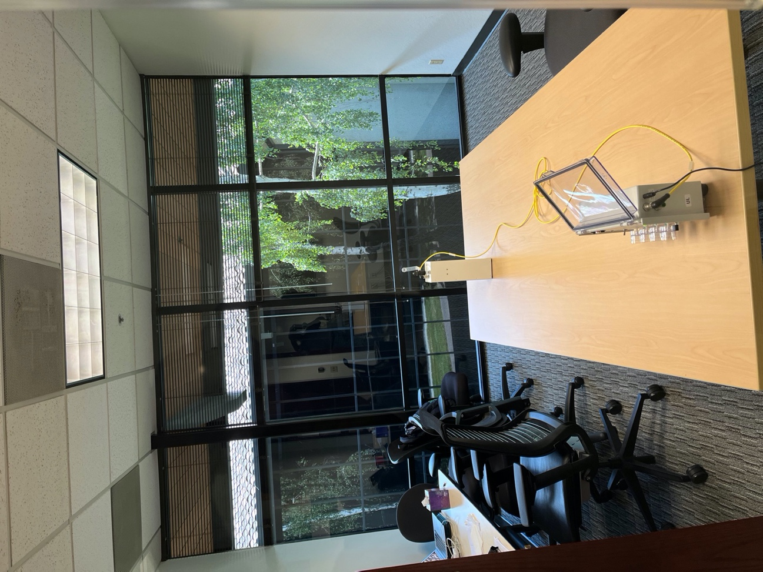

1. **Start the Test**
   1. **Best Practice:** When possible, close all doors and windows in the test area.
   2. Air Sampler
      1. **Best Practice:** Verify the eSprayer Required toggle switch is set to “Yes”, interval switch is set to UL Verification, the eSprayers are under or close to a HVAC supply and the plunger is removed from the syringe.
      2. You must use the Wireless Controller start function to trigger all equipment at the same time.
2. **During the Test do you want to include the recovery process we discussed?**
   1. **Best Practice:** Verify the tag has been released (syringe will be empty).
   2. **Best Practice:** Monitor air-samplers are operational and functional during the test.
   3. Each test runs for one-hour:
      1. Interval 1: (Channel One) T= 0 to 5 minutes.
      2. Interval 2: (Channel Two) T = 45 to 50 minutes. **Note:** Pump does not run for 40 minutes
      3. Interval 3: (Channel Three) T = 50 to 55 minutes.
      4. Interval 4: (Channel Four) T = 55 to 60 minutes.
3. **End of the Test**
   1. Verify the Tag was released (syringe will be empty).
      * 1. Collect the sample cassettes from the air pump.
           1. **Best Practice:** Do not touch the inner circumference or filter while collecting samples.
        2. Place the top cap with “Red Plug” on the cassette base.
        3. Place the “Blue Plug” on the bottom of the cassette.
           1. **Best Practice:** Ensure the plugs are snuggly connected with the cassette.
        4. Discard the syringe and plunger.
           1. Best Practice: Wear clean gloves when handling all components of the syringe.
           2. **Note:** DONOT RETURN SYRINGE OR PLUNGER WITH SAMPLES. DISCARD.
        5. Remove the Nozzle assembly
           1. Cap the right-angle lure connection.
           2. Release the nozzle from the eSprayer.
           3. Cap the nozzle with the red cap.
           4. Place in Ziploc bag for further use or return.

**Best Practice:** Label the bag as “Used”.

**Documentation**

1. Complete Chain-of-Custody and include any issues.
2. Ensure all changes and corrections are completed on floor plans, Project Configuration Form, and portal projects.

**Samples**

1. Verify before shipping
   1. Sample label accuracy for test, sample point and sample number.
   2. Sample quantity.
   3. Chain-of-Custody accuracy and documented issues.
2. Packaging
   1. **Best Practice:** Only package samples from a single test together. Do not comingle samples from different test.
   2. Label the plastic bag with the test number and sample numbers from that test.
   3. **Note:** DONOT PACKAGE OR RETURN TAGS WITH SAMPLES!!! Discard on-site
3. Shipping
   1. Use the return shipping labels when returning samples to the correct lab.
   2. Include a copy of the completed Chain-of-Custody.
   3. Ship samples ASAP after the completion of all tests.
      1. Ship with in 24 hours after test completion.
      2. **Best practice:** Ship same day after test completion.
      3. Ship two**-**day air.
4. Tracking Number
   1. Send tracking number to SafeTraces Project Manager and Lab Contact immediately after shipping.
      1. **Best Practice:** Use email and text to notify the Project Manager and Lab.

**Equipment**

1. Ensure all equipment is accounted for before packaging and shipping.
   1. **Best Practice:** Use Order Form as a check off.
2. Use 70% alcohol wipes to wipe down equipment prior to packing.
3. Package as sent, ensure the equipment is packed suitably for FedEx or other common carrier (or airline baggage handlers). No loose items!
4. Return equipment to supplier.
5. Notify the supplier that the equipment is being returned and send tracking number.

# **Survey Test: PID 417**

**Scenarios**

|  |  |  |
| --- | --- | --- |
| **Scenario** | **Description** | **Time of Tag Application** |
| 1 | Survey Test: Baseline HVAC Off | 0900 |

**Origin Points**

|  |  |  |  |  |  |
| --- | --- | --- | --- | --- | --- |
| **Scenario** | **OP Number** | **OP Name** | **Tag** | **Tag Lot** | **Tag Expiry** |
| 1 | OP-001 | Corridor by Principal’s Office | A1 | 20220321 | Oct. 21, 2022 |
| 1 | OP-002 | Men’s Restroom DC | A2 | 20220321 | Oct. 21, 2022 |
| 1 | OP-003 | East Classroom DO/WO | A3 | 20220321 | Oct. 21, 2022 |
| 1 | OP-004 | Kindergarten DO/WO | A4 | 20220321 | Oct. 21, 2022 |
| 1 | OP-005 | West Corridor | A5 | 20220321 | Oct. 21, 2022 |
| 1 | OP-006 | NW Classroom DC/WO | A6 | 20220321 | Oct. 21, 2022 |
| 1 | OP-007 | SW Classroom DO/WO | A7 | 20220321 | Oct. 21, 2022 |
| 1 | OP-008 | Nurse Office DO/WO | A8 | 20220321 | Oct. 21, 2022 |

**\*\*DC = Door Closed; **DO = Door Open; **WC = Window Closed; **WO = Window Open**

**Sample Collection Methods**

|  |  |
| --- | --- |
| **Sample Type** | **Measurement** |
| Filter | 2.5 L/min |

**Sample Summary**

|  |  |  |  |  |  |  |
| --- | --- | --- | --- | --- | --- | --- |
| **Scenario Count** | **Interval Count** | **Sample Point Count** | **Sample Type Count** | **Sample Count** | **Interval Duration** | **Interval**  **Times** |
| 1 | 1 | 12 | 1 | 12 | 30 min | 0-30 min |

**Samples**

|  |  |  |  |  |
| --- | --- | --- | --- | --- |
| **Scenario** | **Sample Type** | **SP Number** | **SP Name** | **I1** |
| 1 | Filter | SP-001 | Corridor by Principal’s Office | SN-001 |
| 1 | Filter | SP-002 | Men’s Restroom DC | SN-002 |
| 1 | Filter | SP-003 | East Classroom DO/WO | SN-003 |
| 1 | Filter | SP-004 | Kindergarten DO/WO | SN-004 |
| 1 | Filter | SP-005 | West Corridor | SN-005 |
| 1 | Filter | SP-006 | NW Classroom DC/WO | SN-006 |
| 1 | Filter | SP-007 | SW Classroom DO/WO | SN-007 |
| 1 | Filter | SP-008 | Nurse Office DO/WO | SN-008 |
| 1 | Filter | SP-009 | SE Classroom DO/WO | SN-009 |
| 1 | Filter | SP-010 | North Classroom DO/WO | SN-010 |
| 1 | Filter | SP-011 | West Classroom DC/DC | SN-011 |
| 1 | Filter | SP-012 | South Corridor | SN-012 |

**Annotated Floor Plan**

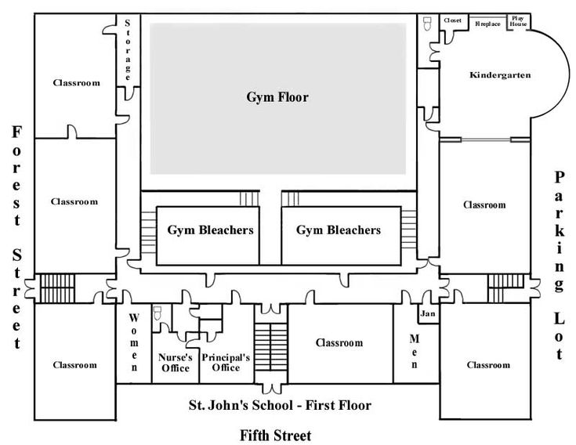

SP-009

SP-012

SP-011

SP-010

SP-008

OP-7

SP-007

SP-005

OP-5

SP-003

SP-004

SP-006

SP-001

OP-1

SP-002

OP-6

OP-8

OP-4

OP-3

OP-2

**Materials and Equipment Order Form**

|  |  |  |  |
| --- | --- | --- | --- |
| **Materials and Equipment: You will Need for this Project** | | | |
| **Tag Kits** | | | |
| **Item** | **Need** | **Confirmed** | **Checked By** |
| Tags | A1-A8 | Yes | MC |
| SDS | 1 | Yes | MC |
| **Air Samplers, eSprayers and Wireless Modules** | | | |
| Air Sampler (1-Channel) with Batteries | 12 | Yes | MC |
| **Energy Supplies and Distance Measurer** | | | |
|  | NA | NA | MC |
| **Laboratory Materials** | | | |
| Filters | 12 | Yes | MC |
| Cassettes | 12 | Yes | MC |
| Cassette Plugs (Red) and Bottoms (Blue) | 12 Each | Yes | MC |
| Ziplock Bags for Samples (Large) | Box | Yes | MC |
| **Cleaning Supplies** | | | |
| Clean Gloves Large (Size Depends) | Box | Yes | MC |
| 70% Alcohol Wipes | Box | Yes | MC |
| **Printed Materials** | | | |
| Clean Floor Plans | 2 | Yes | MC |
| Project Configuration Plan | 2 | Yes | MC |
| Chain of Custody Form | 1 | Yes | MC |
| Labels (OP, SP, SN) | 1 Set Each | Yes | MC |

# **Equipment and Materials**

**Assembled Tag Kit**

**Tag Kit**

**Air Sampler (1-Channel)** 

# **Prepare for Execution**

1. **Assemble the veriDART Kit**
   1. The veriDART Kit will come with the spray top detached.
   2. **Best Practice:** Preferred assembly locations:
      1. Outdoor.
      2. Different floor.
      3. Under an exhaust hood.
      4. DONOT assemble in the test environment.
   3. **Best Practice:** Wear clean gloves for each bucko assembly.
   4. Carefully, remove the bucko top, place in the plastic bag, and attach the spray top. Twist until secure (ensure fully twisted on, it can fall off if not secure). **Do not prime.**
   5. Place the bucko back in the labeled plastic bag and discard the used gloves and continue with the remaining buckos (remember to use new and clean gloves for each event).
2. **Site Tour (Prior to Set-Up)**
   1. Walk the facility to ensure all selected Origin and Sample Points are accessible.
   2. Ensure that the selected points are in the right location on the map.
   3. **Best Practice:** Based on the site tour, make any changes to the Project Configuration Plan prior to project pre-execution.
3. **Verify Origin and Sample Point Set-Up** 
   1. Verify label information and placement location.
   2. Verify Tag Kit information and placement location. **Note:** Do not place air-samplers under HVAC Supply or Return
   3. Cassettes are open faced with intact filter.
   4. **Best Practice:** Turn on all Air Sampler Pumps during set-up. (Green indicator light is on for most pumps)
4. **Determine Test Start/End Time**
   1. Team Leader will provide release start time.
   2. **Best Practice:** Pre-set your watch, phone, or clock for start and end times.
   3. Record the start time on your Project Configuration Form.
   4. Team Leader will give five-minute warning when the test time will be up. You will then prepare to turn off all air-pumps.

# **Execution**

1. **Set-Up**

**3. Spray 10 Consecutive Times**

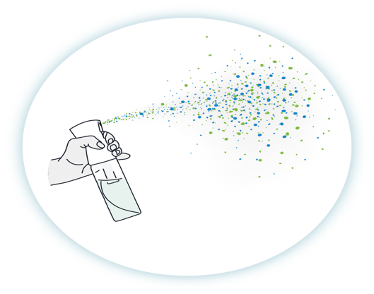

**3. Spray 10 Consecutive Times**



**2. Now Move about Three Feet to either Side of the Air Pump and Weigh Boat**

**2. Now Move about Three Feet to either Side of the Air Pump and Weigh Boat**

1. **Position yourself about Six Feet from the Air-Pump and/or Weigh Boat**

**Technical Questions and Answers**

* **Why do we spray the tracers 10 times/OP?**

**Answer:** During development we found the signal improved over longer distances by doing this.

* **Why is the Sample Point approximately 6 ft away and 3 ft to the side of the Origin Point?**

**Answer:** The goal is to not create “forced” airflow drifting over the air pumps and weigh boats as well as preventing saturation of the filters and weigh boats.

* **What is the most important consideration when determining release direction at the Origin Points?**

**Answer:** Wind direction. You should release “with” the natural direction of the airflow. Avoid releasing over the air samplers and weigh boats as stated above. Also, take into consideration location for air supplies, returns, stand-alone devices including fans when determining where to release the Tag solution.

* **How will the results be affected if I release the Tag solution more or less than 10 times?**

**Answer:** A small variance is built in for miscounting the releases. Best practice is to count aloud from 1 to 10.

* **How will the results be affected if the Air Sample Pump runs shorter or longer than the interval time?**

**Answer:** A small variance is built in for small errors in interval timing. Best practice is to set your watch, clock, timer, or phone to the interval end time(s).

1. **Start the Test**
   1. Team Leader will provide assignments and start time.
   2. Document Start Time.
   3. **Best Practice:** Try to complete the release of all tags in five-minutes. **Note:** If all releases take longer than five-minutes notify you Team Leader for further instructions.
2. **During the Test**
   1. **Best Practice:** Leave the bucko and used gloves at the OP release location. **Note:** The used gloves will be an indication that the Tag was released at the OP
   2. **Best Practice:** After the last release is completed (to reduce the chance of cross contamination) you must stay in your designated area until the sampling interval is over. **Note:** This is a good time to verify functionality of the Air Pumps that you are assigned too.
   3. **Best Practice:** Verify air samplers are operational and functional.
3. **End of Test**
4. **Best Practice:** Turn off “ALL” Air Pumps before collecting samples to reduce over sampling.
   1. Collect the sample cassettes from the air pump.
      1. **Best Practice:** Do not touch the inner circumference or filter while collecting samples.
      2. Place the top cap with “Red Plug” on the cassette base.
      3. Place the “Blue Plug” on the bottom of the cassette.
         1. **Best Practice:** Ensure the plugs are snuggly connected with the cassette.
         2. Discard Bucko.
            1. **Note:** DONOT RETURN BUCKO OR EXTRA TAGS WITH SAMPLES.

**Documentation**

1. Complete Chain-of-Custody and include any issues.
2. Ensure all changes and corrections are completed on floor plans, Project Configuration Form, and portal projects.

**Samples**

1. Verify before shipping
   1. Sample label accuracy for test, sample point and sample number.
   2. Sample quantity.
   3. Chain-of-Custody accuracy and documented issues.
2. Packaging
   1. **Best Practice:** Only package samples from a single test together. Do not comingle samples from different test.
   2. Label the plastic bag with the test number and sample numbers from that test.
   3. **Note:** DONOT PACKAGE OR RETURN TAGS WITH SAMPLES!!!
3. Shipping
   1. Use the return shipping labels when returning samples to the correct lab.
   2. Include a copy of the completed Chain-of-Custody.
   3. Ship samples ASAP after the completion of all tests.
      1. Ship with in 24 hours after test completion.
      2. **Best practice:** Ship same day after test completion.
      3. Ship two**-**day air.
4. Tracking Number
   1. Send tracking number to SafeTraces Project Manager and Lab Contact immediately after shipping.
      1. **Best Practice:** Use email and text to notify the Project Manager and Lab.

**Equipment**

1. Ensure all equipment is accounted for before packaging and shipping.
   1. **Best Practice:** Use Order Form as a check off.
2. Use 70% alcohol wipes to wipe down equipment prior to packing.
3. Return equipment to supplier.
4. Notify the supplier that the equipment is being returned and send tracking number.

**Plug the top cap with the Red Plug**

**and bottom with the Blue Plug**

# **Sample Verifications and Release**

|  |  |  |  |  |  |  |  |  |  |  |  |
| --- | --- | --- | --- | --- | --- | --- | --- | --- | --- | --- | --- |
| **Chain of Custody** | | | | | | | | | | | |
| **Project ID: 416/417 Project Date: 9-24-22** | | | | | | | | **Shipping Information**  **Name**  **Address, Suite**  **City, State, Zip**  **Phone** | | | |
| **Project Name: St. Johns School 1st Floor** | | | | | | | |
| **Number of Samples: 16** | | | | | | | |
| **Lab Contact: Mary Stevens** | | | | | | | |
| **Lab Contact Email: @safetraces.com** | | | | | | | |
| **Lab Contact Phone: 123-234-3456** | | | | | | | |
| **Copy Sent with Samples: Yes No** | | | | | | | | **UPS, FED EX, DHL, Other:** | | | |
| **Number of Pages:1** | | | | | | | | **Tracking Number: 123asd** | | | |
| **Project Leader: Steve Johnson** | | | | | | | | **Contact Information: @gmail.com** | | | |
| **Test #** | **Sample Point** | **Sample Number** | **Sample Type** | **Panel** | **Test #** | **Sample Point** | **Sample Number** | | **Sample Type** | **Panel** | **Comments/**  **4C Pump #** |
| 1 | SP-001 | SN-001 | Filter | C | 1 | SP-005 | SN-005 | | Filter | A | 12 |
| 1 | SP-002 | SN-002 | Filter | C | 1 | SP-006 | SN-006 | | Filter | A | 12 |
| 1 | SP-003 | SN-003 | Filter | C | 1 | SP-007 | SN-007 | | Filter | A | 12 |
| 1 | SP-004 | SN-004 | Filter | C | 1 | SP-008 | SN-008 | | Filter | A | 12 |
| 1 | SP-001 | SN-001 | Filter | A | 1 | SP-009 | SN-009 | | Filter | A |  |
| 1 | SP-002 | SN-002 | Filter | A | 1 | SP-010 | SN-010 | | Filter | A |  |
| 1 | SP-003 | SN-003 | Filter | A | 1 | SP-011 | SN-011 | | Filter | A |  |
| 1 | SP-004 | SN-004 | Filter | A | 1 | SP-012 | SN-012 | | Filter | A |  |
| **Print Name** | | | | **Signature** | | | | | **Date & Time Relinquished** | | |
| Steve Johnson | | | | Steve Johnson | | | | | 9-24-22 @ 1645 | | |
| **Print Name** | | | | **Signature** | | | | | **Date & Time Received at Lab** | | |
| Mary Stevens | | | | Mary Stevens | | | | | 9-25-22 @ 1230 | | |

# **Common Definitions**

1. **veriDART Portal:** The software that is used to create and download all veriDART projects which include Project Configuration Plans, Labels (Origin Point, Sample Point and Sample Number), and Order Forms.
2. **Project ID:** The unique number assigned by the veriDART Portal each time a new project is created.
3. **Project Configuration Plan:** The project plan that is created in the portal. Contains all information needed for the execution of each test.
4. **Test Type:** The test(s) that will be executed onsite. May include one or more test types.
5. **Scenario Description:** The immediate and surrounding test conditions or variable for which the test will be executed. Examples include doors/windows open or closed, use and setting of standalone devices such as HEPA Filters, Air Cleaners, HVAC Settings, etc.
6. **Facility Map:** Outlines the area(s) to be tested. The map (floorplan) is uploaded into the veriDART Portal and populated with the locations for each Origin and Sample Point.
7. **Tag:** The solution that contains a unique DNA sequence. A tag-solution is released at a designed Origin Point and allowed to circulate or exhaust (depending upon the test type) within the test environment over a predetermined interval (test time).
8. **Origin Point:** The location where a single tag is released.
9. **Sample Point:** The location where an air-sampler is placed and collects the air-sample over the interval.
10. **Sample Number:** The number that is assigned to each sample.
11. **Interval:** The time the air-sampler collects an air sample.
12. **Origin Point Label:** Pinpoints the location for each tag release on the floorplan and links that location to with the correct tag.
13. **Sample Point Label:** Pinpoints the location on the floorplan for the placement of each air-sampler.
14. **Sample Number Label:** Links the collected sample to the correct test and sample point location.
15. **Project Pre-Execution:** Team prep and assignments. Assemble veriDART Kit. verify origin and sample point access and description. Verify area and ceiling height. Make changes (document) to project configuration plan. Label sample cassettes. Unpack and wipe down equipment. Set-up and test equipment. Verify accuracy of Origin and Sample Point locations. Ensure sample cassettes are labeled and accurate for the test, collection location and order.
16. **Project Execution:** Tag release. Sampler(s) operating, Verify equipment operation. monitoring, Document issues on Project Configuration Plan. Monitor test area, etc.
17. **Project Post-Execution:** Turn off air samplers. Collect samples. Document any changes or issues on Project Configuration Plan. Prepare Chain-of-Custody.
18. **Chain-of-Custody:** Provides information on the quantity and condition of the samples prior to shipping to the lab for analysis. Sample quantity and condition are verified by the lab at the time the samples are received. Copy is returned with samples.
19. **Sample Return Time:** Samples must be returned to the lab as soon as possible. Samples must be shipped back within 24 hours of test completion.
20. **Equipment Return:** All equipment received must be accounted, wiped down with 70% alcohol before being packed, packed in the correct compartment.
    1. Air samplers
       1. Turned to the off position.
       2. Plastic cover closed and locked.
       3. All power sources and cords disconnected
    2. eSprayers
       1. Syringe and nozzle removed. (Dispose of syringe)
       2. Depressurized. (PSI = 0)
       3. All cord disconnected.
    3. Wireless Modules
       1. All cords disconnected.
    4. Cables, extension cords and power cords must be wrapped-up.
    5. Pressurizer
       1. Disconnect the battery.
       2. Place in the designated compartment at an angle.
    6. Support Cushions
       1. Should be intact and supporting all sides of the equipment.
       2. Layered on top of the equipment before closing and securing. Note: You may have to readjust the cushions and/or equipment if the top of the pelican will not close properly.
       3. Shipping Label
          1. If your equipment was shipped to you remove the original shipping label and securely attach the return label to the outside of the pelican case.
21. **Disposal of Consumables**
    1. Do not return any unused Tags, syringes, buckos, or filtered cassettes to the supplier. Please discard after use and after project completion.
22. **Project Completion:** All test has been executed, samples have been received by the lab, all changes and issues have been documented and accepted in the veriDART Portal, suppler has received all equipment, test is marked “Done” in the veriDART Portal.

# **veriDART Portal: Site, Sign-In and Navigate**

1. Site
   1. Address: <https://prod.veridart.thesafetraces.com/login>
   2. Sign-In
      1. Username: Your email address.
      2. Password: Your first and last name all lowercase with no spaces. Ex. stevesmith
   3. Navigate

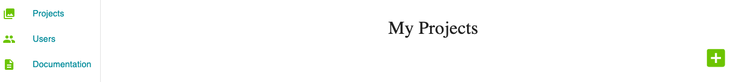

**My Projects Page:** Click “green” button to access Create Project. **Page**

**Sign-In Page**

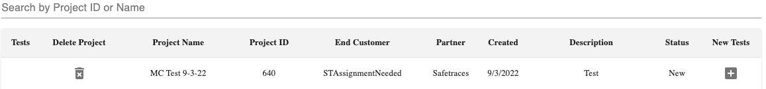

**Create New Test Page or search for past projects**

**Create Project Form Page**

**New Test Form Page**

**Test Details Page with unique associated Project ID**

**Test Details Page:** Input test information for a specific test and select uploaded floor plan for the test.

**Project Details Page:** Overview of all created tests. Add floor plans, new test and

Tag Lot Number and Expiry Date. Access Test Details, Project Configuration, Labels and Materials Page.

**Project Configuration Page:** Contains all test information created under a unique Project Id.

Verify Test and Project details, correct Issues, print for onsite execution

and update when changes occur during onsite execution.

**Labels and Materials Page:** View and print labels.

Download equipment and materials Order Form to request supplies from the supplier.