- Objective
To outline the procedures for setting up and operating Four-Channel Air Samplers with a Flow Rate of 5.5 l/min.

- Procedure
  - Determine the Power Supply
    - Battery
      - When using the battery, ensure that it energized. The battery is fully energized when all five indicator lights are visible. Batteries can be used for 2-3 20-minute cycles before the voltage drops and the Sampler speed decrease. 4 indicator lights are OK, 3 is not.

    - Electric
      - This will require a 12V DC power supply and wall outlet.

  - Four-Channel Air Samplers
    - Ensure that the Air Sampler is Operational
      - Plug the Power Supply into the power port on the right-side of the sampler.
      - Turn on the Power. The solid “Green Indicator Light” lets you know that the Air Sampler is operational.

    - Verify the Settings
      - Sprayer Required
        - When manually releasing Tags set the setting to “No”.
        - If the setting is on “Yes”, you will not be able to start the test.
        - Automatic release of sprays is a feature in development.

      - Interval Duration
        - Set the “Interval Duration” in minutes according to the project plan.
        - If the Interval “Select” knob is in the middle of two durations, you will not be able to start the test.

    - Attach the Filter Cassettes
      - Remove
        - The bottom blue plug from the cassette.
        - The cassette top with the red plug.

      - Labeled Filtered Cassettes
        - Each cassette must be prelabeled and includes the Sample Number (SN).

      - Attach the Filtered Cassettes (Open Faced)
        - The cassette with the lowest SN must be attached to holder number 1 and follow consecutive ordering.

        - Examples:
Channel 1 | Channel 2 | Channel 3 | Channel 4
SN-001 | SN-002 | SN-003 | SN-004
SN-012 | SN-013 | SN-014 | SN-015
SN-077 | SN-078 | SN-079 | SN-080

  - Setup Location Considerations
    - Set up the sampler with the filter faces vertical as noted in the pictures below. This prevents droplets from falling onto the filters.

    - Spray in a direction which does not cause droplets to land on the filters directly.

  - Start the Air Sampler
    - Press on the “Black Start Button”.

    - Start Countdown
      - Once the “Start” button is pressed the red indicator light will begin to blink slowly. You will have 10 seconds until Air Sampler #1 starts collecting the sample. After about 5 seconds, the indicator light will begin to blink faster, which indicates that the Air Sampler is preparing to start.

  - Releasing the Tracer
    - During the 10 second countdown, you must position yourself and prepare to release the Tracer.

    - When the flashing indicator stops, the sampler starts and Air Sampler #1’s blue light goes on, then release the Tracers.

    - If using multiple 4-Channel samplers, start spraying after the last unit starts sampling.

  - Collect the Sample
    - When the “Countdown” is completed the “Blue” indicator light for Air Sampler #1 will come on and the sampler will start to collect the sample.

    - When the first interval is completed then the second Air Sampler will start, and its blue indicator light will illuminate (first Air Sampler will stop and its indicator light will go off). This will repeat until all intervals have been completed.

  - Done
    - Once all intervals are completed and the test is over, the last Air Sampler will stop, and indicator light will turn off. The “Green” Done indicator light will come on.

- Photo Glossary

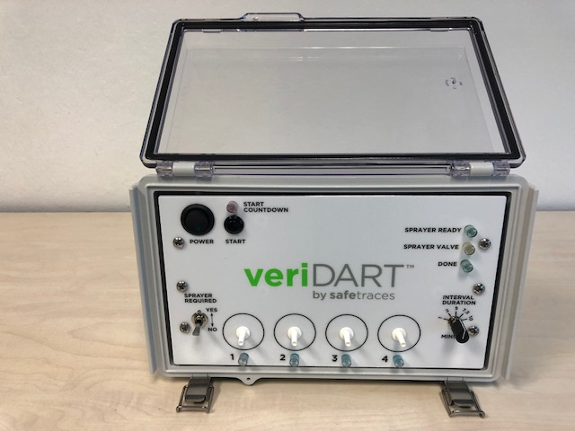
Air Sampler Channels
and Indicator Lights
Auto Sprayer Indicators (not used yet)
Done Indicator
Start Countdown
Sprayer Required Switch
Power Button
Interval Duration

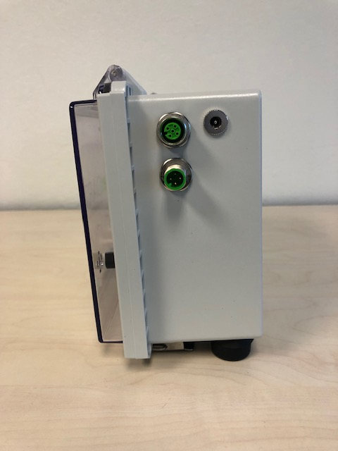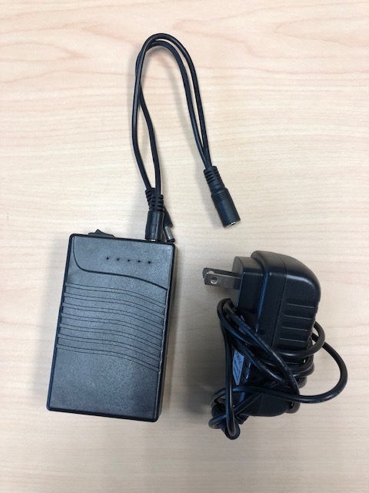
Li Ion Battery
Power Supply
Auto sprayer Connectors (not used yet)
Power Supply Input

