****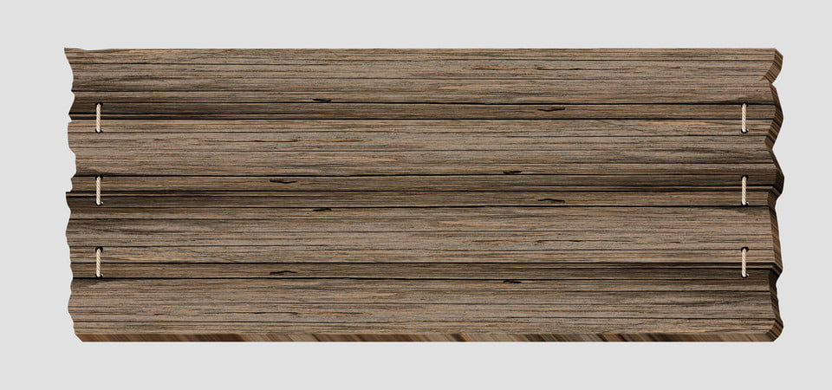

**

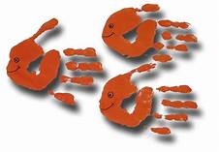

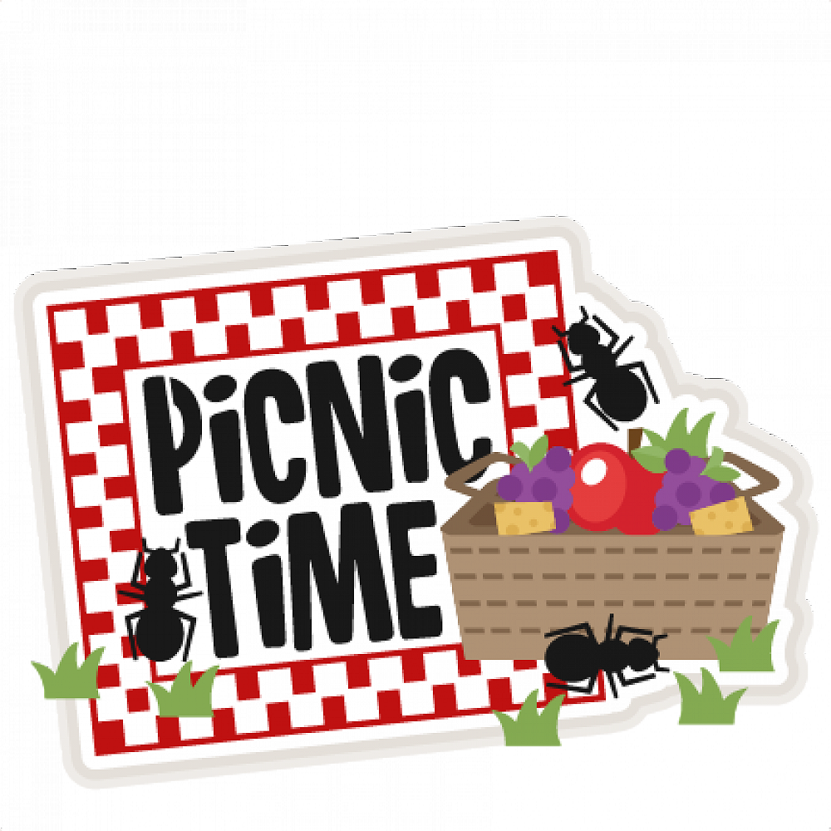



|  |  |  |  |  |  |  |
| --- | --- | --- | --- | --- | --- | --- |
|  |  |  | **1** | **2** | **3** | **4** |
| **5** | **6** | **7** | **8** | **9** | **10** | **11** |
| **12** | **13** | **14** | **15** | **16** | **17** | **18** |
| **19**  **Aloha** | **20**    **Sports Day with**  **Coach Jen** | **21**  **Sand Art Project** | **22**  **Water Play with**  **Coach Jen**  **Ice Cream Truck**  **$3.00** | **23**  **INHOUSE EVENT** | **24** | **25** |
|  **| **27**  **Sports Day with**  **Coach Jen** | **28**  **EVENTS** | **29**  **Water Play with**  **Coach Jen**  **Ice Cream Truck**  **$3.00**  **SUBJECT** | **30 Visit from**  **Outreach Program**  **TO CHANGE** | **1**  **Project** |  |

**SUNDAY MONDAY TUESDAY WEDNESDAY THURSDAY FRIDAY SATURDAY SATURDAY**