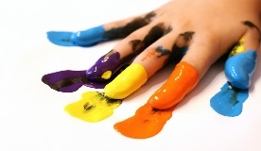****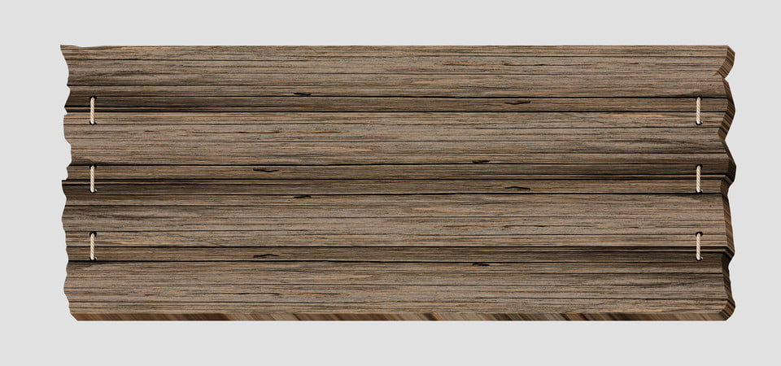

**SUNDAY MONDAY TUESDAY WEDNESDAY THURSDAY FRIDAY SATURDAY SATURDAY**

|  |  |  |  |  |  |  |
| --- | --- | --- | --- | --- | --- | --- |
| **31** |  |  |  |  | **1**  **Project** | **2** |
| **3**  **Team** | **4 NO CAMP**  **HOLIDAY** | **5**  **Water Play with**  **Coach Jen** | **6 Wear your**  **favorite team**  **Jersey** | **7** | **8 JUI JITSU**  **INHOUSE EVENT** | **9** |
| **10**  **Krazy**  **Kolorful** | **11**  **Sports Day with**  **Coach Jen** | **12**  **INHOUSE EVENT** | **13**  **Water Play with**  **Coach Jen**  **Ice Cream Truck**  **$3.00** | **14**  **Project**  **FUN WITH COLORS** |  **| **16** |
| **17**  **Magical** | **18**  **Eric Carle’s Project**  **Sports Day with**  **Coach Jen** |  **| **20**  **Water Play with**  **Coach Jen**  **Ice Cream Truck**  **$3.00** | **21 Dr. Seuss’**  **Magic show**    **INHOUSE EVENT** | **22**  **Dress up as your favorite story character** | **23** |
| **24 Ahoy Matey** | **25**  **Sports Day with**  **Coach Jen** | **26**  **Project**  **Spy glass with tubes**  **EVENTS** | **27**  **Water Play with**  **Coach Jen**  **Ice Cream Truck**  **$3.00**  **SUBJECT** |   TO CHANGE** | **29**  **Currier Magical**  **Pirate Magic**  **INHOUSE EVENT** | **30** |