Daily Trading Journal
This trading journal includes example of trading rules that have not been backtested and are not meant to be blindly followed. Please be meticulous when creating your own trading plan and trading goals. All examples included should merely be seen as examples to showcase what one may want to include in ones personalized trading plan.
[Your Trading Goals] Example: I want to make 1% on my account each week. My goal is to be financially free and unrestrained by time and location through trading. I want to stop living a life of mediocrity and become the person that is independent of others and can, in contrast, be depended on by others. I want to be self-reliant, self-sustaining and proud of my financial achievements.
[Your Trading Plan and Trading Rules] Example:
- Swing trading by looking at the 1W, 1D, 4H, 1H charts
- Trade only high-cap stocks or high-cap crypto pairs
- Risk no more than 1% of my account per trade.
- Max 1:3 Risk-to-Reward Ratio
- Find best entries to trades on pullbacks on the 1h chart
- Only enter trades if they are actually good trades, be critical and assess every move critically
- Daily Journaling, no excuses, each trade goes in the journal

[Date] Example: 10/02/22
[Day / Mood Summary] Example: This morning I woke up feeling rather lethargic and tired, so I went to the gym and took a cold shower to try to get rid of the feeling. Although it still remains a little. I have to be wary of this feeling the whole time and not let it get the best of me. I should take a few less trades today and make sure I think critically by only taking the top trades if they show up, or not take any trades at all. I have already been on a bad trading spree for three days now and should be careful with not continuing this, especially if I’m also feeling a bit down today.
[Ticker of Trade] Example: BTC
[Time of Spotting Trade] Example: 11:07AM
[Thought process on this trade] Example: Trade looks like 19k support will hold since it has served as previous support numerous times. Gonna be a good swing if it retests previous highs at 20400.
[Entry Price] Example: 18964
[Position Size] Example: $17,800
[Stop-loss Price] Example: -0.9% at 18799
[Take Profit 1] Example: 19600
[Take Profit 2] Example: 20000
[Take Profit 3] Example: 20400

[Entry Image] Example:
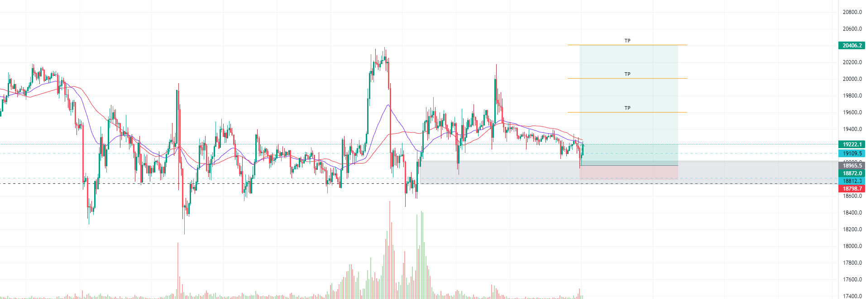

[Trade Reflection / Results] Example: Trade went great, NAILED IT. Nothing to complain about, feels great to place a good trade again, need to make sure I don’t greed next time and keep up with spotting those key support and resistance zones like I did here with spotting 19000 as strong support and 20400 as strong resistance.
[Profit Result] Example: +$1245
[Trade Results Image] Example: 