| **ELTHAM NORTH PRIMARY SCHOOL No 4212** POLICY MANUAL | | | | |
| --- | --- | --- | --- | --- |
| **POLICY NO. 7.2** | **TOPIC: ASTHMA MANAGEMENT POLICY** | | | **Page 1 of 1** |
| **PREAMBLE:** Asthma affects up to one in four primary aged children, one in seven teenagers and one in ten adults. It is important therefore for all staff members to be aware of asthma, its symptoms and triggers, and the management of asthma in a school environment. Asthma attacks involve the narrowing of airways making it difficult to breathe. Symptoms commonly include difficulty breathing, wheezy breathing, dry and irritating cough, tightness in the chest and difficulty speaking. Children and adults with mild asthma rarely require medication; however severe asthma sufferers may require daily or additional medication (particularly after exercise). PURPOSE: To manage asthma and asthma sufferers as effectively and efficiently as possible at school.  **GUIDELINES FOR IMPLEMENTATION:**  1.1 Parents of children diagnosed with asthma are asked to provide to the school a copy of their child’s asthma management plan on enrolment or when a plan has been prepared.  1.2 All students with asthma must have an up to date (annual) written asthma management plan consistent with Asthma Victoria’s requirements completed by their doctor or paediatrician. Appropriate asthma plan proformas are available at www.asthma.org.au  1.3 Asthma plans will be retained by the school in the student medical folder.  1.4 The school will provide an annually updated list of students with asthma management plans on record to staff including specialists, aides and class teachers. Class teachers are responsible for having this medical information available at the front of their roll for days when Casual Relief Staff are teaching.  1.5 Parents/guardians are responsible for ensuring their children have an adequate supply of appropriate asthma medication (including a spacer) with them at school at all times.  1.6 Professional development will be provided for all staff on the nature, prevention and treatment of asthma attacks in line with the recommendations of the asthma friendly schools program. Such information will also be displayed in the First Aid Centre and on the staff intranet in the health and wellbeing folder.  1.7 The school will provide, and have staff trained in the administering of, reliever puffers (blue canister) such as Ventolin, Airomir, Asmol or Bricanyl and spacer devices in all first-aid kits, including kits on excursions and camps. Clear written instructions on how to use these medications and devices will be included in each first aid kit, along with steps to be taken to treat severe asthma attacks. Kits will contain 70% alcohol swabs to clean devices after use..  1.8 The school nurse will be responsible for checking all reliever puffer expiry dates.  1.9 A nebuliser pump will not be used by the school staff unless a student’s asthma management plan recommends the use of such a device, and only then if the plan includes and complies with the Vic Government School’s Reference Guide – Asthma Medication Delivery Devices.  1.10 All devices (spaces) used for the delivery of asthma medication will be cleaned appropriately after each use.  Intervention must be provided immediately for any student who develops signs of an asthma attack according to the school Asthma action plan.  1.11 Children suffering asthma attacks should be treated in accordance with their asthma plan. If no plan is available children are to be sat down, reassured, administered 4 puffs of a shaken reliever puffer (blue canister) delivered via a spacer – inhaling 4 deep breaths per puff, wait 4 minutes, if necessary administer 4 more puffs and repeat the cycle. An ambulance must be called if there is no improvement after the second 4-minute wait period, or if it is the child’s first known attack. Parents must be contacted whenever their child suffers an asthma attack.  1.12 The school is registered as an *asthma friendly school* and will ensure that this registration remains current on a three yearly basis and will undertake as required the requirements for maintaining this registration– www.asthmafriendlyschools.org.au  **PARENTS’ ROLE:**  To support the policy and supporting programs.  To assist children in understanding and taking responsibility for contributing to and maintaining a sustainable future.  To assist children in participating in nutrition habits and practices.  **DOCUMENTS IN SUPPORT OF THIS POLICY:**  Asthma Victoria on line or www.asthmafriendlyschools.org.au | | | | |
| **Program Leader:**  Tandy Johnston | | **Issued in Newsletter:**  Nov 2022 | **Updated / Ratified by SC**  June 2022 | |

Appendix: **3.13 STUDENTS WITH ASTHMA**

**ASTHMA AWARENESS**

As asthma affects up to *one in four primary age* children, *one in seven teenagers* and one in ten adults, it is important for teachers to be aware of asthma, its symptoms and triggers and, most importantly, the management of asthma in the school environment.

Asthma is a condition that affects the small airways (bronchioles) of the lungs. In a person with asthma, the airways are more sensitive than normal. When the sensitive airways are exposed to a ‘trigger factor’ they overreact, resulting in an asthma attack. A variety of different trigger factors may lead to an asthma attack (for example, colds/flu, exercise, pollens, dust, dust mite, or cigarette smoke) and these triggers vary from person to person.

During an asthma attack the airways narrow making it difficult to breathe. The narrowing is caused by constriction of the muscle in the walls of the airways, swelling of the lining layer of the airways, and excessive production of mucus.

Symptoms of asthma commonly include:

* difficulty in breathing
* wheezy breathing (a whistling noise from the chest)
* cough (usually dry and irritating)
* tightness in the chest
* difficulty in speaking.

These symptoms are particularly likely to occur during or immediately after exercise.

Many children and adolescents have mild asthma with very minor problems and rarely need medication. However, some students will need medication on a daily basis and frequently require additional medication at school (particularly before or after vigorous exercise). Most students with severe asthma can have their asthma controlled by taking regular medication.

**ASTHMA MEDICATION**

There are three main groups of asthma medications—relievers, preventers and symptom controllers. A reliever opens up the airways by relaxing the bronchial muscle and is used to relieve an asthma attack. Common brands include Ventolin, Airomir, Asmol or Bricanyl (usually in a blue container). They should be easily accessible to the student at all times. All students with asthma should be encouraged to take their reliever medication immediately they develop symptoms at school.

Students with moderate to severe asthma may also be required to take medication that helps prevent their asthma (a preventer). Preventer medications help reduce and prevent the inflammation in the lining of the airway. Common preventers include Intal Forte and Tilade (usually in a white or yellow container) or inhaled corticosteroids such as Becotide, Becloforte, Respocort, Qvar, Aldecin, Pulmicort or Flixotide (usually in brown/yellow/beige/orange containers). These medications need to be taken on a regular basis, although usually only twice daily (morning and evening) and therefore will often be taken in the student’s home. Intal Forte or Tilade are also used in the prevention of exercise-induced asthma. Preventer medications do not relieve an asthma attack.

Symptom controllers such as Serevent, Foradile, Optrol and Oxis are long acting relievers used in combination with reliever and preventer medication at home.

Leukotriene Receptor Antagonists (LTRAs) are a new class of medication recently available for use with inhaled preventers. They are available in tablet form (eg Singulair and Accolate).

Symptom controllers and LTRAs do not relieve an asthma attack and will not usually be seen at school.

Students with asthma should always carry or have available in the school, appropriate medication. Parents/guardians are responsible for ensuring that their children have an adequate supply of the appropriate medication at school. It is also recommended that parents/guardians provide a spacer at school for their child’s individual use.

**ASTHMA MEDICATION DELIVERY DEVICES**

Asthma medications are generally taken via a hand-held inhaler device such as a ‘puffer’ (metered dose inhaler) or dry powder inhaler (Turbuhaler, Accuhaler, Aerolizer). It is recommended that a puffer be used in conjunction with a ‘spacer’ to assist with fast and more effective delivery of the reliever medication.

Note: Schools should provide a reliever puffer (for example, Ventolin, Airomir, Asmol or Bricanyl puffer) and a matching spacer device in the school’s first-aid kit (see section 4.5.7.6).

Schools are not required to provide a nebuliser pump for their students to use. There is clinical evidence that a puffer and spacer device is as effective as a nebuliser.

The following are disadvantages to using a nebuliser and therefore a school owning a nebuliser:

* nebulisers are expensive to buy and with heavy duty use need to be replaced every few years
* nebulisers need regular care and servicing every twelve months
* nebulisers are less portable and not as easy to clean as spacers
* at least two staff members need to be trained in how to operate the nebuliser (to ensure that a trained staff member is always available)
* most nebulisers need a 240 volt power supply
* medication is only obtainable on prescription (must therefore be provided by parents)
* staff members can only assist the student in administering the medication with written/verbal consent from parent/guardian or doctor (see section 4.5.7.5)
* if more than one student requires the nebuliser pump at one time, it may be difficult for the staff member to assess which student has priority.

If a school chooses to own its own nebuliser it should be tested at a pharmacy every twelve months to ensure that it is in effective working condition.

If a nebuliser pump is recommended by the child’s treating doctor, the school staff are to follow the child’s asthma management plan.

The parents/guardians will need to provide a nebuliser pump at school for their child’s use and this may be done when:

* the treating doctor verifies that the medication can only be delivered effectively through a nebuliser
* the treating doctor provides a signed and dated asthma medication plan with the medication dosage, frequency, and method of use
* the plan is countersigned by the parents/guardians, and updated as needed
* the parents/guardians provide and replace the medication that is labelled with the name of the drug, the dosage, frequency of use, and the child’s name
* the parents/guardians negotiate with the principal and at least two staff members for the use of a nebuliser pump at school for their child, and the staff have learnt how to use the pump
* the parents/guardians ensure that the pump is tested at a pharmacy annually
* the student has their own nebuliser mask, bowl and tubing, and the parents/guardians provide replacement equipment as required
* the student, wherever possible, is responsible for cleaning their own nebuliser mask and bowl
* the medication is stored in an appropriate place (some medications may be required to be kept in the refrigerator)
* the nominated staff regularly check the expiry dates on the medications.

**CLEANING OF DELIVERY DEVICES**

Devices (for example, puffers, spacers) that are used by more than one person must be cleaned thoroughly after each use to prevent cross-infection.

Devices can be easily cleaned as follows:

* ensure the canister is removed from the puffer container (the canister must not be submerged) and the spacer is separated into two parts
* wash devices in warm water and detergent
* rinse
* allow devices to ‘air dry’. Do not rub dry
* to disinfect devices, wipe with a 70 per cent alcohol swab (eg Medi-Swab™ available from pharmacies) paying particular attention to the mouthpiece
* when completely dry, ensure canister is replaced into puffer container and check the device is working correctly by firing one or two ‘puffs’ into the air. A mist should be visible upon firing
* if any device is contaminated by blood, throw it away and replace the device.

**ASTHMA MANAGEMENT PLAN**

Every student with asthma attending the school should have a written asthma management plan filled out by their family doctor or paediatrician, in consultation with the student’s parent/guardian. This should be attached to the student’s records and updated annually, or more frequently if the student’s asthma changes significantly.

Proforma copies of school and camp asthma management plans are available from Asthma Victoria or from Asthma Victoria’s website at www.asthma.org.au

The management plan should include:

* usual medical treatment (medication taken on a regular basis when the student is ‘well’ or as premedication prior to exercise)
* a written action plan detailing medications to be used in cases of deteriorating asthma. This should include how to recognise worsening symptoms and what to do during an acute attack. This action plan is to be provided by the student’s doctor and should be easily accessible to all staff. Staff should identify high risk asthma students and ensure their action plans are updated regularly
* name, address and telephone number of an emergency contact
* name, address and telephone number (including an after-hours number) of the student’s doctor.

**SUPPLEMENTARY FIRST AID SUPPLIES**

As well as ready access to the details of each student’s asthma (usual treatment and action plan), it is essential to have equipment for managing an asthma attack available in every school first-aid kit. The school can have multiple asthma first aid kits located strategically around the campus where asthma may be treated.

The kit must include:

* a reliever puffer (for example, Ventolin, Airomir, Asmol or Bricanyl puffer)
* a large volume spacer device to assist with effective inhalation of the reliever, for example, a Volumatic or Nebuhaler. Consult a pharmacist about matching the spacer with the reliever puffer. (In some instances, a student may use a small volume spacer via a facemask, for example, Aerochamber or Breath-a-Tech with mask)
* clear, written instructions on how to use these medications and devices, plus the steps to be taken in treating an acute asthma attack as described below
* seventy per cent alcohol swabs, eg Medi-SwabTM to clean devises after use (see section 4.5.7.4 Cleaning of delivery devices).

Schools can legally purchase a reliever puffer for first-aid purposes from a pharmacist on the written authority of the principal.

A staff member needs to be given the responsibility of regularly checking the expiry date on the canister of the reliever puffer.

**EXERCISE-INDUCED ASTHMA**

All students with asthma should be encouraged to exercise regularly to improve cardiovascular fitness and general wellbeing. However, exercise (particularly strenuous exercise) can bring on an attack of asthma in about 85 per cent of children with asthma. Exercise-induced asthma may vary considerably from day-to-day and can be particularly troublesome when the student has a cold or flu, is recovering from a recent flare-up of asthma, or during very cold weather. In many instances, the difficulty in breathing comes on soon after completion of the exercise when the student is ‘cooling down’, rather than during exercise.

## Prevention

Exercise-induced asthma can frequently be prevented by a simple warm-up period and medication immediately before the exercise (premedicate with two puffs of either a reliever puffer, or Intal or Tilade, preventers often used in the management of exercise-induced asthma, or both as recommended by the student’s doctor). Obtaining better overall control of the student’s asthma with long-term preventative treatment (for example, Intal, Intal Forte, Tilade or inhaled corticosteroids) also reduces the likelihood of exercise-induced asthma.

## Treatment

If students develop exercise-induced asthma, they should immediately cease the exercise, rest and take a reliever puffer (preferably with a spacer device). Once all symptoms disappear they may be able to resume their exercise program. However, if the symptoms persist, worsen or reappear, the attack needs to be managed as outlined below and the student must not return to exercise.

**EMERGENCY TREATMENT OF AN ASTHMA ATTACK**

If a student develops signs of what appears to be an asthma attack, appropriate care must be given immediately.

## Assessing the severity of an asthma attack

Asthma attacks can be:

* Mild: This may involve coughing, a soft wheeze, minor difficulty in breathing, and no difficulty speaking in sentences.
* Moderate: This may involve a persistent cough, loud wheeze, obvious difficulty in breathing, and able to speak in short sentences only.
* Severe: The student is often very distressed and anxious, gasping for breath, unable to speak more than a few words, pale and sweaty, and may have blue lips.

All students judged to be having a severe attack require emergency medical assistance.

Call an ambulance and carry out the steps listed below while waiting for an ambulance to arrive.

Regardless of whether an attack of asthma has been assessed as mild, moderate or severe, emergency treatment (as detailed below) must commence immediately. The danger in any acute asthma situation is delay. Delay may increase the severity of the attack and ultimately risk the student’s life.

## First aid management of an asthma attack

If the student has an action plan follow the steps immediately (see section 4.5.7.5). If no action plan is available the steps outlined below should be taken immediately. These steps should be clearly displayed in the staff room so that all staff are well versed with them. They should also be written on a card in the first-aid kit.

If the student’s own reliever puffer is not readily available, a reliever puffer should be obtained from the first-aid kit, or borrowed from another student or staff member and given without delay. It does not matter if a different brand of reliever is used.

The steps are:

1. Sit the student down in as quiet an atmosphere as possible. Breathing is easier sitting rather than lying down. Be calm and reassuring.
2. Without delay administer four separate puffs of a blue reliever puffer via a spacer noting the following instructions:

–Shake the asthma puffer, insert it into the spacer and fire one puff into the spacer chamber.

–Ask the student to breathe in and out, as deeply as possible, through the mouthpiece of the spacer for four breaths (the student does not need to take their mouth away for each breath out as the mouthpiece contains a one-way valve).

–Repeat immediately to administer a further separate three puffs, always shaking the puffer between puffs.

1. Wait four minutes. If there is no improvement, give another four separate puffs through the spacer.
2. Wait four minutes. If there is still no improvement, an ambulance should be called immediately (dial 000). State clearly that a student is having ‘an asthma attack’. The ambulance service will always give priority to an asthma attack.

* Repeat steps 2 and 3 continuously while waiting for an ambulance to arrive.
* Contact the student’s parents/guardians and doctor immediately.

Even if the student has a complete recovery from the asthma attack, their parents/guardians or doctor should be notified of the incident.

If a spacer device is not available:

* shake the puffer
* have the student hold the puffer either in the mouth, or slightly away from the open mouth. Either the student, or the staff member, should fire the puffer the moment the student begins to take a slow steady breath in. Ideally, the student should hold their breath for four seconds at full inspiration.
* allow the student to take four normal breaths of air, then repeat the above procedure until four puffs of a reliever puffer have been delivered
* wait four minutes. If there is no improvement, repeat the above steps
* wait four minutes. If there is no improvement, call an ambulance immediately.

Repeat the above steps continuously while waiting for the ambulance to arrive.

If at any time the student’s condition suddenly worsens, call an ambulance immediately.

Reliever puffers are safe. An overdose cannot be given by following the instructions outlined. However, it is important to note that the student may experience harmless side effects of shakiness, tremor or a racing heart.

If a spacer device is **not** available and the student is unable to coordinate using a puffer, an improvised spacer device can be used, for example, have someone cup their hands around the student’s nose and mouth and have a second person ‘fire’ the puffer into the cupped hands, or put a hole in the bottom of a polystyrene cup, place the cup over the student’s mouth and ‘fire’ the puffer through the hole.

**WHAT IF IT IS THE FIRST ATTACK OF ASTHMA?**

A problem that may be encountered is when a student is having difficulty breathing at school, and is not known to have pre-existing asthma. In this situation, administer four separate puffs of a blue reliever puffer via a spacer and call an ambulance immediately. Keep giving four separate puffs of a blue reliever puffer via a spacer every four minutes until the ambulance arrives. This treatment could be life saving for a student whose asthma has not been previously recognised and it will not be harmful if the breathing difficulty was not due to asthma. Reliever puffers are extremely safe, even if the student does not have asthma.

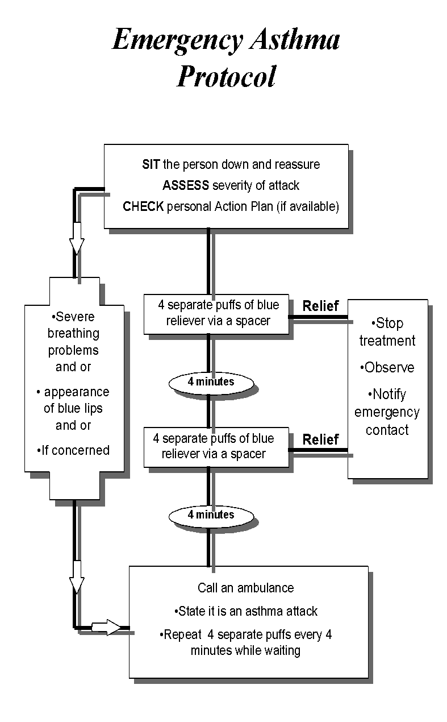

Asthma Victoria provides education, training and resources for students and school staff on asthma at school. Telephone (03) 9326 7088, or 1800 645 130.

Management plan proformas, asthma first aid posters and other asthma resources are available from Asthma Victoria:

E-mail: afv@asthma.org.au

Internet: www.asthma.org.au