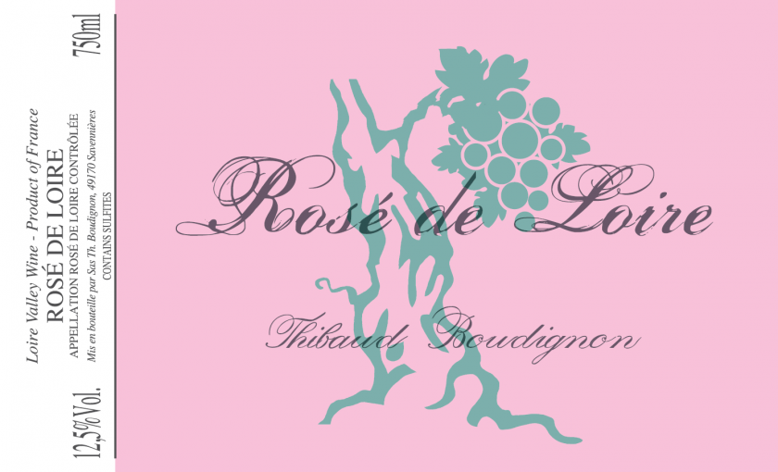
- Practicing biodynamic
- 90% Cabernet Franc, 10% Grolleau
- 25+ year old vines
- Shallow soils of grey schist and rhyolite (volcanic soil) and clay
- Direct press rosé
- Indigenous yeast fermentation
- No malo
- Fermented and aged in stainless steel
- A noble, supremely saline rosé. Delicate texture. Made like a white wine to preserve salinity and structure

