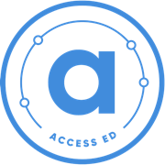

Research-Based Curricula Project Worksheet
School:
Year:
Name:

c
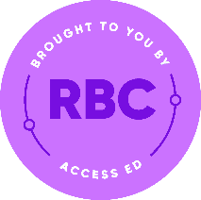
Research-Based Curricula Project Worksheet

Using Research-Based Curricula to get university ready!

The Research-Based Curricula programme involves completing one self-directed coursebook (or more!) of 6 modules on a subject of your choice.
This is an accompanying worksheet for you to track your progress and reflections when completing a Research-Based Curricula coursebook. Completing this and the coursebook will help you with your journey to a top university.
Step 1: Getting started
- Explore the different Research-Based Coursebooks, under the following sections:
  - Arts and Humanities
  - STEM (Science, Technology, Engineering, Maths)
  - Social Sciences
- Download a few coursebooks that sound interesting and read the introductions for an overview of coursebook content
- Choose one coursebook. Fill in the table below!
Getting Started
Name of your Research-Based Curricula coursebook
Why did you choose this coursebook?
Start date
PhD author

First Name.

Research-Based Curricula Programme | The Elephant Group and AccessEd

Click or tap here to enter text.
Step 2: Instructions for coursebook completion
- Work your way through the six resources and activities one by one
- Fill in the Resource checklist and checkpoints on the next page as you go along
- We all work at a different pace, but we recommend completing 2 resources per week
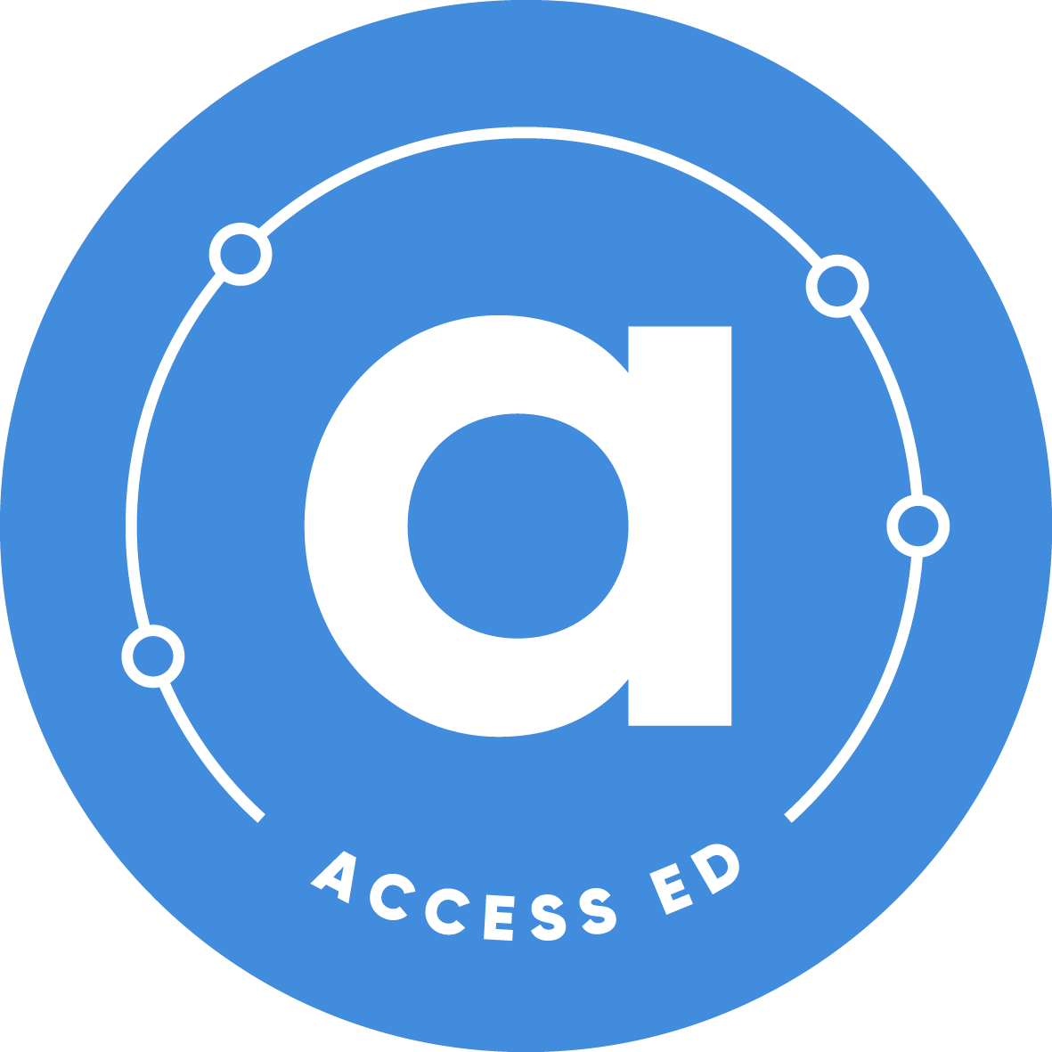
- Complete the Final Reflection Activity and Self-Reflection on page 5
Coursebook Completion

Checkpoint A
Checkpoint B

Resources
6
5
4
3
2
1
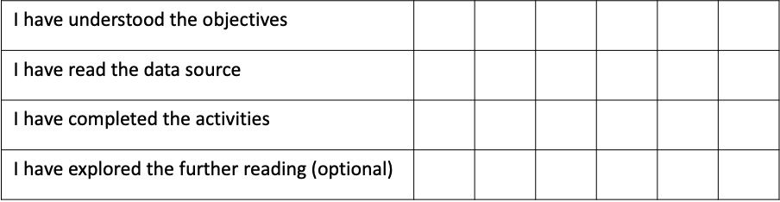

Research-Based Curricula Programme | Elephant Access and AccessEd

Research-Based Curricula Programme | Elephant Access and AccessEd

Checkpoint A

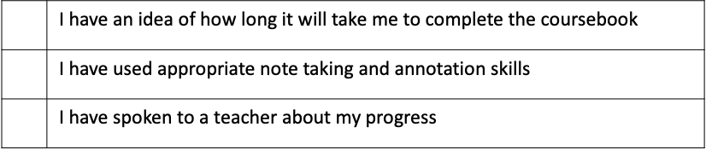

Checkpoint B

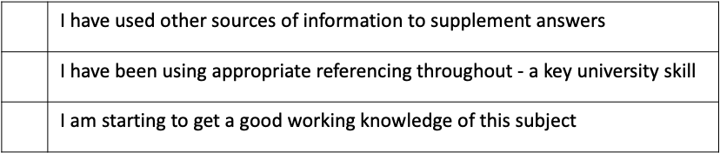

Research-Based Curricula Programme | Elephant Access and AccessEd

Final Reflection Activity

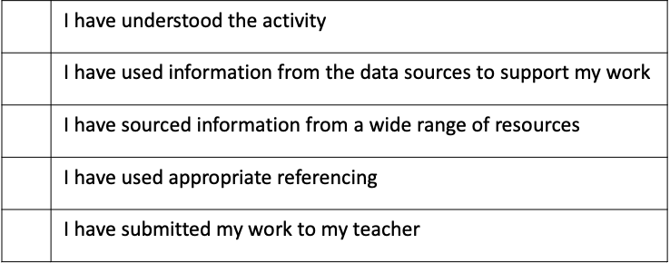

Submit your answers

Step 3: Submit your answers and check in with your teacher
- Update your teacher on your coursebook completion
- Show your teacher this worklog and get comments from them (fill them in below)
- Go to www.access-ed.ngo/the-elephant-group-rbc-programme or click the button below fill in a form showing you have completed an RBC coursebook. You will be sent a completion certificate!
Click here to submit your completion form

Step 4: Next steps
- Consider selecting and completing another coursebook!
- Use AccessEd’s free library of ReachUni tools for university advice and guidance and subject exploration, including the ThinkUni university choice app!

Congratulations on completing your coursebook!

Don’t forget to tweet @ElephantAccess and @_AccessEd using 3 words to describe your experience participating in this programme!
Research-Based Curricula Programme | Elephant Access and AccessEd

Teacher Comments
Programme Completion Self-Reflection

What did you enjoy the most about university-style learning?
What has completing the Research-Based Curricula Programme taught you about resilience?
How has this programme changed how you think about your next steps to university and the subject you might study?
How would you rate your confidence in research-based and university-style learning after finishing this programme?
1
2
3
4
5
Not confident
Very confident
Neutral
Research-Based Curricula Programme | Elephant Access and AccessEd

Research-Based Curricula Programme | Elephant Access and AccessEd

Tick this box if you’d like to take part in submitting a picture, short video, or testimonial about your experience completing a Research-Based Curricula coursebook!

www.access-ed.ngo
@_AccessEd
AccessEd NGO
@_accessed
hello@access-ed.ngo

Kemp House, 160 City Road London, EC1V 2NX

AccessEd is a charity registered in England and Wales (#1186355)

