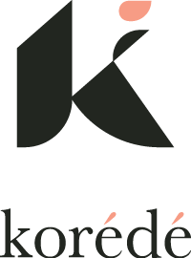 I A.M. Summit

Dear <Insert Manager’s Name>,

Growing professionally and gaining new skills around work/life integration and effectiveness has never been more important. I’d like your support to sponsor my attendance at an upcoming development conference focused on individual growth through story-telling and restorative care. The cohort is made up of a small number of ambitious mothers in leadership roles.

The I AM (Ambitious Mother) Summit (IAMS) by korédé runs from <insert date> and takes place in <insert city and state>.

I will develop one fundamental skill - Story-Telling - within a diverse network of a niche affinity group of other ambitious women. I will be able to apply these skills right away in moving our initiatives ahead and I am willing to give a report of what I learned upon my return.

Two sessions that particularly interest me are:
- <story: insert session name>
- <story: insert session name>

Here is a breakdown of the cost associated with this conference:

- Registration fee: $1,140. This includes all conference sessions, food, lodging and ongoing networking opportunities.
- Estimated transportation cost is <$400>
- I am able to expense these using my corporate card

Additional information is available at www.iamsummit.org

Thank you for considering this request. I look forward to your reply.

Regards,
<Add Name>

