Schuyler Bailar Appearance

FOR IMMEDATE RELEASE
CONTACT: [insert CONTACT NAME and Email]

Schuyler Bailar, award winning NCAA D1 Athlete and Inspirational Educator to speak at [insert LOCATION, DATE at TIME].

Schuyler Bailar was one of the nation’s top-20 15-year-old breast stroke swimmers. By 17, his relay team set a national age-group record. A 25-time National Championship Qualifier, a two-time All-American, he was recruited by and swam for Harvard University on one of the winningest teams in Harvard’s history.

Schuyler is also the first transgender athlete to compete in any sport on an NCAA Division I men’s team.

Schuyler’s difficult choice – to transition while potentially giving up the prospect of being an NCAA Champion on the female team – was historic and timely. His story has appeared everywhere from The Washington Post to 60 Minutes and The Ellen Show.

Schuyler is also a celebrated inspirational educator and speaker, having been hosted at places like the CIA, the NCAA, USA Swimming, TEDx, The Boston Museum of Science and hundreds of other organizations, schools and colleges across the country.
His story explores the universal challenges of trying to "fit-in" in our media-rich world with integrity and authenticity. He explains his struggles and why he ultimately chose to put many potential accolades at risk to be true to himself. Because he has lived his life from many perspectives – woman, Korean American, mixed-race, gay, trans, “Harvard white guy” – his story resonates with young and old, from all walks of life.
His conversational style is engaging, disarming, funny and enlightening and includes an audience Q&A.
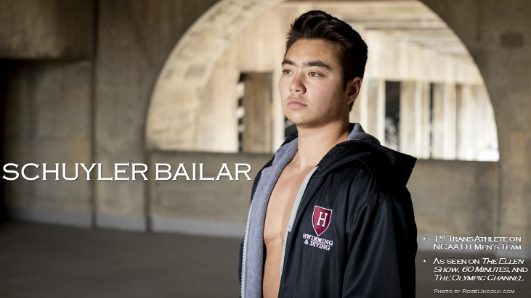
DATE: DATE
PLACE: LOCATION & ROOM
FULL ADDRESS
CONTACT: CONTACT email and phone

