Nourish Your Neighbors
Build Resilience
Easy to Join

As a food business owner, you know the important role that food plays in bringing people closer, and in a time of disaster that role is no different.
As a Food Responder, you have the security of reliable income during a time when your business could otherwise be impacted.
Off the Grid is motivated by our mission to support local small businesses and their communities through disaster.

Serve the community that has supported your business.
Provide critical nourishment- in more ways than one.
Build strong relationships with your community and customers.
Receive payment for each meal you deliver to your community during a disaster.
Continue employing your staff and making vendor purchases.
Recover more quickly after the emergency subsides.
Receive support completing paperwork and requirements.

Be trained on how to deploy meals based on your community’s needs.
Let Off the Grid handle the logistics -while you do what you do best!

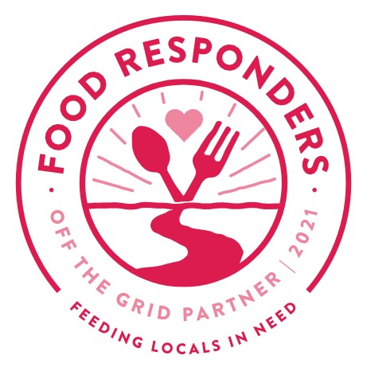
Apply to become a Food Responder in your community by visiting
Sign Up Here

GET PAID TO FEED YOUR COMMUNITY!
BECOME A FOOD RESPONDER
Off the Grid’s Food Responders program empowers restaurants and food service businesses to respond to local emergency needs and increase community resilience to disaster. By joining the Off the Grid network, you can be called upon in the event of an emergency to feed your community when they need it most.

