Many MeloProject in
Burkina Faso
Many Melo project in Burkina Faso

Thatis itWhat Many Mélo ??

Many Mélo eST A textile design project. This project aims to create a network ofsharing,of mixing, creation andCo-The textiles of different African countriesand seek to explore, reflect and redefine the vision that other developed countries have African. Among of theEs Countrychosen for the project,The Burkina Faso can be created, Senegal and Ghana who are different culture and civilization countries. These countries each have their own keymeans, dyes, brodles, sewing, etc.
Then the textile occupying a large place in these companies, Many Mélo is to facilitate the transaction, the exchange, the connection and the mixing of the different textiles of thesePeoples with the outside world.
Many Mélo is not only a textile project but also an idea ofrevolutionculturalatthrough the models of modes inAfrica.

What are the goals of <Many Melo >>:

- Valuating African identity in the rest of the world
- Create a sharing network
- Create a mix network
- Create a network of creation
- Facilitate the exchange
- Create creative ratio
- Create alternativesofinnovation
- Create a revolutionary union of textile industries
- Improve the living conditions of actors and employees in the textile sector.
- Fight against the misuse of textile andC.Hercer opportunities for the liquidation of African textiles.

What is the vision of << Many Melo >>:

Many Mélo is aimed at:
- to a unification in the world of textile
- an alliance between modernity and the traditional
- an alliancebetweenThe culture of Africa and that of other countries outside
- to break the barriers between the African dress and the outside world

What are the materials used by << Many MOEL >>:

Many Malo for its project uses:
- Faso Dan Fani: This is the textile symbolizing each community of Burkina through its color and pattern. It is the traditional pagan that lived with the beauty of the culture of a people. Our search withsome companiesWe have provided information needed on this textile.
So the Faso Dan Fani is a pronounced made ofs cotton and dcolors based on the complexionemail.It existsseveralsTypes of cotton queues and several types of dyes. Thedifferentfilescottondisponibare themBiological cotton, conventional cotton and the coYour crude. Also weretrouvonsThe natural dye made based on fruits, tree and bark leaves, iron surface and natural potash.And in the final the chemical dye made in factories.
We have several groups of Faso Dan Fani we can mention:
- The web: This is the first faith faith Fani called"The armor of the wecking". He is itt made at two pedalsand can only be woven on the big job. The canvas includes the pick, the gfrfrie, the IKT, and the drawing fabric.
- The cherid: It's a fabric made on a cradle with 4 pedals and possibility to do it on 2 pedals.
- The satin: It is also made on a craft and 4 pedals.
Wefor sale- It also reasonswhose tenuntounFor the Marka ethnicity, the Gangla Pelga and Gode for Mossis, Dan Fani Bwaba and Bobo, etc.
Note well:The pricestissuesdepend on the number of profession. That is to say thetissuesmade by the big trade are measured by meter(itThere are motions of 4000f / m, 5000f / m, etc.) and the fabric made by the small craft is measured inPagne (6000F, 7000F, 8000F, 10000F, 25000F)
The Fani fabric can be used to doshoes,bags,calendars,t-shirts,Take the sofas chairs, curtains, bed tissues, etc.
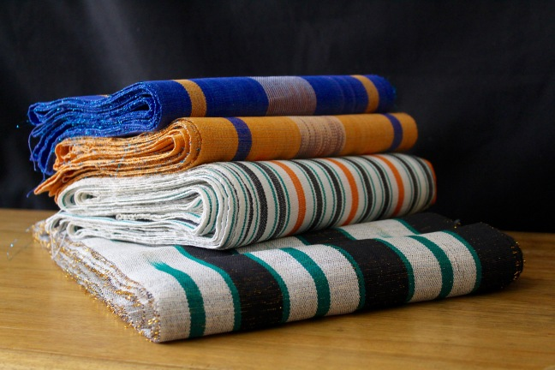
TissuesFaso Dan Fani
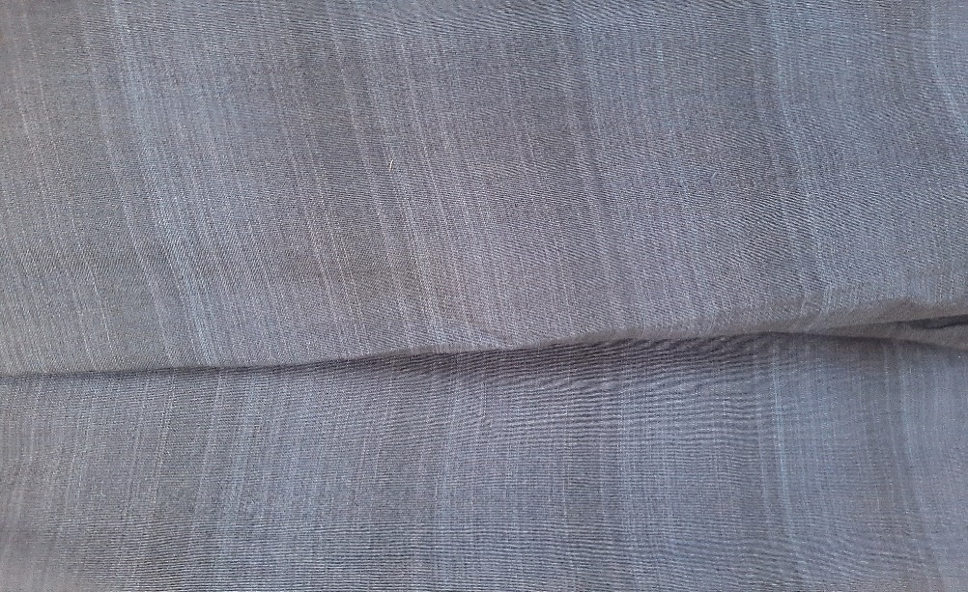
Indiango tissue pattern Dan Fani

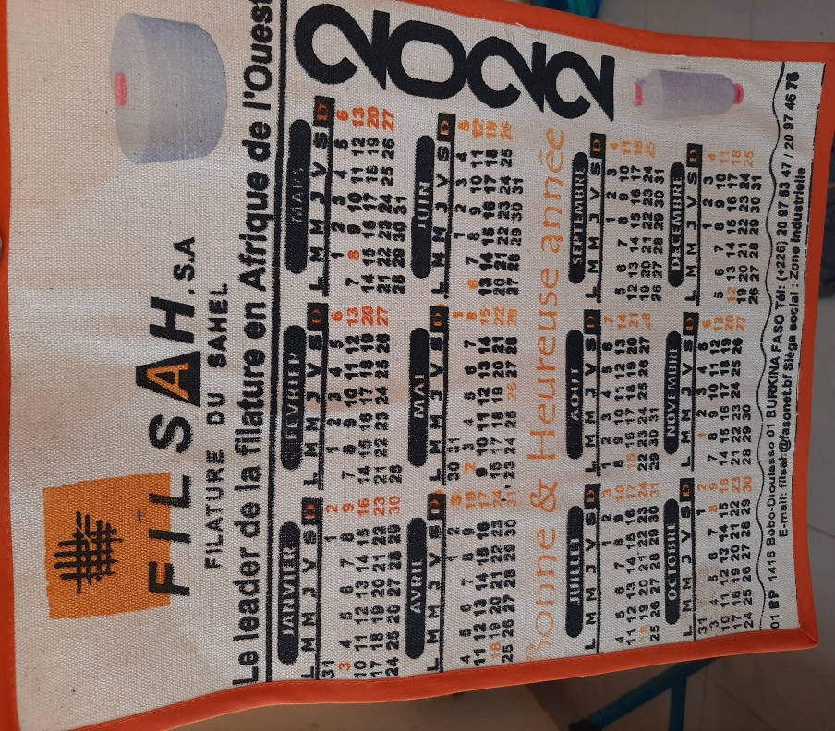
A fabric calendar Fani
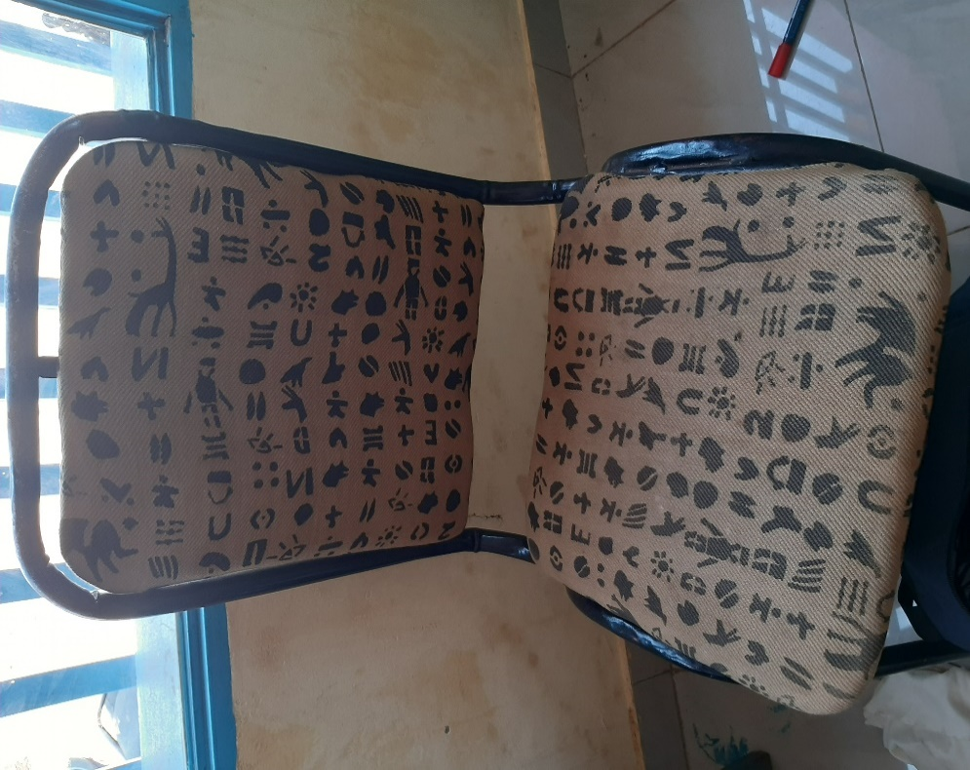
ADan Fani tissue chair
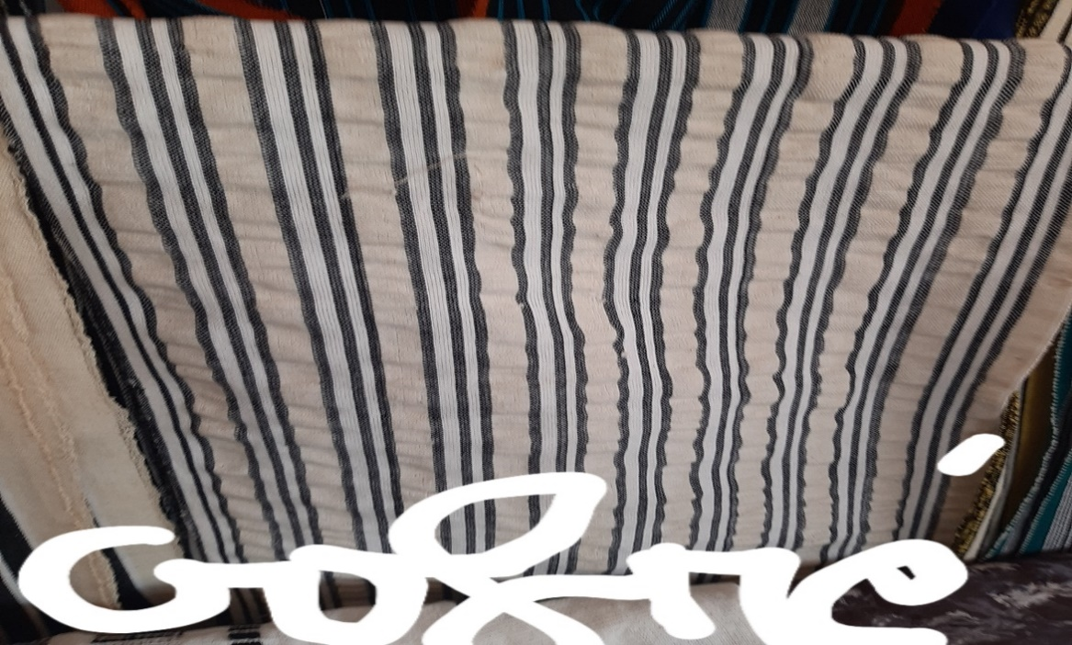
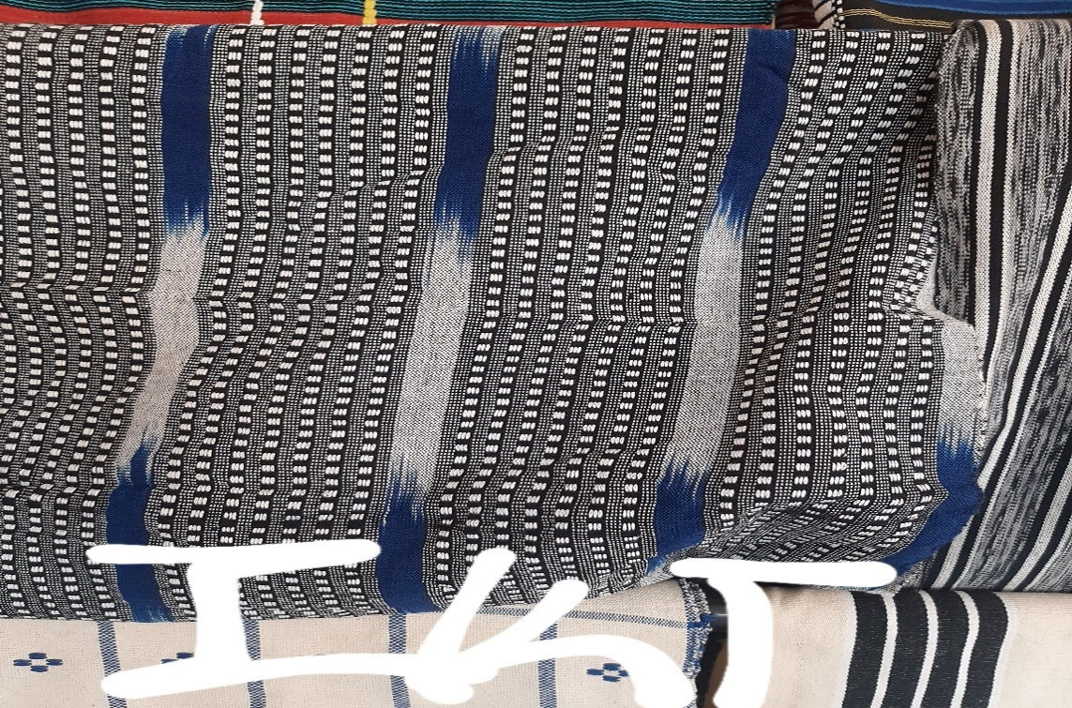
The GOFFER model and the IKT model
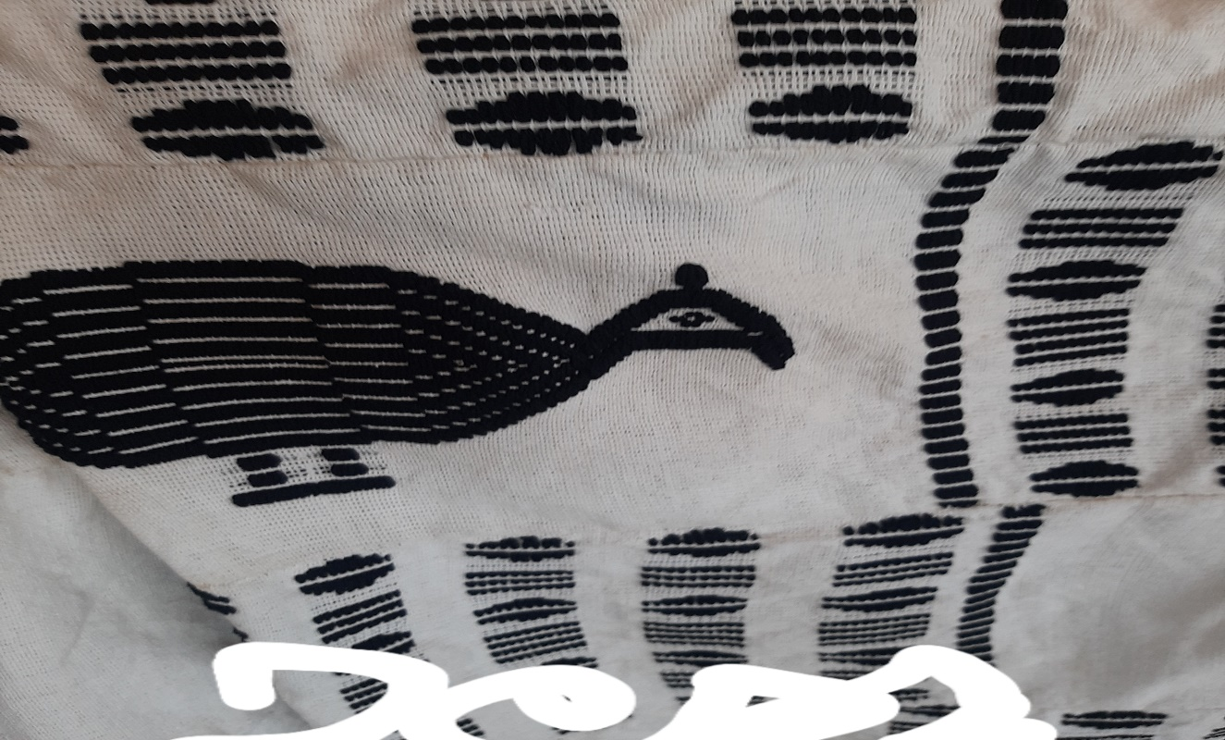
The Fan tissue drawing model Fani
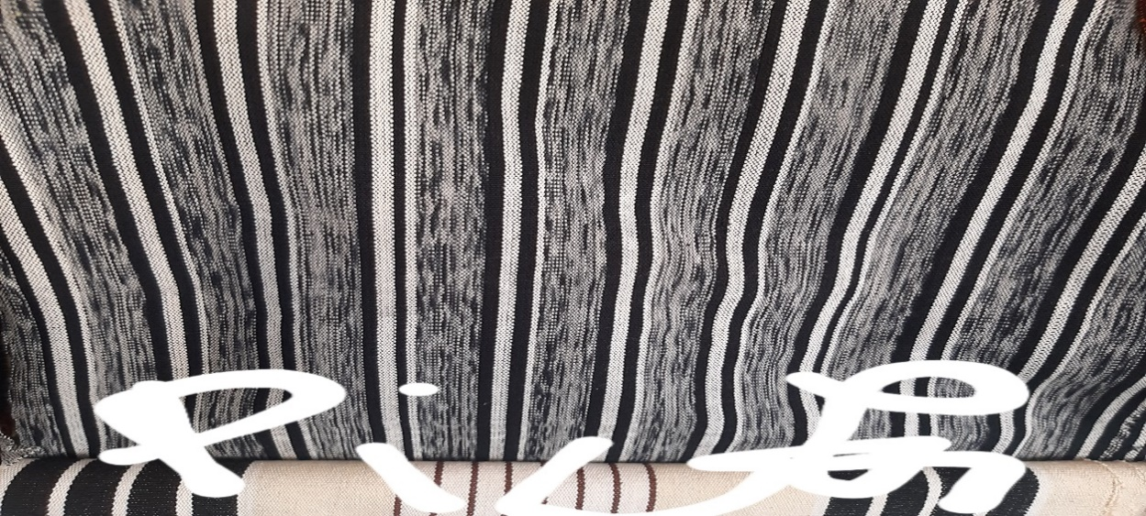
The Picking Model
A fewproceduresweaving:winding, the URDIssage,the cannance,The dyeingand drying, weaving andverificationof the finished product.
- The Bogolan: This is the most original tulbox textiles in Burkina. His reasons for drawings and colors magnify the values and symbols of peoplessahelian. In the past, they werewornthat by hunters, warriors and healers. Today he does the covenant between modernism and the traditional.
The basic material of this pagne is the coupon tissue which is an imported fabric and the Fani fabricThe more dye (wild grape, beamba, dgaged, bagana and candle, etc.)
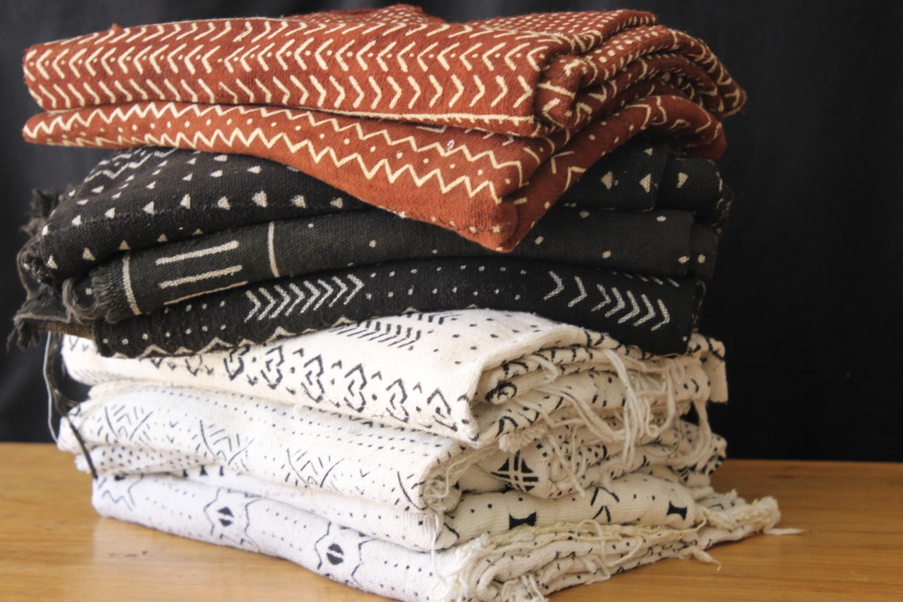
The Bogolan Model

- The Koko Donda: Formerly worn by the middle class, he was called "the pagan of the poor". For a few recent years in Burkina this whale occupies a large place in the world of fashion.Its basic material is also the imported coupon tissue and the Fani fabric plus the dye.
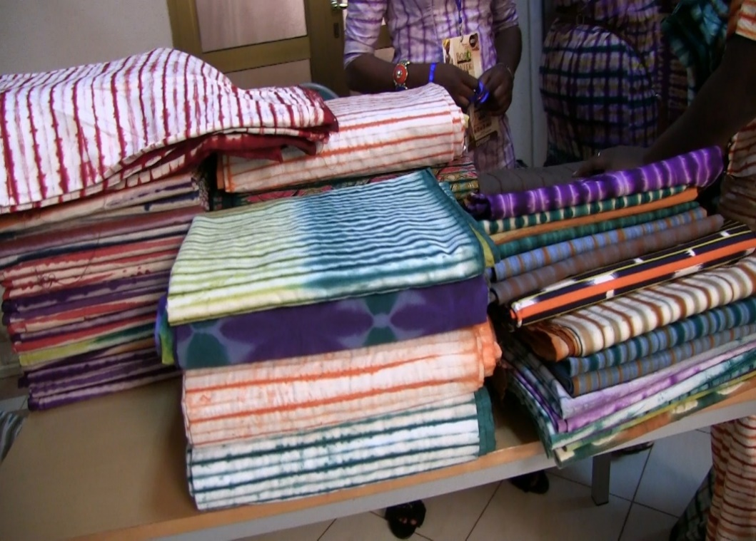
Koko Donda Reasons
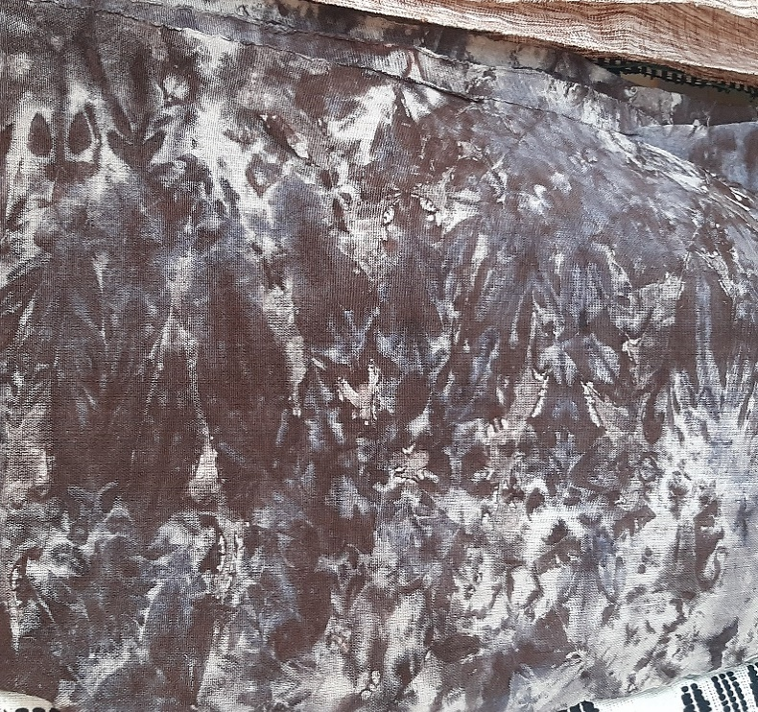
A mOTIF Koko Donda on Facial Dan Fani
They also exist other patterns such as the vertical or horizontal straight line, the Sancaba or cloud pattern, the SITI, the Bajardin attached and not attached, etc..
In addition to these textiles and patients in Murde in Burkina, they exist other reasons of other countries such as:
TheIndigo motifs of Guinea Conakry
The Wax calestages of Côte d'Ivoire
The dyes of Mali onGerman tissues(Basin)
Thewax, kento tissue, khagan fabric and kitengue.
Traditional pages of Ghana and Côte d'Ivoire

Which are the key players of "Many Melo":

Many Melo can have as key players:
-Wesent woven: TheytransformthePharmal textile fiberAnd many other things. We can quote:
- The Faso Textile Cooperative (Cofatex)toSector 24of Boboisaweaving unit that is the fruit ofAustrian cooperation with Burkina Faso under the tune of the United Nations Industrial Development Organization (UNIDO). It was created in March 2002 in Bobo and erected in cooperativesince2005. its objectives are partas part of strugglingagainst povertyby the creation ofjobDans the se theCantor of the artisanal transformation of theSot cock cottoncifiquement. Cofatex wants to accompagnting, valineing the potenhuman tiel,culturalandeconomicof its members in the training and themanufacturingoffabricsand fabrics. FortherebyShe is ambitioning to group, mobilize andorganizeThe artisans of the textile,to developAny cotton processing activities, creates jobs and improve the living conditions of its members.The weaving workshop has 18 loss of 04 pedals and has an estimated production capacity at 650 meter per month.
Finished products of CofatexClothing fabrics, house linens (bed shed, tablecloth,towel, etc..), furnishing fabrics (open-board chair, bed top)curtains, etc.).The dimensions of these tissues are "LAIZE: 100 to 150 centimeter", cutting length: 10 to 40 meters.In addition to the Faso Dan Fani motif, the cooperative collects Koko Donda motifs on Fani tissues.
The services and prospects rendered by COFATEX are the training in weaving, tincture training, continuous development, support counseling, spinning training and mixed seam.
For his team, it is made up of dynamic men and women and lend the challenge of the dress of the resident of African culture. Its target customers are the population, the stylists andThe rest of the world.
- The association DjiguitougouSize to the Bobo sector 21. She wascreatedIn sponsorship with the Humanitas Bobo Center of Slovenia.The seat of the association is within the center.The association makes clothing fabrics and for serviceWeaving training, dyeing training, spinning training and continuous development.It is represented in Slovenia by a shopping center that also exists in Burkina.The team is composed of women and professional men and beginners and more dynamic.Target customers are the population of Burkina and Slovenia. In addition to his Pasnes Faso Dan Fani, she presents the Pognes Bogolans and the Poks Koko Donda.
- Lingani's Centermeans: It's astructureof weavingWho exists since 2021Under the direction of two Lingani Orokia promoters and his mother. The structure works with four stylists, one for the making of the clothes, one for the shoes, one for the bags and the other for the t-shirts. She also works in collaboration with another Dani Nafa weaving association. The company also makes the Koko Donda fabrics. It is composed of a motivated and professional team.
-The TEINdoesuriers: TheycreateThe colors forThe fabrics. We can be cter Famous Cisse at Koko 10 Bobo Sector 10. She is a family business that specializes in the construction of Poks Koko Donda. His team is composed of family members and other stakeholders for more professionalism. Also we can cite the Cofatex, Lingani's designates and the association Djiguitougou.
-Lellists: They create the models with its tissues. We have aZelanda "Mixte Couture"to the sector 24 which is a young stylist structure that exists sinceEd2018. The purpose of the structure is to promoteThe identity of fashion in view of everyone through the valuation of African clothesin its creation.The companyis under the direction of a person whose stylist and is dividedemailin two sections including the clothing brand topicCreated in 2021whichis directed by two associates, the stylist for creation andtheTender making and aStudent in charge of customer research and liquidation of finished produc. TheAnother heading is the simple shape of sewing and training workshop that existed since the creation of the company directed by the stylist. It is composed of a dynamic and revolutionary team that are lending up the scales to achieve the goal.
Also we join Lingani's designates in this area.
In addition to these actors, we also have those who kick the wools, the nets and those who make embroidery by hand or machine.

Who are the target stakeholders of "Many Melo" in Burkina:

Many Mélo is for all of the company. Thus, we can mention:
- The artistic style that includes stone holders and off-stage
- The style of state and private staff servants
- The mechanical worker, metallic style
- The doctor, pharmacist and other style
- The housewife house or housekeeper
- The student style and student
- The person older person
- The Hostess & Girls Style
- etc.
All these styles participleENT THE PROJECT MEN MONE Project Revolution.

What are the strategies of approaches and communication of "Many Malo":

To promote its idea, Many Mélo develops strategies to facilitate its communication. For textile collectors, ONestablishesGeneral questionnaires and specific questionnaires. Also Many Malo works to get the trust of fashion actors and society. It focuses on quality.
For more visibility, Many Mélo organizes workshop activities with women and other fashion world players; photos and photos of the Modern games; color games; etc.
He also participates in organizations in citiessuchthat the fairs.

What are the impacts found by "Many Melo in Burkina":

Forces:
Many Malo facilitates communication between the world of fashion and society. He participates in the creation of employment, participates in the promotionand to improve the skillTextile companies.

Weaknesses:
There is difficulty reaching severalcountry, the proof problemand quality.

Some symbolic meanings of the colors:

Black:maturity,energy, spiritual
Blue: Peace, Harmony, Love
Green: Vegetation, Harvest, Growth, Spiritual Renewal
Pink: Associates with Woman, Essence of Life
Purple: Associated with femininity
Silver: Serenity, purity and joy
White:Purification, Sanctification
Gold:Royalty, Strong Status, Glory, Spiritual Purity
Yellow:Preciosis, Royalty, Health, Fertility.
Brown: Color of themotherland

