The Client : April 2021
This organisation was empowered to investigate, control and evaluate restrictive business practices, abuse of dominant positions and mergers in order to achieve equity and efficiency in the South African economy. There were 13 Exco members, who were also part of a broader Mancom team (40 participants. They were all Professionals: mostly Lawyers and Economists.

Situation: April 2021
The organisation had (like many others) faced turbulence, volatile change and uncertainty as a result of the impact of the pandemic on the economy. This in turn impacted people’s performance as well as team performance problems. Individuals interviewed, mentioned that they were ‘frazzled’ mentally and emotionally, suffering fatigue and were ‘on the verge of burnout’ !
The brief :  To address Personal Resilience | The Brief:  To address Organisational Reslience
- As a result Impact of COVID  - Family stresses  - Feeling of isolation (especially for young professionals who live alone, and are away from their family)  - Feelings of not “being seen and therefore not being “valued” , and as a result being “underutilised”  - Increased work load, lack of personal balance, increased time at one’s computer  - Emotional impact of the pandemic (personal loss and trauma)  - Challenges around job satisfaction and support of core staff vs. support staff  - Questions around growth opportunities / career progression | - Increased stress and pressure  - New work ‘cases,’ over-and-above usual work load / ‘cases’  - Concerns about working from home: and the resultant disruptiions  - Question of sustainability and impact in the wider community (especially in the context of a struggling economy), yet still need to demonstrate growth, and impact externally  - Talent Retention (interventions/programmes needed to retain, engage and grow staff)  - Need to ensure that the staff remain motivated in context of frozen/limited budgets (& no bonuses)  - Need to investigate whether the current policies and performance management processes are fit for purpose?  - Need clarity and to ‘relook’ efficiency and effectiveness of ‘team output’.

PROJECT GOALS :

- Need for a more ‘Empowering set up’…with ‘empowered, highly motivated and confident teams’.
- Teams should not be scared of leadership or feel ‘intimidated by the Leaders.
- Teams should not be afraid to take calculated risks to keep the momentum going on projects.
- The need to co-create a new culture, using a ‘bottom-up’ approach. This should ensure that staff are afforded the opportunity to give input.

The Project Solution to address these needs and achieve the goals.
The Project followed these steps:
Step One: Each of the 40 participants took the online Resilience Up™ Assessment.
Step Two: Various Mancom meetings ( 40 participants) as well as Exco meetings (13 participants) focusing on Personal Resilience
a) Debriefing the 5 Page Resilience Up™ Report (focussed on Individual resilience)
b) Working with in -tact teams: where individuals specified ‘which resilience tips and wellbeing bio-hacks ‘they were each going to use , and integrate into their lives.
Step Three: Various Mancom meetings (for 40 participants) focusing on Organisational Resilience using the Organisational Vital Signs™ Assessment. This assessed the 5 Drivers of the business.
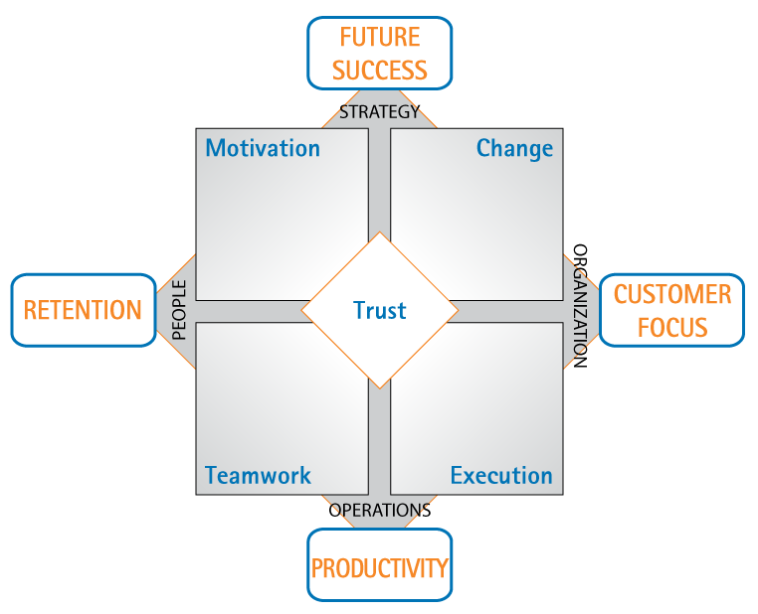
The Resilience Up™ Report (Pg 1) The Organisational Vital Signs Model
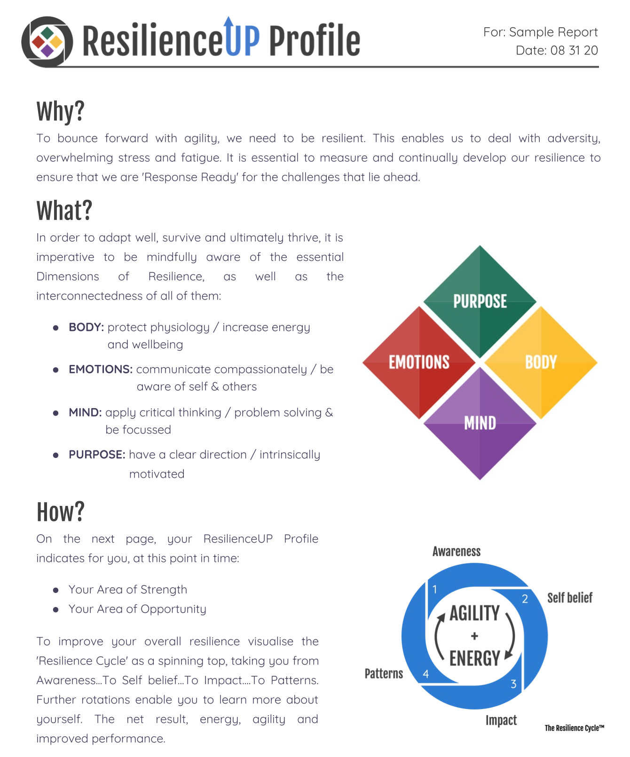

The Organisational Vital Signs Model

- The necessity to keep the employees Motivated;
- The ability to ensure that the employees are able to handle and embrace Change
- The necessity to keep the employees to work cohesively : Teamwork
- The necessity to keep the employees delivering operationally : Execution
- The necessity to ensure that there is a culture of TRUST amongst the employees.

The Results from The Resilience Up™ Assessment

The MANCOM’s area of strength is PURPOSE
- Easily able to connect daily choices with overarching sense of purpose
- Find ways to around issues / obstacles to keep future-focused

The MANCOM’s Area of Opportunity is MIND
- Look for ways to address lack of self-motivation
- Take time to think through unintended consequences of decisions / different perspectives that may be beneficial

MANCOM’s 8 Performance Indicator Results
- Decision-Making – 13.47
- Health – 13.22
- Achievement – 13.06
- Community – 12.52
- Satisfaction – 12.31
- Influence – 12.31
- Balance – 11.81
- Networking – 11.2
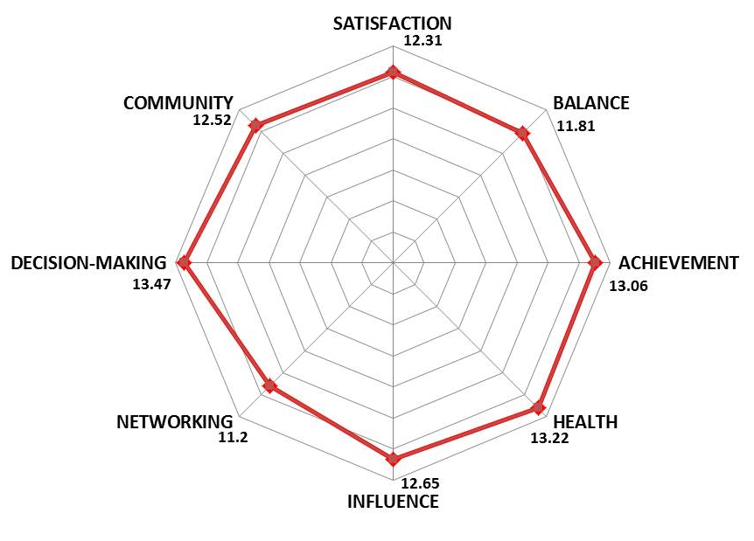

The EXCO’s area of strength is PURPOSE
- Easily able to connect daily choices with overarching sense of purpose
- Find ways to around issues / obstacles to keep future-focused

The EXCO’s Area of Opportunity is BODY
- The health drivers of how to improve eating healthy food (to fuel your brain); sleeping at least 7 hours per night (consistently) and ‘moving’ / exercising at least 30 mins per day (consistently… even if it is 10mins in the morning; 10mins at lunchtime and 10 mins at the end of the day)
- Digital fatigue (10-12 hours of screen time per day) and the negative impact on the brain is now well researched.
Note:
The results for Exco show really good ‘balance’ across all 4 dimensions of resilience, with less than 3 percentage points difference between the highest and lowest dimension. The High ‘PURPOSE’ score is unusual and not often seen in Organisational Resilience. This is an indicator of tremendous commitment, focus and a sense of being intrinsically motivated to work hard for ‘the greater good’.

EXCO’s 8 Performance Indicator Results
- Decision-Making – 14.25
- Health – 13.75
- Achievement – 13.25
- Influence – 13.75
- Satisfaction – 11.87
- Community – 11.5
- Networking – 11.12
- Balance – 10.87

Note :
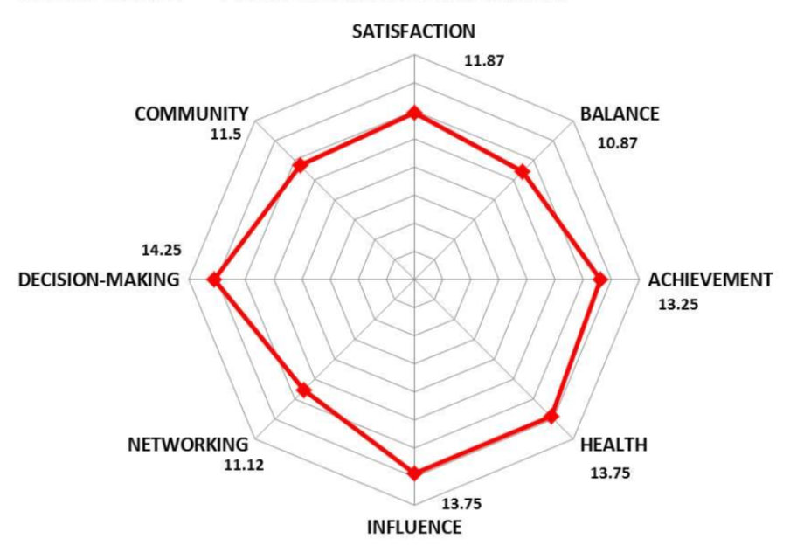
The results for Exco show fairly good balance across all 8 Performance Indicators, except for Networking, Community and Balance. This is often as a result of work volume, and extensive work hours, affecting and having a negative impact on digital fatigue
a)the time to ‘network (a crucial business enabler);
b) WFM (Working From Home) inhibiting team cohesion and interpersonal relationships at work , as well as the long work hours affecting home relationships
c) the ‘low’ Balance is not only work / home life balance, but also the inability (time –wise and/ or as a result of COVID) to activate and ‘enjoy’ hobbies, sports, travel etc.

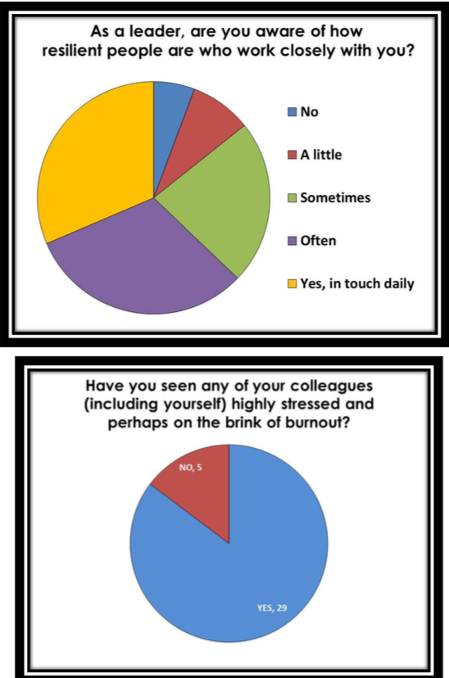
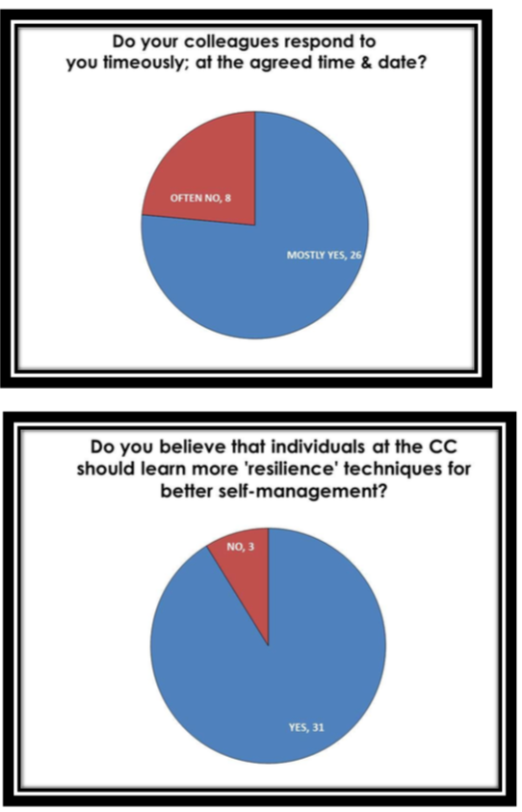
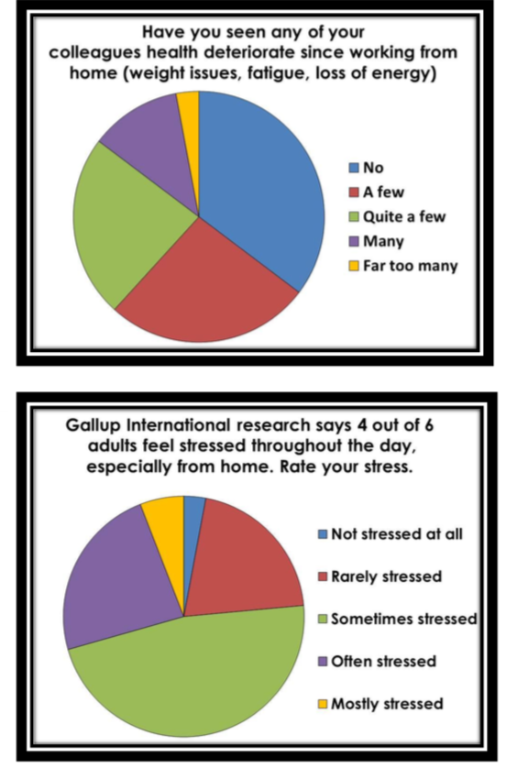
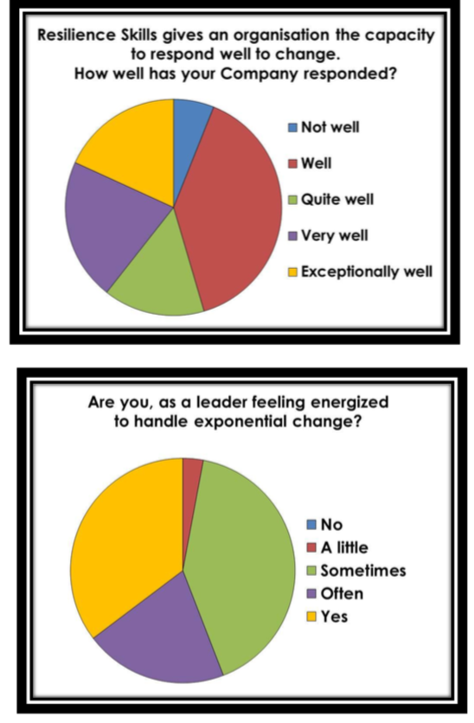
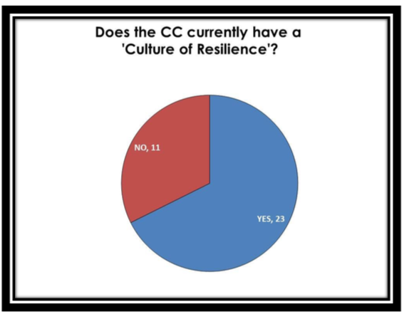
The Results from The Organisational Vital Signs™ Assessment

