St Aidan’s Anglican Church and Community Centre 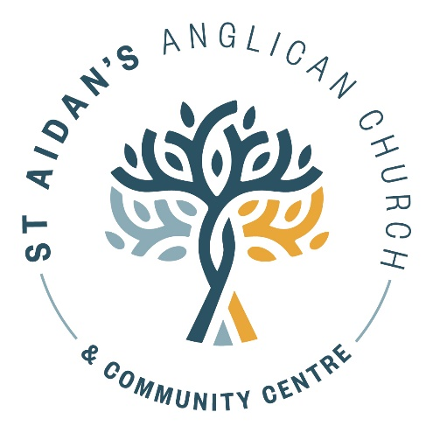

Children and Families worker role (15 hours per week) for 2023.

We are excited at St Aidan’s to be able to offer this new role to support a diverse and inclusive community of faith who welcome people from all walks of life.

St Aidan’s church seeks a creative and relational Children and Families worker. This person must be able to connect and engage with people from St Aidan’s Church and the wider Bryndwr community. Our hope is that they will resource and support the faith development of tamariki and whānau in the parish, as well as develop new opportunities to connect with the local community.

To request a job description email or phone our parish office.

We are looking to find someone to start as soon as possible. Please provide your current cv and a cover letter by email to Rev Jacqui Stevenson by 20th April.

staidans.bryndwr@gmail.com (03) 351 8075

