PANA - A Critique on Sending Irish Defence Forces to Mali
14/1/2019
Irish media reports; Taoiseach Leo Varadkar made his first stop off in Mali where he visited the EU Training Mission to Mali (EUTM), and members of the Irish Defence Forces serving with the mission. The EUTM was founded in 2013 in response to an attempt by rebels to annex the northern part of the country and declare it an independent state. Mali is one of the poorest countries in the world and is prone to Islamist extremism. Mali is one of a number of countries from the Sahel region, the others being Burkina Faso, Chad, Mauritania, and Niger, which the EU are seeking to stabilise as a lot of migrants seek to enter Europe come from those countries.
The Irish media portrayed Taoiseach Leo Varadkar’s recent trip to Africa as a royal tour, a chance to greet the troops, a promise to send yet more Irish Forces under an EU flag, with no analysis on the conflict in Mali or that facing Ethiopia.
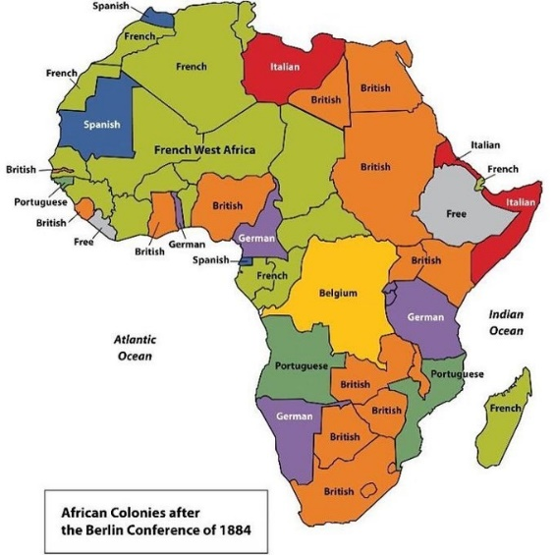
In 1884 the leaders of fourteen great powers in Europe, together with the United States, gathered at the Berlin Conference to decide how all of Africa’s vast resources and land would be divided. Portugal started this scramble for Africa back in the 15th Century, and after 600 years of slaughter and genocide, from the American slave trade to the concentration camps in German South West Africa (Namibia)…best explained by that noble explorer David Livingstone, we put down those natives who got in the way of the three Cs, Christianity, civilisation and commerce. Today little has change on this vast continent as many of these same great powers scramble for even greater resources,
European attitudes to colonisation are maintained through the glorification of imperialist wars, with monuments to their fallen heroes like Lord Kitchener and Cecil Rhodes in London, and within a ten minute walk of the EU Parliament in Brussels you can see an imperial monument to King Leopold II also referred to as the ‘Butcher of the Congo’, who slaughtered over ten million natives on his rubber plantations to ensure a steady supply of produce for the developing US automotive industry.
According to international experts, in 2000 Mali was in position to become the living model of a west-African democracy, instead, 12 years later, it fell into chaos. The Libyan "blowback" took the form of an influx of Libyan weapons and the return of Tuaregs who had formerly fought with Muammar Gaddafi. Those weapons and the presence of seasoned fighters tipped the balance. The Tuareg MNLA and Islamist Ansar Dine rebel groups merged, swept aside government troops and declared northern Mali to be an Islamic state. Ansar Dine began imposing Islamic law in Timbuktu and Al-Qaeda in North Africa endorsed the deal.
A French army intervention in 2013 failed to crush this rebellion and they quickly decided to hand over responsibility for security in the north to the Minusma UN force.
Since 2013 more than 400,000 people have become refugees or internally displaced, and over one hundred peacekeepers have died in Mali, making it one of the deadliest places to serve for the UN.
Historically the French had a major influence on this western or Sahel region, employing the usual imperialist divide and rule tactic, a major cause of ethnic anger today.
The Tuareg are a nomadic farming people spread across this region, alienated from central government they gradually evolved in Mali as nationalist rebels. Like other minorities in this region that have been stigmatised and marginalised leading to increased militancy and radicalisation.
Militancy across North Africa, particularly in Mali, Algeria, Libya, Niger and Mauritania has long been linked to local grievances, poverty and negligible governance in the region, with numerous armed groups splintering, shifting goals, colluding and contesting against each other for dominance in the booming drug/human trafficking, banditry and ransom trade.
The US is propping up tyrannies, financing and training their military, supporting repressive measures against revolting citizens, and this includes peaceful demonstrations, and this is driving more Africans to join terror groups. Between 2011 and early 2016, some 33,000 people in Africa lost their lives to violent extremism.
According to UNDP Report 2017, Journey to Extremism in Africa; it is social, economic, and cultural identity factors alongside alienation from corrupt governments and military repression that are recruiting people to extremist groups. This study included interviews with former members at different levels of rank in two of the continent’s primary violent extremist groups, namely Boko Haram and Al-Shabaab, as well as African recruits to ISIL.
Introducing this report António Guterres United Nations Secretary-General stated;
‘I am convinced that the creation of open, equitable, inclusive and pluralist societies, based on the full respect of human rights and with economic opportunities for all, represents the most tangible and meaningful alternative to violent extremism.’

It has been reported that France is worried that the conflict in Mali may become a launching pad for terrorist attacks on Europe, but possibly more upsetting that it could further destabilise the Sahel region, including neighbouring Niger, France's main source of uranium for its massive nuclear industry. Niger has allowed the US to deploy drones to police the difficult vast desert terrain. The US used a corrupt dictator in acquiring rubber from the Congo Free State, today they continue with similar tactics to ensure a necessary supply of minerals from the DR Congo, with their vast reserves of copper, cobalt and coltan for their electronics industries. This strategy has led to conflicts in neighbouring Rwanda, Uganda and Burundi. Other nations like Nigeria and Chad have a growing Islamist threat from Boko Haram. There is increasing ethnic conflict in South Sudan whilst last month the now pro-western Bashir government here had their security forces kill over 50 peaceful demonstrators as they marched against corruption and IMF imposed austerity cutbacks. Al-Bashir is still wanted by the ICC for genocide.
China has completed a $3.4 billion railway linking Addis Ababa with the important port of Djibouti on the Red Sea. Camp Lemonnier is a major US military drone base in Djibouti, from which most drone strikes on Yemen and Somalia are carried out. Ethiopia has a long history of resisting imperialism, so hopefully their new Prime Minister Abiy Ahmed can maintain peace and stability amongst all the warring factions in this region.

PANA is concerned that Irish Defence Forces (Ranger Wing) are been drawn into a conflict that is the result of European colonial interference in Africa, and this ongoing scramble for African resources is escalating these conflicts.
Under the guise of the 2011 Arab Spring uprisings the US/NATO led an ‘illegal’ invasion that destroyed Libya with the full support of our EU partners France, UK and Italy. This is a major factor in the spread of Jihadist terrorists; are we just being used to mop up their mess.
Taoiseach Leo Varadkar has developed a grand alliance with President Emmanuel Macron, so is this all about gaining a seat on the UN Security Council or are they building support for an EU army. Why is the Irish army part of an EU training mission rather than working with UN peacekeepers and alongside the African Union?
It must be remembered that during President Barack Obama’s period in office the number of US military bases under Africa Command increased from three to eighty-four. Is the militarisation of Africa reducing terrorism, criminality, inequality, poverty, mass migration and corrupt governments?
Hopefully this analysis will encourage more debate amongst our supporters and those Oireachtas and EU Parliament representatives who support Peace and Neutrality and see the danger of ever-increasing militarism and exploitation in Africa

Looking forward to hearing your opinion on this analysis of foreign policy.
Best Wishes,
Tom Crilly,
Communications,
Peace and Neutrality Alliance PANA,
Tel 0035387 2937558

References;

EU Defence Fund for 2021–27 has plans to pour €13 billion into the arms industry from the EU budget…http://people.ie/news/PN-189.pdf
Glackin, Eddie, 2015, The Bloody Trail of Imperialism, The Origins of the First World War, CPI…available from Connolly Books Dublin
Global Campaign Against US/NATO Military Bases, https://noforeignbases.org/
Irish Times, https://www.irishtimes.com/news/politics/oireachtas/irish-troops-may-go-to-mali-to-replace-french-coveney-tells-d%C3%A1il-1.2442049
Mali Crisis, Tuareg Rebels, Algeria hostages,
https://mrunal.org/2013/01/diplomacy-mali-crisis-taureg-rebels-french-troops-algeria-hostages-background-implications-explained.html
Peace and Neutrality Alliance PANA, https://www.pana.ie
Sensini, Paolo; Sowing Chaos, Libya in the Wake of Humanitarian Intervention…available from Connolly Books Dublin
Terror in Britain; What Did the Prime Minister Know? by John Pilger, Global Research, 31/5/2017…https://www.globalresearch.ca/
World Beyond War, https://worldbeyondwar.org/

Rev. Fletcher Harper of GreenFaith, https://therealnews.com/stories/bfletcher1024africa

Patrice Lumumba was prime minister of a newly independent Congo for only seven months between 1960 and 1961 before he was murdered, fifty-six years ago today. He was thirty-six.
The Belgians reluctantly conceded political independence to the Congolese, and two years later, following a decisive win for the Congolese National Movement in the first democratic elections, Lumumba found himself elected to prime minister and with the right to form a government.
The CIA had tried to poison him, but eventually settled on local politicians (and Belgian killers) to do the job. He was captured by Mobutu’s mutinous army and flown to the secessionist province of Katanga, where he was tortured, shot, and killed.
Lumumba would not have been surprised that his successor, Joseph Mobuto was the US strategic ally in Africa for 30 years. Congo was too rich, too big, and too important for the west to lose control as they would have had Lumumba lived.
How ironic that Mobuto was succeeded by Laurent Desire Kabila, whose 10th anniversary of assassination, by his own guards, falls just one day before Lumumba's? (There are conflicting reports as to the exact date of Kabila's death).
Kabila came to power in 1997 as the useful figurehead of the armies of Rwanda, Uganda, and Angola. He trailed some historical legitimacy from his involvement in one of the rebellions against Mobuto, inspired by Lumumba's death.

