Blessing of Journalists | Christ Church Cathedral
February 20, 2019, 12:00 p.m. On the Commemoration of Frederick Douglass, 1811-1895
Orator and Advocate for Truth and Justice; Editor of pro-abolition journal, North Star

Cathedral Welcome, The Reverend Linda Taupier

Please stand as you are able

Hymn No. 607, O God of Every Nation
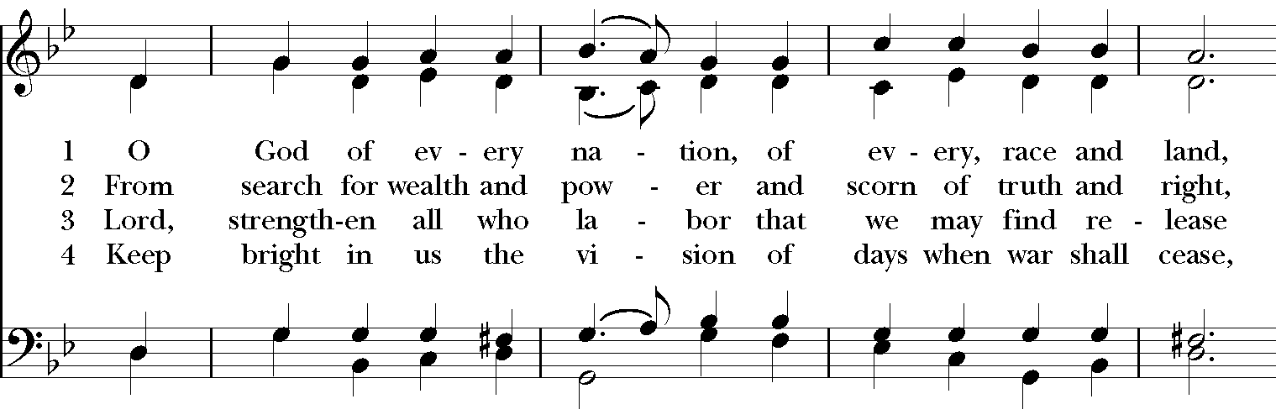
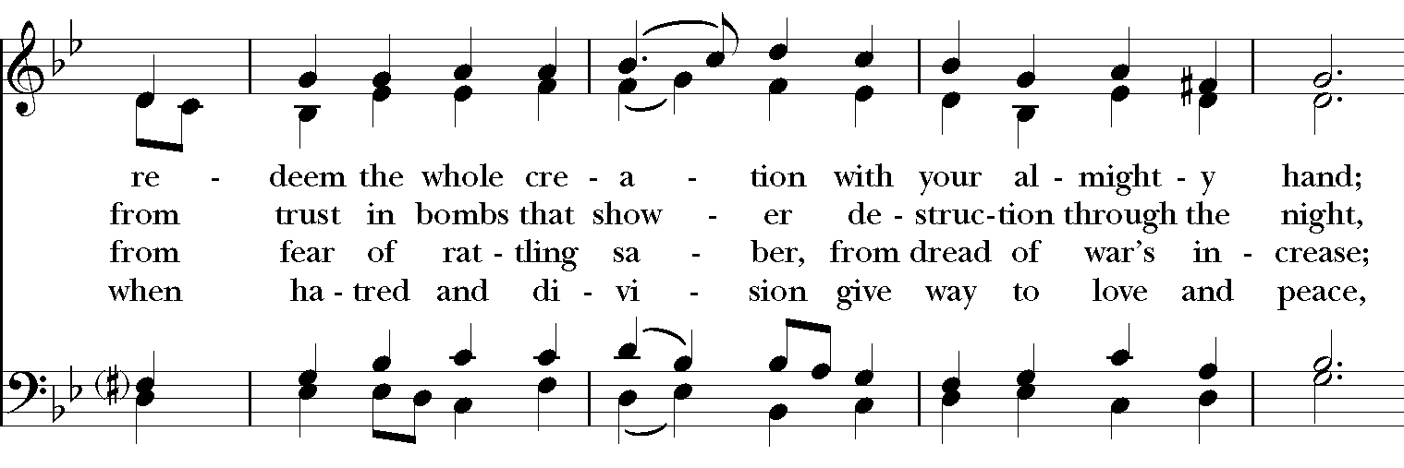
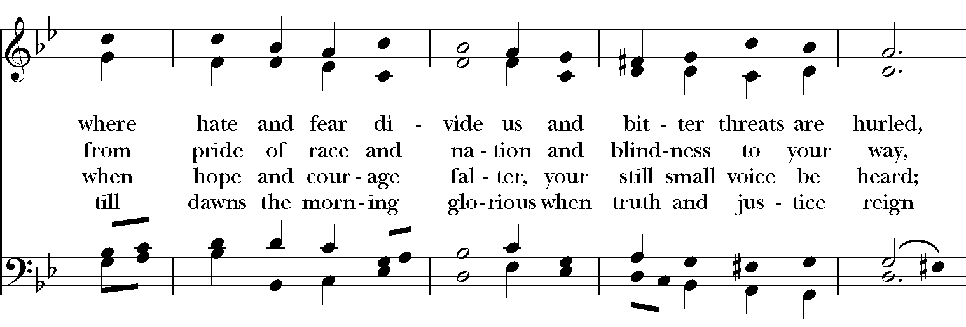
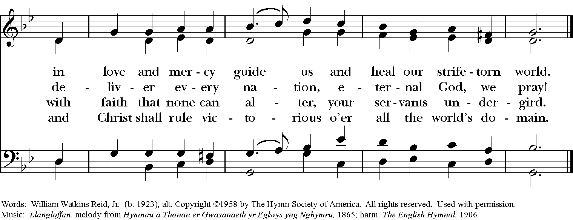

A Reading from the Prophet Micah (Micah 6:1-8), Rabbi Mark Shapiro

Hear what the Lord says: Rise, plead your case before the mountains, and let the hills hear your voice. Hear, you mountains, the controversy of the Lord, and you enduring foundations of the earth; for the Lord has a controversy with his people, and he will contend with Israel. ‘O my people, what have I done to you? In what have I wearied you? Answer me! For I brought you up from the land of Egypt, and redeemed you from the house of slavery; and I sent before you Moses, Aaron, and Miriam. O my people, remember now what King Balak of Moab devised, what Balaam son of Beor answered him, and what happened from Shittim to Gilgal, that you may know the saving acts of the Lord.’

‘With what shall I come before the Lord, and bow myself before God on high? Shall I come before him with burnt-offerings, with calves a year old? Will the Lord be pleased with thousands of rams, with tens of thousands of rivers of oil? Shall I give my firstborn for my transgression, the fruit of my body for the sin of my soul?’ He has told you, O mortal, what is good; and what does the Lord require of you but to do justice, and to love kindness, and to walk humbly with your God?

Response (Psalm 15) (Said in unison)
¹ O Lord, who may abide in your tent?
Who may dwell on your holy hill?
² Those who walk blamelessly, and do what is right,
and speak the truth from their heart;
³ who do not slander with their tongue,
and do no evil to their friends,
nor take up a reproach against their neighbors;
⁴ in whose eyes the wicked are despised, but who honor those who fear the Lord;
who stand by their oath even to their hurt;
⁵ who do not lend money at interest,
and do not take a bribe against the innocent.
Those who do these things shall never be moved.

A Reading from the Constitution of the United States of America 1789,

Jacqueline Galvinhill

Amendment I: Congress shall make no law respecting an establishment of religion, or prohibiting the free exercise thereof; or abridging the freedom of speech, or of the press; or the right of the people peaceably to assemble, and to petition the government for a redress of grievances.

A Reading from Habakkuk (Habakkuk 2:2), Pastor Lauren Holm
Then the LORD answered me and said: Write the vision; make it plain on tablets, so that a runner may read it.”

A Reading from Pope Francis, Pastor Lauren Holm
Excerpt from MESSAGE OF HIS HOLINESS POPE FRANCIS FOR WORLD COMMUNICATIONS DAY -- January 24, 2018
“Informing others means forming others; it means being in touch with people’s lives. That is why ensuring the accuracy of sources and protecting communication are real means of promoting goodness, generating trust, and opening the way to communion and peace.

I would like, then, to invite everyone to promote a journalism of peace. By that, I do not mean the saccharine kind of journalism that refuses to acknowledge the existence of serious problems or smacks of sentimentalism. On the contrary, I mean a journalism that is truthful and opposed to falsehoods, rhetorical slogans, and sensational headlines. A journalism created by people for people, one that is at the service of all, especially those – and they are the majority in our world – who have no voice.”

Hymn No. 593, Lord, make us servants of your peace
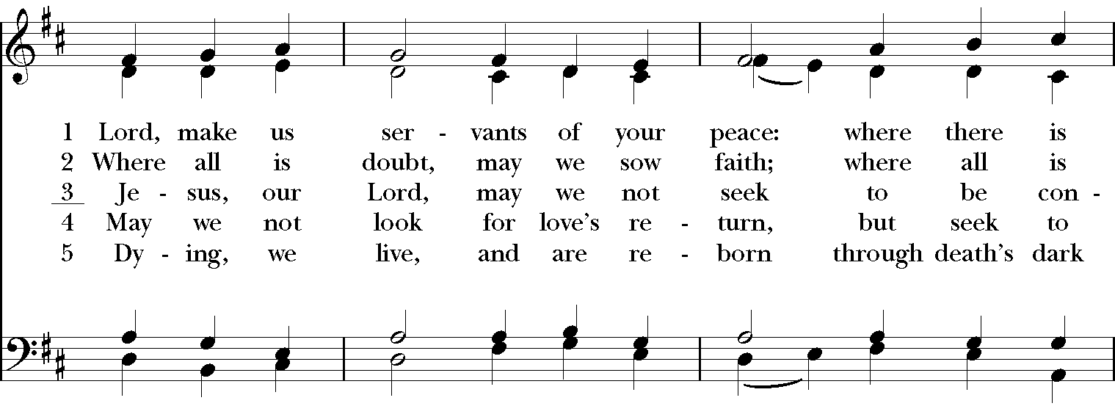
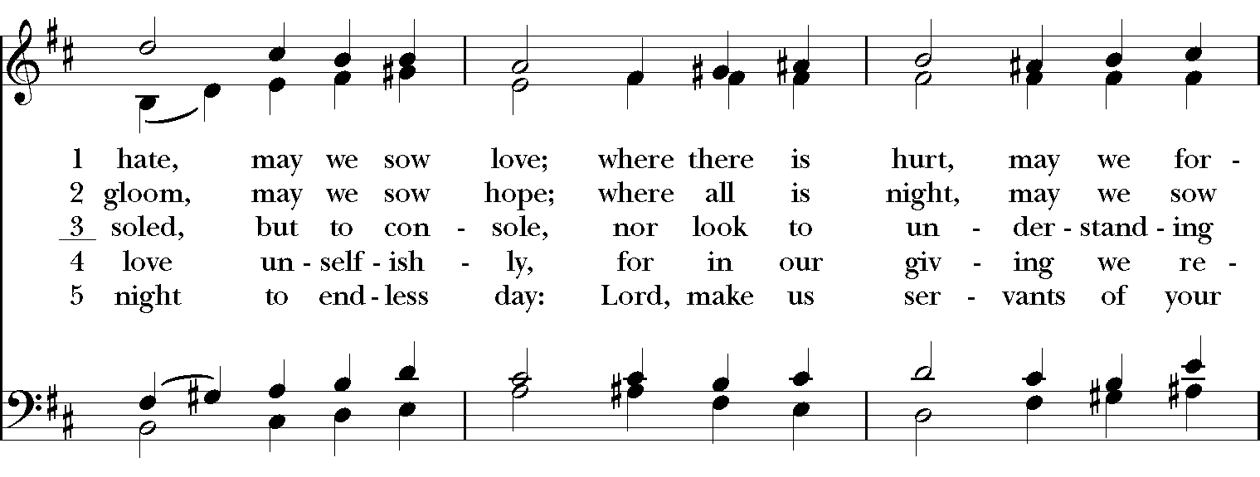
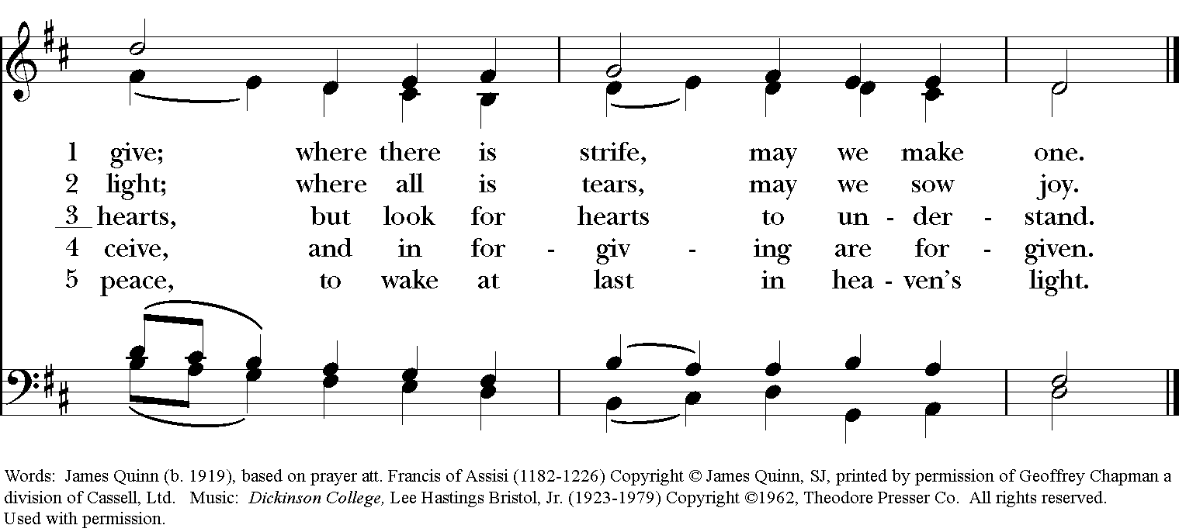
A Reading from Frederick Douglass, June Watson
“If there is no struggle, there is no progress. Those who profess to favor freedom, and yet depreciate agitation, are men who want crops without plowing up the ground. They want rain without thunder and lightning. They want the ocean without the awful roar of its many waters. This struggle may be a moral one; or it may be a physical one; or it may be both moral and physical; but it must be a struggle. Power concedes nothing without a demand. It never did and it never will.”

A Reading from The Gospel According to John (John 8:30-32), The Reverend Linda Taupier

So Jesus said to those who believed in him, “If you obey my teaching, you are really my disciples; you will know the truth, and the truth will set you free.”

Reflection, Ambassador Mark Hambly

Musical Meditation: Largo, from Sonata in C Major J. S. Bach (1685-1750)
Amanda Stenroos, violin

Presentation of the Bishop’s Award To Journalist Carrie Saldo
The Right Reverend Douglas Fisher, Bishop Diocese of Western Massachusetts

Prayers of the People, The Reverend Victoria Ix
We pray, in this changing era of journalism, for those from the various forms of media who fulfill the sacred trust of reporting on the lives and events of this world. In your mercy,
People: Hear our prayer.

We remember especially those who are pressured by their government, those who are threatened and silenced, those who are put in harm’s way by their work, and those who have lost their lives throughout the world reporting on the news. In your mercy,
People: Hear our prayer.

We remember those whose news has been labeled “Fake,” and whose stories and reporting have been dismissed and belittled. In your mercy,
People: Hear our prayer.

We pray for those whose truth is not valued and whose voices are not free. In your mercy,
People: Hear our prayer.

In particular, we pray for men and women who are newspaper journalists, whose words grace the pages of our lives. In your mercy,
People: Hear our prayer.

We pray for television reporters and journalists, those appearing on camera and those working behind the scenes. In your mercy,
People: Hear our prayer.

We pray for radio journalists, whose voices carry the weight of events from near and far. In your mercy,
People: Hear our prayer.

And we pray for journalists working through the internet, exploring the truth of the media in a new way. In your mercy,
People: Hear our prayer.

We pray for the members of the White House Press Corps, whose work is so central to the functioning of our democracy. We pray for their persistence and dedication to the truth and their commitment to an impartial and free press. In your mercy,
People: Hear our prayer.

And we pray for civility in our public discourse, for our ability to rise above surface differences and set aside personal agendas and bias, and we ask for God’s grace to seek the undivided truth – that truth has nothing to fear, that all will be revealed in the light, and that every story is a story of God’s creation, worthy of being shared. In your mercy,
People: Hear our prayer.

We offer before you now the following journalists for whom prayer has been requested, asking for the blessing of the Divine One, who is light and life, to be upon them at this time and to remain upon them always. (Names are read).

At the conclusion of the names, the Bishop says the following collect:
O God, you made us in your own image and redeemed us through Jesus your Son: Look with compassion on the whole human family; take away the arrogance and hatred which infect our hearts; break down the walls that separate us; unite us in bonds of love; and work through our struggle and confusion to accomplish your purposes on earth; that, in your good time, all nations and races may serve you in harmony around your heavenly throne; through Jesus Christ our Lord. Amen.

Bishop’s Blessing for Journalists
Adapted from Prayer for Journalists by St. Francis de Sales, patron saint of writers and journalists
Please stand as able.

Bishop: Almighty God,
Strengthen and direct, we pray, the will of all whose work it is to write what many read,
and to speak where many listen.
Assembly: May we be bold to confront evil and injustice:
May we be understanding and compassionate of human weakness;
May we reject the half-truth which deceives, and the slanted word which corrupts.
Journalists: May the power which is ours, for good or ill, always be used
with honesty and courage, with respect and integrity, so that when all here has been written, said and done, we may, unashamed, meet God face to face.

Bishop: And may the blessing of God Almighty be upon you and remain with you forever. Amen.

Recessional Hymn, No. 594, God of Grace and God of Glory

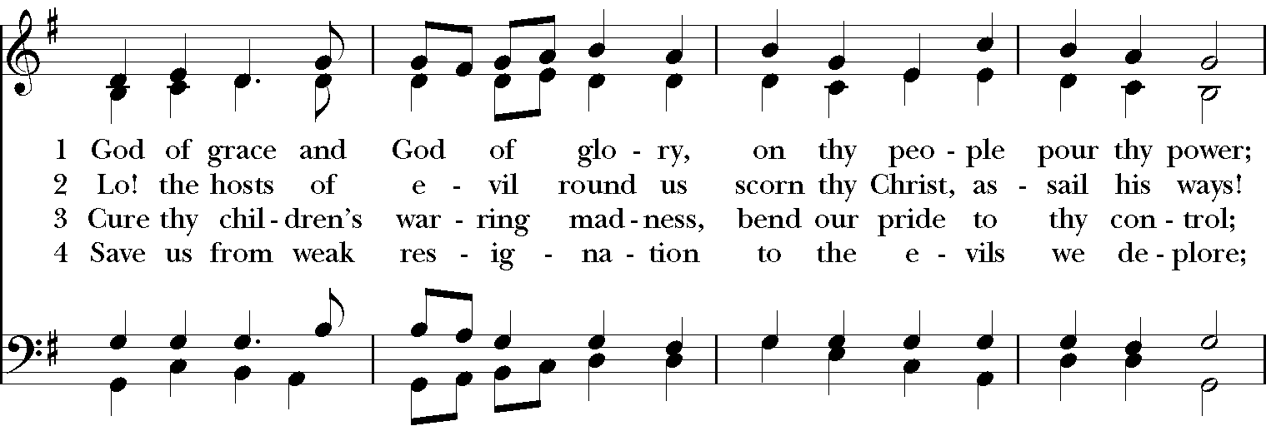
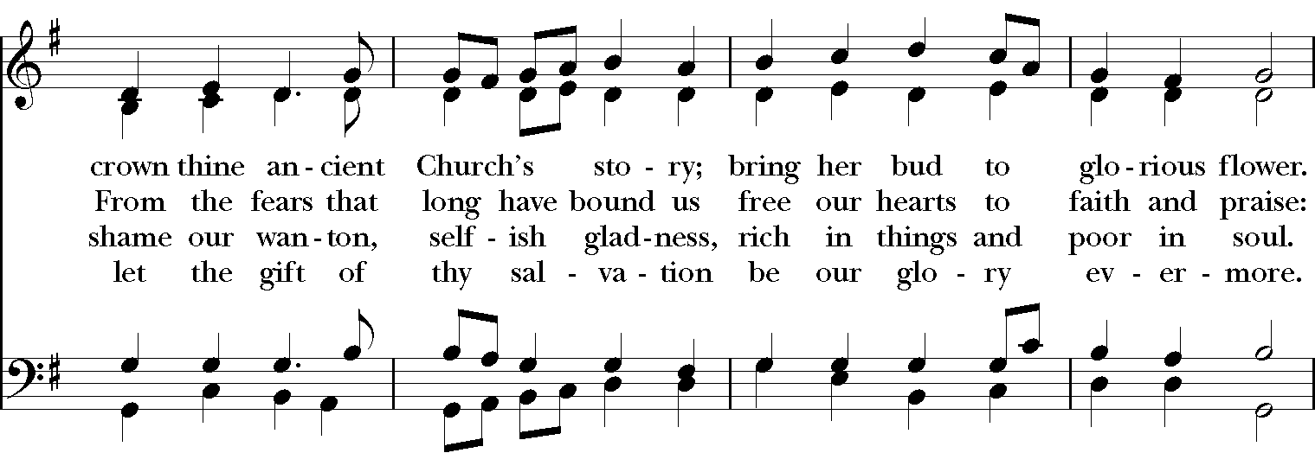
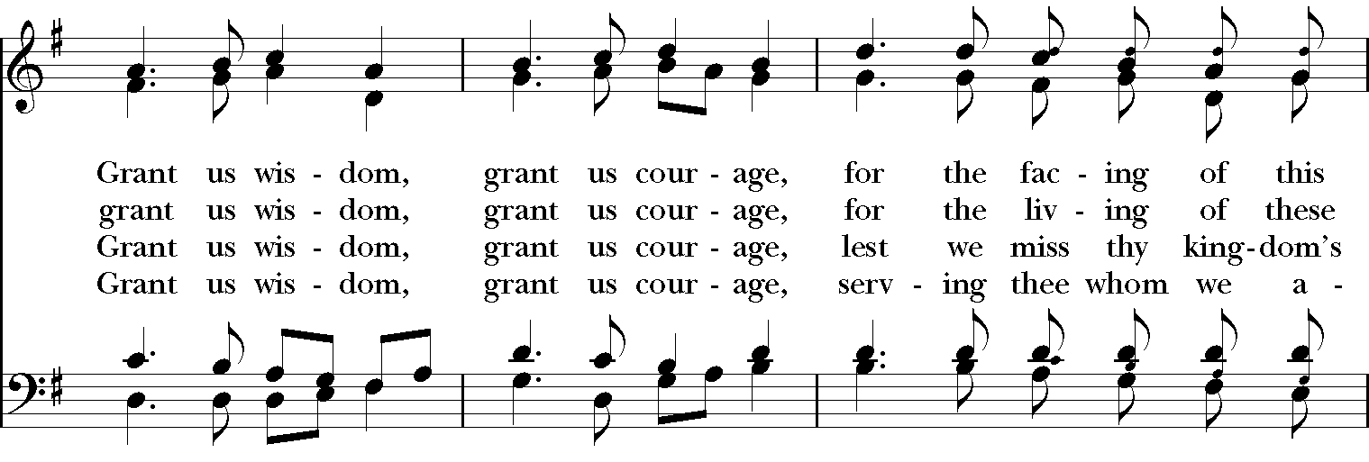
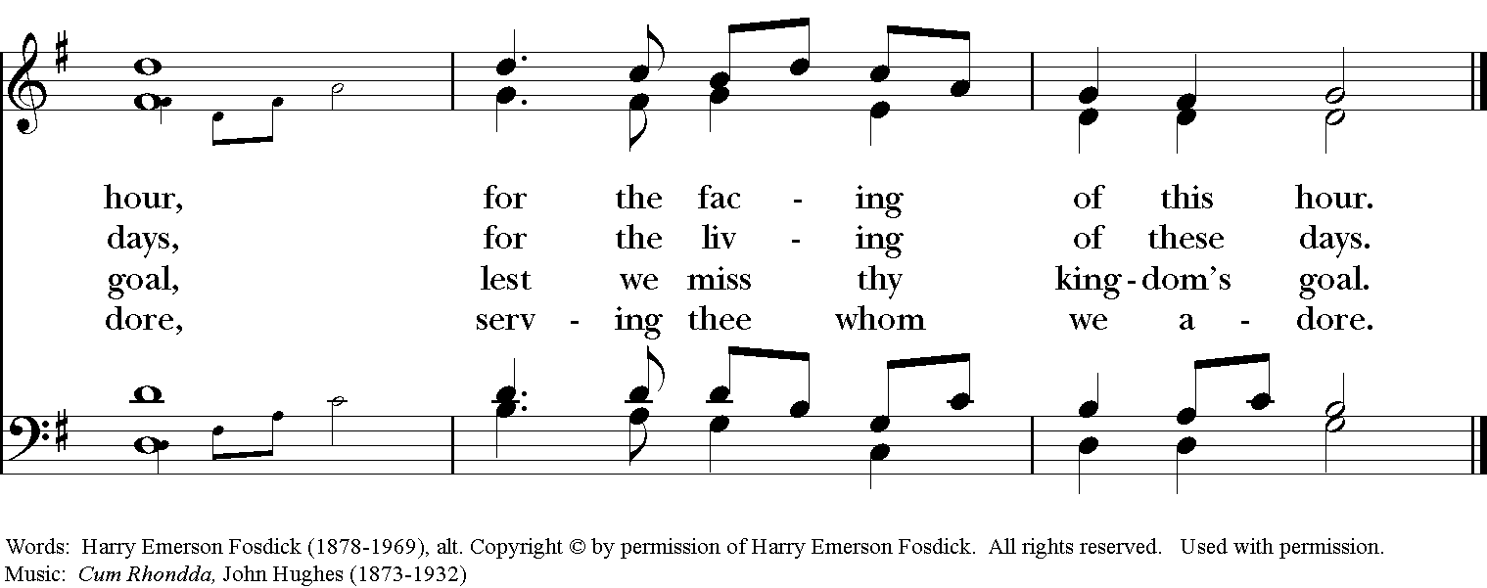
2019 Bishop’s Award: Carrie Saldo

The Bishop’s Award is given to a local journalist of any medium who demonstrates excellence in bringing local and national concerns to the people of Western Massachusetts. Carrie Saldo, our first recipient, is the host of WGBY's “Connecting Point” – a news magazine program rooted in local subject matter; from politics to the arts that airs weeknights at 7:00 PM. She is also a reporter for Greater Boston and WGBH Public Radio. An experienced and award-winning journalist, her years in the industry include reporting for PBS and NPR member stations, The Berkshire Eagle and Berkshire Living magazine.

As an enduring symbol of the power journalists possess to move the heart of the nation toward the common good, the award recipient will be given a framed page from “The North Star,” the abolitionist paper founded by Frederick Douglass.

“The conscience of the American public needs this irritation. And I would blister it all over, from center to circumference, until it gives signs of a purer and a better life than it is now manifesting to the world.”

- Frederick Douglass, Speech before the American Anti-Slavery Society, May 11, 1847.

Participants in the service

The Right Reverend Douglas J. Fisher Bishop, Episcopal Diocese of Western Massachusetts
Ms. Jacqueline Galvinhill Lawrence House Intern at Christ Church Cathedral
The Reverend Lauren Holm Pastor, Bethesda Lutheran Church
Reverend Victoria Ix Communications Director, Missioner, Episcopal Diocese of Western Massachusetts
Mr. Larry Picard Piano
Rabbi Mark Shapiro Rabbi-in-Residence, Christ Church Cathedral
Ms. Amanda Stenroos Violinist
The Reverend Linda Taupier Deacon, Christ Church Cathedral
Ms. June Watson Christ Church Cathedral

Christ Church Cathedral
Catedral Iglesia de Cristo
E p i s c o p a l D i o c e s e o f W e s t e r n M a s s a c h u s e t t s

Gathered by God from many cultures
Transformed by the grace of Jesus Christ
Sent out empowered by the Holy Spirit

35 Chestnut Street | Springfield, MA 01103 | www.cccspfld.org 413.736.2742

Christ Church Cathedral is an inclusive community welcoming all people regardless of faith, ethnicity, gender, sexual orientation, or creed.

You are loved here and we are thrilled to have you with us.

Thank you for joining us for this service.

