Scripture Isaiah 51:1, 3

Listen to me, you that pursue righteousness, you that seek the Lord. Look to the rock from which you were hewn, and to the quarry from which you were dug. For the Lord will comfort Zion; he will comfort all her waste places, and will make her wilderness like Eden, her desert like the garden of the Lord; joy and gladness will be found in her, thanksgiving and the voice of song.

Shared Silence (3 min)

The Prayer of Jesus

Prayer

Merciful God, return us now to working and relating in our world; return us, stimulated by hope, strengthened by faith, and directed by love. Thus, we are heartened to reconcile all people, created, redeemed, and sustained by you. In the name of Christ.
Amen.

Let us bless the Lord.
Thanks be to God.
______________
* Confession, Assurance and Prayer taken from Daily Prayer for All Seasons

Morning Prayer for the Martyrs of Gun Violence

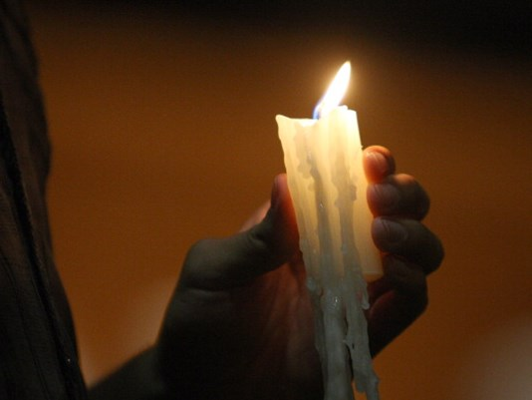

Sentence
“God is to be found in all things, even and most especially in the painful, tragic, and sinful things, exactly where we do not want to look for God.” Richard Rohr

Confession
Lord Jesus, you come into our lives when we are least prepared for you. As you enfolded your betrayers, so embrace us who struggle to love. Reconcile us with our sisters and brothers, and, for the sake of your love, forgive us all our sins.

Assurance of Pardon Psalm 103:11-13

As far as the heavens are high above the earth,
so great is your loving response to those who are humble;
so far does your enduring strength
uphold those who face the darkness within.
As parents are concerned for their children,
so you come to those who reach out in faith.

Litany
We remember them…
Blacksburg, VA 2007: 32 people killed
Kyrie eleison
Binghamton, NY 2009: 12 people killed
Kyrie eleison
Fort Hood, TX 2009: 13 people killed
Kyrie eleison
Aurora, CO 2012: 12 people killed
Kyrie eleison
Newtown, CT 2012: 27 people killed
Kyrie eleison
Charleston, SC 2015: 9 people killed
Kyrie eleison
San Bernadino, CA 2015: 14 people killed
Kyrie eleison
Orlando, FL 2016: 49 people killed
Kyrie eleison
“But God sees. God needs us to break the cycle of fear, hatred and scapegoating with a love that defies the darkness.” Bishop Fisher

Rise up, O Lord;
Lift up your hand, O God;
Do not forget the afflicted. Psalm 10:12
Shared Silence (3 min)

Psalm 46

1 God is our refuge and strength, *
a very present help in trouble.
2 Therefore we will not fear, though the earth be moved, *
and though the mountains be toppled into the depths of the sea;
3 Though its waters rage and foam, *
and though the mountains tremble at its tumult.
4 The LORD of hosts is with us; *
the God of Jacob is our stronghold.
5 There is a river whose streams make glad the city of God, *
the holy habitation of the Most High.
6 God is in the midst of her; she shall not be overthrown; *
God shall help her at the break of day.
7 The nations make much ado, and the kingdoms are shaken; *
God has spoken, and the earth shall melt away.
8 The LORD of hosts is with us; *
the God of Jacob is our stronghold.
9 Come now and look upon the works of the LORD, *
what awesome things he has done on earth.
10 It is he who makes war to cease in all the world; *
he breaks the bow, and shatters the spear, and burns the shields with fire.
11 “Be still, then, and know that I am God; *
I will be exalted among the nations; I will be exalted in the earth.”
12 The LORD of hosts is with us; *
the God of Jacob is our stronghold.
Glory to the Father, and to the Son, and to the Holy Spirit:
as it was in the beginning, is now, and will be forever. Amen

