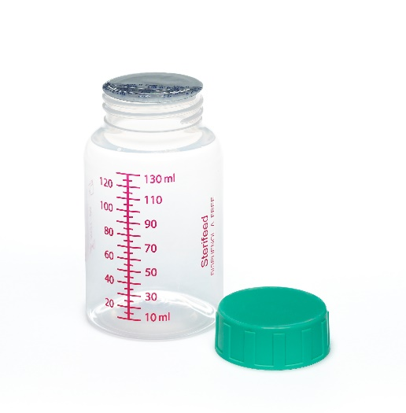 Bottles with Foil Seal
Description
Induction sealed cap closures provide absolute security during pasteurization and transportation of milk. Used in conjunction with the Sterifeed Data Logger, batch codes provide confirmation that the bottle has been pasteurized in accordance with published medical standards for identifying the source/donor.
The safety seal prevents even minute volumes of water from diluting the milk during pasteurization and cooling. The seals also feature a tab used to avoid touching the neck of the bottle when removing the tamper evident foil seal.
Order Info
Code | Description U/M |  | U/M
14094K 50ml Foil Seal Bottle, Bulk 200/Cs
14097K 100ml Foil Seal Bottle, Bulk 100/CS
14095K 130ml Foil Seal Bottle, Bulk 100/CS
14096K 250ml Foil Seal Bottle, Bulk 100/CS

(Nutritional Support Section)

