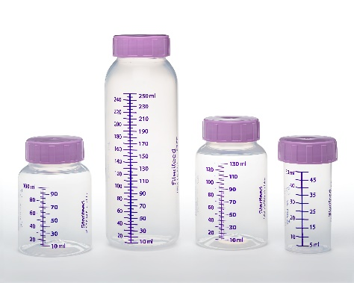 Disposable Collection and Storage Bottles

Description
Sterifeed’s disposable bottles come in a large range of sizes for all hospital requirements; 50mL (1oz), 100mL, (2oz), 130mL (4oz), 250mL (8oz). They’re clearly marked with accurate graduations every 5mL and are rigid to prevent force feeding. Bottles are airtight and leak resistant to ensure maximum shelf life for breast milk when stored in refrigerator or freezer.
Available in bulk, or individually wrapped in a temper evident PE bag, they are suitable for freezing and pasteurizing. Bottles are made from FDA food grade clarified polypropylene, and are 100% free of Bisphenol-A (BPA), Bispenol-S (BPS), DEHP and Phthalates.
Order Info
Code Description U/M | Description | U/M

14000K 50mL Disposable Bottle Bulk 200/Cs
14001K 130mL Disposable Bottle in Bulk 100/Cs
14002K 250mL Disposable Bottle in Bulk 100/Cs
14003K 100mL Disposable Bottle in Bulk 100/Cs
14100K 50mL Disposable Bottle in Tamper Evident Bag 200/Cs
14101K 130mL Disposable Bottle in Tamper Evident Bag 100/Cs
14102K 250mL Disposable Bottle in Tamper Evident Bag 100/Cs
14103K 100mL Disposable Bottle in Tamper Evident Bag 100/Cs

