The Hummi Micro-Draw Blood Transfer Device from Kentec Medical, Inc
Hummingbird Med Devices, Inc. would like to take this opportunity to introduce our innovative new product for obtaining umbilical catheter blood samples from premature infants, the Hummi Micro-Draw Closed Method Blood Transfer Device, providing:
Reduced Infection Risk…..and Reduced Risk for IVH Development in the Premature Infant.
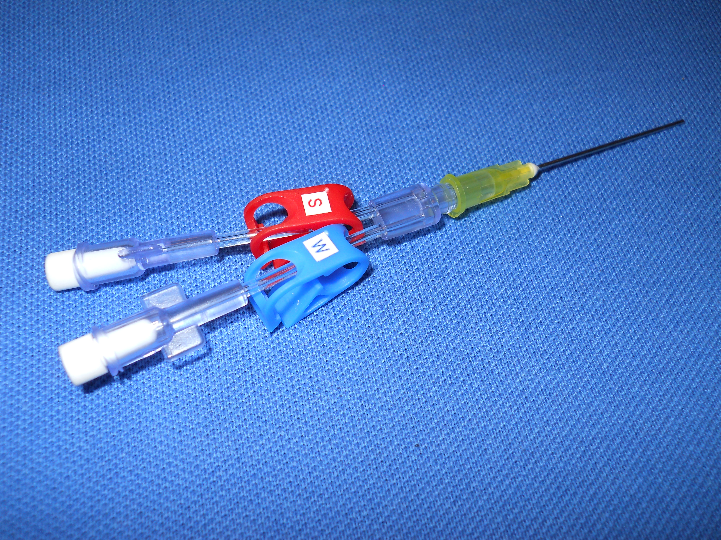
Hummi Micro-Draw Closed Needleless Method Blood Transfer Device
Filling Unmet Needs for the Premature Infant
The Hummi Micro-Draw Blood Transfer Device is the first device of any type to address the emerging need to maintain a very stable hemodynamic balance in the cerebral and systemic circulatory system of the very low gram weight baby in the first days and weeks of life when using umbilical catheters.
Intraventricular Hemorrhage…..Major Complication of Prematurity
The goal of maintaining hemodynamic balance in the neonate is paramount in reducing the risks for the development of IVH (Intraventricular Hemorrhage), which is the primary causative factor in the development of Mental Retardation and Cerebral Palsy in the premature infant.
Current Methods for Umbilical Catheter Blood Drawing Contribute to Complications
One of the strongest risk factors that showed an increased risk for IVH/PVL was the use of umbilical catheters, and the withdrawal and infusion of blood and fluid that goes along with current methods of using the umbilical catheters for blood sampling in the premature infant.
Unfortunately, recent studies indicate that current methods for blood drawing, moving 4mL to 6mL of blood and fluid during an umbilical blood draw definitely alters cerebral hemodynamics, including alteration of cerebral blood flow and decreased oxygenation of cerebral blood.

The Hummi Micro-Draw Blood Transfer Device:
Reducing the Risk Factors for Infection and IVH Associated with Umbilical Catheter Use
The Hummi Micro-Draw represents a new closed method for doing umbilical catheter sampling that reduces the total movement of blood and fluid during the draw procedure by 70% for every blood draw vs current methods. This reduction in blood and fluid movement significantly reduces the risk for alteration in cerebral hemodynamics, including cerebral blood flow alterations and cerebral de-oxygenation which can lead to the development of Intraventricular Hemorrhage in the premature low birth weight baby.
This is accomplished with the Hummi Micro-Draw by taking the clearance and sample directly from inside the catheter hub, using a blunt capillary size tube for access through a split septum T-connector with microbial barrier protection.
The Hummi Micro-Draw System maintains a closed system in use, is never open to atmosphere during use and has the smallest footprint for closed access to a line or catheter of any device or closed system used for blood drawing. Many NICUs are reporting reduced infection rates when using the Hummi Micro-Draw system vs. their previous blood draw method.
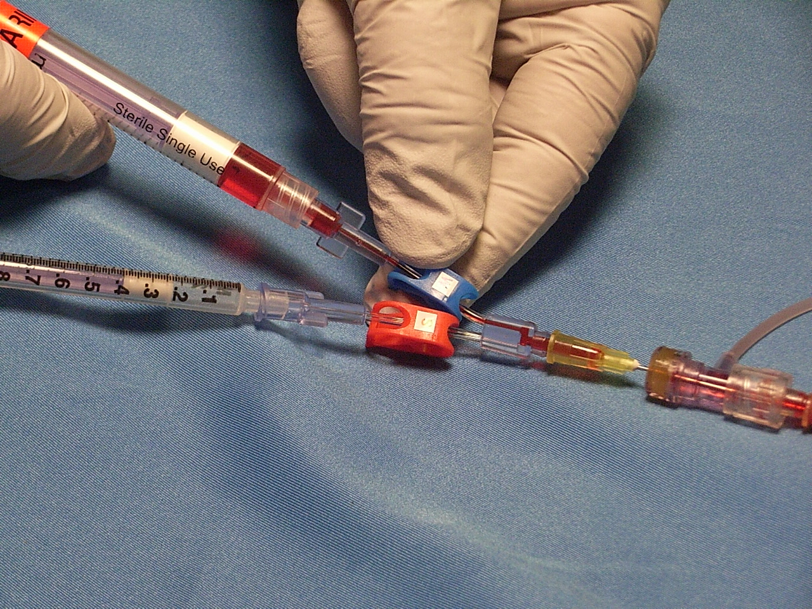
Umbilical Catheter Clearance of 0.5mL 1
The Hummi Micro-Draw with split septum Micro T……a simple, closed yet effective solution to reducing the risks for infection and the development of IVH/PVL in the premature infant when using umbilical catheters. No existing device on the market for neonatal blood drawing can provide both infection risk reduction and risk reduction for the development of IVH in the premature low gram weight baby.
Ending 2019 more than 25% of all NICU beds in the United States are using the Hummi-Micro Draw Blood Transfer Device. The Hummi Closed System is now available fully integrated into a full range of Umbilical Catheters, providing further improvement in infection risk reduction in the neonate.
Kentec Medical, Inc
17871 Fitch Irvine, Ca 92614
800-825-5996 Toll Free
949-833-9730 Fax
www.kentecmedical.com
Sales@kentecmedical.com

Kentec Medical, Inc
17871 Fitch
Irvine, Ca 92614
800-825-5996 Toll Free
949-833-9730 Fax
www.kentecmedical.com
Sales@kentecmedical.com

