Installation
Ground Preparation……………………………………………………………………….3
Water, Electricity, and Installation Materials…………………………….……4
Production and Operations
Water analysis……………………………………………………………….….5
Consumables/products …………………………………………………....5
Propagation and Nursery……………………………………………………
Marketing ………………………………………………………… …………....8
Packaging Recommendations…………………………………………….
Plant Protection
Introduction…………………………………………………………………..
List of compatible plant protection products………………..

As the new owner of a TAPKIT, we recommend you follow the following guidelines to ensure the greenhouse site is ready for installation before the kit arrives. This will allow for a smooth installation process. In addition, we recommend you review the i-Droponics Management App that is included in your purchase of a TAPKIT unit. You have access to the app for an entire year. That's a whole year of support for your daily routine, from seeding and harvest to cleaning and more, absolutely free.

INSTALLATION
- Ground Preparation

Model | Structure Dimensions in ft | Total Required Area in ft
Tapkit 25K Long | 32.8’ x 167.3’ | 46’ x 180.4’
Tapkit 25K Double (Twin) | 60’ x 90’ | 79.3' x 109.6'
Tapkit 10K | 30’ x 90’ | 43’ x 103’

· Soil compaction, leveling, and preparation:
- Level the designated area according to the following specifications:
o Compact soil to >82%
o Longitudinal slope – 1.5- 2.5%
o Cross slope - 0%
- Ensure the ground surface is smooth, free of stones, debris, bumps, depressions, etc.
- All to be completed before delivery of TAPKIT.
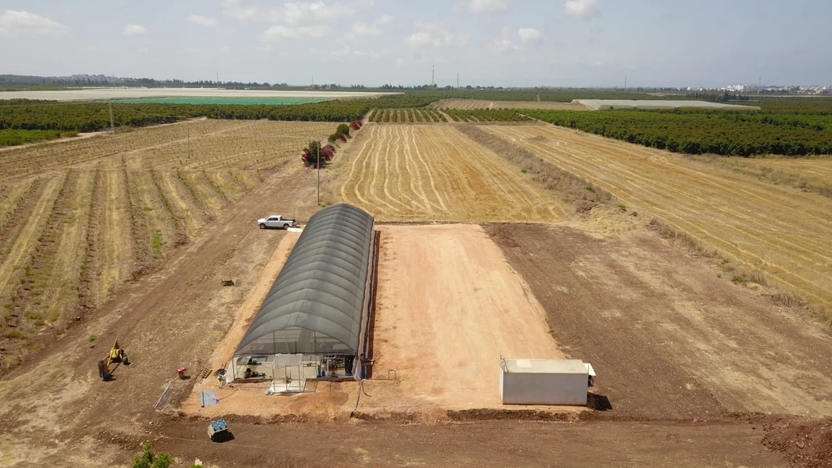

- Water Supply
- Water-supply pipeline – 2" in diameter, should be buried, reaching the lower end of the greenhouse. Placed 1.5 meters (5 feet) outside the greenhouse with a 2-inch valve with BSP threading.
· Dynamic flow rate and pressure: 10 cubic meters/hour at 3 bar (44 GPM at 45 psi).
- Drainage: prepare for daily drainage of up to 1 cubic meter (35 cubic feet).

A backflow preventer on the water supply is recommended. Check with local regulations for water supply.

- Electricity
- The electrical cabinet servicing the TAPKIT is at the lower end of the greenhouse adjacent to the irrigation center. The cabinet needs to be:
· Three-phase
· 400 V
· 63 A
- It is necessary to install a residual-current switch inside the electric box of the kit, according to an electrician's recommendations.

- Installation materials

· PVC cement: You will need about four canisters (32oz-946ml each) of low VOC cement for the irrigation systems.

· PVC pipe cleaner: About two canisters (32oz-946ml each)

Production

- Water analysis

TAPKIT agronomists will prepare the optimal fertilization formula for your TAPKIT based on the chemical profile of your source water. You may sample your source water and have it sent to the nearest laboratory for analysis of the following elements:

· pH
· EC
· SAR
· N − NO3–
· N −NH4+
· N (total)
· P
· K
· Ca
· Mg
· Na
· S
· Fe
· Mn
· Zn
· Cu
· B
· Mo
· Cl
· HCO3

- Consumables

· Fertilizers
Fertilizers provide the essential elements necessary for the healthy development of your crops. Once the chemical analysis of your source water is available, TAPKIT's agronomist will prepare the fertilization formula for you. The formula details the annual quantities needed for each element and compound. The fertilizers must be 'Fully soluble' / 'Greenhouse Grade.'

The common fertilizers used for TAPKIT are:

- Calcium Nitrate
- Potassium Nitrate
- Magnesium Nitrate
- Ammonium Nitrate
- Potassium Sulfate (SOP)
- Mono Potassium Phosphate (MKP)
- Micro-element combination
- Fe Chelate 6%
- Mn Chelate
- Zn Chelate
  - Boric Acid

Visit tapkitusa.com/supplies to find a trusted supplier from which you can purchase your fertilizers!

- pH Adjustment
Acids are used to balance the pH of the solution daily. We recommend two types of acid:
  - Phosphoric acid 75%
  - Nitric acid 35%

· Hydrogen Peroxide
Hydrogen peroxide is used as a sanitizer, helping to maintain a pathogen-free solution. Our recommendation is to use the following formula:
  - Hydrogen peroxide 35%
  - Hydrogen peroxide measurement sticks: in the scale of 0-10 ppm

Note: Other formulas might be available, differing in their active ingredient concentration. If another concentration is used, estimated annual quantities will need to be recalculated.

- Propagation and Nursery
To propagate your seedlings, the following is needed:
Product | Description & Recommendation | Recommended Distributor
Peat Moss | A natural growing media that provides seeds with the optimal environment for germination and rooting. Recommend using white peat moss mixed with perlite. | BFG
Vermiculite | A natural clay mineral that increases the substrate's water holding capacity so that the seeds will germinate in a moist environment. We recommended using vermiculite #2 | BFG
Medium Substitutions | Peat moss and vermiculite can sometimes suffer supply shortages. Here is a biodegradable alternative! | BFG
Seeds | We recommend choosing seeds that are resilient to diseases and are common in the market. | BFG
Plastic Tags | Tags mark and differentiate the seeding batches through the growing cycle. They come in various shapes and are reusable. | BFG

Note: You can order seedlings from a local nursery for the first 3-4 growing cycles till your seedlings are ready for transplant. Make sure to purchase only high-quality, well-developed (including the root system), disease and insects' free seedlings, preferably grown in peat moss.

MARKETING AND SALES
How to sell, sell, sell!
· Identify target markets
- Neighborhood, direct sales to consumers – This is the most profitable channel for selling your product. A single TAPKIT can serve 100-150 households.
- Farmers markets
- Local fresh produce stores and restaurants
- Large-scale kitchens in your area, like schools, hotels, nursing homes, etc.
- CSA Programs & Partnerships

- Market research – Products, pricing, and packaging
  - Check the prices of packaged produce available. This will serve as a good reference for setting your selling price to various customers
  - Check what produce seems supplied the most in your area.
  - Learn your potential customers' preferred packaging (plastic bags/ clamshells) and each product's standard weight (or size).
  - Ask your neighbors, local chefs, grocery stores owners for their perspective about hydroponic and local produce.

• Implementation
  - Start producing
  - Experiment with smaller volumes of 12-15 different varieties
  - You can transition into 5-7 once you see what your market needs from you!
  - Your target market may change, and so should you! Stay flexible and keep the three above steps in mind if you feel it's time for a change.

· Packaging Recommendations

After investing a lot of effort, resources, and love into growing your crop, you're going to want packaging that can protect and preserve its freshness for your customers to enjoy. Here are some manufacturers of packaging and some examples of what they can be used for. Look through the packaging at your local market to see what is the most appropriate for your area, or contact one of our experts! TAPKIT businesses have found the most success using clamshells or sealed bags – they can guarantee freshness for at least two weeks!

Container Type | Suggested Supplier
Plastic Bags | A Roo
Clamshell  (Look for words like vented or anti-fog) | Good Natured Products
Ties | Elastitag

Product/Use | Price | Company |  | Size | Picture
Herb Clamshell | 25 cents/clamshell | Good Natured Products |  | .5 oz | 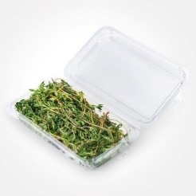
Herb Clamshell | 26 cents/clamshell | Good Natured Products |  | .75-1 Oz | 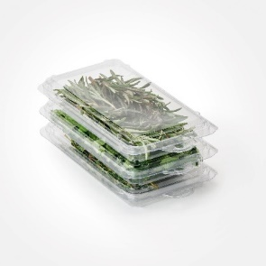
Herb Clamshell  Herbs | 59 cents/clamshell | Good Natured Products |  | 3 oz  3x 6.5x 2.75 | 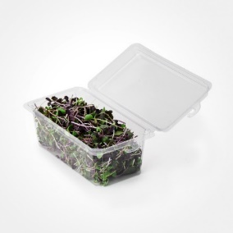
Cut lettuce clamshell | 77 cents/clamshell | Good Natured Products |  | 48 oz | 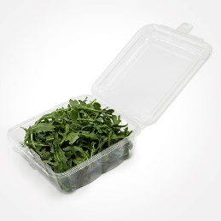
Sealable Herb Sleeves | 12 cents/sleeve | A-roo sealable herb sleeves |  | 10 x 12 x 2  5.75 x 8.5 x 3.75” | 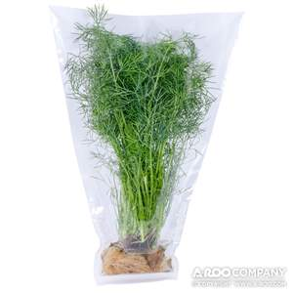
Bibb lettuce clamshell  Head lettuces | 61 cents/clamshell | Brenmar |  | 7-7/8 x 7-13/16 x 5-3/8 in. | 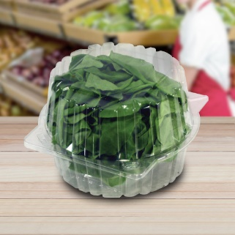
 |  |  | Substitutions/Misc
Herb Tie  Herbs | 11.64/ thousand | Elastitag |  |  | 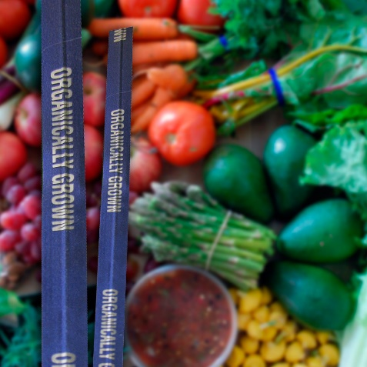
Elastitag  Herbs | 897.00/6000 tags (including the price of the label!) | Elastitag

- Plant Protection

With your TAPKIT, we offer many cultural and integrated pest and disease management strategies that help reduce the need for pesticides and herbicides. These include:
  - A set of double doors to each greenhouse
  - Insect screening covers
  - Insect sticky cards for monitoring pest populations
  - Greenhouse coverings
  - Recommendation for daily crop inspections
  - Fans for air circulation
  - Water sanitizers

Many organic pesticide and fungicide options can be implemented in your plant protection program to help decrease the threat of pests in your greenhouse. Your spraying program will focus on prevention rather than correction, heavily reducing the need for pesticides. This offers many environmental and economic benefits and allows you to produce herbs and leafy greens free of pesticide residue and marketed as pesticide-free.

A TAPKIT agronomist will recommend a spraying program to prevent insect and disease issues- typically, around three products are used at a time. Ensure you learn as much as possible about what you are spraying- read the directions and MSDS included with each product, in addition to adhering to your TAPKIT agronomist's recommendations. Below is a list of every pesticide/fungicide that TAPKIT is experienced with and may recommend to you, with links to the BFG online store. Most are organic!

List Of Possible Pesticides
Active ingredient | Brand/BFG Link | Pests Covered
Abamectin | Nufarm | Mite, leaf miner, aphid, whiteflies, thrips
Cyromazine | Syngenta | Leaf miners
Buprofezin | Sepro Corporation | Whiteflies, mealybugs, leafhoppers, planthoppers, scales
Pyrethrum | OHP | Aphids, whiteflies
Neem Oil | OHP | Thrips, aphids, whiteflies, mites
Azadirachtin | OHP / Biosafe | Aphids, caterpillars, mites, thrips, whiteflies
Spirotetremat | Bayer | Thrips
Spinosad | Corteva | Thrips, leaf miners, caterpillars
Pymetrozine | Syngenta | Aphids, whiteflies
Lambda-cyhalothrin | Syngenta | Ants, aphids, leaf miners
Pyrethrins | Mycorrhizal Applications | Aphids, caterpillars, leaf miners, mites, thrips, whiteflies
Beauveria bassiana | Bioworks | Aphids, thrips, whiteflies
Potassium salts Fatty Acid | Gowan / OHP | Aphids, mites, whiteflies
Chromobacterium | Marrone | Aphids, caterpillars, leaf miners, mites, thrips, whiteflies
Isaria fumosoroseus FE 9901 | Blacksmith Bioscience | Mites, thrips, whiteflies
Isaria fumosoroseus Apopka Strain 97 | OHP | Aphids, Caterpillars, leaf miners, mites, thrips, whiteflies
Mineral Oil | Bioworks | Aphids, mites, thrips, whiteflies
Burkholderia spp. Strain A396 Cells | Marrone | Aphids, caterpillars, leaf miners, mites, thrips, whiteflies
Bacillus thuringiensis kurstaki | Nufarm Americas | Worms, caterpillars

List of possible Disease Treatments:
Active Ingredient | Brand/BFG Link | Diseases Covered
Bacillus subtilis | BioWorks | Downy mildew, powdery mildew
Streptomyces lydicus | Mycorrhizal Applications | Downy mildew, powdery mildew
Extract of Swinglea glutinosa | Gowan | Powdery mildew
Extract of Reynoutria sachalinensis | Marrone | Powdery mildew
Bacillus amyloliquefaciens Strain F727 | Marrone | Downy mildew, powdery mildew
Bacillus amyloliquefaciens | OHP | Downy mildew, powdery mildew
Hydrogen peroxide+ Peroxyacetic acid | Biosafe | Downy mildew, powdery mildew
Dimethomorph | BASF | Downy Mildew
Mancozeb-Dithiocarbonate | Bionide | Downy Mildew

You're all set now! Good luck with your fresh start to fresh produce!! TAPKIT's experts are here to assist you in any matter.

