business blueprint the e-commerce academy

Scenario (Business Area):<name>
Business Process: <name>

Project Identification
Project Name |  | CPI/Project Number |  | Project Type  (Business Consulting, Implementation, Upgrade, Internal, other)
Customer Name |  | Customer Number |  | Planned Start/Finish
Project Sponsor | Program Manager |  | Project Manager (Customer)
Project Manager (SAP) | SAP Service Partner(s) |  | Project Manager (Service Partner)

Table of contents

Introduction 4
Introduction 4
Management / Executive Summary 4
Reference Documents 4
How to Read this Document 4
Project Charter 5
Project Overview 5
Project Scope/Scope Document 5
Project Objectives 5
Project Stakeholders 6
Assumptions and Constraints 7
Risk Assessment 7
Significant Changes to the Current Status 7
Value Determination 8
Business Objectives and Expected Benefits 8
Major Business Pain Points (to achieve business objective) 8
Key Financial Performance Indicators (KPIs) 8
SAP Organizational Structure 9
Introduction “Organizational Unit” <Org Unit Name> 9
Requirements & Expectations 9
Global Design Decisions 9
Naming Convention 9
Assignment of SAP Organizational Units 9
Changes to Enterprise Structure 9
Impact of Future State Organization on SAP Organization Elements 9
Configuration Considerations 9
Authorization/Security Considerations 10
Control Requirements 10
Organizational Model 10
Business Requirements 10
Design Aspects 10
Master Data Concept 11
Master Data Element, e.g. Vendor 11
Requirements & Expectations 11
Systems List 11
Data Conversion Requirements 11
Data Cleansing Requirements 12
Master Data Ownership 12
Authorization/Security Considerations 12
Control Requirements 12
Data Archiving Requirements 12
Organization Impact Considerations 12
Data Management 14
High-Level Migration Concept 14
Business Object Scope 14
Business Object Detail 14
<Business Object> Data Element Mapping 15
<Object Name> Data Entry Input Format and Data Preparation Procedure 15
<Object Name> Dependencies 16
<Object Name> Legacy Data Normalization and Cleansing 16
<Object Name> Validation and Reconciliation 16
Roles and Responsibilities 18
Project Dependencies 19
Events and Dependencies 19
Legacy Data Archive 19
Business Process Landscape (PL1) 20
Business Process Landscape Description 20
Cross Process Related Topics 20
Business Scenario (Business Area/Process Group) Scope 21
Business Process and Solution Design 22
Process Overview <Process Name> 22
Business Process Description 22
Business Requirement 22
Business Process Diagrams 23
Locations Where this Business Process is Performed 24
Key Policies/Operational Decisions or Logic within the Process 24
SOX Considerations 24
Reference to Key Process Changes and Process KPIs 24
Process Step Detailed Requirements & Solution 25
Integration Points 25
Potential Future Process Improvements (out of scope for this implementation) 25
Functional Solution for Process “xx-xx” 26
Organization Structure Considerations 26
Master Data Considerations (including all relevant data relationships) 26
System Configuration Considerations 26
Technical/Development Related Items (WRICEF) for Process “xx-xx” 27
Reporting (operational and analytical) 27
Interfaces 27
Data Conversion / Historical Data 28
Enhancements 28
Output (e.g. forms) 29
Workflow 29
Authorization 29
Organizational Change Related Items for Process “xx-xx” 30
Change Impact Summary 30
Technical Solution Management 31
Technical Integration Design 31
System Administration Procedures 31
Support Strategy and Procedures 31
Authorization Requirements and Design 32
Security Requirements 32
User and Identity Management 32
Integrated Solution Management 33
Test Strategy and Approach 33
Appendix 34
Glossary 35
Document History 36

Introduction
Introduction
This document states all of the conceptual results of the project XPROJEKT. These project results were devised and decided on by the project team and the department experts from customer XCUSTOMER during the Business Blueprint project phase. This is the main concept document of the project. It is supplemented by separate specifications for custom developments.

The content of this document forms the basis and the guidelines for the subsequent Realization phase.
This document aims to describe the future business solution based on SAP software. Both, IT subjects and organizational issues that are required to understand the situation, are described in it.
Any additional explanations that are only relevant when the project is in progress are given in the various project management plan documents, which the project management team will provide on request.

Authors and contributors can be referred to in section Document History.
Management / Executive Summary
<Give a very condensed summary of the business blueprint here. This section should give the reader a basic overview of the key aspects. Focus more on process-related issues than technical aspects. The summary should not be longer than three pages.
This is a mandatory section.>
Reference Documents
<Give references to important documents on which the business blueprint is based or quote from the most important passages of these documents. This section generally should not be longer than two pages.
For large and complex projects, this section can easily become too long and unclear. In that case, only create cross-references to the documents in the bibliography; do not quote from them (Insert > Reference > Cross-reference). This section is mandatory.>

The following describes the foundations of the project work that affected the initial designs and concepts of the project. The information here is a selection of the most important information. The complete information is available on the shared project file server at \\Path\here\there\File.doc.
How to Read this Document
Throughout the document SAP terminology is used unless otherwise noted. The document also refers to process hierarchy levels as stated in Solution Manager. A process level map is included into the glossary.

Project Charter
[Section corresponds with Project Charter - Template]
Project Overview
Project Overview
Current Situation
“As-is” situation – Build on the “Handoff Package received from Discovery and Evaluation Phases of the CEL, here and in the following
Proposed Resolution
Describe the ”To Be” situation – What the project will deliver; the resolution to the functional/operating need.
Project Scope/Scope Document
Project Scope
What work needs to be completed during the project
Solution/Service Description
Document the characteristics of the solution/service the project was undertaken to create. This will be refined during the Planning Process.
Project Goal
Describe the overall goal that is to be achieved by the project – Build on the “Handoff Package received from Discovery and Evaluation Phases of the CEL
Project Objectives
Project Objectives
Aligned to Corporate and Organizational Strategies and Project Goal. Objectives should be “SMART” and derived from requirements, benefits, project need, and measures of success. SMART: Specific, Measurable, Accountable, Realistic, Time-bound
Deliverables
Produced by the team to ensure success

Business Case Summary
Executive Summary
Out of Scope

Total Estimated Project Costs
Estimated Total Project Costs through Closing
Rough | $
Range | $ | to | $

Implementation Strategy
The implementation approach selected for the project based on the analysis of solution options conducted during the Evaluation Phase of the CEL

Project Planning
The schedule and major milestones of the project
Project Stakeholders
Project Stakeholders
Individuals and organizations who have an interest in the project
Name - Title | Organization

Assumptions and Constraints
Assumptions
Items believed to be true for and project limits – based on the Discovery and Evaluation Phase, can be further developed

Constraints
Items beyond the control of the Project Team that limit options – based on the Discovery and Evaluation Phase, can be further developed
Risk Assessment
Risk Assessment
Factors that may have a negative impact on the project
Significant Changes to the Current Status
<In this section, state the project’s most significant changes (“impacts”) to the customer’s current processes, company policies, and external factors. Later, these impacts can be used to determine which people need to be addressed by change management (communication matrix). This section should be 1–2 pages long.
If the current status has been documented, refer to the relevant documents.
We especially want to recommend that specific agreements are made in advance with the customer’s personnel or works council, because changes often require their consent and the agreement procedures can be very time-consuming. Make the size and importance of this section proportional to the size of the project.
This section is mandatory.>

Value Determination
[Section corresponds with a Value Map and to sections of Business Scenario Requirements and Design - Template]
Business Objectives and Expected Benefits
<Describe the business objective and expected benefits. These are the measurable improvements that result in achieving their business requirements.>

Business Objectives and Excpected Benefits
Business Objectives | Process Change  (Key Business Requirement) | Value Owner | Biz Case KPI (financial) | Target Benefit

Major Business Pain Points (to achieve business objective)
<Provide a high-level list of requirements and expectations.-link to the Value Dependency document>

Major Pain Points from weaknesses analysis
Pain Point ID | Pain Point Description | Impact on Business | Contact

Key Financial Performance Indicators (KPIs)
<List the KPIs)>

Key Performance indicators
KPI Name

SAP Organizational Structure
[Section corresponds to Organizational Structure Requirements and Design - Template]

<Explain the SAP organizational structure and units (clients, company codes, plants, and so on) that were chosen for the project. We highly recommend using graphical illustrations to do so.
Note that body of this paragraph can be entered manually or generated from the SAP Solution Manager using the Organizational Unit template for this purpose. The generated blueprint will have to be inserted in this overall document. Each organizational unit will be described below. This section is mandatory.>
<Insert Org. Structure diagrams as necessary>

oRGANIZATIONAL sTRUCTURE
ID | Relevant Organizational unit SAP | Corresponding organization (Customer…) | Explanation if necessary (e.g. Mandatory)
 | Company code | Company Code | (Initialized from Plant Code)
 | Maintenance Plant | Mill | Physical site where Maintenance activities will be done
Introduction “Organizational Unit” <Org Unit Name>
This section will introduce the Organizational Structure Unit, its purpose and major characteristics for the business.
<List organization structure items required to support his business Scenario (Business Area/Process Group). For each item, note the customer requirements and describe the SAP solution to meet the requirements>
Requirements & Expectations
< Create a bulleted list of your requirements for a specific SAP organizational structure. Using an organizational structure diagram describe in detail each element within the structure.
These are the minimum requirements for this section.>
Global Design Decisions
< Provide an overview of the system design approach to be taken for this organization structure. List the key design decisions that impact this SAP organization structure. Make note of the requirements that are being met by this design, and those to be left out of the design.>
Naming Convention
< Describe the naming and numbering conventions that the company will use for this structure item. Identify changes that must be made in order to accommodate SAP requirements and/or best practices. (Final design decisions not required at this time) >
Assignment of SAP Organizational Units
< Describe the assignment of organizational unit(s) in the SAP System that is relevant to the company’s enterprise. Include how the SAP organization structures inter-relate. Include any reasons for deviations from organizational structure guidelines. >
Changes to Enterprise Structure
< Describe the effect of this structure item on the customer’s enterprise structure. For example:
- Will the credit collection procedure be moved to customer service?
- Will the plant be able to process more orders per day?
- Will there be an impact on head count?
Impact of Future State Organization on SAP Organization Elements
< Identify the impacts on this SAP organization element resulting from the future state organization. If there is no change from what was entered in Requirements, indicate it. >
Configuration Considerations
< Describe issues of importance to the company in relation to system configuration. Capture decisions on how specific fields will be used in ways that are not standard SAP (i.e., using storage location for material valuation). The information captured here should be sufficient for an SAP Application Specialist to complete configuration in Realization Phase.
Authorization/Security Considerations
< Describe the company’s security requirements in this area. Don't cover the creation of authorizations in too much detail. Sensitize the team to the system functions and get the process owners to think about access to the system and its data.>
Control Requirements
<Enter control requirements with their respective rankings.
Organizational Model
<Describe the business organization model, insert an overview diagram as available >
Business Requirements
This section will describe the major requirements of the company in respect to this unit. This includes financial, logistics, authorization and reporting requirements
Design Aspects
This section will describe the chosen design. It documents the relation between the SAP Organization structure unit and companies business organization model; the consequences of the choices made and the naming/coding conventions. This includes the consequences for the financial, logistics, authorization and reporting concepts.

<Insert Org. Structure diagrams as necessary>

Master Data Concept
[Section corresponds to Master Data Requirements and Design - Template]

<The master data concept should state all master data elements (material master, customer master, vendor master, bill of material and so on) that will be needed to operate the software. For the master data, you must describe which requirements there will be in terms of data maintenance and data transfer from the legacy system. Also state which technical and business requirements there are with regard to harmonizing and maintaining the master data. It is important that you define the organizational maintenance of master data and specify the distribution concepts. This section is mandatory. Note that the following section needs to be filled in per master data element
Master Data Element, e.g. Vendor
Requirements & Expectations
< Construct a bulleted list of requirements and expectations for this structure item. This list should be specific to The Company and reflect business input. Critical points should be clearly visible. List and describe in as much detail as possible any regulatory requirements that will need to be met. (i.e., ATA, SPEC2000, Quality, Engineering). >

Check List:
- Expectations
- Business Requirements
- Regulatory Requirements.>
Systems List
< This section should list all the current systems applicable to this Master Data. (Include even small homegrown applications and databases like Access / Excel). Capture the site/facility/BU for which these systems are relevant. Next to each system on the list indicate whether the system will be replaced by SAP. If not replaced by SAP, will an interface be required. (Keep in mind the goal is to minimize the number of Interfaces) >

Check List:
- System
- Facility
- Business Unit
- Replaced
- Not Replaced
- Interface
Data Conversion Requirements
< The objective of this section is to gather information on data conversion needs. To do this we will need to know, for each system being replaced or partially replaced by SAP:
- the volume or number of records in each system
- if this data is in more then one system. If yes, which ones and what are the business rules for conversion
- if there are conflicts, which system should be loaded first >
Check List:
- Volume of Records
- Other Systems Affected
- Priority/Sequence of Data
- Transactional Data
- Historical Data
- Other Data
- Development Request
Data Cleansing Requirements
< Complete for all data to be converted. Indicate the number of master data records in each of the systems to be replaced by SAP:
- Does the data have a standard format? What are those standards?
- Is the data to be cleansed for this site within this site, and is it “originating” data or “resulting” data?
- How would you rate/describe the quality of the data with those systems, by system?
- What tools and resources are required to cleanse the data? Are the tools currently available?

Complete the decision process to determine if data cleansing can be done manually or whether an automated process is required. >
Check List:
- System: Number of Master Data Records
- System: Data Quality
- Data Description: Applicable Standards
Master Data Ownership
< Describe the process for Master Data Creation and Maintenance, including
- the person(s) who are responsible for initiating (making the request for) the master data record
- who adds information to the record
- who maintains the record
- is there a need to restrict access to the data? The people need to be listed by function or organization. (NOT by name) >
Check List:
- Master Data Elements: Initiates, Creates, Adds, Maintains, Access Restriction
Authorization/Security Considerations
< Describe The company’s security requirements in this area. Don't cover the creation of authorizations in too much detail. Sensitize the team to the system functions and get the process owners to think about access to the system and its data.>
Control Requirements
<Enter control requirements with their respective rankings.>
Data Archiving Requirements
< Gather all requirements related to data retention, archiving and retrieval. Where relevant, refer to Regulatory Policies, Legal Policies, Fiscal Policies, Audit and Business Policies. (Provide the policy name and a link to the relevant document). Include the minimum online storage period and long term retention requirements. Identify any requirements for archiving hardcopy documentation. >

Check List:
- What Data
- What Length of Time
- What Regulatory, Fiscal, Audit, Business Policies.>
Organization Impact Considerations
< Identify the people issues that may need to be addressed arising from the organization and system requirements that affect this process / function.
Identify the organizational change management initiatives underway related to this sub-process/function.
Areas of impact may be as follows:
- organization structure - a new department, reporting relationships
- jobs - competencies, technical and soft skills required
- workload - increased workload requires more personnel to perform a task
- human factors - are people afraid to lose their jobs; are they afraid they will no longer be able to perform responsibilities
- work environment - are tools and reports changing?, are other related systems impacted?, working relationships with other departments or within a department
- barriers - multiple geographic facilities, other initiatives impacting the same stakeholders
If there are none, indicate it. >

Data Management
[Section corresponds to Manual Data Migration Plan - Template]
High-Level Migration Concept
In this section, describe how the required master data and transaction data will be migrated from the old system into the project’s new system(s). For example, it may be necessary to migrate customer masters, material masters, accounting documents, or production orders. State which migration programs are required for which master data and which transaction data, and any possible dependencies between data (for example, a material master is necessary before any production orders can be created). This section is necessary in order to provide an overview of the additional programming effort that the project will require. Most of these programs need to run stably in the Go-Live Preparation ASAP phase.
This section is mandatory. If there is no migration concept, state that this is the case.
Business Object Scope
The following table lists the Business Objects that will manually migrated.

MIgration Object
ID | SAP Business Object | Source Application | Source Table / File | Data Volume
1
2
3
4
5
6
7
8
9
10
Business Object Detail
The following section is designed to provide detailed information for each of the business objects in scope for manual migration. The section below needs to be copied and repeated for each business object. The repeated sections will describe the following information for each individual business object:

- Data element mapping and logic
- Data entry input format and data preparation procedure
- Cleansing requirements
- Dependencies
- Validation and reconciliation requirements and process
- < Business Object #1 >
The purpose of this section is to describe the procedure to be followed and the values to be entered when manually converting legacy data for <Business Object>. Use the following information as a detailed guide for converting <Business Object> legacy data into the SAP Application.

<Business Object> Data Element Mapping
This section is designed to capture a detailed data element mapping between the target SAP table and the source application table or file.

<Object Name> Data Element Mapping

The source of the data for <Object Name> is the <Source Application> and the data is contained in the <Source Table or File>.
Source of Data
Target Column | Datatype | Required | Source Column | Datatype | Default Value | Validation | Rule #

<Object Name> Business Rules

This section is designed to define and describe the data element business rules. Business rules can address cleansing and transformation requirements associated with migration of legacy data.
Data Element Business Rules
Rule ID | Rule Description
1
2
3

<Object Name> Data Entry Input Format and Data Preparation Procedure
The following section defines the input format for data entry and the data preparation procedure required for capturing and preparing the data.

Data Input Format

Describe the input format that will be used for data entry. Include a screen shot of the input format and provide additional instructions as required. Examples may include:
- A legacy report that contains the data records and elements
- A data dump loaded into Excel that contains the data records and elements
- The direct entry of manual data based on an on-line legacy application

Data Preparation Procedure

Describe any data preparation procedure required to obtain the manual data entry records. Examples may include:
- The execution of a legacy report with specific selection criteria
- The extraction of data from a legacy application and the loading of that data into an appropriate input format
- The navigation and selection instructions for the on-line legacy application
- The selection or exclusion criteria for data records included in the input format

<Object Name> Dependencies
The following section identifies and describes the dependencies to other data objects or configuration data required for manual entry of this business objects.

Data Object Dependencies
Describe any dependencies to other business objects. Examples may include:
- A GL account number must be available before entering a Vendor record
- A Vendor must be available before entering an open AP Invoice record

Configuration Data Dependencies
Describe any dependencies to application configuration data. Examples may include:
- List of values for Vendor types
- GL segment values for GL accounts

<Object Name> Legacy Data Normalization and Cleansing
The following section identifies and describes any required data normalization and cleansing that is required in the legacy application prior to the manual data entry process. This operation may not be required on all projects since the selection and data entry rules may address these requirements.

Data Normalization
Define the normalization process required to be performed in the legacy application prior to manual data entry. Examples of data normalization include:
- Elimination of duplicate data records
- Elimination of inactive data records not required for the migration

Data Cleansing
Define the cleansing process required to be performed in the legacy application prior to manual data entry. Examples of data normalization include:
- Cleansing of address fields such as zip code, state and county
- Correction of data elements for consistency purposes for fields containing values such as “Yes/No”

<Object Name> Validation and Reconciliation
The following section describes the process and procedures required to validate and reconcile the manual data.

Data Validation
Describe the data validation process required to be performed once the data is entered. Examples of data validation include:
- Performing manual transactions within the SAP Application using the manually entered data
- Testing dependent data migrations, manual or automated, where the manual data has a direct dependency

Data Reconciliation
Describe the data reconciliation process required to be performed between the legacy source system and SAP Application once the manual entry is completed. Examples of data validation include:
- Record counts between the source and target sources
- Data summary value comparisons such as open balances or quantity on hand

Roles and Responsibilities
The following section is designed to define the project roles required to support the manual migration plan and to identify the appropriate project members who will be responsible for fulfilling these roles.

Project Roles
The table below contains recommendations on project roles and descriptions. This information should be adjusted to align to the individual project structure and requirements.
Project Roles
ID | Project Role | Description
1 | Legacy Data Owner | Business owner of legacy data. This role could be involved in the data mapping, creation of manual procedures, performing data entry and reconciliation.
2 | Legacy Analysts | Data analysts responsible for the legacy data. This role could be involved in the data mapping, creation of manual procedures, cleansing of legacy data, performing data entry and reconciliation.
3 | Data Entry Clerk | Resource tasked with the entry of manual data.
4 | Subject Matter Expert | Consulting resource knowledgeable about the specific business object and application module. This role could be involved in the data mapping and creation of manual procedures.
5 | Migration Analyst | Migration team member responsible for supporting the development of the data migration plan and management of the manual data migration effort.

Project Responsibilities
The table below contains a mapping of the project roles and the individuals assigned to these roles for each of the business objects.
Project Responsibilities
ID | Business Object | Project Role | Responsible Resource
1 | <Business Object #1> | Legacy Data Owner
 |  | Legacy Analyst
 |  | Data Entry Clerk
 |  | Subject Matter Expert
 |  | Migration Analyst
2 | <Business Object #2> | Legacy Data Owner
 |  | Legacy Analyst
 |  | Data Entry Clerk
 |  | Subject Matter Expert
 |  | Migration Analyst

Project Dependencies
The following section identifies the execution events for the manual data entry throughout the project lifecycle and dependencies to other project tasks and milestones. This is not intended to replace the function of the project plan, it is simply provides the migration team a high level view of the timing for delivery and resource planning purposes. The events and milestones need to be adjusted to align with the specific project implementation strategy and requirements.
Events and Dependencies
The table below outlines the various execution events for the manual entry process.
Events and Dependancies
ID | Execution Event | Dependent Task / Milestone | Data Volume Required
1 | Unit Testing | Unit Testing of manual data migration process | Partial
2 | Application Configuration | Application setup approval | Partial
3 | Automated Migration Unit Testing | Unit Testing of automated data migration process | Partial
3 | Automated Migration System Testing | System Testing of automated data migration process | Full
4 | Integration Testing | Integration Testing of SAP Application | Full
5 | User Acceptance Testing | User Acceptance Testing of SAP Application | Full
6 | Data Migration Production Simulation | Production Simulation of full data migration process | Full
Legacy Data Archive
<The Legacy Data Archiving includes planning for Legacy data usage data archive objects and the Legacy specifications and data retention rules for the Master data archive objects. SAP or other appropriate party supplies the programs and methods for the validation and checking that each archive object proposed to be archived, stored and deleted meets the business completion rules. The default delivered retention times and business completion rules supply the baseline framework for the data archive solution. Master Data Archiving Objects are supplied by SAP and each customer selects which Data Archive objects will be used.>

Business Process Landscape (PL1)
[Section corresponds to Business Process Map - Template]
Business Process Landscape Description
<Provide a description of the business process Landscape. Please note the variations to the process. If the variations are considerably different then consider creating a separate document for the other variation.>
Sample
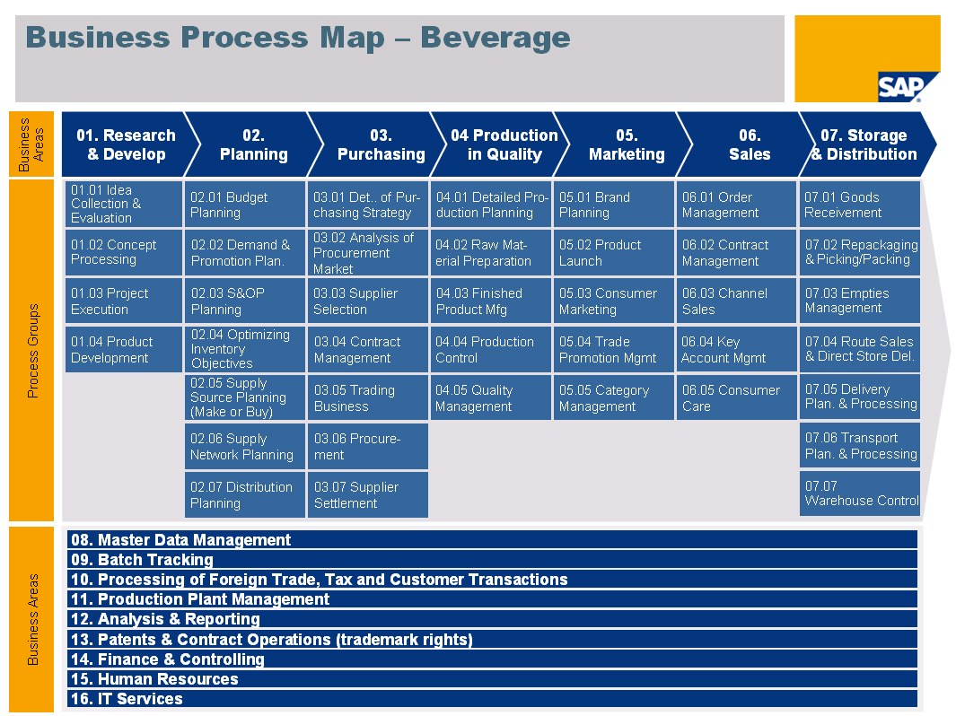
Cross Process Related Topics
<Provide a description of the cross process related topic..>

Business Scenario (Business Area/Process Group) Scope
[Section corresponds to sections of Business Scenario Requirement and Design Document - Template]

<List the business processes within the scenario. Indicate whether they are in or out of scope of this Business Scenario (Business Area/Process Group). Identify the proposed SAP Solution(s) i.e., SD, WM >

Business Scenario (Business Area/Process Group) scope
ID | Process Name | Description | In Scope | SAP Solution
 | Production Planning | Production planning activities generates all of the production plans in support of business requirements | Yes | PP
 | Manufacturing Execution | Manufacturing execution will create and release production orders, assign serial numbers to the upper assemblies, confirm operational steps once complete, receive assemblies into warehouse stock. | Yes | PP, WM, MM

Business Process and Solution Design
[Section corresponds to Business Process Design Document - Template]
Process Overview <Process Name>
<This section needs to be created for each process. Therefore, copy and paste the process section as often as necessary.>
Business Process Description
<Provide a description of the business process. Please note the variations to the process. If the variations are considerably different then consider creating a separate document for the other variation.>

Process Characteristics
Process Trigger
Process Input
Process Output
Process Owner
Process Volumes
Process Frequencies

Business Requirement
[Section corresponds to Business Process Requirements Document - Template]
<Provide a high-level list of requirements and expectations.-link to the Value Dependency document and to be leveraged for Business Process Requirement Gathering sessions>

Business Requirement (High level)
Req. ID | Requirement Description | Standard / Gap | Priority | Contact

Business Process Diagrams
<Insert to process model.>
Sample

Locations Where this Business Process is Performed
<List all geographic locations/offices, plants, warehouses etc., where this process is performed. Refer to To-Be Process Landscape.>
Key Policies/Operational Decisions or Logic within the Process
<Describe key policies, operational decisions, and logic related to this process.>
All the Key policies / operational decisions relating to Billing process have been detailed in the following documents, and maintained in Solution manager.
- KDD_xx_001 xxx
- KDD_xx_002 xxx
SOX Considerations
<List company policies and SOX consideration within this business process. E.g. segregation of duties and/or reporting requirements.>
- Segregation of duty requirements.
- Approvals documented in workflow (credits, FOC)
- Pros quote and pricing approval workflow
- xxx

Reference to Key Process Changes and Process KPIs
<Refer key process change document on process level>
KPI Name | Driver
- Reduce early price check (EPC) issues at the point of sale order release by 50% within the first three months – (Jointly with PROs). | Pricing check with PROs at FG creation

Process Step Detailed Requirements & Solution
< This section refers to the AIS model. Process Step Roles, Input and Outputs are captured as part of the process model. This sections contains a descriptive walk-through of the process. Describe the solution for each step or event and any unique variations to the step or event and the related design considerations, gaps, configuration and/or development items.>
Process Step Description
ID | Process Step Description | Ref. to Requirements as applicable | Measure of successful delivery | Solution Description | GAP Description (WRICEFW ID)
XX-xx-001
XX-xx-002
XX-xx-003

Integration Points
<List known integration topics/issues with other SAP modules / components, etc..>
Integration Points
ID | Integration Point | SAP Component | Data Element | Contacts

Potential Future Process Improvements (out of scope for this implementation)
<Summarize future improvements, based on requirements that have been discussed that will NOT be implemented in the project. >

Functional Solution for Process “xx-xx”
<This section needs to be created for each process. Therefore, copy and paste the process section as often as necessary.>
Organization Structure Considerations
<Document all organizational structure related items that are related to this business process e.g. plants, etc. Note the requirements and the related design considerations.>
Master Data Considerations (including all relevant data relationships)
<Document all relevant master data requirements / implications and all master data relationships. Attach diagrams as necessary for illustrating any relationships e.g., Results Analysis data relationships, or illustration that shows how work centers, capacities, cost rates all relate together, or the relationship of key data elements for profitability analysis, etc.)>
System Configuration Considerations
<Identify configuration requirements/considerations as they are known at this point. i.e., Order types, billing types, copy routines, item categories, risk categories, condition types, pricing procedures, settlement rules, etc. This section could be lengthy dependent on the nature of the solution and the level of detail of design. The more complex the topic the more detail you want to have in this section. This could be just short of actual configuration notes but you should include special items that you do not want to forget about during configuration>

Technical/Development Related Items (WRICEF) for Process “xx-xx”
<This section needs to be created for each process. Therefore, copy and paste the process section as often as necessary.>
Reporting (operational and analytical)
<This is just a listing. Details for the report in the functional spec. If the reporting will be done out of BW then list the info sources etc.>
Reporting
WWRICEF-ID | Description | Report Type (ABAP, BI, BOBJ) | Data Elements | Relevant KPI | Owner
XX-xx-R001
XX-xx-R002
XX-xx-R003

Interfaces
<Identify all interfaces required to provide inputs to or outputs from this part of the process. Provide a functional description of the interfaces including the source and type of data.>
Interfaces
WRICEF-ID | Description | Interface Method | Applications | Data Elements | Frequency / Volumes | Owner
XX-xx-I001
XX-xx-I002
XX-xx-I003

Data Conversion / Historical Data
<Note all master and transactional data conversion requirements. Please note specific fields that are unique to this design and the business requirement that drives that design. Note whether manual and automated data conversion requirements. Provide details of all data required from Legacy Systems (Consider System name, level of detail, time dimension). Identify requirements for historical data conversion mandatory for the process. This is not meant to be an exhaustive functional spec but a place to list conversions related to this process.>
Conversions
WWRICEF-ID | Conversion Object | Source | Conversion Activities (e.g. cleansing) | Conversion Method (manual / automated) | # of Objects to be converted | Owner
XX-xx-C001
XX-xx-C002
XX-xx-C003

Enhancements
< List the required enhancements based on the proposed gap resolutions listed in the Detailed Requirements and Design documents. Provide as much detail on the requirements and design considerations as you can. If there is a large enhancement then consider detailing that in a separate design or functional spec. document. >
enhancements
WRICEF-ID | Description | Data Object (Sales Order) | Functional Gap | Alternative SAP Standard | Reason | Owner
XX-xx-E001
XX-xx-E002
XX-xx-E003

Output (e.g. forms)
<Identify outputs and forms>
Output / Forms
WRICEF-ID | Description | Data Object (Sales Order) | Output Type (Form, EDI, etc.) | Frequency | Volumes | Owner
XX-xx-O001
XX-xx-O002
XX-xx-O003

Workflow
<Identify workflow requirements for this process. Provide detailed requirements for the workflow. e.g., purchase order approval process and authority levels etc.>
Workflow
WRICEF-ID | Description | Data Object (Sales Order) | Engaged Parties | Owner
XX-xx-W001
XX-xx-W002
XX-xx-W003

Authorization
<Indicate any special authorization requirements associated with this process e.g. Segregation of duties. Identify the groupings or type of employees that will have access to system functionality for this activity, if applicable.>
Authorizations
ID | Authorization | Role | Data Objects (Sales Order / TA code) | Reason | # of employees
XX-xx-A001
XX-xx-A002
XX-xx-A003

Organizational Change Related Items for Process “xx-xx”
<This section needs to be created for each process. Therefore, copy and paste the process section as often as necessary.>

Change Impact Summary
<Identify business process changes and the impact to the company and to individual roles.>
Organizational Change Impact
Change Impact Summary | Old Way | New Way | Positive Impacts  To Company  To individual roles | Negative Impacts  To Company  To individual roles
Process Strategy e.g.,
Principles
How
High-level data flows
Process & Metrics (focus on key changes to specific steps and transactions)

Roles, responsibilities and organization
Who’s accountable?
Who’s responsible?
Who’s consulted?
Who’s informed
Roles, responsibilities and organization
Who’s accountable?
Who’s responsible?
Who’s consulted?
Who’s informe

Technical Solution Management
[Section follows guidelines of the Technical Solution Management]
Technical Integration Design
<The purpose of Technical and Integration Design is to detail and document the technical and integration design of the future Solution Architecture and System Landscape. The document is based on technical requirements defining details of the solution transformation in view of technical infrastructure and SAP Netweaver Components (Portal, BI, MI, PI). Basis for this is the definition of the Business Process Model and mapped Solution/Application for it - done in detail during Blueprint Business Process Requirement analysis.
The Technical and Integration Design specifies the productive landscape design –the Development Environment might have to meet different demands to support the project, following different project standards and procedures. During this blueprint phase the general concept for the development and test landscape (for which solutions are development and test systems required etc., including instance and client usage) have to be specified. The standards and procedures for those systems are broke down in the Development Environment.>

<Define a high level system landscape design including transport strategy and interfaces topology>
System Administration Procedures
<Refer to standards for the System Administration Procedures, hyperlink or name documents and location. Typically System Administration Procedures include:
- System change request management
- Support package procedures
- System security procedures
- Performance optimization procedures
- Handling of Spool / Fax and email (including tool selection)
- Batch Process Management (including tool selection)
- Backup / Restore concepts (including tool selection)
- Disaster Recovery procedures
- Specify the general maintenance strategy including maintenance calendar and scheduling of maintenance activities.
- Define periodic system maintenance plans, detailing how the systems are maintained and administered according to daily, weekly, monthly, and annual timetables
- Define database administration procedures, documenting procedures for maintaining all databases in the SAP software landscape
Support Strategy and Procedures
<Describe the planned system landscape as it will be after the go-live. Explain the architecture that is planned for live operation. You should mostly use graphical means of illustrating the architecture and you must include the neighbouring legacy systems. This section is not about hardware or servers. Do mention permanent interfaces.
This section should be 1–2 pages long. This section is mandatory.>

Authorization Requirements and Design
<Explain any dependencies between this process and certain user roles or security levels. The dependencies for the authorization concept that will be created are determined based on this information. In some cases, certain processes will lead to new user roles being created, refer to process model to derive an understanding of roles.
Depending on the content of the process, this section can become very long. In that case, name the roles in question and refer to another document that contains the full details. Generally, this section should not be longer than one page.
This section is mandatory. Even if there are no requirements for the authorization concept, it is important that you state that this is the case.>
Security Requirements
<List Security Requirements>
User and Identity Management
[Refer to User Role Concept - Template]

Integrated Solution Management
[Section follows guidelines of the Integrated Solution Management]
Test Strategy and Approach
< The purpose of this deliverable is to outline key elements of the testing methodology that the project will be using as the “guiding principles” and common framework for Testing. This is a point-in-time view of Testing and will not be updated over time. The Testing Plan will define the individual testing cycles for the Realization Phase of the project; relying on the guiding principles in the testing strategy and approach document.>

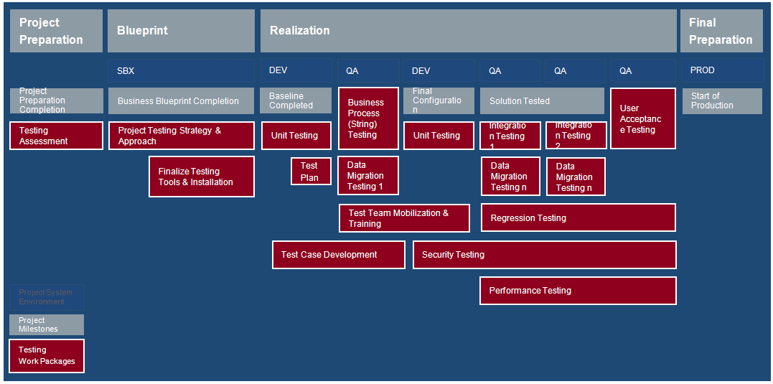

Appendix
Related/Referenced Documents
Document Name | Version | Brief Description

Attachments
Document Name | Version | Brief Description

Glossary
The following illustration maps process definition and levels. For simplification this document refers to Solution Manager terminology and levels, unless stated otherwise

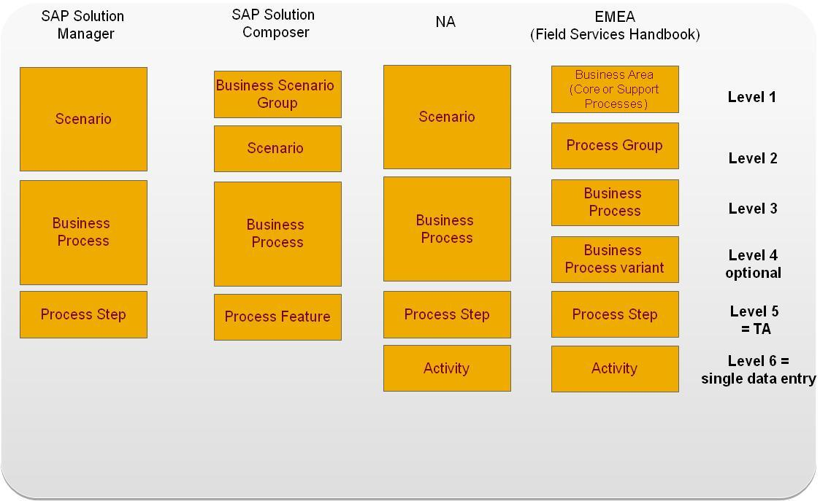

Document History
Authors & Participants
Role | Name
Business System Analyst
Project Process Owner
Business Unit Process Owner
Consultant
Workshop Participant

Revision History
Date | Document Version | Document Revision Description | Author
<< Date >> | 1.0 | Draft for customer review | << Name >>

Reviewed and Approved By
Name | Title | Date | Approved
<<NAME>> | Business System Analyst
<<NAME>> | Project Process Owner
<<NAME>> | Business Unit Process Owner
<<NAME>> | Corporate Process Owner
<<NAME>> | Internal Audit

