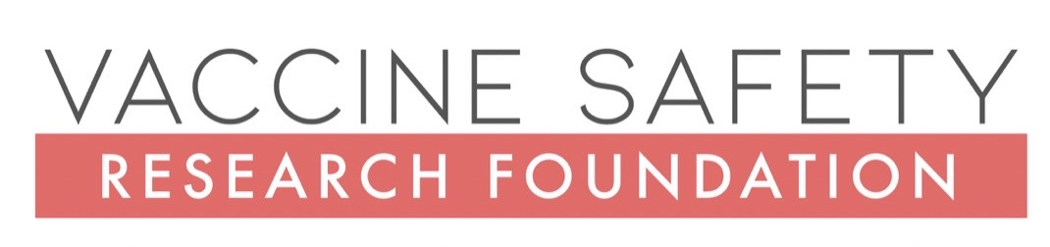
ADVISORY

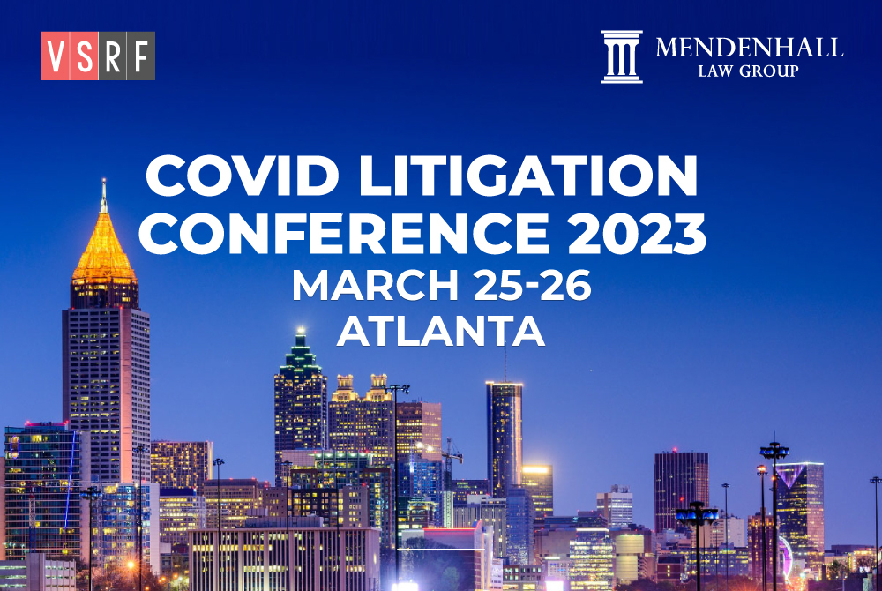

WASHINGTON, DC - We have exciting news – in March, VSRF is partnering with the Mendenhall Law Group to host the Covid Litigation Conference 2023 (CLC 2023) from March 25-26 in Atlanta, Georgia. Over the next 10 years, Covid lawsuits are expected to see huge growth, an unfortunate development that reflects the need to bring justice in the courts for hundreds of thousands of people negatively impacted by harmful Covid-19 policies.

The demand is overwhelming and CLC 2023 is the first conference launched to help educate attorneys on best practices in litigating these types of cases. We will feature informative panels on cutting-edge, Covid-related legal issues and will provide an excellent opportunity for lawyers interested in this burgeoning field to network and support each other moving forward. CLE has also been requested.

Our speaker list continues to expand and includes Mary Holland (Chief Counsel of Children's Health Defense), Tricia Lindsay (Tricia Lindsay Law), Robert Barnes (Barnes Law, LLP), Warner Mendenhall (Mendenhall Law Group), Jeff Childers (Childers Law), and Bobbie Ann Flower Cox (Cox Lawyers, PLLC.)

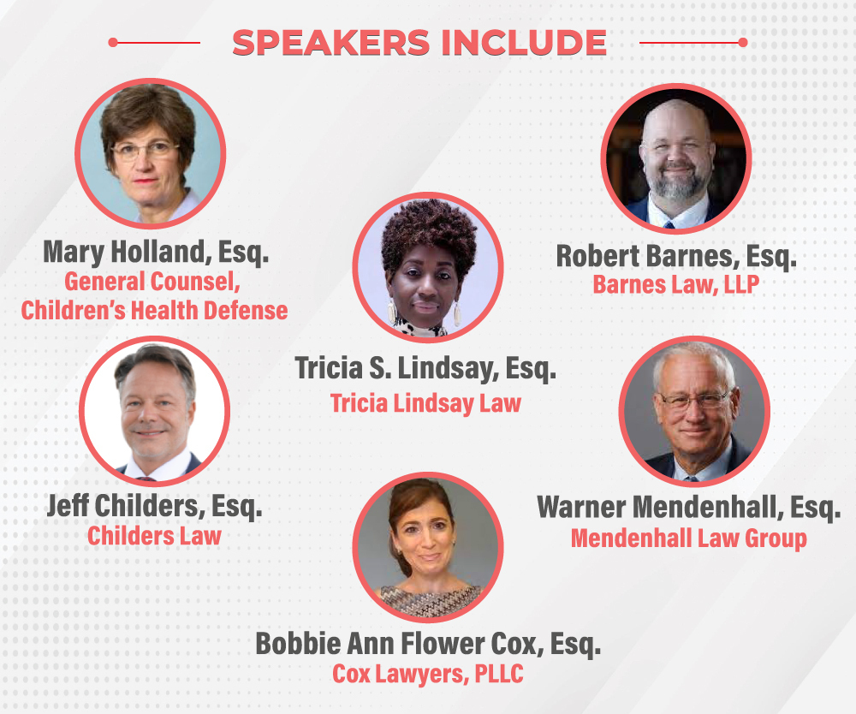

Pierre Kory, MD, Co-Founder & Chief Medical Officer of the FLCCC and Ryan Cole, MD, a Mayo-trained Board-Certified Anatomic/Clinical Pathologist, have will also be speaking as medical experts. Panelists will be joined by plaintiffs in current Covid lawsuits to lead nine panels covering the following areas of litigation:

- Employer Mandates: State/federal, ADA, worker’s compensation, individual & class action plaintiffs

- Education Mandates: Public & private K-12 schools, public & private universities, Title 10, coercion, informed consent, fraud, conflicts of interest.

- Medical License: Medical board certification, tortious interference, First Amendment, fraud, libel, violation of Administrative Procedures (APA or equivalent)

- Fraud: False Claims Act, pharma fraud, VAERS fraud, SBA and PPP fraud, whistleblower protection

- Civil Rights: Public access/accommodation, ADA, informed consent (state agencies), due process, religious liberty, First Amendment

- Censorship: First Amendment, collusion, racketeering (federal agencies)

- Vaccine Injury: Includes liability, informed consent, mandates by institutions, VICP, CICP

- Hospital Negligence: Includes Remdesivir, denial of early treatment protocols, vaccine coercion

- Mass Torts: Includes Covid vaccine injury and hospital misuse of Remdesivir

While the conference is presented with lawyers as the primary audience, the public is welcome to also purchase tickets to attend.

For more information and to get special Early Bird Registration pricing, please visit www.VacSafety.org/Events.

CONTACT: Trevor FitzGibbon
(Cell) 704-775-0487
TrevorFG@Protonmail.com
##

