FDA Vaccine Expert Advises Against Latest Covid Booster

Right now, they are saying that we should trust mouse data and I don’t think that should ever be true. I don’t think you should ever ask tens of millions of people to get a vaccine based on mouse data….

- Dr. Paul Offit, Voting Member of FDA’s Vaccines and Related Biological Products Advisory Committee (VRBPAC)

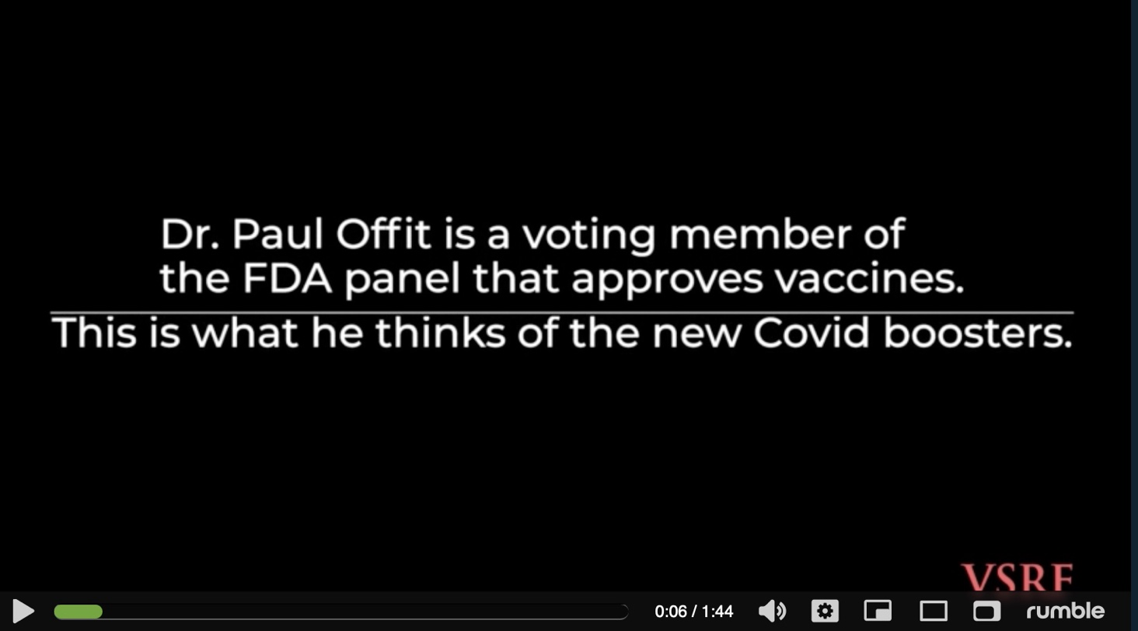

FOR IMMEDIATE RELEASE, WASHINGTON, DC -- In a troubling new video slated for release Monday, Dr. Paul Offit, senior advisor on the FDA’s committee of vaccine experts admits that he will not take the latest Covid-19 “bivalent booster”. The video features a series of sharp criticisms by Offit, directed at both the flawed process resulting in FDA approval, as well as the dubious safety and efficacy of the boosters themselves. If Paul Offit will not take the booster, the video asks, “Then why should you?”

The novel booster formula combines mRNA instructions targeting two Omicron strains circulating last spring and early summer, BA.4 & BA.5., but this formula has not gone through a single human clinical trial for safety and efficacy. The new booster has only been tested on 8 mice.

Offit explains: “Right now, they are saying that we should trust mouse data and I don’t think that should ever be true… I don’t think you should ever ask tens of millions of people to get a vaccine based on mouse data.”

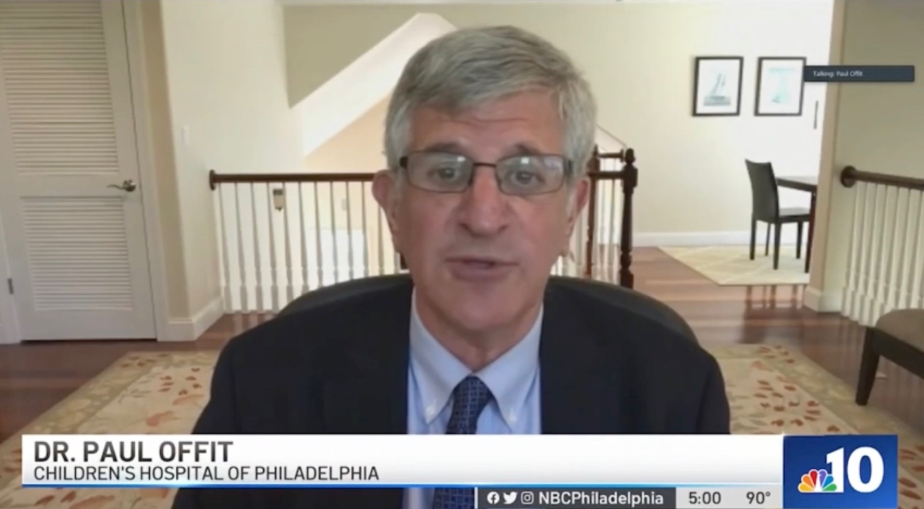

Why Ignore Protocols and Push for the Booster’s Approval so Quickly?

Referring to the booster approval Offit says, “It just surprised me that we were willing to go forward with this with such scant evidence,” and he adds, “It just felt like ‘the fix was in’....”

Who is Paul A. Offit, MD?
According to the Children’s Hospital of Philadelphia, Paul A. Offit, MD, is the Director of the Vaccine Education Center and an attending physician in the Division of Infectious Diseases at Children's Hospital of Philadelphia. He is the Maurice R. Hilleman Professor of Vaccinology at the Perelman School of Medicine at the University of Pennsylvania, and an internationally recognized expert in the fields of virology and immunology. He is a member of the Food and Drug Administration Vaccines and Related Biological Products Advisory Committee (VRBPAC) and co-editor of the foremost vaccine text, Vaccines.

CONTACT: Trevor FitzGibbon
(Cell) 704-775-0487
TrevorFG@Protonmail.com
-##-

