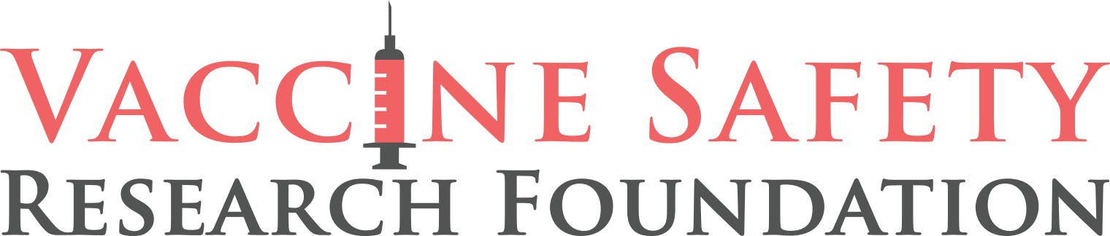

NEW VIDEO RAISES ETHICAL QUESTIONS FOR FDA
Exposes flawed agency policy as Covid-19 vaccines for kids allowed to stay on the market despite mounting evidence of serious harm.

FOR IMMEDIATE RELEASE, WASHINGTON, DC, OCTOBER 5, 2022 -- A heartbreaking new video released today by the Vaccine Safety Research Foundation shines a light on the growing number of children diagnosed with myocarditis after taking the Covid-19 vaccine.

In the video, top cardiologist, Peter McCullough, MD, testifies before the Pennsylvania state senate on the sudden death of children shortly after getting their Covid shots. One of those children was 16-year-old Ernesto Ramirez Jr., who died of cardiac arrest five days after taking the shot.

The video incorporates Pfizer's television ad strategy in late 2021 to recruit children for its clinical trials. In the ad, the company’s message is that any child who volunteers for the trial for Pfizer’s novel vaccine will become a hero. "Bravery," "helping others," and "courage" are the qualities describing kids who sign up for Pfizer’s clinical trial.

The video juxtaposes Pfizer’s hero ad with an ad released by a New York City hospital recruiting children to its ICU ward who may have myocarditis. Myocarditis, or inflammation of the heart, is a proven side-effect from Pfizer’s Covid-19 vaccine.
Marty Makary, MD, of Johns Hopkins, dispels the claim that Covid-19 infection poses a higher risk for myocarditis than the Covid vaccines, and a large study of 790,000 patients published in April 2022 is singled out among several studies that validate this conclusion.

All instances of child death and permanent disability reported to the CDC’s Vaccine Adverse Event Reporting System (VAERS) following a Covid-19 vaccine through September 23, 2022, are disclosed in the video.

Finally, citing a peer-reviewed and published study, the case is made that a large majority of vaccine side effects and deaths are never reported to VAERS, estimating them to be under-reported by a factor of 31 times. The FDA is normally protective of children, removing dangerous products off the market after very few kids are harmed. Addressing the clearly devastating impact of Covid-19 vaccines on children, the video closes asking a final question.

The video can be seen here.
For more information, please visit VacSafety.org.
VSRF SOCIAL MEDIA LINKS
VSRF Promo on Twitter, Gettr, Gab, TruthSocial, Facebook, Telegram

CONTACT: Trevor FitzGibbon, 704-775-0487
-##-

