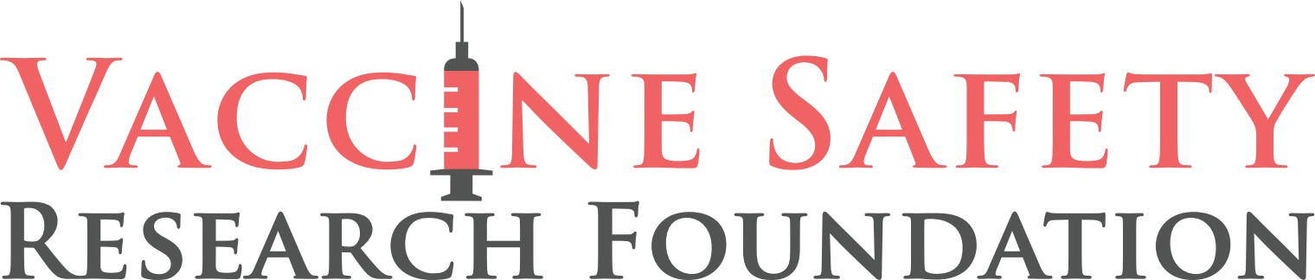

TONIGHT’S SHOW

RICHARD URSO, M.D. & RYAN COLE, M.D.

Founders of Global Covid Summit Discuss Latest Research on Harmful Side Effects of COVID-19 Vaccines (Especially for Children)

Watch the preview here.

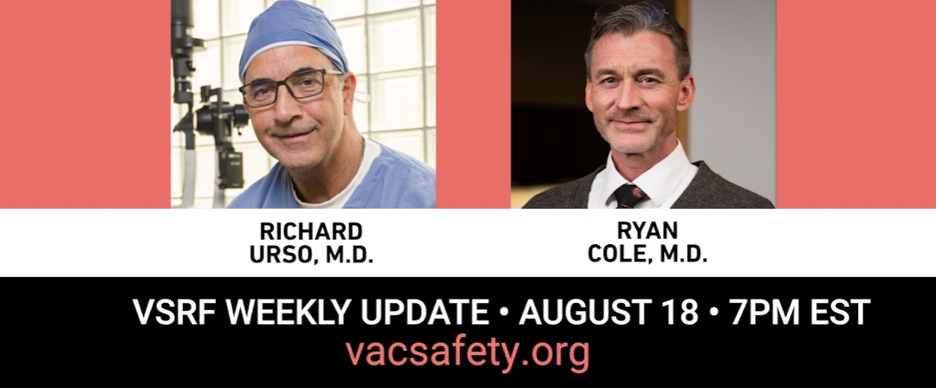

WASHINGTON, DC - Join us tonight, Thursday, August 18 at 7pm Eastern/4pm Pacific, for the VSRF Weekly Update. Richard Urso, M.D. and Ryan Cole, M.D. founders of the Global Covid Summit (GCS), will share the current news and their recent GCS summit in Ireland.
They will also share the latest research on the harmful side effects (especially in children) of the COVID-19 vaccines. They will discuss the following:
- The CDC’s admission of its mishandling of the COVID-19 crisis and overhaul of the agency.

- Spike harms, potential long hauler, and vax injury mechanisms of action, and treatments.

- The Thai pre-print study which found harmful cardiovascular effects of the mRNA COVID-19 vaccines on adolescents.

- The American Heart Association’s research into the route the Spike Protein takes to damage heart muscle cells.

Bring your questions for a full Q & A!

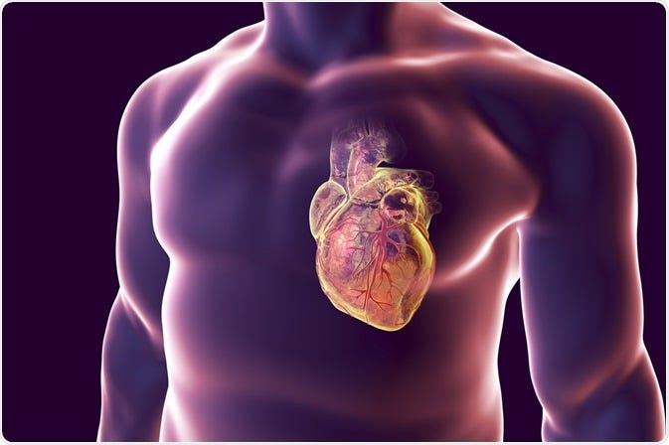

Register here to watch on Zoom
Live stream on Rumble

CONTACT: Trevor FitzGibbon
(Cell) 704-775-0487
TrevorFG@Protonmail.com

-33-

