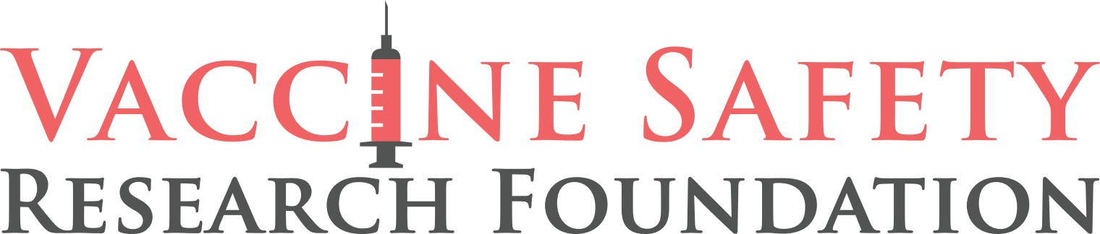

TONIGHT: Pfizer Whistleblower Brook Jackson and Attorneys, Robert Barnes and Warner Mendenhall

She was fired on the same day she blew the whistle.

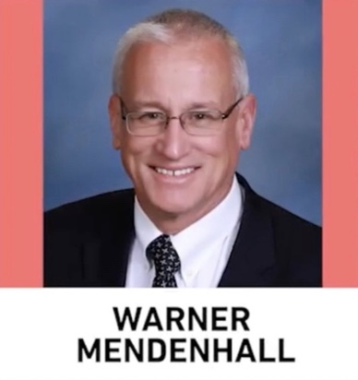
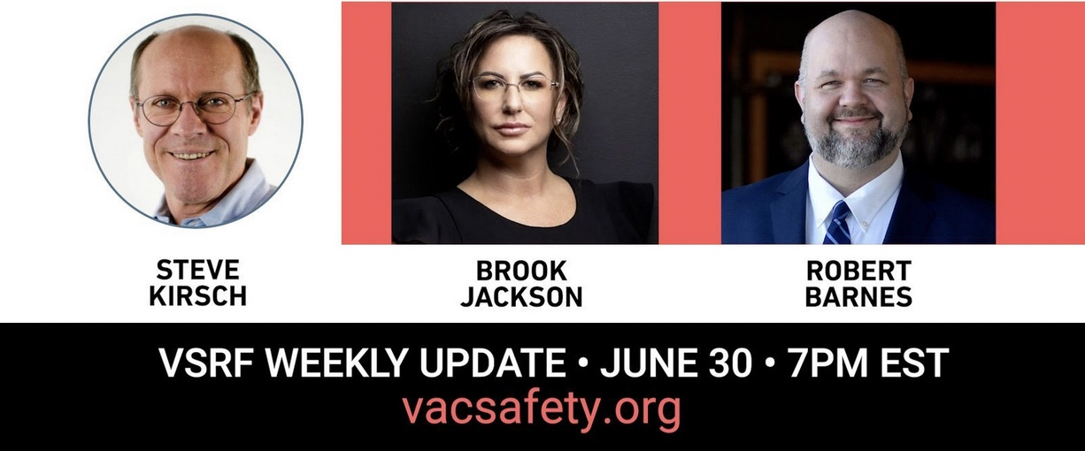

WASHINGTON, DC - Tonight, the Vaccine Safety Research Foundation (VSRF) will speak with Pfizer whistleblower Brook Jackson. Joining her will be two of her legal counsel, Civil Rights attorneys Robert Barnes and Warner Mendenhall who will discuss Big Pharma’s growing legal problems and the status of various mandate lawsuits across the country.
As a regional director of Ventavia Research, Jackson revealed that the company falsified data, unblinded patients, employed inadequately trained vaccinators, and was slow to follow up on adverse events reported in Pfizer’s pivotal phase III trial. Six hours after filing a complaint with the FDA, she received a phone call from her boss, informing her of her termination.
The credibility and significance of her story rose to prominence following its publication in the British Medical Journal (BMJ). And despite Pfizer’s harassment and legal games Jackson and her legal counsel face, they are pushing this as fast as possible.
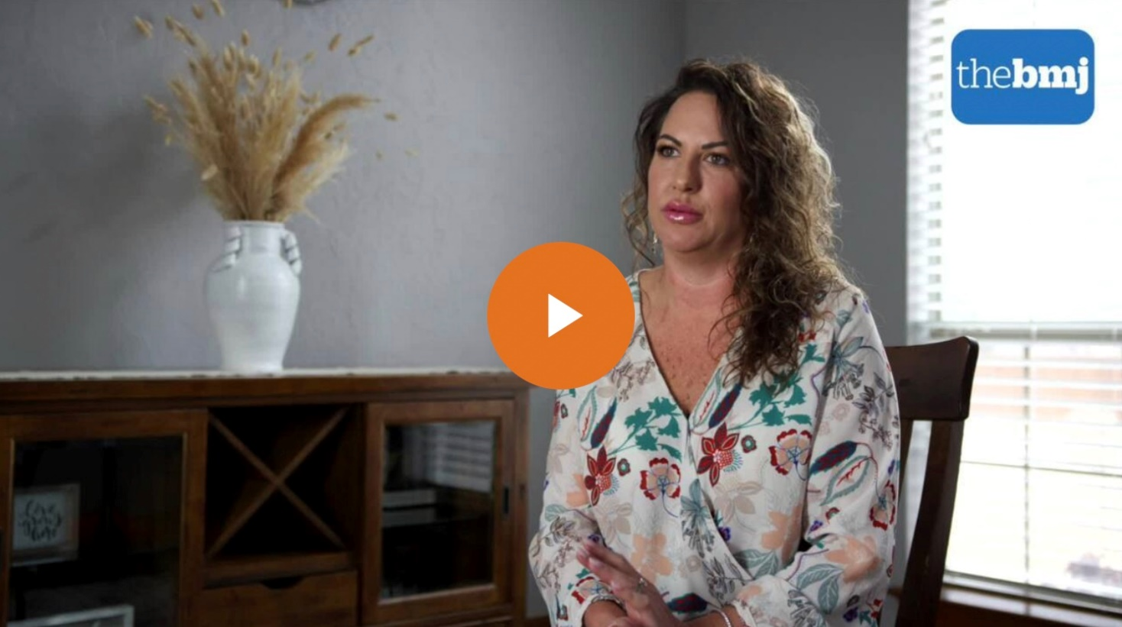
Presently, Pfizer has filed a motion to dismiss the case. Jackson’s response to the motion to dismiss is due by August 6. There is a stay on discovery until the judge rules on the motion.
When asked what led her to blow the whistle, Jackson said, “I had a powerful sense of personal responsibility: I was proud of my industry and being part of Pfizer’s vaccine study. I understood that data integrity and the safety of the people volunteering to be in this trial was paramount.”
“Fast forward nearly three years - I no longer recognize the country I live in and have lost trust in the authorities responsible for protecting public health.”
Jackson continued, “I will continue to bring attention to the clinical trial fraud until those responsible are held accountable and until every single vaccine victim is recognized.”

Register here to watch on Zoom
Live stream on Rumble
CONTACT: Trevor FitzGibbon
(Cell) 704-775-0487
TrevorFG@Protonmail.com

-33-

Vaccine Safety Research Foundation, a project of The Kirsch Foundation 4546 El Camino Real B10 #182
Los Altos, CA 94022

