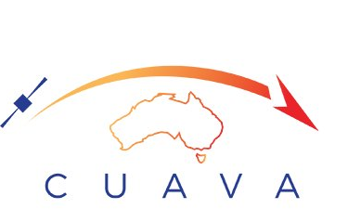

Waratah Seed Satellite Interface Control Document

PREPARED BY: XUELIANG BAI,
Youngho Eun,
Patrick Oppel
Reviewed BY: Xiaofeng Wu

aPPROVED bY: Iver Cairns

date: 22/03/2022
POC: patrick.oppel@sydney.edu.au, x.bai@sydney.edu.au

Revisions
 | Version No. | Author | Change Log
19/07/2021 | V1.0 | XL , YH | First release
6/08/2021 | V1.1 | XL | Small tweaks on wording and project schedule
17/08/2021 | V1.2 | XL | Change of project schedule
23/08/2021 | V1.3 | IC, XL | Small tweaks on wording and project schedule
02/09/2021 | V1.4 | XL, IC | Minor changes to the UART connection description
02/09/2021 | V1.5 | XL, YH | Adjusted the stack to increase payload volume to 21.6mm  Updated WS-1 CAD in Figure 2
22/02/2022 | V1.6 | PO, XL | Updated electrical interface  Revised project schedule  Copyright
22/03/2022 | V1.7 | XL | Corrected the max. height for 0.5U, 0.75U and 1U in section 4.5.1

Table of Contents
1. Introduction and Scope 4
2. WS-1 Bus design 4
2.1. Bus design based on CUAVA-1 heritage 4
2.2. Bus capability Summary 5
2.3. Payload Computer Design 6
2.3.1. Payload Computer Design Overview 6
2.3.2. Payload Computer Communication interfaces 6
3. WS-1 Software Design. 7
3.1. KubOS overview 7
3.2. Kubos Core Services 7
3.3. Mission Applications 7
3.4. Designing Payload API and Service 8
4. Payload Interfaces 9
4.1. Electrical Interface 9
4.2. Power budget 9
4.3. Power constraints 9
4.4. PC104 interfaces 9
4.5. Mechanical Design: 10
4.5.1. Standard mechanical interface 10
4.5.2. Customized mechanical interface for larger payloads 11
5. WS-1 Design Restrictions and suggestions 12
6. Qualification Testing/Flight Acceptance and Licencing 12
7. Project Schedule 12

Introduction and Scope
Waratah Seed is intended to be Australia’s 1st Ride-Share satellite and the first NSW-built satellite (specifically a 6U CubeSat) focused on space industry & commercial applications. Waratah Seed is a pilot space qualification project to launch NSW-developed space technology into orbit to test and prove functionality. The project is focused on developing Australia’s space sector, particularly NSW space industry.
The Waratah Seed project is led by the ARC Training Centre for CubeSats, Uncrewed Aerial Vehicles (UAV) and their Applications (CUAVA). CUAVA is funded by the Australian Research Council. Working with its academic, industry and government partners, its primary mission is to train the next generation of workers in advanced manufacturing, commercial space, and UAV applications. In doing so CUAVA will develop new instruments and technology to solve crucial problems, and develop a world-class Australian industry in CubeSats, UAVs, and related products. CUAVA has been in operation since December 2017, with headquarters at the University of Sydney. As well as CUAVA, the Waratah Seed partners are the Australian Centre for Space Engineering Research (ACSER) at University of New South Wales (UNSW), Saber Astronautics, Delta-V Space Hub, Macquarie University and the University of Technology Sydney (UTS).
The design of the Waratah Seed-1 (WS-1) Satellite bus is based on the 3U CUAVA-1 CubeSat bus, but with upgraded ADCS system and an additional high-speed communication system subject to requirements and contribution. This document is created to provide a concise overview of the various interfaces of WS-1 for payload developers. The satellite design is subject to changes due to payload requirements and budget constraints before the CDR stage without prior notice. It is recommended to reach out to the Waratah Seed engineering team after using this document to guide your initial payload design.

WS-1 Bus design

Bus design based on CUAVA-1 heritage
The satellite bus is mainly designed using commercial-off-the-shelf (COTS) products as listed in Table 1.
Table 1: WS-1 bus components
Subsystems/Functional components | Component Description | Source
On-board controller (OBC) | ISIS iOBC Onboard computer | https://www.isispace.nl/product/on-board-computer/
Full duplex UHF/VHF transceiver | ISIS.TrxVU full duplex radio | https://www.isispace.nl/product/cubesat-antenna-system-1u-3u/
Deployable VHF/ UHF antenna system | ISIS.deployable antenna system | https://www.isispace.nl/product/isis-uhf-downlink-vhf-uplink-full-duplex-transceiver/
Electrical power system (EPS) and battery pack | ISIS Compact EPS Type C (8 outputs and 4 battery pack, 45Whr) | https://www.isispace.nl/product/modular-electrical-power-system/
S-band communication system | Satlab SRS-4 Full-duplex High-speed S-band Transceiver | https://www.satlab.com/products/srs-4/
S-band Antenna | S-band patch antenna | https://www.iq-spacecom.com/products/antenna-s-band
Solar Panels | ISIS Modular Solar Panels (MSP) for 6U structure | https://www.isispace.nl/product/isis-cubesat-solar-panels/
Attitude Determination and Control system (ADCS) | CubeSpace CubeADCS 3-axis reaction wheels (1-3Deg pointing accuracy) | https://www.cubespace.co.za/products/integrated-adcs/3-axis/
Satellite Structure | ISIS 6U CubeSat Structure | https://www.isispace.nl/product/6-unit-cubesat-structure/
Payload OBC | In-house designed, can be customized subject to payload providers’ requirement | Based on the Pocket Beagle opensource design: https://beagleboard.org/pocket
Flight Preparation Panel and debug interface panel | In-house designed, can be customized subject to payload providers’ requirement
Included in the above bus components is a high-speed communication system to increase the downlink bandwidth. The probable high-speed radio system is written above but is yet to be confirmed. If a payload has large data needs then these need to be communicated to the Waratah Seed team; meeting these needs may require additional financial contributions to be made by the payload team.
Optionally, we can add a star tracker to increase the pointing accuracy to 0.5-0.1 degree (subject to payload provider’s requirements and contributions).
A system diagram, with assumed payloads, is shown in Figure 1.
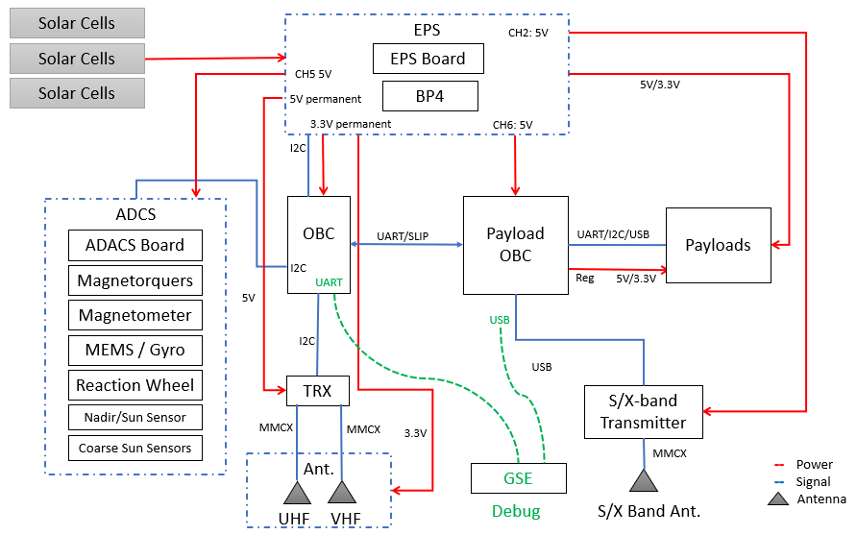
Figure 1: WS-1 system diagram
Note that most of the payloads shall be connected to the payload OBC rather than the satellite OBC unless specified otherwise. Both the satellite OBC and the payload OBC will be running a customized Linux (KubOS, as discussed in section 3). It is possible to have a second payload OBC if the number of the payloads is more than the payload OBC ports. The satellite OBC and the payload OBC(s) are connected via the Serial Line Internet Protocol (SLIP) interface as point-to-point ethernet connection(s). Each telecommand uplinked to the satellite radio(s) will be enveloped by a “space packet” (https://public.ccsds.org/Pubs/133x0b2e1.pdf), where the command ID, IP address, port number etc. are specified. When received by the satellite radio, the radio service will distribute the command to the correct payload service. For more details about the radio service, please refer to SW-1 Preliminary Design Review.

Bus capability Summary
CPU: 400MHz, 32-bit ARM9 CPU
RAM: 32MB SDRAM
SD-Card: 2 x 2GB
UHF/VHF data-rate: 9600bps
S-band (TBD): 4Mbps
Pointing accuracy: 1-3 Degree
Solar panel power: ~20W
EPS and battery: 6 configurable outputs (5V or 3.3V) with battery maximum depth of discharge 7.5Whr
Bus volume (without payload computer): approximately 1.5U as shown in Figure 3.
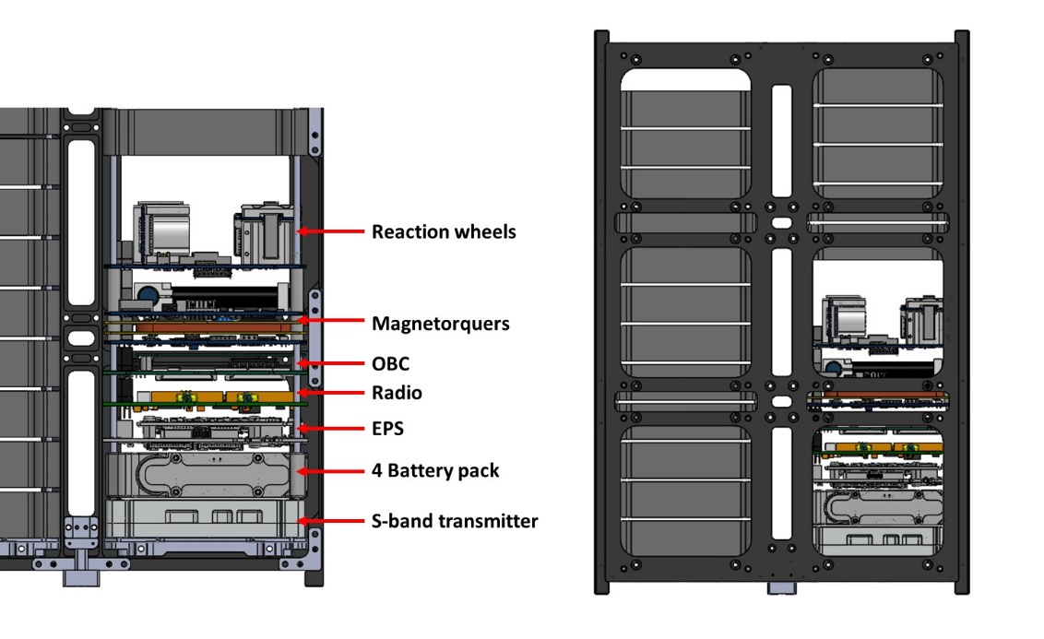
Figure 2: Waratah Seed Bus Design

Payload Computer Design

Payload Computer Design Overview
The payload computer design is still in progress. The design will be based on the Pocket Beagle design (https://github.com/beagleboard/pocketbeagle).
The payload computer will be connected to a 5V@2A power channel. It will include a power selection chip to select and deliver 5V@1A to up-to 12 payloads. It is recommended to use a Beaglebone Black or Pocket Beagle board to test the software interface during payload development. Depending on the number of payloads, it may be possible to add a second payload computer on the WS-1.
Before payload delivery, the Waratah Seed or CUAVA team will provide a payload computer to the payload team to test the software interface.

Payload Computer Communication interfaces
- UART (3 sets): 6pin picoblade connector. up to 500kbps (115.2kbps if using Serial Line Internet Protocol (SLIP)) LSB first, no parity, 8 data bits, 1 stop bit
- I2c (up to 6 devices): 6pin picoblade connector. 400kbps
- USB hosts (4 sets via a USB hub controller): Considering TF38-22S-0.5SV (pin allocation TBD)
- USB slave: Reserved for debug
- Ethernet port (1 set): Considering FPC or nano Dsub (pin allocation TBD).

WS-1 Software Design.

KubOS overview
The flight software is developed in-house by the CUAVA software team at the University of Sydney based on an open source embedded Linux named KubOS (Kubos, n.d.). KubOS is a package framework that runs directly on satellite hardware combining a customized Linux distribution, subsystem APIs, and core services. It provides some of the core functions for satellite developers such as File Transfer Protocol, mission scheduler etc.
Due to power constraints imposed by the ISIS OBC, we are designing a payload computer as discussed in Section 2. The payload computer(s) will also use the KubOS platform and will connect to the OBC via a point-to-point ethernet connection. The CUAVA team will provide the CROSS compiler for either of the computers and it is NOT necessary to design your software API and service again in the case that we want to relocate your payload from payload computer to the OBC.
The OBC software architecture is shown below.
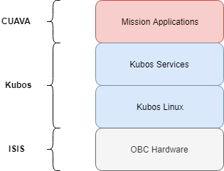
Figure 3 - Architecture Overview
- Mission Applications: Governs the behaviour of the satellite
- Kubos Services: Core and hardware services for interacting with the satellite, including services for mission specific bus components and payloads
- Kubos Linux: Custom Linux distribution designed for embedded devices
- OBC Hardware: ISIS on-board computer and in-house design payload computer

Kubos Core Services
Core services provide critical flight software capability but do not interact with hardware. The payload Concept of Operation (CONOP) will be based some of all of the below core services. They are developed by Kubos and currently include:
- Shell service (design by CUAVA)
- Telemetry database service
- File transfer service
- Process monitoring service
- Application service/registry
- Monitor service

Mission Applications
Handle all the onboard decision making and form the backbone of the satellite’s operation. The payload service will be based some of all of the below mission applications. The applications can include but are not limited to:
- Bootup and initialisation
- Time management
- Command processing
- Telemetry processing
- Data storage
- Fault protection
- Payload operation, logging and monitoring
There are also some mission specific Applications heritage from the CUAVA-1 mission that can be used for payload CONOP design:
- Radio inhibit and antenna deployment application
- ADCS commissioning and detumbling application
- ADCS pointing application

Designing Payload API and Service
Each payload on the satellite will require its own software for operation that will interface with the mission application software. When the payload is delivered, it shall come with functional payload Application interface (API) and service for testing (we can NOT consider the payload as “delivered” without a working service), it is possible to deliver your payload Application(s) after the payload hardware is delivered and before the environmental testing.
In addition to the documentation provided by KubOS, the CUAVA team also has tips and guides in our group wiki and code template to assist your payload service software design. The Waratah Seed and CUAVA teams will also provide workshops to get your team started and support during your development process.
The services discussed above, together with the ground station terminal software forms the Mission Architecture as shown below:
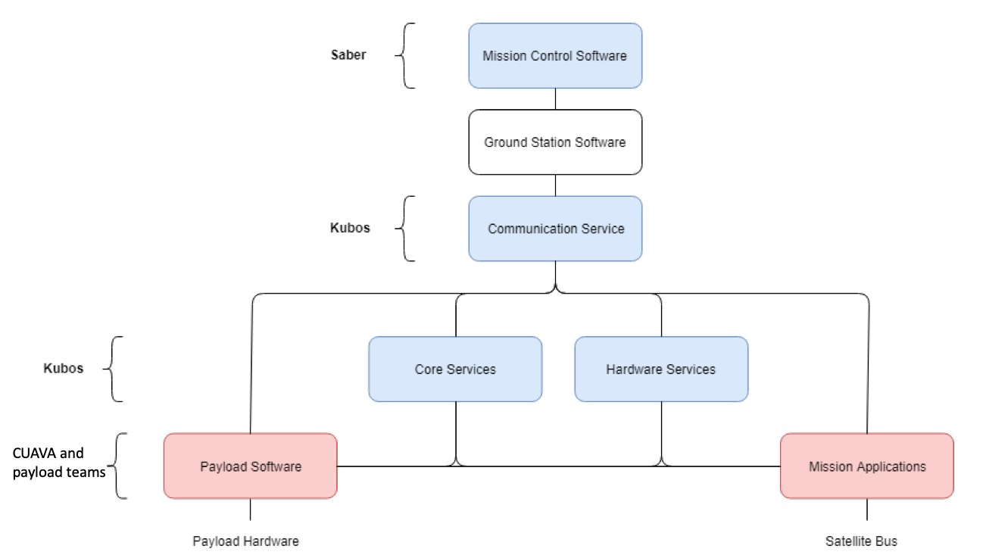
Figure 4 - Mission Architecture

Payload Interfaces

Electrical Interface
As mentioned in Section 2, ALL payloads shall be connected to the payload computer unless the Waratah Seed team specifies otherwise. The power will be delivered in the same connector with the communication bus from the payload computer. You can choose from UART, i2c interfaces (slave devices only), USB Host or Ethernet:
- UART (4 sets): 6pin picoblade connector. up to 500kbps (115.2kbps if using Serial Line Internet Protocol (SLIP)) LSB first, no parity, 8 data bits, 1 stop bit I2c (up to 6 devices)
Pin | Connection | Wire colour
1 | GND | Blk
2 | 5V/3.3V | Red
3 | RxD | Yellow
4 | TxD | Orange
5 | GND | Brown
6 | 5V/3.3V | Green
- i2c (Slave only): 6pin picoblade connector. Up to 400kbp, pull up resister already exist on the payload computer.
Pin | Connection | Wire color
1 | GND | Blk
2 | 5V/3.3V | Red
3 | SDA | Green
4 | SCL | Brown
5 | GND | Blue
6 | 5V/3.3V | White
- USB and ethernet connectors: please consult the Waratah Seed team for availability and pin allocations.
The allocation of the electrical interface allocation (especially for UARTs) will follow a first in first served principle and be subject to coordination between payload teams.
6-pin picoblade connector is recommended and should be easily accessible for integration/reintegration. For UART and i2C, and we generally encourage pin 1 to pin 1 connection. Please specify in your ICD if designed differently. Note that other connector types may introduce higher cabling cost.

Power budget
For a nominal ~500km SSO orbit, WS-1 payloads will have approximately 5.0 watt-hours (Whr) available per orbit. This may be improved depending on utilisation of ADCS and mission pointing requirements.

Power constraints
All payloads with size 0.5U or smaller shall restraint the power consumption below 5W@5V1A. For larger payloads with higher power consumption (up to 10W@5V2A), it is recommended to directly connect the payload to the PC104 stack and obtain power from EPS directly. There is a limited number of such 5V2A power channels and please consult the Waratah Seed team for availability.

PC104 interfaces
This section is intended for i2c payloads that connect directly to the PC104 stack. The ground pins are H2-30, H2-29 and H2-32. The power channels are from H1-48 to H1-51. Due to design constraints, the number of the power channels directly from the PC104 stack will be extremely limited. Please discuss with the Waratah Seed team prior to your final PCB board design.
Note that Vbat (H2-45/46, ~8V), permanent 3.3V (H2-27/28) and permanent 5V (H2-25/25) are NOT available to the payload teams.

Mechanical Design:

Standard mechanical interface
The WS-1 satellite follows the CubeSat mechanical interface. Each stack has 4 ribs connected by 4 threaded rods. The pictures below illustrate the integration process and a complete 1U stack.
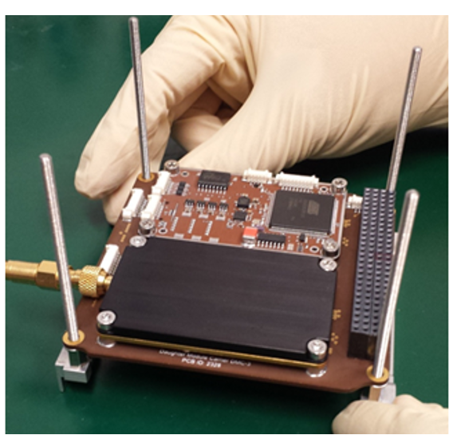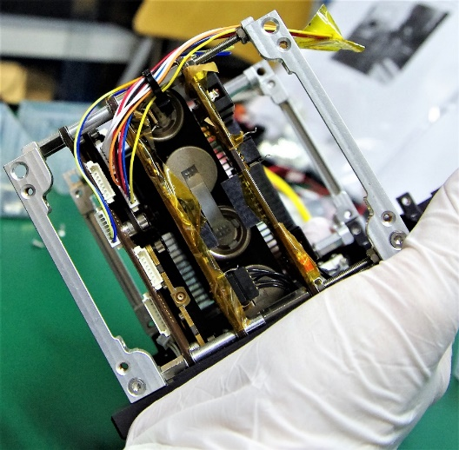
Figure 5 – Mechanical interface for PCB boards
For a standard 0.25U payload slot, the design should comply with the mechanical design as shown in Figure 6. Dimensions are given in mm. If your payload is selected, the Waratah Seed team will provide satellite CAD to guide your design. The mechanical interface (Metrics, mm) for the CubeSat standard PCB is shown in figure 6 (referenced the Pumpkin satellite CubeSat Kit PCB Specification). The imperial version of the drawing is attached in Annex 1.
Note that even if you are not using the PC104 stack for electrical interfaces, it is recommended to have it in place to increase the mechanical integrity of the stack. It is possible to have an alternative mechanical mounting design if the Waratah Seed team agrees following detailed discussions.

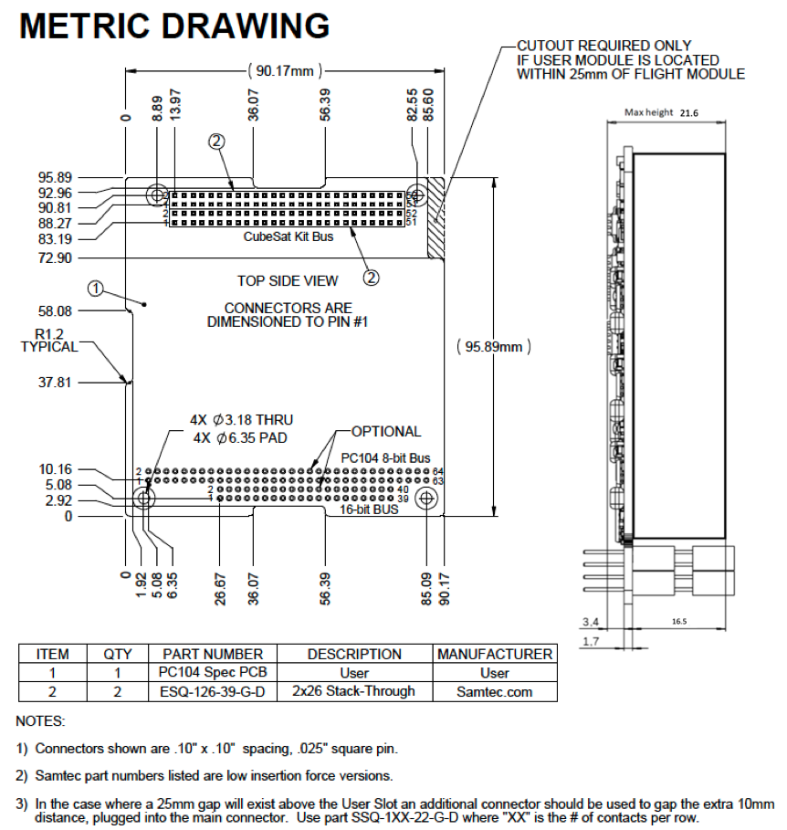
Figure 6 – WS-1 payload mechanical interface (measurements shown in mm) *
* For a 0.5U, 0.75U, 1U payload slot, the maximum height is 45.2mm, 68.8mm and 92.4mm respectively (Pin header height shall change accordingly). For 0.5U and larger payload slots, it is possible to customize design the mechanical interface subjective to discussion with the Waratah Seed team.

Customized mechanical interface for larger payloads
For 0.5U or larger payloads, it is possible to design a customized mounting structure. It is also possible, for larger payloads, to have apertures and to protrude outside the satellite structure for up to 6.5mm (subject to launcher’s requirements). However, the location of the apertures, protrusions and customized structure designs will be subject to other design constraints (i.e. ADCS design, solar panel design etc.). If customized design is desired, please discuss with the Waratah Seed team as early as possible and certainly before 30th Dec 2021. Such customized design may also involve extra costs.

WS-1 Design Restrictions and suggestions
- No battery or supercapacitor is allowed on the payload. The payload MCU will sync the time with the OBC when start/restarted if time-stamped payload operation is required.
- Use Surface Mounting Components (SMC) where possible for better vibration and vacuum performance.
- All mechanical design shall specify 10μm (or lower) as tolerance to the manufacturers
- Conformal coating is welcomed for flight models
- Please use NASA’s outgassing data to guide your material selection: https://outgassing.nasa.gov/. CUAVA recommends the below glues and tapes based on our past missions:
- Thermal Tape: Sigraflex Foil F05010E or F05010TH or Cho-therm 1671
- Aluminium tape: 3M™ Aluminium Foil Tape 425 and 435 (425 has been tested in vacuum chamber).
- 3M Scotch-Weld 2216 Epoxy
- UHU 300 Epoxy
- Thread locker: Loctite 243 (Not included in the NASA database but widely used)

Qualification Testing/Flight Acceptance and Licencing
All WS-1 payloads shall complete a vibration test for sinusoidal and random vibration unless waived by the Waratah Seed engineering team. A recommended qualification level is shown in Table 2. The acceptance test level will be updated once the launch vehicle is selected.
Table 2 Recommended Acceptance test level (NASA GEVS Table 2.4-3).
Frequency (Hz) | ASD Level (g²/Hz)
 | Acceptance
20 | 0.013
20 – 50 | +6dB/Oct
50 – 800 | 0.08
800 – 2000 | -6dB/Oct
2000 | 0.013
Overall | 10 G_{rms}
Duration (minutes/axis) | 2
Thermal vacuum test is recommended but not mandatory. The Waratah Seed team reserves the right to require a thermal bakeout if a payload sensitive to outgassing (i.e. an optical payload) is selected for WS-1.
All payloads that generate RF signals (for both communication and non-communication purposes) must coordinate with the Waratah Seed team after selection to obtain frequencies coordination provided by International Amateur Radio Union (IARU), and International Telecommunication Union (ITU).

Project Schedule
We aim to deliver the WS-1 satellite by January 2023, with launch in April 2023. The Waratah Seed team needs to provide a 6-month notice (TBC) if we want to delay the launch. Also, the Waratah Seed team will need at least 4 months to assemble, integrate and test the WS-1 satellite prior to delivery. Please see Table 3 for the due dates for the delivery of Engineering Model (EM) and Flight Model (FM). It is not required to provide two payload models. The Service Agreement describes the conditions under which Waratah Seed may reject a payload without refund if the due dates are not or cannot be met.
The current schedule with estimated due dates is listed below.
Table 3 WS-1 Project Schedule
Milestone | Estimated Due Date
Interface Control Document | 31st August 2021
Rideshare Payload Applications close | 28th Sep 2021
Shortlisted applicants notified | 5th October 2021
Private Pitch | 19th October 2021
Public Pitch | 9th November 2021
Written applications close | 30th November 2021
Finalists and shortlist announced | 10th December 2021
Preliminary Design Review | 28th February 2022
Payload EM delivery (Payload Competition Winners) | 31st May 2022
Payload EM delivery (Commercial Clients) | 30th June 2022
Payload EM functional and vibration Testing (up to payload team) | 30th June 2022
Critical Design Review | 31st July 2022
Payload FM delivery (Payload Competition Winners) | 1st September 2022
Payload FM delivery (Commercial Clients) | 1st October 2022
FM Satellite integration and Functional testing | 31st October 2022
Environmental testing | 30th November 2022
FRR and delivery | 31st January 2023

Annex 1, Imperial (in) version of CubeSat Kit PCB specification (credit to Pumpkin Inc.) 