Models of bike share

Public bike share: self-service on-street stations (docked, virtual-hub based)
Bikes are placed on-street, typically in clusters of 5-20, either with fixed docking stations or within virtual geo-fenced hubs with markings on the ground to show the space is allocated to bike share.
The bikes are placed in key locations around the town/city and at regular intervals in between for convenience. The locking technology for the bike may be on the frame itself or embedded in the docking station.
The bikes can be returned to any station to end the hire, and with some technology it is possible to lock them on cycle parking stands if the docking station is full. Typically, pricing models encourage half hour, short hop hires, although they can be hired for longer.

Example of docking station systems - Santander Bikes in London
Example of low-tech docking station with tech on the bike - Nextbike in Stirling / Glasgow
Example of virtual-hub based bike share – Beryl bikes in Hereford & Bournemouth

Pros:
- Predictable locations for finding bikes
- Supports one-way short trips
- Highly visible stations act as a marketing tool
- They can offer access via the terminal or keypad on the bike without requiring a smart phone
Cons:
- Higher set up costs due to the on-street infrastructure required to facilitate sign up, payments and bike docking
- Sometime planning permission is required for public highway sites
- Electricity supply is sometimes required although stations are often solar powered

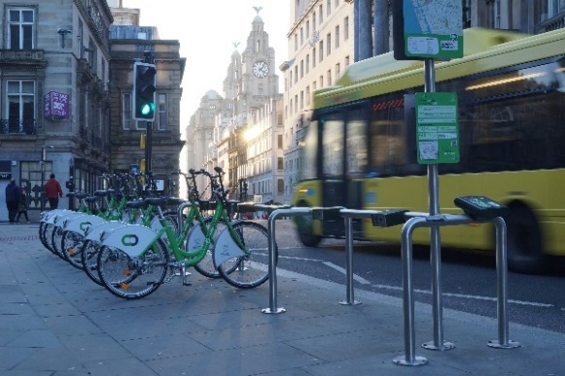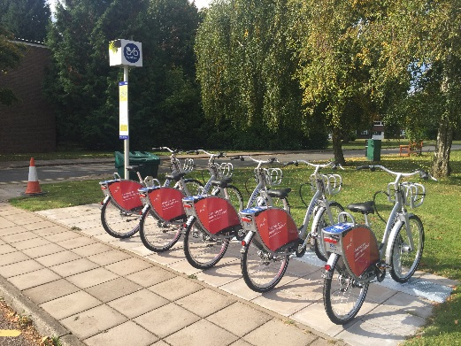

Free-floating bike share
Free-floating systems enable bikes to be dropped off at any location within a city or town’s boundaries. This system typically has similar characteristics to virtual hub-based bike share.

Example of free floating: Lime bikes - London & Milton Keynes
Pros:
- A potentially lower cost and convenient solution compared to on-street docking bike share
- Allows users to end their hire at a point convenient to them
- Can be useful in areas with limited paving space
Cons:
- Operational distribution challenges
- Uncertainty for customers finding a bike
- If not monitored, bikes can be left in awkward places for street users

Workplace pool bikes and community hubs
For many years, bikes have been offered in a shared capacity at workplaces and in communities. Typically, the bikes are all stored in one location and the keys are accessed via a designated person or through a key safe. Sometimes bikes can be booked by the hour, or alternatively hubs can offer longer loans. Community hubs are often combined with other cycling services such as secure parking, route advice and maintenance, or wider transport information.

Examples:
- The Hub, Stockton on Tees (Sustrans)
- Stirling Cycle Hub
- Nottingham Cycle Hubs
- Workplace Hubs e.g., University of Leeds
Pros:
- Support provided by member of staff at point of hire
- A physical presence acts as a visible promotional tool
- Integration with other activities
Cons:
- Restricted opening hours
- Staffing capacity
- Back to base hires only

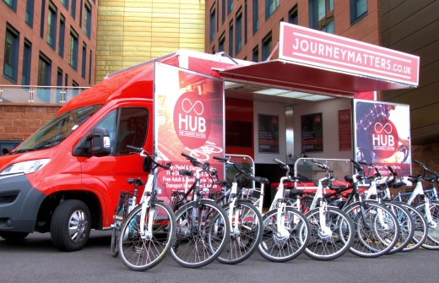
Bike libraries / loans
The concept of bike libraries is a relatively new one, although many places have offered the loan of a cycle as a ‘try before you buy’ for some time. Bikes are held in a diverse range of community locations including traditional libraries and sports centres or are brought into the community using mobile transport.

Examples of bike libraries / loans:
- Journey Matters bike loans, Rotherham
- Yorkshire bike library
- West Lothian bike Library
- Manchester e-cargo bike loans
Pros:
- Free loan of bikes or low cost
- High conversion to purchase
Cons:
- Requires organisation of partners to enable permissions and capacity

Railway Station Hubs
Bike hire at railway stations serve to offer an alternative onward travel mode. They can also be used as a central location for community bike hire. Some offer back to base hires while others can be returned to other bike hire stations, in some cases the pricing model encourages full day hire

Examples of rail station docking:
- Brompton Bike Hire, across the UK
- All city public on-street bike share schemes have bikes at rail stations
Pros:
- Integrated with rail use
- Based on national network and often requires no infrastructure to expand
- Supports longer hires
Cons:
- May require staff to access
- May require back to base hires in some instances

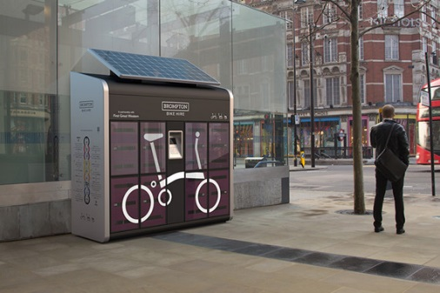
Bike share lockers
The locker model is similar to the docking station bike share scheme in that it offers self-service on-street access. Locker schemes are often back to base which can restrict who can use them, although some are one-way hires.
Examples of bike share lockers:
- Brompton Bike Hire at rail stations (offers one-way hire so you don’t need to bring it back to the same locker)
Pros:
- Lower start-up costs
- Quick to install if no planning permission is required
Cons:
- Bikes are not visible so it can be less clear what is on offer
- Most only offer back to base not one-way hires

