Self-Compassion

Prior to starting, ensure that you have viewed the homefun assignments so you can confidently review them with the client.
Hi _______________
Welcome back to the session today. We are currently in session 5 of 6 sessions. After today, we only have one more session left. I want to remind you that should you want to continue working on some of the material we have covered or explore any issues on a deeper level, it would be best to do so with your counselor, as this coaching program only covers 6 sessions.

Today we will talk about self-compassion. Before we begin with our warm up exercise, I would like to check in with you. How are you feeling in this moment, what sensations, thoughts, and emotions come up for you right now? Can you rate your mood from 1-10?

Let’s start off with our warm-up based on positive psychology….
- (If needed: The reason why we do this is to help us focus, highlight, and identify some of the positive things that you do and are doing to manage your social-emotional well-being.)

  - How has another person shown that they care about you within the past week?
  - What has happened this week that has been exciting?
  - Describe something fun that you did today.
  - What was something nice you said to someone this week?
  - Describe something that made you laugh this week.
  - Describe something you were thankful for this week.
  - What was a challenge you overcame this week?
  - What was something that made you feel happy this week?

Let’s continue now with a tangible exercise to experience the practice of self-compassion.

Exercise: Self-Compassion or “Loving Kindness” Meditation:
Like all of our short exercises, you can ideally continue to incorporate these into your day-to-day lives. Like previous exercises, these activities are based on mindfulness principles.

Take a moment to reflect on a challenge you are facing in your life.
- Now, imagine someone else facing a similar challenge.
- Can you evoke a sense of compassion or kindness toward this other person?
- Notice how this feeling of compassion feels in your body.
- Wish them well.
- See if you can extend that same quality of loving kindness toward yourself?
- Wish yourself well.

Q) What was that like? Did it feel awkward, comfortable...?

ASK THE CLIENT WHAT SELF-COMPASSION MEANS TO THEM?

Self-compassion and the practice of “loving kindness” engages us in the act of friendliness toward yourself and others.

The powers of self-compassion should not be underestimated. According to Harvard Health, self-compassion “yields a number of benefits, including lower levels of anxiety and depression…Self-compassionate people recognize when they are suffering and are kind to themselves. According to Dr. Kristin Neff, a leader in the field of self-compassion, self-compassion consists of being mindful, self-kindness and common humanity.

Ok so let’s spend some time discussing the worksheets from last week:
- Gratitude Journal (Explore if this be part of your regular practice, including gratitude towards the self e.g., Something I can be proud of is ________ )
- PRACTICES FOR BOOSTING SELF-COMPASSION (pick one to try this week)

DISCUSS HOMEWORK VIDEOS OR WATCH TOGETHER IF NEEDED

VIDEO: The Power of Self Compassion- 4 MINS
https://www.youtube.com/watch?v=BTQP7XzDxjI

Everyone has a critical voice that begins when we are children. This voice might say things like:
- I am not doing a good job
- I am not enough
- I need to do better
- I must change
- I am not worthy
- No one else makes mistakes
- You are stupid
- People do not like me
- I am too weird

Q) Are there any other statements that your own critical voice makes? (Ask Client)

Q) What would you say to a friend that has made a mistake? (Ask Client)

- It is ok
- You are holding onto this more tightly than anyone else
- It does not reflect your character

Q) How would it feel to use that same friendly voice on yourself?
- Decrease in anxiety/feeling a weight lifted
- Increased feelings of happiness and feelings of calm
- If you tell yourself you are enough, then you begin to believe it

Q) How would the world look differently with self-compassion?
- Recognize a shared common humanity
- If you extend the self compassion that you show to others, that is where true growth can happen
- Approach ourselves from a place of love rather than criticism = magical

VIDEO: Be Kinder to Yourself- 4 MINS
https://www.youtube.com/watch?v=AyQdeYjXUhE

Step 1: Think of a situation in your life that is difficult and causing your stress

Step 2: Call the situation to mind and see if you can feel the emotional discomfort in your body. Where do you feel it?

Step 3: Say to yourself, this is a moment of suffering. I can just notice what is going on for me in the present moment without judging it as good or bad. This hurts me or this is stress.

Step 4: Say to yourself that suffering is a part of life and recognition of your shared humanity with others. You might also say anything that feels right in the moment.

- Other people feel this way
- I am not alone
- We all struggle in our lives

Step 5: Put your hands over your heart. Feel the warmth of your hand and say “ May I be kind to myself?” Or choose another phrase such as

- May I learn to accept myself as I am?

Q) What statement feels most natural to you?

Q) What will your phrase be?

Do you think this 5 step process might be something you can implement when the self critical voice is very strong and present?

HERE IS ANOTHER EXAMPLE OF A PHRASE YOU CAN SAY TO YOURSELF BASED ON THE Ho’oponopono Meditation for Self Compassion, Forgiveness and Balance:
There is a beautiful Hawaiian practice called ho'oponopono, which means "bringing back to balance." This is a very self compassionate practice, grounded in forgiveness, acceptance and gratitude, that you can enact when you are experiencing difficult emotions. When you are experiencing a difficult emotions, say (you can place a hand over your heart as you do so)
"I'm sorry,
Please forgive me.
Thank you,
I love you."

How does it feel to hear these phrases? Notice if any blocks that arise within you when you attempt these phrases. Ask yourself, gently where could these blocks to self-compassion be coming from?

Beauchemin, M. (2022, January 1). Understanding ho'oponopono: A beautiful hawaiian prayer for forgiveness. Grace & Lightness Magazine. Retrieved January 3, 2022, from https://graceandlightness.com/hooponopono-hawaiian-prayer-for-forgiveness/

CHANGING NEGATIVE SELF_TALK
We are often very hard on ourselves unnecessarily.
- Most likely we would not speak to someone that we love the way that we speak to ourselves.
- Changing critical self-talk can be a challenge, but with motivation and practice, it can be done.
- The following practices can help reduce self-criticism and cultivate a more compassionate relationship with the self:
Step 1
- Increase awareness of self-criticism: in the upcoming week, try to notice when you use self-critical talk or become critical of yourself as much as possible.
- Pause and take three deep breaths.
- Notice what you say to yourself when you fail or have made a mistake.
- Are there key phrases that you say to yourself?
- What is the TONE of your voice when talking to yourself?
Step 2
- Take action, soften your critical voice
- After noticing self-critical talk, think about what you would say to a loved one in the same situation. Now use these words to rephrase what you say to yourself.
- Also pay attention to the tone of voice - How would you like to talk to yourself?
- Practice the TONE that you want to use with yourself when you are feeling great about yourself.
- Identify what you are criticizing yourself for. The inner critic can provide useful feedback but most often the way this feedback is presented is far from constructive. Try to take a “learning stance”: What can I learn from this feedback? How can I talk to myself as I would a young child who is learning about this for the first time? How can I use the inner critic’s feedback in a more motivating and constructive way?
Ask the client to reflect on this.

We are near the end of the session, so it’s time to facilitate another short exercise with you.

THIS IS A DIRECT EXCERPT FROM MBSR PROGRAM HANDBOOK (MaineHealth Community Education Program/Bitterauf, 2016, p. 27):

Gaining a sense of yourself, and cradling the sense of yourself in your awareness, repeat these words silently to your own sense of self:
May I be safe
May I be happy
May I be healthy
May I live with ease

Maybe it seems artificial and stilted to say such things to yourself, for yourself. Maybe you’re not feeling loving kindness in this moment - and that’s okay. Whatever you’re feeling, you can hold the intention of loving kindness... offering it from wherever you are... however you are now...
So practicing once more, noticing how you may be drawn towards this practice or away from it: May I be safe
May I be happy
May I be healthy
May I live with ease

Now develop an image or think of someone you love or care about and repeat these words silently:
May you be safe
May you be happy
May you be healthy
May you live with ease

And now exploring the experience of moving loving kindness outward again, bringing to your heart and mind someone to whom you feel neutrally towards- neither disliking nor liking them and offering these wishes:
May you be safe
May you be happy
May you be healthy
May you live with ease

Now, moving towards a person who you dislike or is difficult to deal with. Holding them in your awareness and sending loving kindness with these phrases...
May you be safe
May you be happy
May you be healthy
May you live with ease

Now we will expand this out further ... gain a sense of your family and / or local neighborhood and community and hold this, with a sense of yourself included and repeat silently:
May we be safe
May we be happy
May we be healthy
May we live with ease

Now gain a sense of all sentient beings in your world, with a sense of yourself included and repeat silently again:
May we be safe
May we be happy
May we be healthy
May we live with ease

Ask client to rate their check out mood from 1-10

Ask client to identify the takeaway(s) from today’s session

Home Practice - NEXT SESSION THE CLOSING TOPIC WILL FOCUS ON DEVELOPING YOUR MINDFULNESS DAILY LIVING PLAN

Videos:

Being With All of Your Experiences- 3.5 MINS
https://www.youtube.com/watch?v=jaNAwy3XsfI

Everyday Mindfulness - 5 MINS
https://www.youtube.com/watch?v=QTsUEOUaWpY

    - What are the main points of each video?
    - What skills/strategies did I learn?
    - How can I apply these skills to my own situation?

Read and/or work on handouts:
- The Mindful Month Calendar (try out a mindful week)
- Daily Mindfulness (pick one of either a formal or an informal practice each day)

End of Session 5

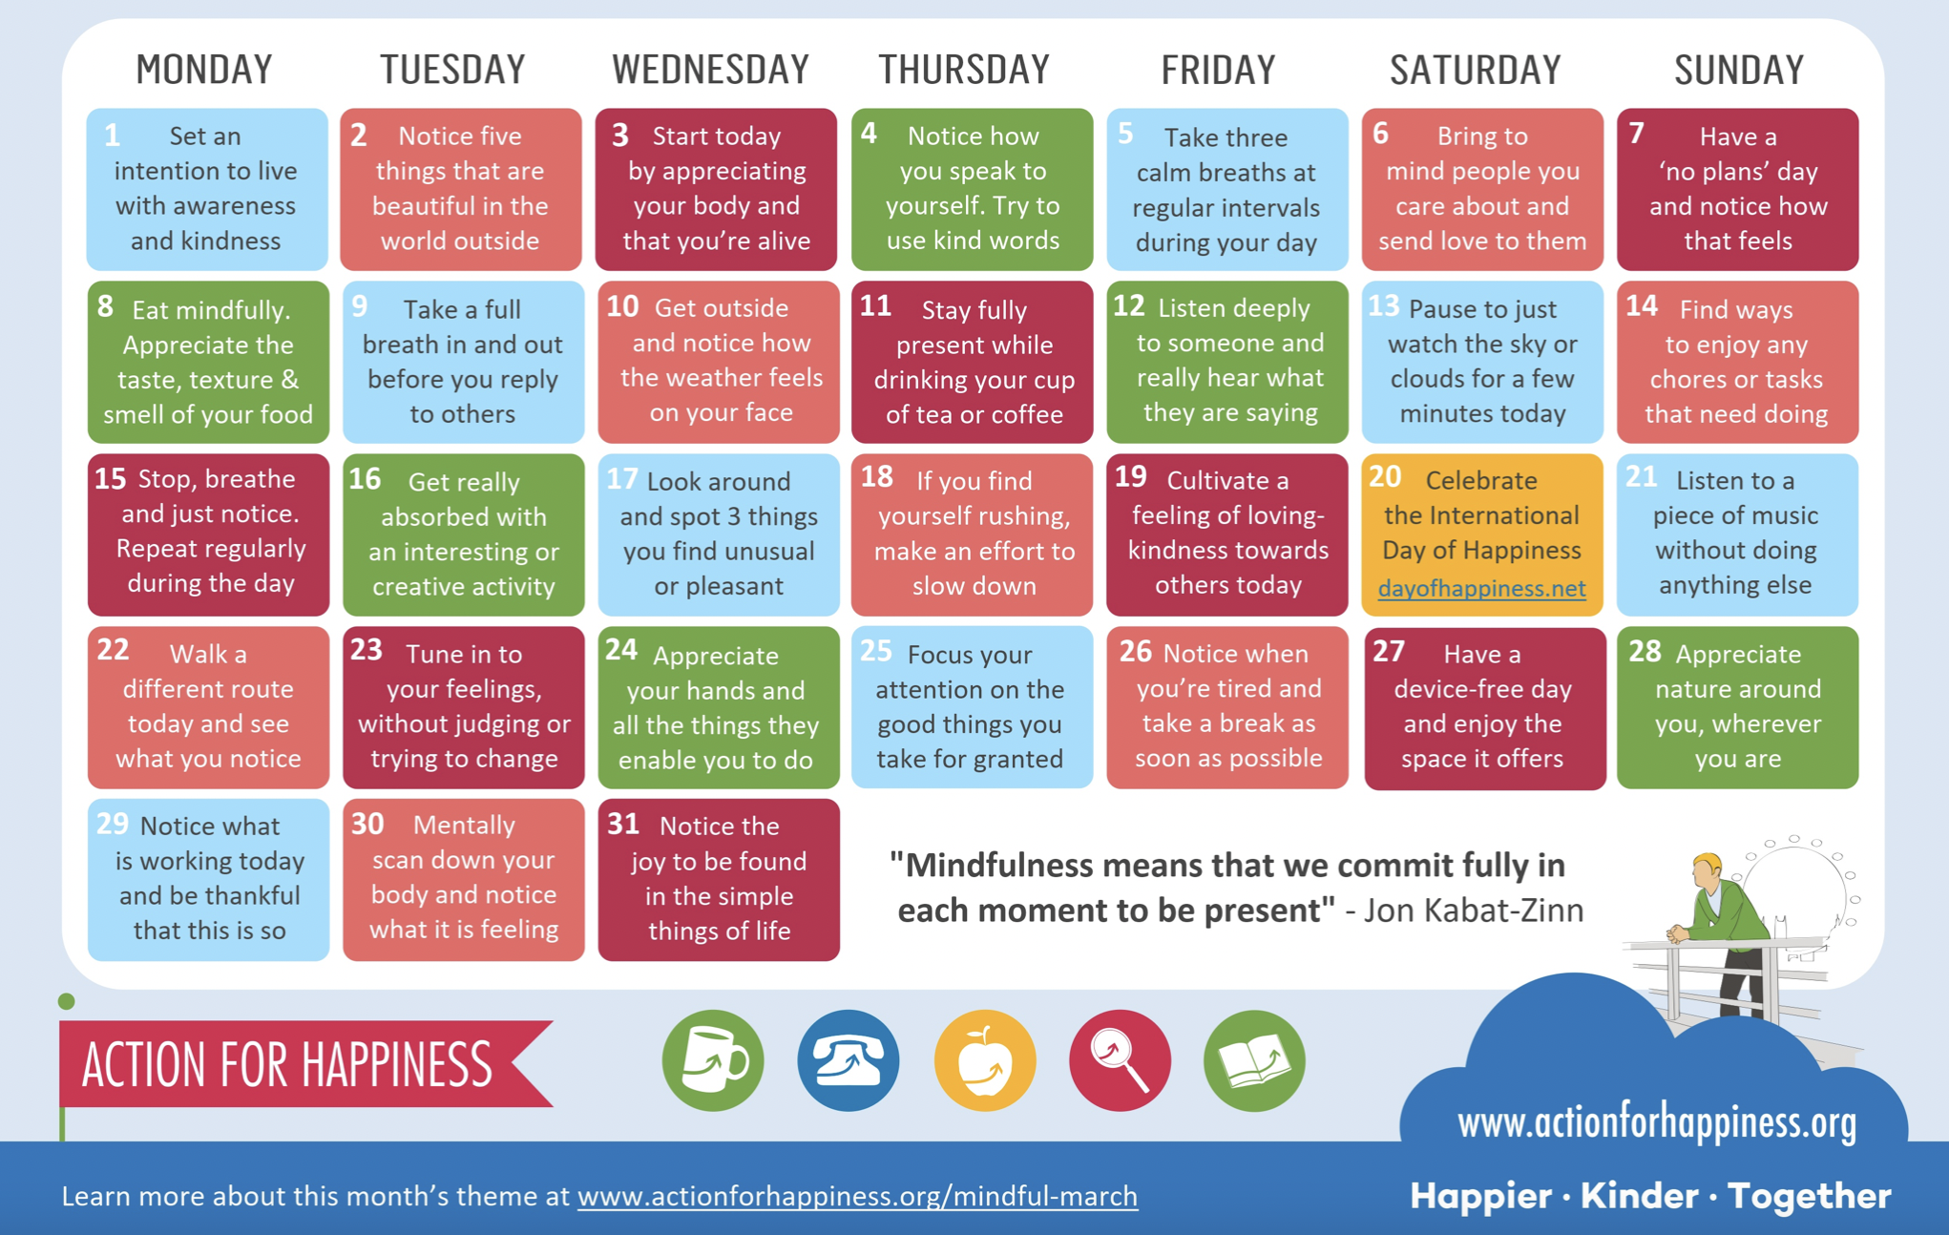

THIS IS A DIRECT EXCERPT FROM THE DBT ASSIGNMENT WORKBOOK (Pipitone & Doel, 2020, p. 1-2):

