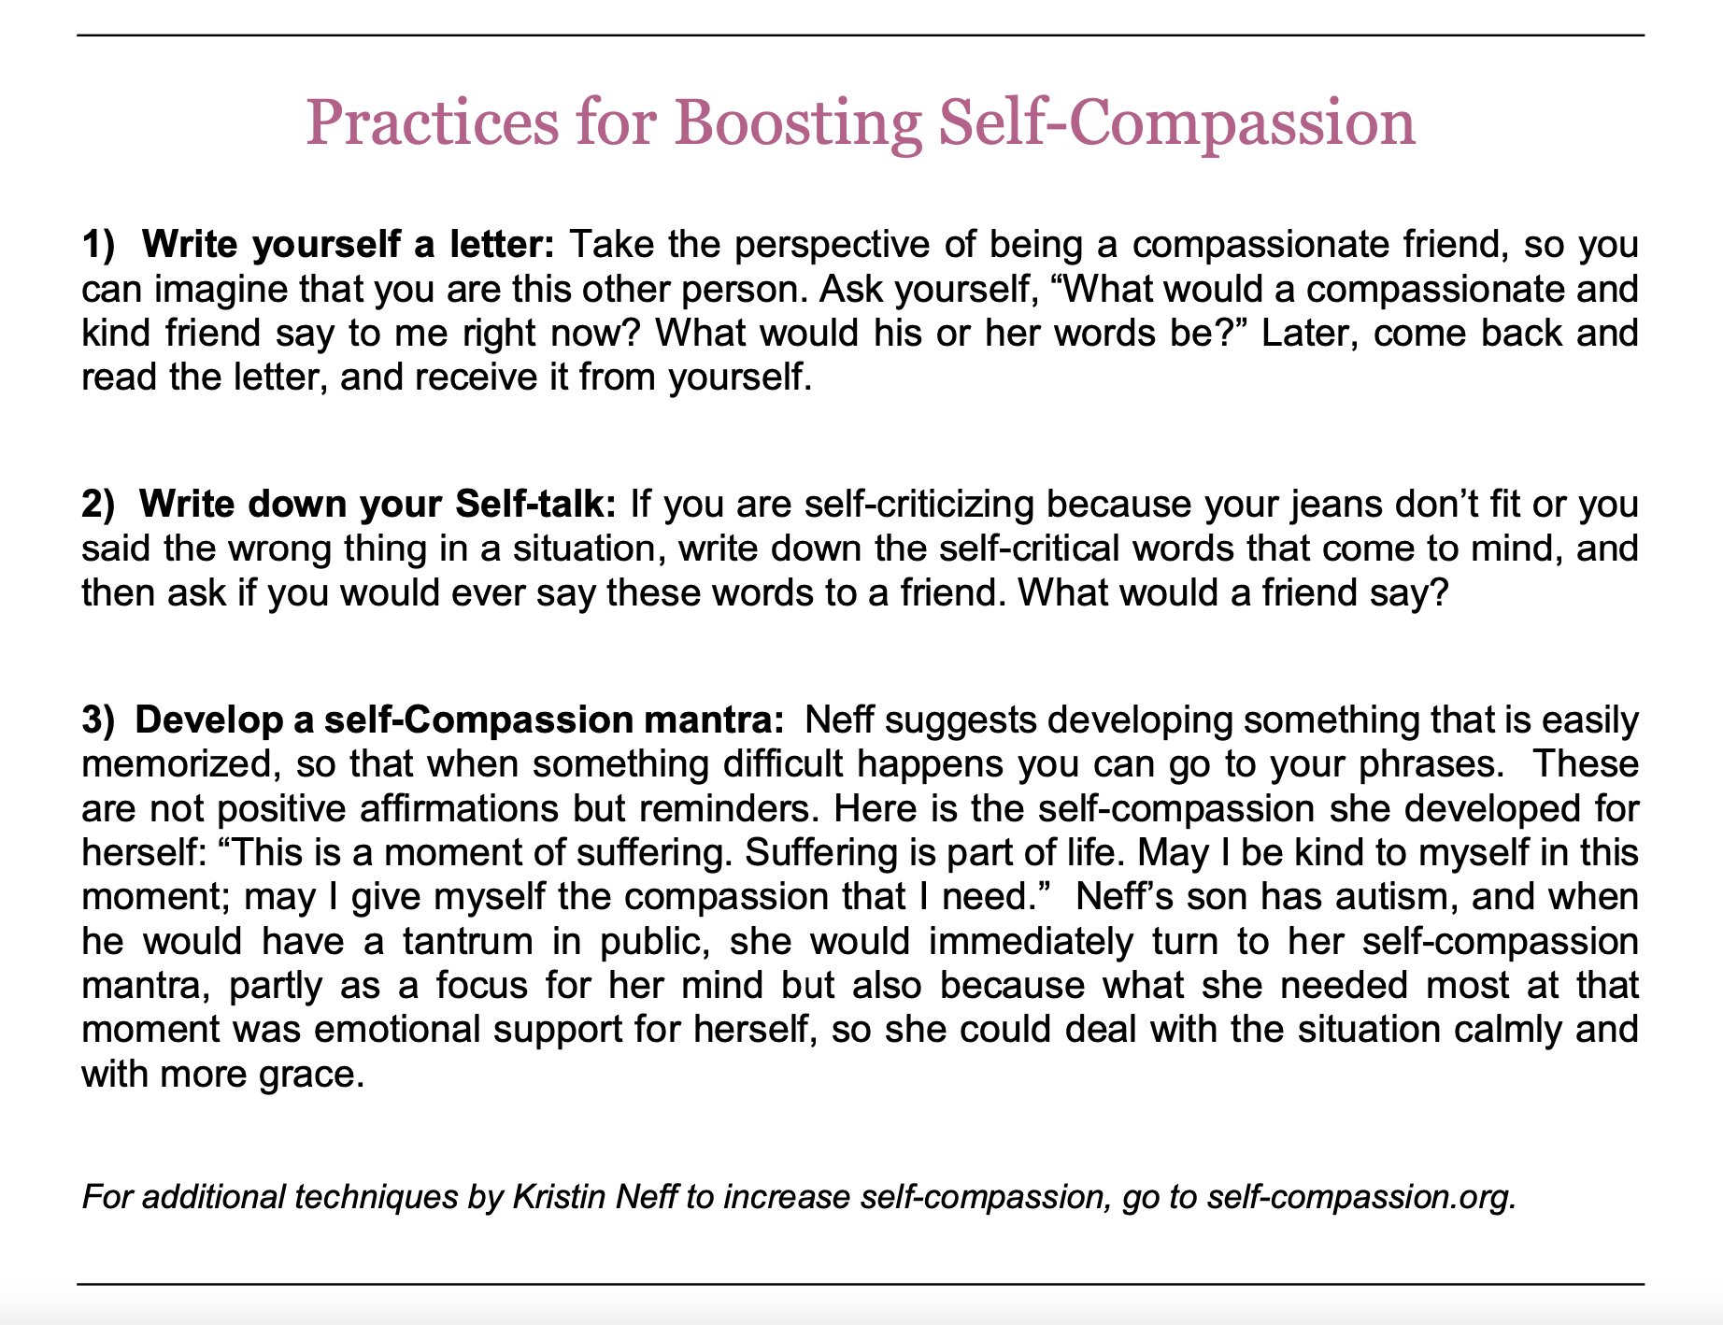
Palouse Mindfulness MBSR course www.palousemindfulness.com

