Fongo Quick Guide

- Using fongo will allow you to communicate with your clients using your own phone, but with a different phone number.
- Local calls on fongo are free
- Voice mail is free
- You can purchase a text messaging plan: $2.79 for 1 month, $5.49 for 3 months, or $9.99 for 6 months.

Instructions for downloading and setting up a fongo number:

- Download fongo through your app store
- Once downloaded, open the app and click ‘register’
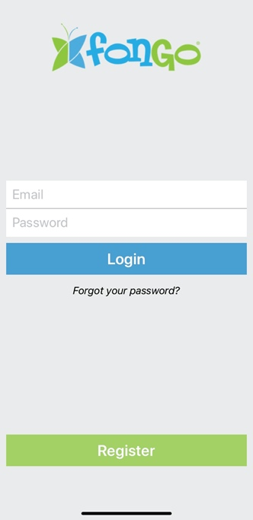
- Fill in the information requested to create an account (email, and password) and press continue
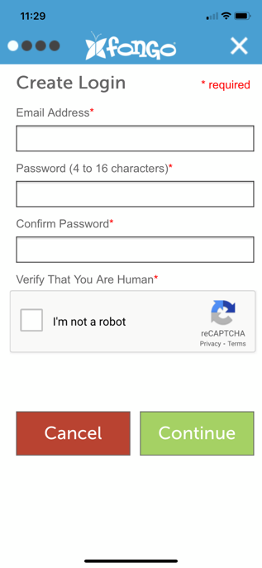
- Choose the province and city you are located in. Once you choose those, the ‘select phone number’ drop down menu will populate, and you can then choose a phone number that will be your fongo phone number.
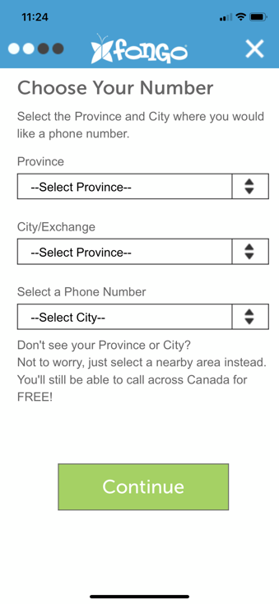
- You will now need to fill in information for 911emergencies (this is a requirement for all phone numbers in Canada).
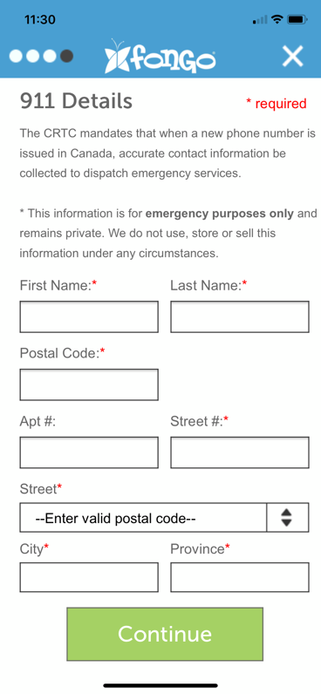

- Lastly, you will need to review the terms and conditions and checkmark that you have read them, then press finish
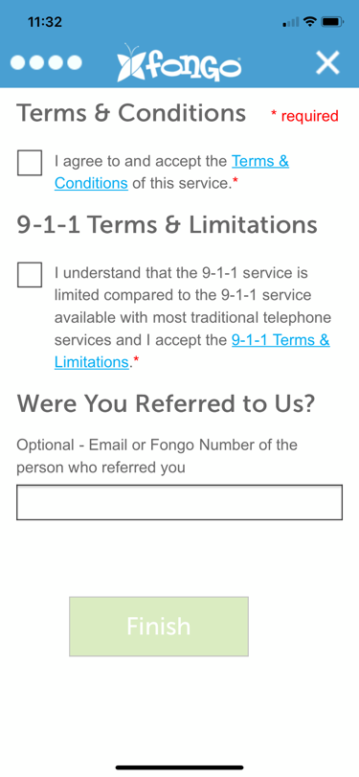
- Once you have set up, go back to the login window and login with the email and password you created at the beginning of this process.
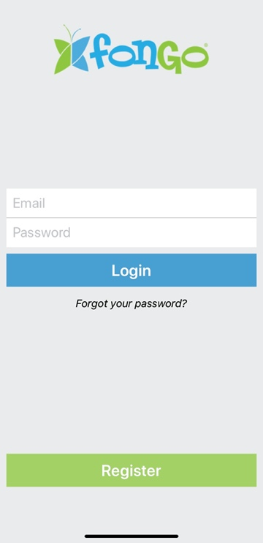

Making a call:
- To make a call, simply press the menu button ( ) and choose the ‘dialpad’ option. This will take you to a standard dialpad similar to any phone.
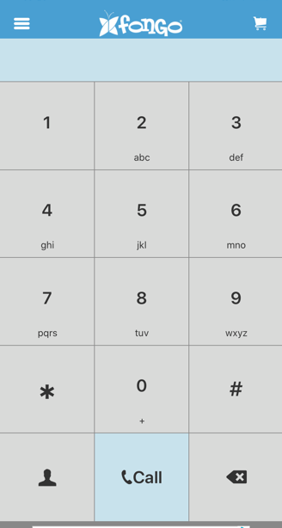
- You can dial a number from this window or press the ‘contacts’ () icon to access your contacts (those are the same contacts you have saved on your phone).

Purchasing text messaging package:
- From the menu bar, press the ‘add ons’ then choose ‘unlimited Canada texting’
- Choose the plan you wish to purchase
- At this point you will need to follow the instructions on your screen to complete the purchase (this will depend on your type of phone, iOS/ Android/ other).
- You should then be able to use the ‘messages’ section in the menu bar and send and receive messages similar to how you would with your regular phone.

Setting up your answering machine:
- To set up a personal answering machine message go to the ‘voicemail’ section in the menu bar.
- Press the phone icon . This will initiate the answering machine system and you will need to follow the instructions of the automated voice system. To set your own personal message press 3 for personal options, then 3 for greetings, and then 2 for personal greeting and 2 again to record your own personal greeting.

Tips:
- Once you set up your fongo app, go to the ‘account’ section in the menu and then ‘settings’ to modify any options like ringtones, volume, call forwarding, etc.
- Saving your clients’ phone numbers on your phone using MFFS and then their name will keep all your clients in one section of your contacts and will make it easier in the future if you would like to delete these contacts.
- For more information you can visit https://support.fongo.com/hc/en-us/categories/201668326-Fongo-Mobile

If you have any other questions about the app please feel free to email meirav.r.mffs@gmail.com

