Session 6

Communication Skills

Positive Psychology Question
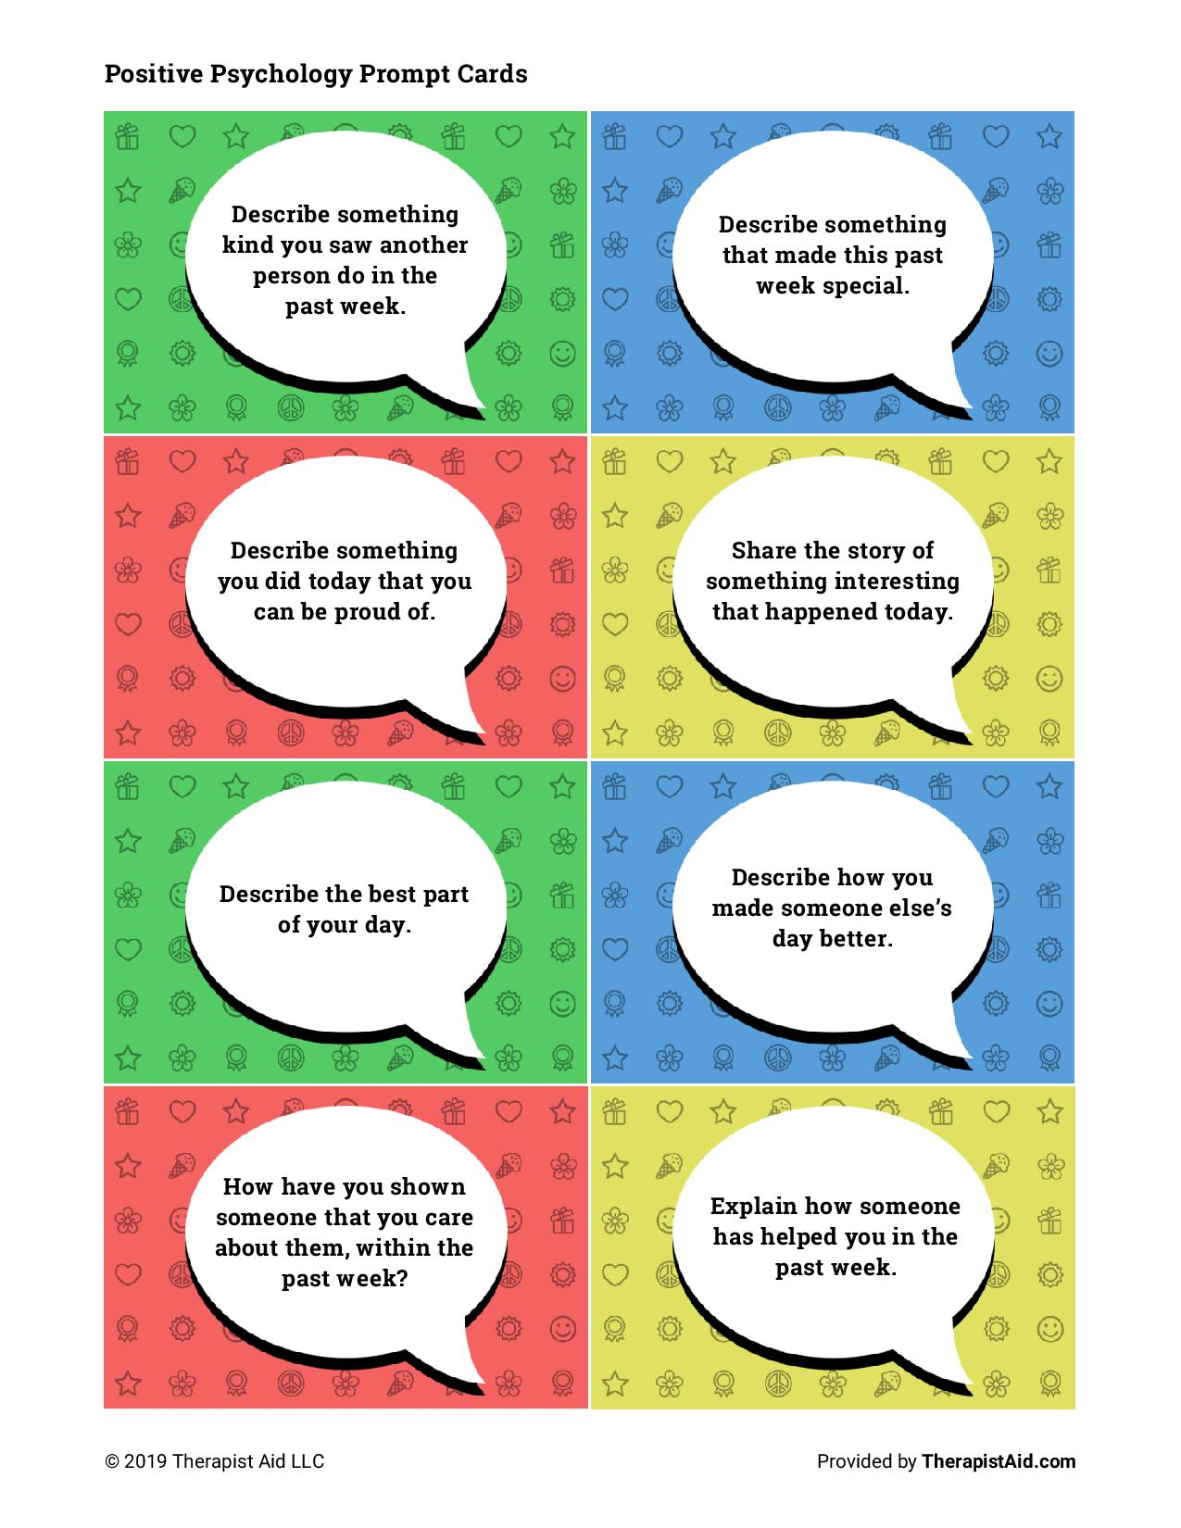
Review Homework: Couples Gratitude Journal

https://www.youtube.com/watch?v=Bk7MWcPjdUM&ab_channel=EstherPerel
How to Be Assertive Without Being Aggressive – Esther Perel
- What are the main points of this resource?
- What skills/strategies did I learn?
- How can I apply these skills to my own situation?
Communication Skills
How do you ensure that what you say is received in the way that you intended? Especially when the recipient is someone who is completely different from you? This process is an ever changing and life altering journey, and one of the most vital challenges in life – effective communication. We have many forms of language. The language spoken in our country, the regional language of our local town/city. The cultural language of our environment, which can include financial status and community associations. There are multiple layers of our own language and adding another person in a relationship can often cause a loss of translation. Often a daunting challenge.
Once you begin to ‘crack the communication code’ of your spouse and understand what language they use to communicate, then communication in general gets a lot easier. Communication will always be a work in progress, yet understanding your spouse in this way will strengthen your harmony greatly and give you a ‘code’ which you can apply to the various seasons that you’ll go through as a couple.

- Take time to consider the communication in the home you grew up in. Was the communication between family members and/or parents clear and effective? Was it minimal and abrupt, or sporadic and aggressive?
- What type of communication do you want to have in your relationship and what would you leave out?
- What do you consider to be healthy communication, what components must healthy communication have?
- How would you describe your communication style?
- How would you describe your partners communication style?

According to Psychologist Alfred Adler there are 3 responses to the parenting you experienced growing up: to react to it, to respond to it, or to re-create it. Your childhood experience may have been wonderful and you may have many tools to take into your relationships with confidence and certainty. However, many of us are not able to reflect positively on our early years and maybe fewer understand the elements that can lead to that negative environment. Some have good and bad experiences and are able to learn from both sides of the spectrum. Ultimately we are responsible and need to decide what we bring into our relationships and what we leave out.
What will you choose?

The Interpersonal Gap developed by John L.Wallen:
Wallen’s model of communication refers to the fact that there is often a difference between the message we intend to give someone and the message they actually receive. This “gap” between our intent and the actual effect results from filters that our messages go through as they leave us and reach the other person.
When we intend to communicate something to someone, we must encode our thoughts into observable behaviour (speech, actions, etc.). This encoding takes place through our filters. These filters include our past experiences, our physical and emotional state, and our beliefs about the world. This behaviour is then decoded by the other person(s) as they try to create meaning from what we have just said. Their decoding process also occurs through a filter of their beliefs, physical and emotional states, and past experiences.
Wallen suggests that there are four primary communication skills that are useful in helping to reduce the interpersonal gap and to increase the likelihood that the intent will be the same as the effect. These communication skills allow us to check out our perceptions and provide additional clarity to our own communication: paraphrasing, behaviour description, empathy, and description of feelings.
Paraphrasing
This communication skill simply requires us to repeat back to the speaker what we have heard him or her say. It is a way to check out the message to make sure we clearly understood it. (“Let me tell you what I heard and see if I got the message correctly.”) It can also be helpful to invite a paraphrase from someone if we don’t think they heard what we were trying to say. (“I’m not sure I said that as clearly as I wanted to say it. Can you tell me what you heard me say?”)
Behaviour description
This skill involves providing a description of observable behaviour that is free of assumptions. It invites the other person to comment on the meaning of the behaviour. (“You’re speaking very loudly.
Can you help me understand what is going on for you?” rather than “What are you angry about?”) You can also use this to do a perception check to find out what is going on when the other person’s behaviour doesn’t match his or her verbal message. (“You say you are not angry, but your fists are clenched.”)
Empathy
Empathy involves inviting clarity on the emotional content of their message by stating your own interpretation of their emotions and asking for clarity. It prevents us from operating on assumptions about how someone is feeling. (“You seem angry. Is that how you are feeling?”)
Description of feelings (“I” Statements)
This skill allows us to tell someone how we are feeling without blaming. (“I feel worried when I don‟t know why you are late.”) We take responsibility for our feelings.
These skills require that we listen to the other person and pay attention to and acknowledge the impact of the person’s communication on us as well as the impact of our communication on him or her. Use of the skills reduces the number of assumptions made during communication. In essence, they decrease the effect of the filters on the communication and thereby reduce the interpersonal gap.
Final Exercise
Take Ten Breaths
- This is a simple exercise to center yourself and connect with your environment. Practice it throughout the day, especially any time you find yourself getting caught up in your thoughts and feelings.
- Take ten slow, deep breaths. Focus on breathing out as slowly as possible until the
- lungs are completely empty—and then allow them to refill by themselves.
- Notice the sensations of your lungs emptying. Notice them refilling. Notice your rib
- cage rising and falling. Notice the gentle rise and fall of your shoulders.
- See if you can let your thoughts come and go as if they’re just passing cars, driving
- past outside your house.
- Expand your awareness: simultaneously notice your breathing and your body. Then look around the room and notice what you can see, hear, smell, touch, and feel.
Bonus (if time) participants can do later

Full Body Breath Scan
Start by inhaling through your nose, expanding your stomach, and counting to five. As you breathe in, visualize soothing warm light filling your feet, and then exhale through your lips for a count of five, while visualizing yourself releasing any tension you may have been carrying there.
Repeat this process for your ankles, your shins, your knees, and so on, all the way up to your head. After you finish scanning your entire body, you’ll likely feel lighter, calmer, and more at ease.
Homework:
Relationship Building Activities (if client not in a relationship ask them to consider holding onto this for when they are)
End: Review key concepts.

