Performance Guidelines for [ABC Co]

Introduction
Replace square brackets with company specific text

Performance management objectives
At [ABC Co], our performance and development processes have been aligned with the organisation culture. The key objectives the process is designed to deliver on, include:

Employee Growth and Development
Learning new skills and growing as a person is both motivating and rewarding. Helping our people to achieve new highs and overcome challenges is a key part of our performance experience. Not only does
this help individual growth and fulfilment, but also increases a sense of belonging as individuals become increasingly valuable contributors to their team.

Performance and Accountability
Delete any of the performance management objectives that are not applicable to your organisation.
Much of the work we perform is related to broader team efforts and being accountable means team members can count on each other to do their part.
Accountability helps increase team cohesion with characteristics of trust, empowerment, and autonomy. It also improves individual performance as employees take ownership and pride in their work.

Goal Setting and Alignment
Our goal framework helps provide work clarity and prioritisation for individuals while ensuring we're all pulling together in the same direction to achieve the top-level goals of Crewmojo. Our goal framework
provides an effective way of agreeing expectations; and by connecting individual work to the bigger
picture our daily activities carry more meaning and purpose.

A Culture of Coaching and Feedback
By fostering a culture where people are comfortable asking for and receiving feedback from peers, managers and team members, we can significantly accelerate learning loops and minimise wasted work. Trust and engagement is lifted as we authentically work to make ourselves better and more productive contributors to the team.

Employee Engagement and Retention
We aim to nurture an environment that engages our employees because we understand that engaged
employees feel more fulfilled, enjoy working together and achieve their best performance. We believe
employers and employees that find this level of alignment in their work and values tend to grow and stay together longer.

Consistent and Scalable People Practices
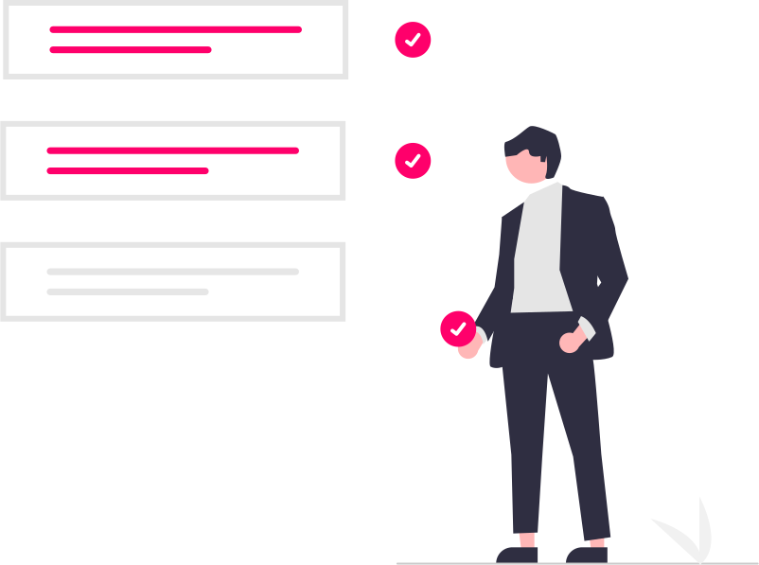
Creating a consistent approach to people development allows us to scale the culture that has got us to where we are now. This consistency enables us to set clear
expectations and agree standards for what the
performance experience looks like, no matter which team or part of the organisation we work in.

Team Contribution and Cohesion
A lot of our work is achieved in teams and we encourage employees to actively seek out opportunities to amplify their team's impact. Our philosophy of team success extends to the both the work we do and the sense of trust and belonging we create.

Our Approach
Our approach to performance is based on continuous conversations, with feedback, coaching and recognition taking place throughout the year. Regular check-ins between managers and employees provide ongoing opportunities for growth and development, enabling individual and organizational performance success. The performance year is wrapped up with a fair and simple review process.

Key Drivers of Performance
The table below outlines key drivers of performance at Crewmojo, all performance activities can be connected back to one or more of these key drivers.

Driver Weighting

Achievement of individual work goals:  This is 'what you do' and includes the outcomes you are responsible for achieving as part of your role. | Equal Importance
Demonstrating organisation values:  This is 'how you do your work' and includes the way you go about achieving your goals, relating to others, and behaving in alignment with our core values. | Equal Importance
Personal development:  This captures the skills you need to develop to achieve your outcomes and progress towards your career aspirations. | Equal Importance

Change weightings if required.

Our Performance Experience has Three Key Stages to the Cycle:

1. Align & Plan | 2. Coach & Feedback | 3. Annual Summary  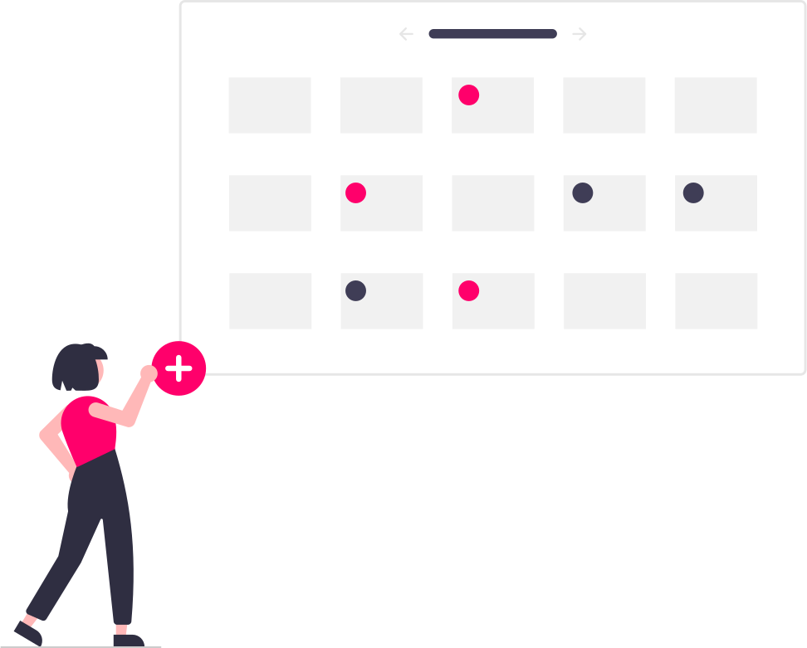

Stage One: Align and Plan
The aim of this stage is to set clear goals with measurable outcomes that are aligned with the organisation's top priorities. This is a collaborative process between managers and team members with opportunity to discuss expectations, how we go about our work, and how this aligns with our core values.

This section provides key information on our goal framework, and the process for setting and agreeing goals with your manager.

Performance Goal Setting
Change framework if required (SMART, KPI etc).

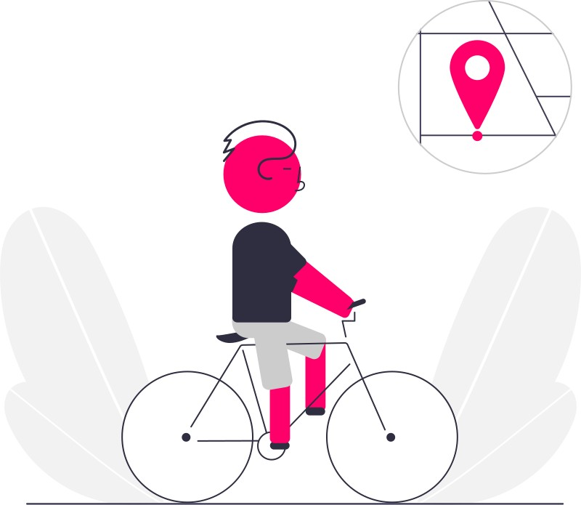
Goal Framework
At a high level, our goal framework is aligned with the OKR (Objectives and Key Results) model. The 'Objective' component describes the goal we are trying to achieve and the 'Key Results' are a measure of progress towards achieving the objective.

Goal Cycle
Our goal cycle is based on an annual cadence. This has the benefit of minimising the administration associated with the goal setting process. However, it also means goals should be well thought out as they need to stay valid for a longer period of time.

Goal Planning
We start the goal planning process in [MONTH]. This allows enough preparation time to ensure everyone has appropriate goals ready for each new goal cycle.

Goal Alignment
Our strategic goals are set at the executive level and cascaded down through the organisation to provide a clear direction of where efforts should be focused. The cascading process helps ensure our work is aligned and connected to the major organisation outcomes we are seeking to achieve.

Goal Privacy

Individual goals are considered private between you and your manager, however you may share your goals with other team members when approved or if a collaborative approach makes sense. | Team level goals are transparently shared across the organisation to help communicate current priorities being undertaken by different teams and to foster greater collaboration. | Company level goals are shared openly with employees to show a guiding light of where the organisation is headed and to show how individual and team goals are connected to the bigger picture.
Number of Goals
Aim to set a number of goals that will stretch and challenge you, but don't set so many that it becomes easy to lose focus on what's important. As a guideline we suggest a minimum of [3] goals and a maximum of [5] goals.

Goal Discussion
Prior to setting your goals, meet with your manager to collaborate on what your key focus areas might be in the upcoming cycle. In preparation, think about your role and your strengths, and where you can make a strong contribution.

After setting your goals, meet with your manager to ensure you are aligned with expectations for what you will do and the outcomes you'll seek to achieve.

Development Planning

Personal Development
We encourage employees to establish goals that nurture a sense of personal growth while achieving their business goals. Aim to set development goals in the following areas:

Skills for Current or Future Roles
Build your subject matter expertise in your current or aspirational roles. Start by reflecting on your strengths and identify areas you would like to improve that will help you achieve your role more effectively or upskill for a future role.

Leadership Skills
Consider feedback you may have received or areas you would like to focus on that will help you be a better leader, team member or contributor. It might be skills like listening, speaking, presenting, being coachable, a better coach etc.

Career Discussion
Career growth for employees is an important part of the
Crewmojo performance experience. To ensure each person has an opportunity to discuss their growth and development, the discussion should take place around the same time as the goal setting process.

Remember a successful career journey is very individual, for some it might be deeper expertise, others it might be broader experiences or leadership opportunities.

Some of the most valuable development can be achieved with on-the-job experiences or assignments - be sure to contemplate how these experiences may be integrated with your role as well as traditional training programs.

This conversation is most effective when there is mutual contribution between manager and team member.

Stage Two: Coach and Feedback
This stage is focused on building employee success with the plan developed in Stage 1 and is primarily facilitated with frequent 1:1 catch-ups between managers and team members; and sharing regular feedback.

A key topic of discussion and feedback will naturally be goal progression, any barriers, and course corrections. However, the purpose of each catch-up can be dynamic and you are encouraged to focus on different topics of importance throughout the year.

Goal Progress
Checking in with your manager on your goal progress can significantly improve goal achievement rates. We suggest a monthly catch up with a focus on any hurdles you've run into and gaining clarity for where you will focus in the coming month to progress your goals.

Managers: Focus on supporting your team member, unblocking challenges, and alignment of expectations.

Values Discussion
Values at [ABC Co] are important to us. While our goals help guide what we do, our values guide how we do it. Each value is supported by behaviours that we like to see demonstrated as part of the way we do things around here.

Managers are encouraged to incorporate a values discussion at least half-yearly (but can be any other time too) in their 1:1s with each team member. A good framework for the discussion might be to brainstorm together behaviours to continue, start or stop.

Interim (mid-year) Review
The mid-year check-in takes place in the month of [MONTH] and is a lighter version of the end of year summary. The mid-year check-in is a formal but brief process to ensure goals are on track and team members have clarity for the next half.

Stage Three: Annual Summary
This stage creates the space for celebrating success, reflecting on how we work together, what has been learnt and contributions to team & organisation.

The process references the plan created in Stage 1, and notes captured in feedback and coaching conversations during Stage 2.

Timing of Reviews
The review process takes place in the month of [MONTH] each year. This is designed to align with the company goal setting process and strategic year.

Self-Review
The self-review is a time to reflect on the last 12 months. Consider areas where you've thrived, key achievements and areas you would like to improve or develop. In the self-review you'll asked to think in the context of the following:
- Rating your achievement of performance related goals.
- Rating how you've embodied and lived the organisation's values.
- Commenting on key achievements and areas you might improve relating to your performance goals.
- Reflecting on 'how' you've gone about your work in context of our organisation values.
As a manager, you'll be able to see your team member's self-review as supporting data to help make a more informed manager review.

Manager Review
The aim of the manager review is to summarise performance and contribution, using data from the ongoing process throughout the year, meaning there should be no surprises at this point of the cycle. Key components of the summary will include:
- Rating or category of performance against the measurement scale.
- A summary of performance and contribution for the last 12 months.
- Feedback about standout areas of strengths.
- Feedback on areas to consider for development.

1:1 Review Discussion
The written part of the review process encourages individual thought, reflection, and synthesis of multiple inputs. Equally important is the conversation that stems from the written component to clarify understanding, seek feedback and where necessary amend initial words.

We encourage managers to meet 1:1 with their team members after the review pack has been shared with team members to answer any questions on the content or discuss feedback in more depth.

Conclusion
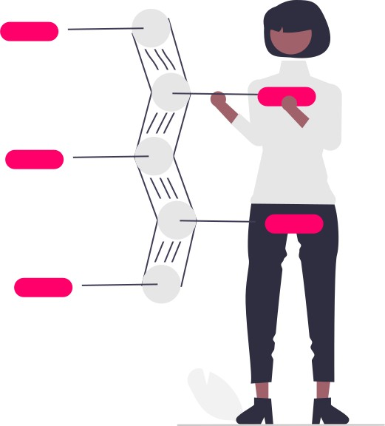
At [ABC Co], our performance framework is based on a Continuous process, designed to nurture:

- Goal setting alignment and success
- Employee growth and development
- Performance and accountability
- A culture of coaching and feedback
- Employee engagement and retention
- Consistent and scalable people practices
- Team contribution and cohesion.

Performance is often defined as a way to get the most out of your people. For us, it’s a way of working, where each person is supported but accountable, engaged, motivated, and making progress with meaningful work.
It’s a way to build connected relationships while working on something bigger than ourselves. At the heart of this way of working is a systemic alignment of organisation purpose, employee fulfilment, and customer outcomes.
Managing all of this at scale can be tricky. Contact Crewmojo to see how we make this easy.

