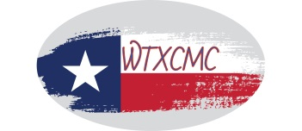
West Texas Community Mediation Center (WTXCMC)
Presents

40-hour Basic Mediation Training
January 3, 6-7; 13-14, 2022

This 40-Hour Basic Mediation Course is a 5-day (8:30am – 5:30pm) training is being offered to the general public. The training is completely online while remaining live and interactive. This course is designed to give individuals the skills and credentials they need to serve as a mediator in the State of Texas. The training focuses on the community-based mediation model. Individuals actively participate in practice mediation following each lecture session, and certificates are provided to participants upon completion of the course.
PLEASE NOTE: Requirements for participation in this online training include:
- Registrant must use a laptop or desktop computer during the training that has a camera and microphone. (No tablets or cell phones)
- To meet the standards for the training, the registrant must attend the full 40 hour course and be visible by camera the entire time.
- Recording of sessions by the registrant is not permitted.
Please proceed to online registration: www.wtxcmc.org

Training Fee: $900.00

Volunteer Opportunity: Pay $700.00 and commit to one mediation/quarter- Complete online Volunteer Application.

Or mail this form to: P.O. Box 484 * Big Spring, Texas 79721

VIA: CHECK ___ M.O. __ Credit Card No: _____________________ Exp: ____ Sec Code: ___

PARTICIPANT NAME: _________________________________________________________
ADDRESS (include city, state & zip): ______________________________________________

COMPANY OR ORGANIZATION: _______________________________________________
EMAIL ADDRESS: ____________________________________________________________

PHONE : _____________________________________________________________________

For additional information email: wtxcmc@gmail.com or call 432-517-4200 office * 301-792-3340 cell

