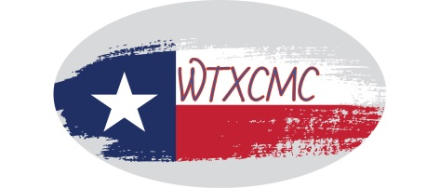
West Texas Community Mediation Center (WTXCMC)
501 S. Runnels Street * P.O. Box 484 * Big Spring, TX 79721 * 432-517-4200

Presents

40-hour Basic Mediation Training
January 3, 6-7; 13-14, 2022
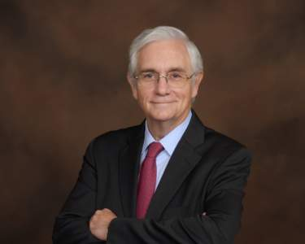
Professor
Texas State University Walter Wright, Esq., Instructor

This 40-Hour Basic Mediation Course is a 5-day (8:30am – 5:30pm) training being offered to the general public. The training is completely online while remaining live and interactive. This course is designed to give individuals the skills and credentials they need to serve as a mediator in the State of Texas. The training focuses on the community-based mediation model. Individuals actively participate in practice mediation following each lecture session, and certificates are provided to participants upon completion of the course.

Register online at WWW.WTXCMC.ORG
OR

Mail the attached registration form to:
WTXCMC, P.O. Box 484, Big Spring, TX 79721

For more information email: info@wtxcmc.org or wtxcmc@gmail.com

