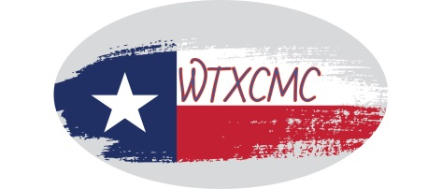
West Texas Community Mediation Center (WTXCMC)
501 S. Runnels Street * P.O. Box 484 * Big Spring, TX 79721 * 432-517-4200

Presents

“Restore the Respect”
School Mediation Training Workshop

Please join us for a full day of training
August 13, 2021 from 8:00am – 5:00pm

Part 1- Mediating In-School Conflicts
Part 2 – Mediating Attendance/Truancy Issues

This workshop will share evidence-based restorative mediation techniques for use with teachers and students in Grades K-12. The workshop will show the process of starting a teacher-student AND/OR attendance/truancy mediation program in your school district. Instruction will include, but not be limited to: conducting successful mediations, and collecting and monitoring data to measure the effectiveness of the interventions. The workshop will also show how to use the technique to mediate conflicts between students to stop aggressive and bullying behaviors.

Register online at WWW.WTXCMC.ORG
OR Mail the attached registration form to:
WTXCMC, P.O. Box 484, Big Spring, TX 79721

For more information email: info@wtxcmc.org or wtxcmc@gmail.com

